16
16
Training Toolkit 16 Lessons from Brexit
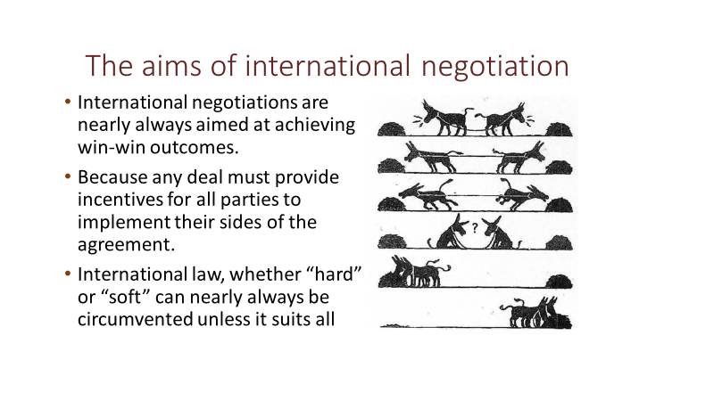
This note is not intended as an argument for or against Brexit, it simply draws on my training course for IFMSA Students, who need to learn something about international negotiations to participate in the World Health Assembly, as a basis for considering some basic issues raised by the negotiations.
Some international laws are described as “hard law”, when ratified agreements specify consequences of non-compliance in national and international courts, other resolutions can be described as “soft law” agreements expressing intentions, but without clear consequences. In practice virtually all international laws whether “hard” or “soft” can be circumvented if they are not seen as in the interests of all parties. What are the key interests of the UK and EU in Brexit negotiations? How would a deal be enforced?
The position taken by parties in negotiations may reflect, or sometimes hide, underlying interests. These are the bedrock for any negotiation, so clear understanding of the interests of all sides is essential. In this case the UK is seeking to avoid EU Federalism, to take control of its own laws and borders and to be free to make trade deals in world markets. Some Member States of the EU were seeking closer union, while others stressed the importance of maintaining integrity and principles of free movement of trade and labour, while ensuring Member States benefit from union. There are also financial considerations including the £39bn financial settlement, described as the “divorce bill” to be paid by the UK, see later. Discuss the interests of parties to Brexit negotiations. What would a win-win outcome look like?
While trade, democracy and border issues have been much debated there are also wider questions of global governance at stake. Threats arising from: climate change, pollution of the seas, global health, terrorism, corruption, poverty and sustainable development urgently need international collaboration. Moreover globalisation, which is one factor driving public concern, also requires global governance of the multi-national corporations. Regional bodies including the EU, often created to ensure peace and cement trading relationships have begun to address these global governance issues. Participation in any form of regional or global governance inevitably requires some sharing of powers and responsibilities. Will the UK voice in global governance be stronger within or independent of the EU?
Brexit was decided upon by the mandate of a UK referendum, which is not defined in its (unwritten) constitution but was introduced by a parliamentary vote. Others claim that, as a representative democracy, the referendum was only “advisory” and Parliament must still be paramount. Equally it is argued that membership of the EU imposes governance on the UK without accountability to the people. This is difficult to deny not only because, though it does have a written constitution, the mechanisms of the EU are complex but because it has been easier to blame the EU than to explain how and why decisions were agreed. The view that EU laws are made by “unelected bureaucrats” persists, though in fact laws must be agreed by the Council of Ministers from Member Countries which consults (but may not be bound by) the EU elected parliament. Both the EU and the UK must also seek to maintain their membership (the 27 remaining states of the EU and the Home Countries of the UK). How is the lack of understanding of democratic processes destroying trust in the EU and UK government?
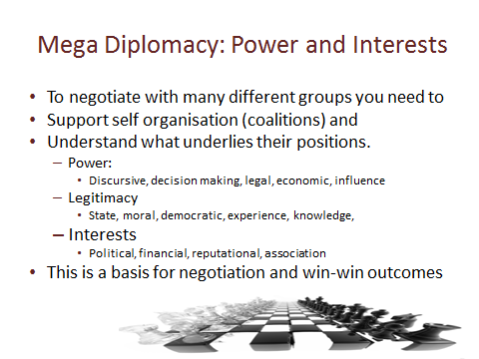
The modern world of mega diplomacy requires leaders to work with many different partners and sometimes opponents. A starting point is to gain an understanding of factors that underlie the position taken by each of the parties involved. It is important to understand the basis of their power, which may derive from: discursive power - being able to define the situation and set norms, decision making power – ability to take decisions without deferring to others, legal power – based on rights established by international and national laws, economic power – controlling financial or other resources e.g. security, or influence – the ability to sway the behaviour and choices of others (the public or other parties). Discuss the power base of EU and UK parties involved in Brexit negotiation.
The economy and trading conditions may be one source of power. The EU is the second largest economy in the world and accounts for 44% of UK export earnings. The UK GNI is the second largest in the EU and is larger than the combined GNI of 19 of the smallest EU Member States. The UK imports more goods from EU countries than it exports – a trade deficit of £67 billion. However, service industries, account for 83% of the UK economy, generating a trade surplus of £135 billion (excluding travel and transport), about half is generated from the EU. How does this affect the balance of power and interests?
There are other forms of power and interests involved. Public concern has focused on the idea that “most UK laws” are decided by the EU, though in practice only 13% of UK laws mention the EU and laws are agreed by UK governments. There is also concern that free movement of labour is undercutting UK jobs and wages and adding public sector costs, though studies suggest EU migrants contributed over £20bn to the UK economy. This can be linked to a general unease at globalisation and its impact on traditional manufacturing employment. Have politicians addressed these concerns?
In practice it is often important to distinguish between the position and power of the organisations represented in a negotiation and the personal position and power of the individuals in the room. Negotiators can be limited or empowered by instructions they receive and the strength and clarity of the coalitions supporting their position in the negotiation. Was this true of May, Johnson and Tusk?
It is also essential to understand the factors that support the legitimacy of each party. These include: state legitimacy – the authority vested in a state institution to act on behalf of citizens, moral legitimacy – based on human rights and equity, democratic legitimacy – established through the election of representatives, (or in this case a referendum giving an alternative basis for democratic power) knowledge – expertise derived from research or skills gained through experience. Individuals will also build personal legitimacy, earning the trust and respect of others at the negotiation, though in some cases the reverse may happen. What was the basis of legitimacy of May, Johnson, Tusk and others?
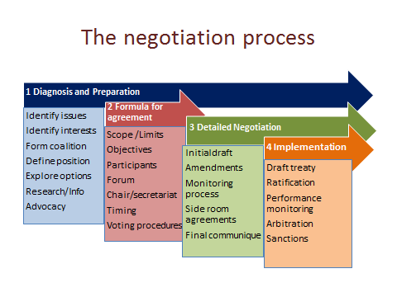
The process (based on Lister and Lee, (2013) “The process and practice of negotiation”, in Kickbusch, Lister et al. [eds] Textbook on Global Health Diplomacy. New York: Springer) can be discerned in all negotiations. Consider whether the following point were addressed during Brexit negotiations.
Diagnosis and preparation is the most important phase; careful timing and selection of issues, identifying interested parties and their interests, creation of “coalitions of the willing”, defining a clear realistic position and aims, exploring options for agreement and undertaking research and advocacy to build a case and create the conditions in which parties are open to negotiation are essential. Was this done? Did Cameron, May or Johnson identify key aims? Was a coalition of the willing established?
The formula for agreement is crucial, it defines the scope and limits of agreement it is hoped to achieve, its legal form, aims and objectives, who will participate and how negotiations will be conducted. In this case it is clear that the EU team carefully defined this process. A “heads of agreement” may be negotiated, setting out the points of agreement on which detailed negotiation will take place (e.g. the Political Declaration). It may be possible to agree on general principles and to plot a path to an agreement to meet the interests and aims of all parties. How was the formula for agreement negotiated for Brexit, why did failure to negotiate this disadvantage the UK?
Detailed negotiation may involve participants setting out their opening positions or may use an initial draft with points at which disagreement must be resolved identified. Parties to the negotiation then propose amendments and address issues such as: how the outcome is to be monitored and what should happen in case of default from the agreement. The main agreement may be encouraged by “side room” agreements to overcome obstacles. Did this happen? What was UK opening position Were there side room agreements to overcome issues such as the Irish Border?
Timing is always an important issue in negotiations, prepare for long nights and last-minute changes. An initial agreement is often not the end of negotiation, it may be the start of another phase, which will involve continuing negotiation of the acceptance, interpretation and performance of the agreement. Timing can be a potent weapon in negotiation and ability to dictate the timing of meetings is crucial. Does this help explain our nail-biting times? What happens next?

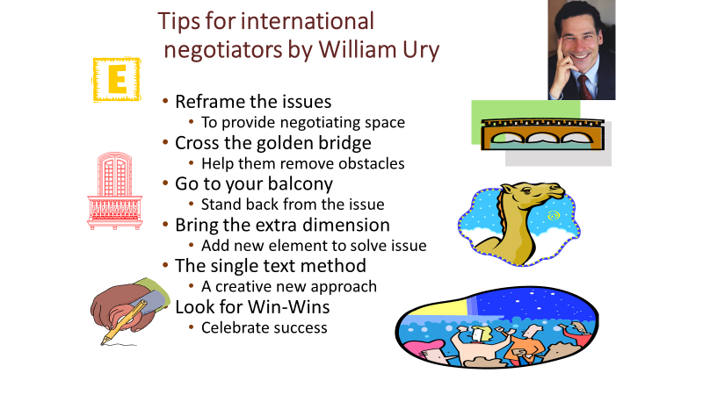
In negotiating for win-win outcomes from international negotiations we can learn from experience, most of these tips are taken from William Ury, the world leader in negotiation skills (you can find talks by him at http://www.ted.com/talks/william_ury.html .) This can help us reflect on lessons from Brexit.
Reframing the issue means setting the issue in a different policy context, helping people to address the issue in a different way. In what ways was Brexit framed in: economic, political, security, domestic and global contexts by the different parties involved?
“Crossing the golden bridge” refers to the importance of helping your opponent to overcome the barriers that face them in reaching a compromise agreement acceptable to others, to do this you need to accept and work with “where they are coming from” and talk them through the obstacles they face. What attempts were made to encourage parties to cross the bridge by encouragement or coercion?
“Going to your balcony” means not getting sucked into arguments, keeping a clear perspective on the aims of the negotiation and discussing issues not personalities. If someone attacks you on a personal level don’t react, take the discussion back to underlying issues, hopefully it will make them look small. Did the parties focus on the big picture or did the disputes become petty and personal?
In some negotiations it can be helpful to introduce an additional element so that everyone wins from the outcome. The story of 17 camels shows this see http://www.wussu.com/humour/camels.htm In other cases there are elements that can be removed from negotiations to simplify agreement. Can you identify the extra camels in Brexit negotiations? Or factors that could be taken out of negotiations?
The single text method was used to develop the road map for peace in the Middle East, both sides started from hard-line positions and would not give way, so the American chair of negotiations started afresh with a single text both sides could take or leave. Is Johnson proposing a single text for Brexit?
Negotiations often involve coalitions of those in favour or opposed to particular outcomes. It is vital to maintain the strength of the coalitions, as although the leaders may have a clear position, their strength in negotiation may depend on maintaining support from the other coalition members and parties. What went wrong in May’s attempts to build and maintain her coalition? Did Johnson do any better?
Advocating for a set of ideals or principles may make you feel good, but achieving progress towards action on issues requires an understand of the points of view and interests of other parties and to negotiate the best possible next step attainable. This is “the art of the possible” not “virtue signalling”. Negotiations often require compromise to reach a least-worst outcome and avoid the worst outcome. Identify examples of virtue signalling and least-worst outcomes in the Brexit negotiations.
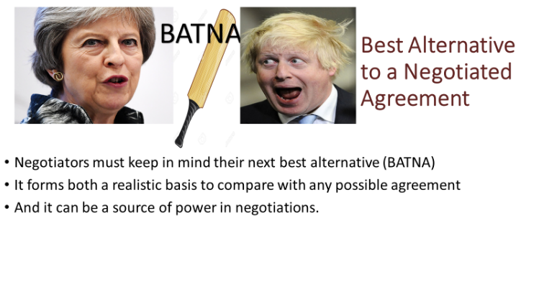
William Ury favours “principled negotiations” based on creativity and reasoning to achieve win-win outcomes for international settlements. But others take lessons from commercial negotiations in which the power of the participants and their relative need for a deal is nearly always a factor. In practice lessons can be drawn from both principled negotiations and the use of power in commercial settings.
One of the clearest indications of power and need for agreement is the Best Alternative to a Negotiated Agreement (BATNA). This alternative may be disadvantageous to all, but a party showing indifference to this outcome can give the illusion of greater negotiating power. In most situations this is not set out in detail but is an unspoken threat. May did not feel it necessary to threaten a No Deal because this was recognised as disadvantageous to both sides, but this has been an opening gambit by Johnson. However, in a democratic system it is difficult to maintain an illusion of indifference to no deal while public debate unpicks its disadvantages. Has UK opposition to a “No Deal Brexit” reduced UK negotiating power?
Johnson also attempted to show power by threatening that UK would withhold some of the £39bn “divorce settlement”. But £16.4bn of this is payments for 2019 and 2020, £19bn is for commitments already made when UK was an EU member, about £9bn is pension commitments and the EU will return £3bn. Can you identify the references to power in Brexit exchanges, are they realistic?
Control of the message and language used to advocate for a negotiating position is also vital in complex public negotiations. This will be impossible unless the negotiating position is itself clear and shared throughout a coalition of those supporting an agreed outcome. Even those generally in support of one side may undermine the message by setting unrealistic expectations or by castigating other coalition members. While repetition reinforces the, messages substance is also important. Discuss the language: “Brexit means Brexit”: “Crashing Out”: “May’s Deal”: “No Deal”: “Clean Break”: “Surrender Act”.
While there are lessons for leadership, there are also lessons for supporters. Any negotiation on behalf of others requires trust in the negotiators and good communication between leaders and supporters. Leaders need to show commitment to shared goals and fragmented supporters need to resolve their needs and preferences in order to coalesce around a realistic option. Negotiations nearly always involve compromise which supporters will only accept if they are part of the process. What errors were caused by a failure of those supporting Brexit to resolve their differences or trust their negotiator?
Support groups need to reach out to communicate with the public whose views and interests they profess to represent. Currently it seems that many such groups have been more interested in communicating within their own silos than addressing public concerns or achieving consensus. One factor has been that groups often coalesce around a “pure ideal” of their aims. They choose leaders to reflect this, which makes it more difficult for them to accept compromise without detracting from their position within the group. In this case ambitions for political leadership may also be a factor in leave and remain groups. Did groups supporting Brexit improve understanding of the issues and gain public support? Is Boris offering a realistic compromise?
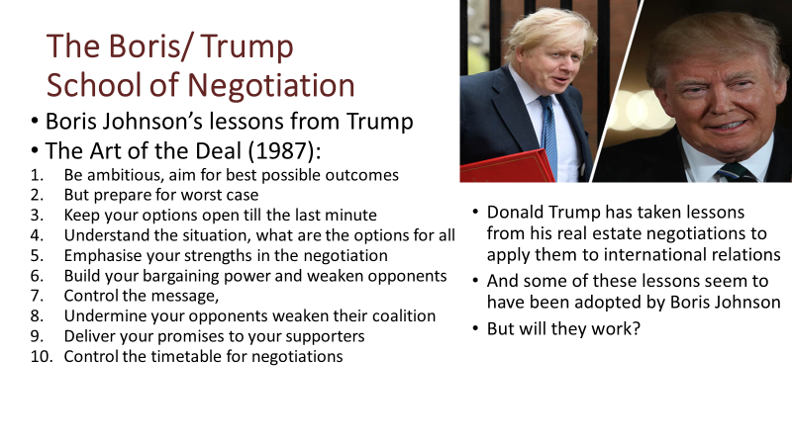
Some claim that Donald Trump has been successful in applying his approach to negotiations, as set out in his in 1987 book “The Art of the Deal”, to international relations. They point out that in dealing with Kim Jong-un, the supreme leader of the Democratic People’s Republic of Korea, Trump’s negotiations have achieved more than previous decades of arms-length diplomacy. They also point to trade negotiations with China, claiming that US industry is being strengthened by the trade tariff increases. Others point out that rather than weakening Kim Jong-un, talks have reinforced the dictator’s power and that rising trade tariffs are likely to weaken the global economy and harm American consumers.
It appears that Boris Johnson has adopted at least some of Donald Trump’s advice, putting himself forward as a strong leader with the ambition to achieve the best possible deal but being fully prepared for the worst case – No Deal scenario, keeping his options open by refusing to put forward concrete proposals until the last moment, underlining the strengths of the UK and trying to divide the EU by talks in Ireland and trying to control the timetable by continued promise of Brexit by 31 October (both failed).
What seems clear is that, while there may be some similarities between commercial negotiations and international relations, it is essential to rethink negotiating tactics in a context in which:
- Any agreement must be seen as beneficial to all (if they are to abide by the agreement),
- The conduct of negotiations will inevitably be transparent to some extent.
- Johnson’s threat of No Deal is not believable to the EU and is opposed by UK Parliament.
- He cannot reveal that his No Deal threat is a bluff without reinforcing the EU’s position.
- The deadline for agreement seems impractical and puts pressure on UK but not EU
- It is not in EU’s interest to reinforce Johnson by allowing him to claim victory!
- The December Election was won by claiming an instant answer to long term issues!
Boris Johnson, seems to have adopted Trump’s “bully boy” negotiating tactic in responding to parliamentary opposition, claiming to have won an amazing new deal which is hardly any different to “May’s Deal”, winning a snap election based on Brexit that the opposition lost, attempting to prorogue Parliament (though this has been found illegitimate). Perhaps he will now be able to adopt a more constructive approach taking lessons from William Ury about the potential for creative exchanges leading to solutions that would allow all sides to achieve better outcomes. What strengths and weaknesses do you see in Boris Johnson’s approach to Brexit negotiations?
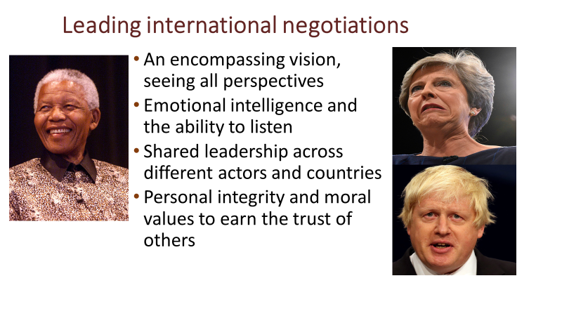
Leadership of diplomacy and negotiations may be described as the art of “meta leadership” (https://npli.sph.harvard.edu/meta-leadership-2/ ). This requires: a belief in the goals negotiated and an encompassing vision - understanding the perspectives that all the parties bring to an issue, but with a vision that transcends their differences. It requires emotional intelligence and the ability to listen to others, which is a much under-rated skill in a world obsessed with gesture politics and grandstanding leadership. Leaders need to be able to prompt others to take the lead, recognising their skills and strengths and giving them support and encouragement rather than competing with them. Underlying these skills, negotiation leaders need personal integrity and moral values that earn respect and trust. Was meta leadership shown by May? Did May show belief in and a clear vision for Brexit? Did Boris Johnson appear to be willing to listen to all opinions?
Meta leadership combines and goes beyond elements of “servant leadership”, “leadership through constructive conversations” and “distributed leadership” (if you Google around these phrases you will find examples of the application of these ideas to political leadership). For me these values are best illustrated by a quotation from Nelson Mandela’s book “Long Walk to Freedom” (1995).
As a leader... I have always endeavoured to listen to what each and every person in a discussion had to say before venturing my own opinion. Oftentimes, my own opinion will simply represent a consensus of what I heard in the discussion. I always remember the axiom: a leader is like a shepherd. He stays behind the flock, letting the most nimble go out ahead, whereupon the others follow, not realizing that all along they are being directed from behind.
This quotation illustrates the importance of listening to others, summarizing – often framing issues in terms of underlying values and guiding the direction of others – all key attributes of diplomacy and skills in international negotiations.
While there has been a lot of emphasis upon the leadership qualities or lack of them shown by May, it is also apparent that the leadership shown by any political party or social group is a shared responsibility and a product of team-work or the lack of it. Leadership of the Labour Party seems to have listened only to selected Party Members and not to the wider support base needed to win an election. Leadership of the Liberal Democrats seem unable to see reason. Perhaps for this reason trust in politicians of all parties has dissipated.
What failures of leadership would you ascribe to groups supporting Leave or Remain in UK.
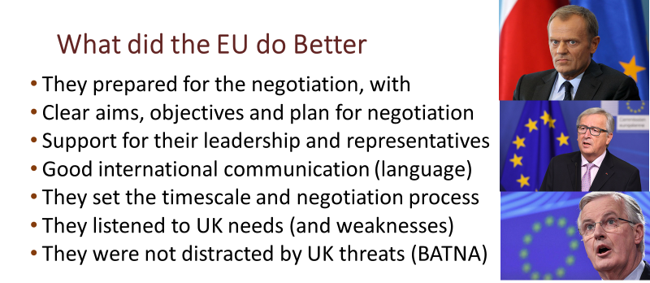
In comparison to the UK the EU were well prepared for the negotiation of Brexit. The danger to the unity of the EU and possibility that other countries would leave if Brexit was seen to be easy or advantageous was obvious. Many hoped that the UK, having held a referendum vote for an unspecified “leave the EU”, might reconsider once the practical issues were understood.
They therefore agreed their aims and objectives in a clear joint negotiating position. They quickly introduced the role of their chief negotiator Michel Barnier and his team and established clear communications with other EU leaders such as Donald Tusk (President of the European Council) and Jean-Claude Juncker (President of the European Commission). They in turn established communications with government leaders and officials of the other 27 EU member states. This meant that attempts to “divide and rule” by talks with leaders such as Emmanuel Macron and Angela Merkel were countered.
It is also apparent that the language which was used to refer to the negotiations was coordinated, or at least copied from one EU leader to another. This was at times conciliatory and at times scornful and while it did not affect UK opinion, or at least only made attitudes harden, it has been a factor in enhancing the EU reputation and deriding the UK in other countries.
The EU were handed a key timescale by the UK when Theresa May declared the date of the UK Brexit, before the UK had prepared a clear position or any form of agreed plan for negotiation. This meant the EU could decide the process of the negotiation (the formula for agreement), it appears that the UK made very little attempt to negotiate this. The error was repeated by Boris Johnson’s 31st Oct deadline.
The EU leaders and negotiation team showed they understood the UK position and were prepared to compromise to facilitate alternative solutions to issues such as the Northern Ireland border, the problem was that the UK had no clear alternative to offer (as shown by the Boris option).
Both sides in the negotiation were aware of the disadvantages of a “no deal Brexit”. To suggest that it would have helped to flaunt this as a threat seems irrelevant. In practice the EU was better prepared for a no deal outcome than the UK. All this and more can be seen in the BBC Panorama programme “Britain’s Brexit Crisis” if you can, download this from the BBC IPlayer (if you have a UK TV license). Rather than countering these arguments, this has been castigated as an example of BBC bias.
What do you think the EU did better than the UK in Brexit negotiations?
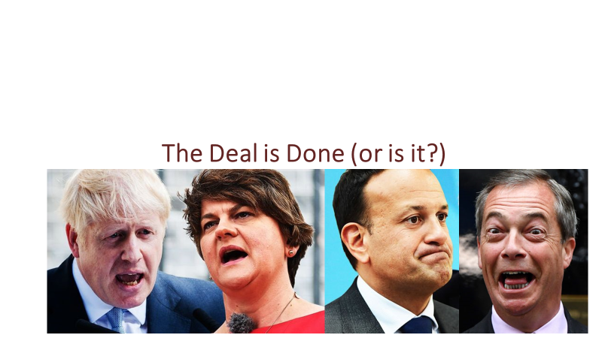
A deal has been drafted, hailed by its supporters as a “Tournedos Rossini of a Deal”. While Farage and others describe it as a reheated version of the so called “Disastrous May’s Deal” with the addition of concessions agreed with the Irish Taoiseach, Leo Varadkar and a face-saving formula offered to the Democratic Unionist Party of Northern Ireland but rejected by their leader Arlene Foster. It may be ratified by the European Council of Ministers, but the UK parliament is finding it difficult to swallow. As this issue has split both major political parties, it has already run into further political obstacles.
This is not the end of negotiations it is merely the start of a new phase in which terms must be agreed for trade and cooperation. The most important aspects of which will include cooperation on global issues such as climate disruption, security and international development, issues concerning corporate tax and workers rights and the regulation of trade most importantly for the UK with respect to service industries including finance and business services, education and health and information technology.
