15
Graham Lister

Training Toolkit 15:Lessons from the Coronavirus
Coronavirus: Why is Everyone Worried?

For a free WHO online course explaining public health responses to the Corona Virus click here a guide for the general public with symptoms can be found here.
Corona viruses cause diseases in mammals and birds. In humans, the viruses cause respiratory infections, including the common cold, which are usually mild, though rarer forms such as SARS, MERS and COVID-19 can be lethal. Transmission of disease from animals to humans is due to close, unhygienic contact, usually in markets. Spread of the disease is through cough or sneeze droplets and contact with contamination of surfaces. So called “superspreaders” have a high likelihood of passing on the disease but may have a mild reaction or may be in an incubation period so may travel and pass on the disease without being aware. There were no vaccines or antiviral drugs to prevent or treat the infection.
By mid-February 2020, 60,000 people were diagnosed with these infections, about 1,500 people had died. Other corona virus diseases include SARS (Severe Acute Respiratory Syndrome) and MERS (Middle East Respiratory Syndrome), these were contained after deaths of some 800 people from SARS and about 200 people from MERS. The impact of these outbreaks in 2003 and 2015 were estimated to cost the global economy about $15-$20 billion for SARS and about $8 billion for MERS. The impact of the current outbreak is likely to be greater and the Chinese economy is twice the scale it was in 2003 moreover the global economy is more precarious. In February 2020 the World Economic Forum estimated the potential cost at between $350 billion and over $1 trillion see here.
Other zoonotic diseases that can be passed from animals to humans include Ebola and Influenza. The 2013 Ebola outbreak is estimated to have caused 11,000 deaths and cost the global economy (mostly the West African economies) about $25 billion. The annual global Influenza pandemic results in about 300,000 - 650,000 deaths each year and costs the US economy about $90 billion a year and probably 3 times this for the global economy. The 1918 influenza pandemic resulted in 30-50 million deaths.
It appears that the Corona virus COVID-19 is transmitted more readily than Influenza, this is measured as R-naught (R₀) - the number of people typically infected by one carrier: for Influenza this is about 1.3, for 2019-nCov it may be 1.4 or more. It is more deadly than influenza which usually results in death for 0.1 - 0.05% percent of those contracting the illness (90% of deaths are amongst people over 65) for 2019-nCov it has been estimated at 3.4% initially (reducing as detection and treatment of the disease progresses). SARS and MERS had lower R₀ values but higher death rates amongst those infected.
You may worry that attributing economic values to pandemics, trivializes the human cost of illness and disease but it helps to provides a context to the expenditure on institutions such as the World Health Organisation about $4.5 billion and total health aid currently about $40 billion. Note that all these estimates are rounded and approximate you may be able to update the outcomes over the next year.
SfGH may wish to campaign for a drastic reevaluation of the scale of investment required for global governance of health and health aid in view of our increasing vulnerability to global pandemics. These four pages discuss issues arising from the Corona-19 pandemic.
The Science and Fakery of COVID-19
It is now a year since I posted an initial guide to COVID-19, since then the situation has become little clearer but a lot more threatening, more than 150 million cases have been identified worldwide and over 3 million people have died in the global pandemic. It is therefore particularly important to distinguish fact from fiction. This was underlined by Dr Tedros Adhanom Ghebreyesus, director general of WHO, who called on countries to “Test, Test, Test”. A high rate of testing has been seen as a major reason for the success of South Korea in dealing with the virus see here.
In the UK, Europe, Australia and USA drive through facilities are being set up to take sample swabs for laboratory testing, though all countries are struggling to establish sufficient capacity to meet demand. Health services in middle and low-income countries will not be able to provide this service and patients are less likely to have cars. Home test kits provided by community health workers are probably the only option, these are being developed and are available in some high-income countries. It might be possible to price such kits for high income countries at a price that would support provision for lower income countries, to reduce the risk of this virus becoming endemic in these countries. It is sad to note that while the high-income world is stepping up the production of ventilators and critical care beds for COVID-19 patients, such facilities are unlikely to meet demand in most parts of the world.
Measures that can be shared globally include community strategies for suppression and mitigation and vaccines. The scientific analyses that have led to the formulation of such measures for COVID-19 are illustrated by the latest paper from the Imperial College COVID-19 Response Team, “Impact of non-pharmaceutical interventions (NPIs) to reduce COVID19 mortality and healthcare demand” here . While the assumptions and projections used for this analysis are naturally uncertain this shows how policy can be formulated on the best available evidence.
A vaccination programme must gain the understanding and consent of the public. This is undercut by “anti vaxxers” spreading disinformation and lies on the internet. These movements, identified by WHO as amongst the ten greatest threats to public health, see here, have been led by politicians and religious leaders. It has been estimated that in the UK about 17 % of people would prefer not to have a vaccination and this rises to 35% in US, with a split by political party - 19% Democrat and 49% Republican see here. In other circumstances a long term programme of education and dialogue would be indicated, but time is short, legal action may be needed to curb the spread of lies.
The UK Department for International Development has allocated £500,000 to the Humanitarian-to-Humanitarian (H2H) Network, which has extensive experience addressing the spread of misinformation during epidemics, Translators without Borders, which monitors false information in various languages and translates validated content from WHO and other health agencies and Evidence Aid, which updates a database of research on diseases each day. This is reported by Health Information for All (HIFA) who also play an important role in this field see here. HIFA works closely with the IFMSA and SfGH.
Review the paper from Imperial College and discuss its implications for UK policy for COVID-19.
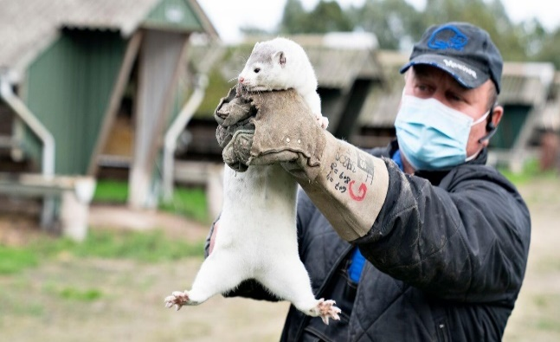
COVID 19- SARS CoV-2 Mink: The Next Waves

Mink farms in Denmark were culled of some 17million animals, after it was found that a strain of COVID -19 had mutated to the animals and had returned to humans resulting in 12 cases of a new variant SARS-CoV-2 (the virus that causes COVID 19) read the WHO report here.
Disease mutations are most likely amongst farmed animals (such as poultry, pigs, or cows) that are kept in unnaturally close confinement. Similar mutations in mink farms have previously been noted in the USA, Netherlands, Spain, Sweden and Italy. Other animals that have been in contact with infected humans, such as, dogs, domestic cats, lions and tigers, have also tested positive for SARS-CoV-2. (Severe acute respiratory syndrome coronavirus 2)
The significance of such mutations and transmission from humans to animals and back is that it suggests that farmed, domestic or wild animals may form reservoirs of forms of Covid infection. Moreover, as strains of disease develop in this way, they may prove to be more resistant to vaccines and potentially more deadly to humans. This could result in waves of continuing pandemics of strains of this virus.
This underlines the importance of rethinking the strong link between human and animal health. About 60 percent of all human infectious diseases are transmitted from animals. According to the US Centre for Disease Control and Prevention, 3 out of 5 emerging infectious diseases of humans are also caused by infection transmitted from animals. A recent study found that some 60% of all mammals are farmed and only 5% live in the wild. Mistreatment of animals on factory farms (99% of animal products consumed in USA are produced in factory farms), as domestic pets and as caged exhibits has a price not only for the wellbeing of animals but also for human health. Furthermore, many studies have shown that climate change targets cannot be achieved unless meat consumption is reduced.
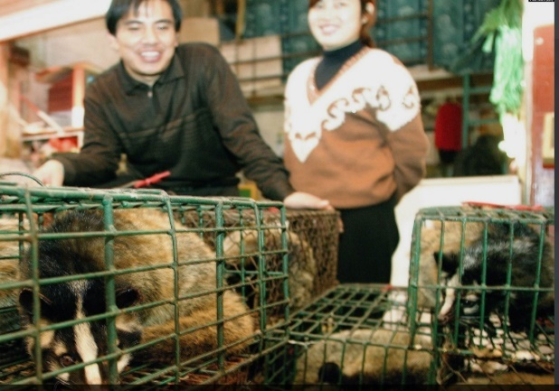
This was vividly shown by the emergence of COVID 19 from the markets of Wuhan. It is thought the disease arose first in bats and probably passed through another intermediary animal. This was 16 years after the SARS Pandemic of 2003, which was found to arise from the sale of live Civet Cats as a gastronomic delicacy in similar wet markets.
Students for Global Health may wish to discuss how animal and human health could be betterprotected by global and national action.

Delivering Vaccines for Covid 19
As a range of vaccines becomes available in high and upper-middle income countries, attention is focused on how they will be delivered. Key questions include:
- Will vaccines be affordable to low-income countries and households?
- Is the necessary organization and infra structure in place to deliver vaccines?
- Do the public understand and accept the need for and benefits of vaccination?
- Will there be a need for repeated annual vaccinations?
A study by the Global Health Innovation Center of Duke University School of Nursing here found that high and upper middle income countries have already placed orders for some 3.8 billion doses of vaccine with options for a further 5 billion. At the same time COVAX - the global initiative launched by the WHO and GAVI, to ensure universal access to Covid-19 vaccines, see here, has secured only enough doses to cover 250 million people. This may leave 3.5 billion people with no access to vaccination, as a reservoir of a fast-mutating endemic Covid – 19.
The organization and logistics required to deliver vaccines will be testing for countries like the UK with well-resourced healthcare systems. For many countries of Africa, Asia, the Pacific and South America it will be a much greater challenge. Fortunately it appears several of the vaccines being developed will not require ultra-low temperature cool chain delivery but they will need refrigeration in remote health centers. They will need to be administered and managed, for rural communities by frontline Nurses or Community Health Workers. Doses will need to be rationed and monitored and in some countries a degree of corruption and fakery is unfortunately highly likely. Vaccines are only one element of the steps necessary to manage the pandemic, treatment, testing, tracing and isolating will also be required.
Unfortunately sharing of vaccines has been embroiled in disputes about the efficacy of different versions, the rights to vaccines of people in high -income countries and the contractual rights of the governments that have ordered supplies. This may be called “Vaccine Nationalism”. In January, at the 2021 Executive Board session of the World Health Organization, Director-General Tedros Adhanom Ghebreyesus described the hoarding of COVID-19 vaccines by wealthy countries as a “catastrophic moral failure.” President Biden has proposed that patents on Covid Vaccines should be waived, but Germany and several other European countries have opposed this.
It seems that even if vaccines provide long term immunity (which seems doubtful beyond 18 months) reservoirs of mutating Covid -19 amongst humans and animals in low income countries lacking access to vaccines may require a continuing annual global vaccination programmes.
Student for Global Health are invited to discuss the implications for global health of the struggle between narrow nationalism and a global understanding of health.
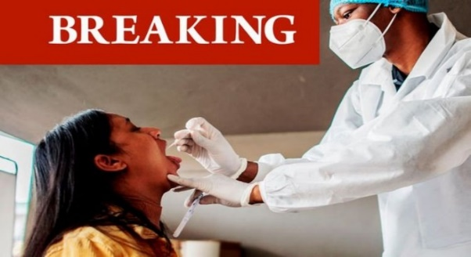
COVID-19 in Africa:
One year on:
Impact and Prospects
This report published by the Mo Ibrahim Foundation can be found here, it outlines the impact on health systems and the economies of African countries of the Covid -19 pandemic. It notes that the direct health impacts of the first waves of the pandemic have been relatively less severe in many Central African countries, though countries in the North and South of the continent were more affected. But it also acknowledges that though most countries reacted quickly with containment and contact tracing measures, many Central African countries lack the systems necessary to record or analyse the incidence of infection and variants with confidence. . The main impacts noted have been on services addressing diseases such as malaria, TB and HIV/AIDS, which pose a greater threat to lives in Africa, and Mental Illness (particularly for young people), a major global health problem.
Researchers from the Kenyatta, Washington and Liverpool Universities here, suggest the low level of deaths in Africa from Covid-19 (as of 5th July 2021 less than 100,000, 2/3rd in South Africa) may be attributed to the younger age of populations, warmer climate, under reporting and possibly prior exposure to related diseases. A summary can be found on the Sky News service here.
Covid has also had a profound social and economic impacts on African countries, hindering education and gender equity, and increasing political instability. Many African countries have been pushed into recession for the first time in thirty years, increasing unemployment and poverty (so far it is reported that the number of people in extreme poverty has grown by 15 million). The report notes the need to seize the opportunity to “build back better”, by supporting pan African health organisation such as African Centre for Disease Control (see here) and strengthening Africa’s ability to produce and purchase supplies such as vaccines and work together for a sustainable future.
In addressing the pandemic Africa has been hampered by being priced out of the market for PCR testing and waiting for the COVAX scheme to deliver promised vaccines. Although 400 million Johnson and Johnson single dose vaccine have been purchased for Africa relatively few have yet been administered leaving Africa with only 1.2% of its population fully vaccinated by 1st July 2021.
The impact of failure to address the health and socio-economic needs of much of Africa, is global. Poverty means that many people live in insanitary conditions, in close contact with a wide variety of wild and domestic animals, with poor access to healthcare services. These are conditions that greatly increase the likelihood of the emergence of new variants of Covid and indeed many other diseases particularly those affecting younger age groups. Low levels of infection in earlier waves may increase vulnerability. This nightmare scenario is emerging as Covid-19 cases arising from a range of new variants including Delta are surging by 25% per week and associated deaths are rising by 15% per week (01/07/21), as reported by Dr Matshidiso Moeti, WHO Regional Director for Africa here.
The Build Back a Better World (B3W) here and COVAX here initiatives offer hope that the high-income countries will at last accept their responsibility, but this seems certain to be another case of too little too late unless strong public support is mobilised across the world.
SfGH members should consider the threat to Africa and the world of vaccine nationalism.

