11a

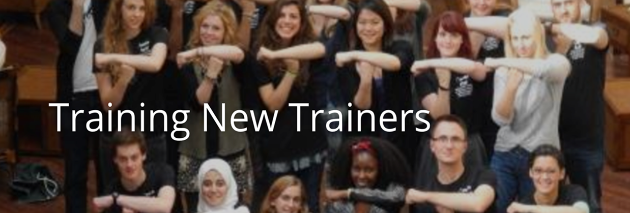
Training Toolkit 11a Leadership Thoughts

Some Useful Thoughts on Leadership

These thoughts may be a useful way of stimulating discussion over coffee or lunch:

“Leaders don’t create followers they create more leaders” – Tom Peters

“Trust is the emotional glue that binds followers and leaders together”. - Warren Bennis & Bert Nanus

“The superior man understands what is right, the inferior man understands what will sell” Confucius

“A leader takes people where they want to go. A great leader takes people where they don't necessarily want to go but ought to be”. - Rosalynn Carter

"It's not a question of how much power you can hoard for yourself, but how much you can give away."-Benjamin Zander

“Leadership and learning are indispensable to each other” John F Kennedy

"Powerlessness is a state of mind. If you think you are powerless, you are." - Tom Peters

“Action to be effective must be directed towards clearly conceived ends” Jawaharlal Nehru

“By three methods we may learn wisdom. First, by reflection, which is the noblest: second by imitation, which is the easiest: and third by experience, which is the bitterest” Confucius
“Be willing to make decisions. That's the most important quality in a good leader.” - General George Patton.
“As a leader... I have always endeavoured to listen to what each and every person in a discussion had to say before venturing my own opinion. Oftentimes, my own opinion will simply represent a consensus of what I heard in the discussion. I always remember the axiom: a leader is like a shepherd. He stays behind the flock, letting the most nimble go out ahead, whereupon the others follow, not realizing that all along they are being directed from behind”. - Nelson Mandela
“The true leader is always led” Carl Gustav Jung
“I must follow the people. Am I not their leader?” – Benjamin Disraeli
“The key to successful leadership is influence not authority” - Kenneth Blanchard
“There is no one best way to manage”.- Joan Woodward
“When inquiry and advocacy are combined, the goal is no longer 'to win the argument', but to find the best argument”.- Peter Senge
“The time is always right to do what is right” – Martin Luther King Jnr
“This is pre-eminently the leadership quality--the ability to organize all the forces there are in an enterprise and make them serve a common purpose. Men with this ability create a group power rather than express a personal power.” – Mary Parker Follett
“Enduring setbacks while maintaining the ability to show others the way to go forward is a true test of leadership” - Nitin Nohria Professor of Administration at Harvard Business School
“A leader or man of action in a crisis almost always acts subconsciously and then thinks of the reasons for his actions” – Jawaharlal Nehru
“Do something, if it works, do more of it, if it doesn't, do something else”. - Franklin D. Roosevelt
“You must be the change you wish to see in the world”.- Mahatma Gandhi
“No problem can be solved by the same consciousness that created it. We must learn to see the world anew”. - Albert Einstein.

“People don’t resist change they resist being changed” – Peter Senge
“I am convinced that if the rate of change inside an organization is less than the rate of change outside, the end is in sight”.- Jack Welch, CEO of GE
“The illiterate of the future are not those who can't read or write but those who cannot learn, unlearn, and re-learn”.- Alvin Toffler
“Real knowledge is to know the extent of one’s ignorance.” Confucius
“The first step in the evolution of ethics is a sense of solidarity with other human beings”. - Albert Schweitzer
Eight Steps to Create Change:
1. Establish a sense of urgency
2. Create a guiding coalition
3. Develop a vision and strategy
4. Communicate the change vision
5. Empower broad-based action
6. Generate short-term wins
7. Consolidate gains and produce more change
8. Institutionalise new approaches in the culture
- John P. Kotter, "Leading Change"
“Change is the law of life. And those who look only to the past or present are certain to miss the future”.- John Fitzgerald Kennedy
“Change does not take time -- it takes commitment”.- Thomas Crum
“When written in Chinese, the word CRISIS is composed of two characters- one represents DANGER and the other represents OPPORTUNITY”. Anon
“There is nothing more difficult to take in hand, more perilous to conduct, or more uncertain in its success than to take the lead in the introduction of a new order of things”. - Niccolo Machiavelli
“One's philosophy is not best expressed in words; it is expressed in the choices one makes. In the long run, we shape our lives and we shape ourselves. The process never ends until we die. And, the choices we make are ultimately our own responsibility”. - Eleanor Roosevelt
“The main challenge for information-age corporations is the retraining of manager, not the retraining of workers”.- John Naisbitt
“Bicycle Management: Bend your back to those above you while you trample on those below”. _Anon
“Mushroom management: keep them in the dark and pour manure on them twice a day”. - Anon
“There's no reason that work has to be suffused with seriousness.... Professionalism can be worn lightly. Fun is a stimulant to people. They enjoy their work more and work more productively”.- Herb Kelleher, CEO, Southwest Airlines
“The actions of a responsible executive are contagious”.- Joe D. Batton
“Empowerment is all about letting go so that others can get going”. - Kenneth Blanchard
”We do not produce excellence when we feel uninvolved, insignificant, and threatened”. - Kouzes and Posner
“Managers are people who do things right; leaders are people who do the right thing”. - Warren Bennis
“Maintain a positive attitude at work: Ask employees what they enjoy about their work. Too often, conversations center too much on mistakes and problems. When you ask. "What did you like about that last project?" you encourage employees to become conscious of how to get satisfaction from work. And they may think of ways to do their jobs better”.- James Champy, author of Reengineering the Corporation and Reengineering Management
“The best executive is the one who has the sense enough to pick good men to do what he wants done, and self-restraint enough to keep from meddling with them while they do it”.- Theodore Roosevelt
“We found that the most exciting environments, that treated people very well, are also tough as nails. There is no bureaucratic mumbo-jumbo ... excellent companies provide two things simultaneously: tough environments and very supportive environments”. - Tom Peters
”I have three precious things which I hold fast and prize. The first is gentleness; the second is frugality; the third is humility, which keeps me from putting myself before others. Be gentle and you can be bold; be frugal and you can be liberal; avoid putting yourself before others and you can become a leader among men”. - Lao-Tzu
“A leader is one who knows the way, goes the way and shows the way” - John C Maxwell
“People cannot be managed. Inventories can be managed, but people must be led”. - H. Ross Perot
“Inspired leaders move a business beyond problems into opportunities”.- Dr. Abraham Zaleznik
“Nothing is so potent as the silent influence of a good example”.- James Kent
“Coaching isn't an addition to a leader's job, it's an integral part of it”.- George S. Odiorne
“Being powerful is like being a lady. If you have to tell people you are, you aren't”. - Margaret Thatcher
“Truly great leaders spend as much time collecting and acting upon feedback as they do providing it”.- Alexander Lucia
“Leadership is practiced not so much in words as in attitude and actions”.- Harold Geneen
“The motivating team leader is that one person with a dream for the future”.- Dr. Losoncy
”Leaders manage the dream. All leaders have the capacity to create a compelling vision, one that takes people to a new place, and then to translate that vision into reality”.- Warren Bennis
“The first responsibility of a leader is to define reality. The last is to say thank you”. - Max DePree
“The best leaders are clear. They continually light the way, and in the process, let each person know that what they do makes a difference”.- Stephen Covey
“Leading is influencing, guiding in direction, course, action, opinion”.- Warren Bennis
“Treat a man as he is and he will remain as he is. Treat a man as he can be and should be, and he will become as he can and should be.”- Johan Wolfgang von Goethe
“Effective team leaders adjust their style to provide what the group can't provide for itself”.- Kenneth Blanchard
“To get a feel for the true essence of leadership, assume everyone who works for you is a volunteer”.- Kouzes and Posner
“The mediocre leader tells The good leader explains The superior leader demonstrates The great leader inspires”.- Buchholz and Roth
“Effective team leaders realize they neither know all the answers, nor can they succeed without the other members of the team”.- Katzenbach & Smith
“Impossible is a word found only in a fool’s dictionary” – Napoleon Bonaparte
“Leadership is an activity -- an influence process in which an individual gains the trust and commitment of others and without recourse to formal position or authority moves the group to the accomplishment of one or more tasks”.- Dinkmeyer and Eckstein
“The key element in good business management is emotional attitude. The rest is mechanics”.- Harvey Geenan
“Managers control. Leaders create commitment.”- Jonh Zenger
“If he works for you, you work for him.”- Japanese proverb
“If you really want people to respond to your leadership, you have to have a personal relationship with them. they need to know you're dependable and that you'll be there if they have a problem. That's personal power to me.- Noreen Haffner
“It is not fair to ask of others what you are not willing to do yourself”. - Eleanor Roosevelt
“Always say two positive things before you criticise anything or anyone”.- Graham Lister
“If you want 1 year of prosperity, grow grain.
If you want 10 years of prosperity, grow trees.
If you want 100 years of prosperity, grow people”.
- Old Chinese proverb
“A leader is one who knows the way, goes the way and shows the way”. - John Maxwell
“Leadership is the wise use of power. Power is the capacity to translate intention into reality and sustain it”.- Warren Bennis
“A pat on the back is only a few vertebrae removed from a kick in the pants, but is miles ahead in results”. - W. Wilcox
The wicked leader is he who the people despise.
The good leader is he who the people revere.
The great leader is he of whom the people say, "We did it ourselves." - Lao Tsu
“My grandfather once told me that there were two kinds of people: those who do the work and those who take the credit. He told me to try to be in the first group. There is much less competition.” - Indira Gandhi
“Leadership should be more participative than directive, more enabling than performing” - Mary D. Poole
“Leadership, like swimming, cannot be taught by reading about it” –Henry Mintzberg
"Do not wait for leaders. Do it alone, person to person” - Mother Teresa
Further contributions are welcome one group in Oman selected quotations and set them to pictures and music which was used as an introduction to their course. It was very impressive.

