9
Graham Lister
Training Toolkit 9: Global and Planetary Health
Global and Planetary Health
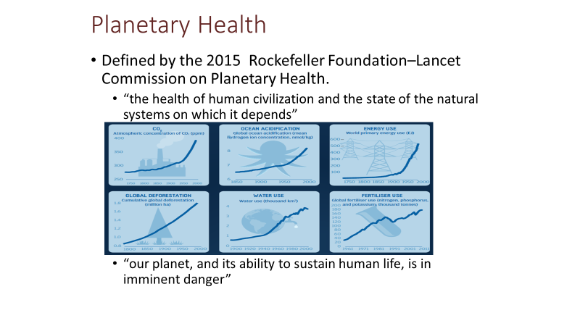
The idea that humans depend upon the health of the environment that sustains us and regulates the climate, air and sea quality and the 8.7 million species that live on our planet is not new. Charles Darwin observed both this dependence and the threat, for example, posed by the loss of coral reefs in 1842. But the last 50 years have seen imminent threats to human life and health posed by CO₂ and other emissions, demand for energy, water and food, acidification of the oceans, deforestation, overuse of fertilisers and contamination of land and seas by plastic waste .
Rachel Carson, author of “Silent Spring” (1962) raised concerns about the threat to marine and animal life posed by overuse of fertilisers and pesticides. James Lovelock developed a more radical view of the Earth, as a living organism that regulates the conditions that sustain life. His 2006 book “The Revenge of Gaia”, points to the catastrophic consequences of failure to address global warming. Every year oceans absorb ~ 2.8 billion tons of CO₂ (25-40% of 8-9 b tons emissions), making seawater less alkaline, killing marine life. 12.7 million tons of plastic waste ends up in oceans each year killing marine life and entering our food chain (Google these issues), the science is still uncertain but the risks are clear.
Many ecologists believe that human impact on nature, is now comparable to five previous catastrophic events over the past 3.5 billion years, during which up to 95 percent of species disappeared. A 2015 study by Gerardo Ceballos et al here estimated current extinction rates are up to 100 times higher than the natural background rates. A 2019 paper by Johannes Le Roux et al found that biological diversity is reducing at up to 350 times background rate see here.
The release of greenhouse gases (mostly CO₂) is now estimated at some 51 billion tons per year all adding to the threat of global warming and climate disruption. This poses a threat to human existence with a short fuse, the UN Intergovernmental Panel on Climate Change warned there are only 12 years for global warming to be kept to a maximum of 2^{O}C, beyond which it may be irreversible. Similar danger signals are apparent for sea acidification and loss of rain forests, see the Planetary Health Alliance here.
Given such threats to the lives of all our grandchildren and future generations one might assume that global diplomacy would focus on this issue rather than petty national interests. This requires intelligent, well informed, ethically responsible global diplomacy. But as President Trump’s withdrawal from the Paris Agreement has shown, this is in short supply. A more enlightened approach can be seen at the Global Climate Action Summit and the Youth Summit on this issues, see here. The Rockefeller Foundation Page is here, the Lancet Planetary Health Journal is here and the LSTHM Centre on Climate Change and Planetary health can be found here. You should also see TED talk by Noam Chomsky here and the 2020 report by Mckinsey and Company here.
The following 11 pages provide some insights into planetary health and impacts on global health.
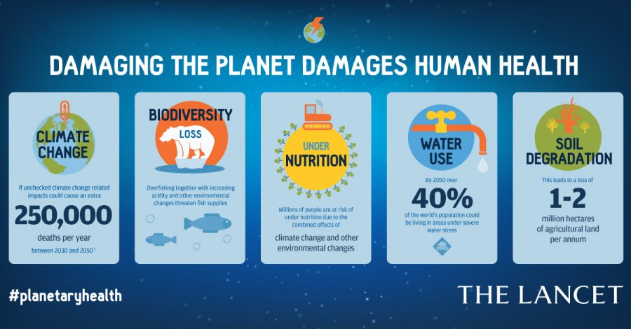
Courses in Planetary and Global Health
Students for Global Health may be interested to participate in the launch of the recent free online course from The Planetary Health Alliance which is a consortium of over 200 universities, non-governmental organizations, research institutes, and government entities from around the world committed to understanding and addressing global environmental change and its health impacts. They are launching this course in partnership with Telessaúde-UFRGS, the Instituto de Estudos Avançados da Universidade de São Paulo (IEA-USP) and the Brazilian Society of Family Medicine (SBMFC). The course – translated from Portuguese to English provides a mixture of evidence-based modules, quizzes, activities, and interactive forums, spanning topics from infectious disease, food and water, climate change, mental health and other issues see this link.
For other courses on aspects of Planetary and Global Health you may wish to review the following sources some of the courses are free, though many are fee paying:
Top Global Health Courses - Learn Global Health Online | Coursera
Courses | Global Health eLearning Center (globalhealthlearning.org)
Free Health Tutorial - Global Health - The Essentials | Udemy
Online Global Health Courses | Harvard University
Note the online Harvard Courses include a free course on the health impacts of climate change.
SfGH Trainers may wish to run a session sharing members’ impressions of the available courses. It would also be a very helpful move to encourage SfGH Trainers to run courses on Global and Planetary Health for Schools and other Graduates as it is vital to prepare future generations for the consequences of the failures of their previous generation.

How to Reduce Your Damage to Global Health
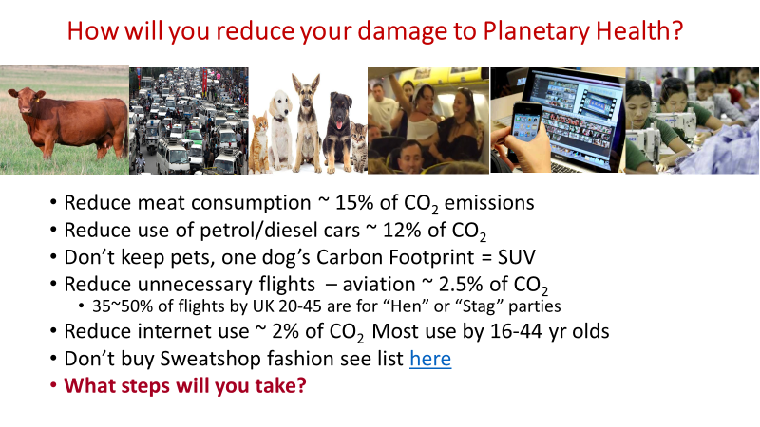
Students for Global Health will want to review their personal impact on CO₂ emissions and other aspects of planetary and global health, see the book or video version of Al Gore’s “An Inconvenient Truth”. There are a great many possible steps that can be taken as individuals. These are some of the difficult choices that everyone will need to take if we are to limit global warming to 2%. A BBC video shows further examples of measures that can be taken see here.
If you are considering Veganism see the documentary “Cowspiracy” available from Netflix.
Action by Multinational Companies to limit their impact on climate change are discussed by Bill Gates in an interview published online by the Economist here. He emphasises the need for government taxation such as carbon taxes to provide the incentive for private sector action. Emphasis on social responsibility for companies may not be enough to drive the market to take action for planetary health. Action by investors to follow Environmental and Social Governance (ESG) criteria see here is crucial.
At national level steps are being taken by some countries as public awareness of planetary health increases. A summary of UK government action and inaction to reduce emissions can be read here.
The need for international action on climate change is exemplified by the potential disaster looming from coal fired power stations planned to meet Africa’s power needs over the coming century. . Across Africa dozens of new coal fired power plants are planned, despite the fact that the Sahara region has the capacity to meet the energy requirements of not only Africa but also Europe and much of Asia see here .
It is clear that global action to avert climate change is essential to our survival and it is encouraging to see that the first action of the Biden administration was to re-commit the USA to the Paris Climate Accord. The commitment of national and international bodies will be on show at the UN Climate Change Conference to be held in Glasgow in November this year see here. But it is now clear that the target of reducing global temperature rise to below 2% is unlikely to be met due to inaction.
SfGH groups may wish to discuss the ways in which members can contribute to the global target of reaching carbon neutrality by 2050. Calls for global action must be matched by personal commitment. SfGH Trainers should monitor progress towards agreements at the Glasgow CoP 26 conference.
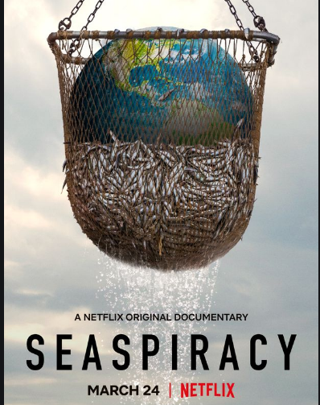
The Impact of the Fishing Industry on Planetary Health

Students for Global Health should catch the documentary by a young man called Al Tabrizi on Netflix. It makes a compelling case that the fishing industry is a major cause of global warming, the plastic pollution of the oceans and the harm to living species. The documentary shows that:
- The seas and their fish and other living organisms form an ecosystem which stores 93% of the world’s carbon see here.
- This ecosystem is endangered by unregulated fishing that:
  - Litters the oceans with discarded plastic fishing nets amounting to some 46% of the plastic in the ocean, killing sea life and ends up in the food chain as microplastics see here
  - Kills huge numbers of sea creatures as “bycatch” this includes sharks, porpoises, seals and seabirds see here.
  - Lays waste to vast areas of sea bed, by trawling, which destroys some 3.9 billion acres a year, much more damaging to the environment than the loss of 25 million acres of rain forest each year and releasing as much carbon as air travel see here.
- That claims of sustainable fishing are a sham as regulation of fishing vessels at sea is almost impossible so the control of bycatch and protection of other seas creatures such as whales and dolphins is unchecked, read the Bloom Report here.
- Farmed fish can be fed with the produce of wild fish and are subject to many forms of disease see here.
Seaspiracy shows how the public are diverted from the consequences by industry advertising and the “myths” of sustainable fishing and fish farming. Some of the claims made in the video are disputed and you should also consider the comments made by Green is the New Black here. The documentary also highlights examples of the mistreatment of slave labour by fishing boat owners in East Asia and the senseless slaughter of sea life.
While there is uncertainty around some of the specific estimates used in this documentary, the overall message is clearly proven: the global fishing industry is effectively unregulated and is doing immense harm to the environment and our future health and survival.
In the UK the Marine Conservation Society (see here) has been spreading the messages of Seaspiracy and supports action to protect our shores and sea-beds. In April 2021 they announced the start of their programme for rewilding the sea-beds around our shores. They also provide information and run campaigns for beach cleaning, deposit return schemes to reduce bottle pollution. Perhaps partly in response the UK’s Blue Planet Fund (see here) will provide £500 million to support lower-income countries to tackle unsustainable fishing, protect and restore coastal ecosystems like mangroves and coral reefs, and reduce marine pollution.
SfGH should consider their response to the video and the UK Blue Planet Fund. Note the links used here are not taken from the report but are independent sources.
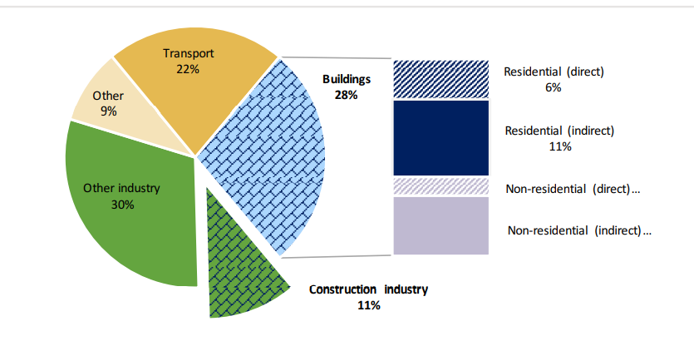
Buildings and Construction the Largest Energy Users and Source of CO₂

This diagram, taken from the UN Environment Programme 2017 Global Status Report, shows the share of global energy-related CO₂ emissions by sector see here. The energy consumption related to buildings (for heating, air conditioning, lighting and other uses) reflects the efficiency of heating and cooling systems and the insulation of buildings. The use of energy in construction includes: energy use to make building materials, to transport them to site and to install them. Concrete is a major factor in the CO₂ impact of the construction industry both because energy is used to heat calcium carbonate to produce lime and because this chemical reaction releases CO₂ and methane. Estimates suggest that concrete accounts for between 4-8% of total CO₂.
Construction and new buildings are an increasing driver of emissions in low and middle-income countries as they seek to provide homes and facilities for their growing populations. Construction is currently increasing by about 6.5% per year in Africa and between 4-8% in China.
The impact on emissions due to energy consumption depends upon the sources of energy used. Globally, while renewable sources now account for some 25% of energy production, energy-related CO₂ emissions rose 1.7% to a historic high in 2018 see here. This was due to a continuing rise in consumption of oil, natural gas and coal and a low rate of improvement in efficiency. Global Energy Monitor, see here, tracks the planning, funding and operation of coal, gas and other power stations across the world, it shows the continued growth of carbon fuel power stations that will certainly increase CO₂ emissions and hasten climate change. While use of renewables is increasing at about 4% a year it seems very unlikely that this will offset the impact of new coal and gas power plants across the low and middle-income countries of Africa and Asia.
And yet as many have pointed out a relatively small area of the Sahara could supply all global energy needs from solar panel farms. There are many arguments about this online, so you can Google your own views. But there are signs of hope with major solar and thermosolar parks (the latter produce heat to drive turbines that produce electricity) under development in Tunisia and Morocco.
Construction technology is also evolving towards greener solutions, see EDGE (Excellence in Design for Greater Efficiencies) here. EDGE is a World Bank initiative set up in 2014, supported by the UK government and others to promote greener construction by developing and sharing new solutions and certifying green construction programmes. For example, President Uhuru Kenyatta’s policy in Kenya, is focused on the Big 4 issues: manufacturing, food security health, housing, see here. Housing policy includes a commitment to EDGE principles, but as always, there is a wide gap between policy and progress, made more difficult by the pandemic.
Students for Global Health may think that construction has little to do with global health, but think again, planetary health and climate change mean we have to rethink every aspect of life.

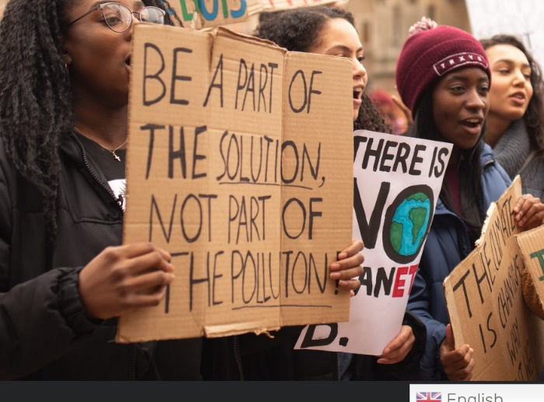
Lessons from the Mock COP

The Conference of the Parties (COP) meeting to discuss action on climate change was due to meet in Paris in November 2020 bringing together all the countries that agreed to the Paris Accord together with a range of other participants. It was seen as a major chance for governments to agree decisive action on climate change. Perhaps a last chance! But the conference was postponed due to Covid-19 and will now meet in Glasgow from 1-12th November 2021.
Seizing the moment a student organization - Students Organising for Sustainability (SOS-UK) a charity set up by students and staff at NUS in 2019, set up an online Mock Cop Meeting with representatives of young students (13-24) from 140 countries to discuss action on climate change. The organization is run by 18 young students and 216 volunteers, with very little funding obtained from crowd funding. It ran an online international conference of young students gaining world-wide media coverage . See the Mock Cop site here and their Conference Declaration.
This shows the sort of initiative that could be taken by SfGH and IFMSA to raise awareness and action on the need for global and planetary health action to address threats to future generations and achieve equity in health. They will generate a conference statement to world leaders from the youth of the world as a contribution to the full COP26 when it convenes.
Lessons for SfGH and IFMSA include, getting the timing right to achieve maximum impact, having a clear internet presence and promoting and supporting young leaders in their presentation and ongoing interaction with politicians and the young students they represent.
SfGH and IFMSA could take on a role in spreading awareness of global and planetary health issues by teaching at schools and colleges and running their own global events (as well as participating in WHA). Teaching not only deepens understanding of these issues it also helps develop essential communication and leadership skills.
Any small contributions to the Mock Cop 26 Crowd Funding, collaboration with SOS-UK and signing the declaration would show SfGH solidarity with a potential ally in a crucial battle for our future.
SfGH trainers should download and share the conference declaration which is here.

Students invent answer to the tyre particle threat

The Tyre Collective/James Dyson Awards/Getty Images.
Micro-particles of rubber and other materials shed by tyres make up almost half of road transport particulate emissions. They are small enough to be inhaled and can cause different lung diseases and developmental issues, they can also enter the water and food chain. Tyre particulates are the second largest source of microplastic pollutant in oceans after single-use plastic. A group of students calling themselves “The Tyre Collective”, has produced a solution to this problem by designing an electrostatic device which capture 60% of the particles. The device won the James Dyson Award, announced on Nov. 19. They are now seeking patents and hope to see commercial production of their invention, see here.

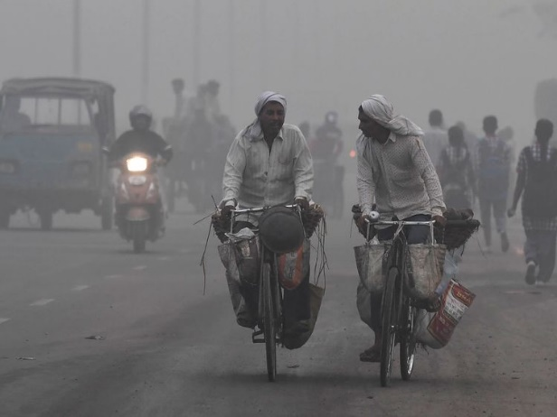
This is a global issue affecting health in all countries. In New Dehli it has been said that air quality exacerbated by tyre particulates is so bad that it is worse than smoking 50 cigarettes a day.

The students from UK, Hong Kong, India and USA met while studying design at Imperial College and the Royal College of Art they are: Siobhan Anderson, Hanson Cheng, Deepak Mallya and Hugo Richardson. They recognized the threat to global health posed by tyre particle emission and developed their solution.
Students for Global Health will wish to congratulate The Tyre Collective and be inspired by their success.

The Economics of Biodiversity: The Dasgupta Review
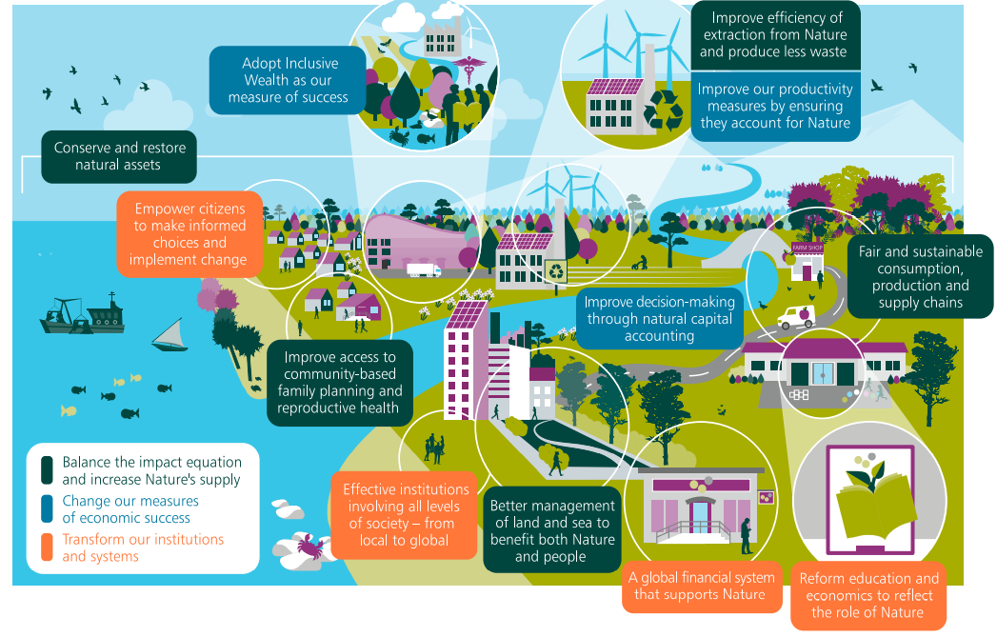
The review, led by Sir Partha Dasgupta published on 2nd February 2021 here is a major challenge for global citizens and their governments to re-examine community, national and global goals in the light of the damage being done to the biosphere. It demands that measures of economic and social progress should take into account the total impact on both human and natural capital (inclusive wealth) across generations and social divides between rich and poor. It also calls for major institutional changes at national and global levels to reduce the harm being done to our planet.
The report estimates that from 1992 to 2014, global human capital per person increased by about 13%; but the stock of natural capital per person declined by nearly 40%. Natural capital includes factors that directly or indirectly produce value to people, including ecosystems, species, freshwater, land, minerals, the air and oceans, valued in terms of its impact on future health and wellbeing. The total impact on Nature suggests we would require 1.6 Earths to maintain our living standards. Current extinction rates, are around 100 to 1,000 times higher than the baseline rate, and they are increasing.
Government policies in almost every country pay people more to exploit and degrade the biosphere than they do to protect it, offering perverse subsidies in fields such as: agriculture, water, fossil fuels, fisheries, energy and fertilisers. The report estimates that subsidies harmful to biodiversity total around US$500 b per year, but when environmental costs are taken into account (as loss of Natural Capital) the total cost of subsidies is at least US$4 to US$6 trillion globally per year. These figures dwarf the size of public finance devoted to conservation and restoration and sustainable use of the biosphere, e.g. domestic public finance for sustainable use of biodiversity totals around US$68 billion per year globally.
Prince Charles has complained that the message of planetary health is lost in the jargon of economists, so we can simply say that loss of “natural capital” due to perverse subsidies for things that harm the environment creates a cost to future generations, that is increasing by about $5 trillion per year.
Students for Global Health interested in climate change and other aspects of planetary health should read the report (or at least its highlight messages) and demand action at national and global levels as a duty of care for the health and wellbeing of future generations.
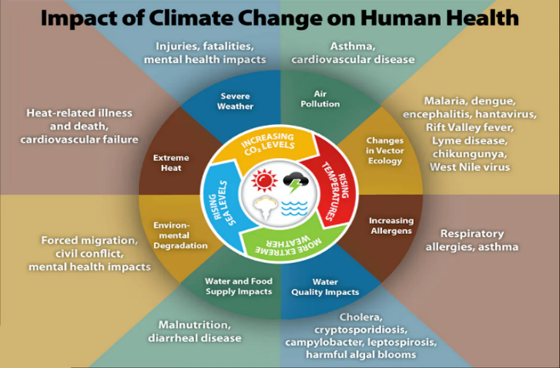
Estimating the Impact of Climate Change on Human Health

A report published in the Lancet Planetary Health Journal on 9th February provides estimates of “The public health implications of the Paris Agreement” see here. It models impacts on health in 9 countries: Brazil, China, Germany, India, Indonesia, Nigeria, South Africa, UK, and USAs over the next 20 years. The study compares estimates of deaths that would arise from 3 climate related causes if countries follow their current policies with estimates of deaths that would arise if policies were adapted to meet the objectives of the Paris Climate Accord and if higher targets were set.
They estimate that meeting the Paris Accord could lead to reductions of: 1·18 million air pollution-related deaths, 5·86 million diet-related deaths, and 1·15 million deaths due to physical inactivity, per year, by 2040. More ambitious climate policies are estimated to lead to further reductions of 462 000 deaths attributable to air pollution, 572 000 deaths attributable to diet, and 943 000 deaths attributable to physical inactivity per year, in the 9 countries, with a total population of about 4 billon people (51% of global population). These estimates look beyond the WHO estimate of some 250,000 deaths per year, from malnutrition, malaria, diarrhoea and heat stress arising from climate change see here.
But these are only a subset of the impacts on human health from climate change and other aspects of planetary health abuse. Failure to manage planetary health is likely to lead to substantial increases in deaths due to: severe weather events (droughts, floods, heatwaves and storms), famine due to crop failures, loss of water sources, loss of fish stocks due to decrease in ocean alkalinity, contamination in the food chain by micro plastics and chemicals, conflict in areas of resource shortage, mass migration and increase in zoonotic diseases (such as SARS and Covid-19). UCL Centre for Climate Change Migration and Conflict takes this view here and see Attenborough’s message to the UN here.
In 2017, there were 56 million deaths globally; nearly half of these (49%) were people who were 70 years or older; 27% were between 50 and 69 years old; 14% were between 15 and 49; 1% were older than 5 and younger than 14; and almost 10% were children under the age of 5. More than half of total deaths were attributable to cardiovascular disease and cancer. The impact of planetary health issues, such as those noted here, will change this, it will lead to a vast increase in premature deaths and a deepening divide between health and wellbeing in rich and poor countries.
Climate change is a threat not just to human health but to the survival of life on our planet, as discussed by the Cambridge Centre for the Study of Existential Risk, they note that some scientists have estimated that there is a 10% risk of an eventual irreversible global temperature increase of 6⁰ C see here.
Students for Global Health should take a lead in responding to the threats to planetary and human health, as it is their generation and their children that face the consequences. The Cambridge Institute for Sustainability Leadership could provide important resources for developing the leadership skills required for this crucial task here.
Bill Gates’ Vision “How to Avoid a Climate Disaster”

Bill Gates’ book published on 16th February 2021 presents a vision of the ways in which global, national, local and personal action can reduce the emission of greenhouse gases from 51 billion tons per year to zero. It is a complex and seemingly overwhelming problem demanding action on the causes of greenhouse gas emission: power generation (27%), construction and manufacturing (31%), agriculture (19%), transport (16%), home heating and air-conditioning (7%).
Steps that can be taken to address these major sources of greenhouse gases are explained in simple language showing their potential contribution to the target of reducing emissions to zero. While current technology does not offer a complete answer in any of these fields the book shows the potential for action now and potential areas for further research and development. The book goes on to discuss some of the steps that will be needed to adjust to climate changes. Steps to reduce emissions and the potential to adjust to climate change are illustrated by examples, though these are only first steps.
The book also gives some examples of geoengineering measures that might be taken to reduce global warming, for example by brightening clouds to scatter sunlight, though as yet the impacts of such measures have not been fully researched.
Bill Gates goes on to discuss the Government policies which are important in driving the investment in emission lowering technology and the research and development to drive innovation for a zero target. These include carbon taxes and investment in low emission power generation as well as investment in research and innovation. He deals frankly with the need for the high-income countries that have caused most of the greenhouse gases to take a lead in research and funding and providing aid for the lower income countries likely to be most affected by global warming.
While government policies and funding will be essential a plan for getting to zero requires the ideas and innovation of businesses and the public as political and social actors and as consumers. Employers and employees are encouraged to take a lead in reducing the emissions of their business. The public are asked to consider behaviour changes in diet and lifestyle and to demand greener products and services.
The book notes that the world has never faced any issues of this scale. It will require global: cooperation and agreement, government policy changes including carbon taxes, investment, research and funding, action by businesses and the public including changes in lifestyle and consumer choices, at a scale beyond any achieved so far.
Bill Gates is one of the investors in Carbon Capture technology (alongside Oil and Gas Companies) see YouTube here. It is not yet clear that this technology is a solution he has also supported innovations such as testing the release of chalk dust to reduce solar warming see his interview here.
SfGH can obtain Kindle edition of “How to Avoid a Climate Disaster: The Solutions We Have and the Breakthroughs We Need” as a basis for a group discussion.

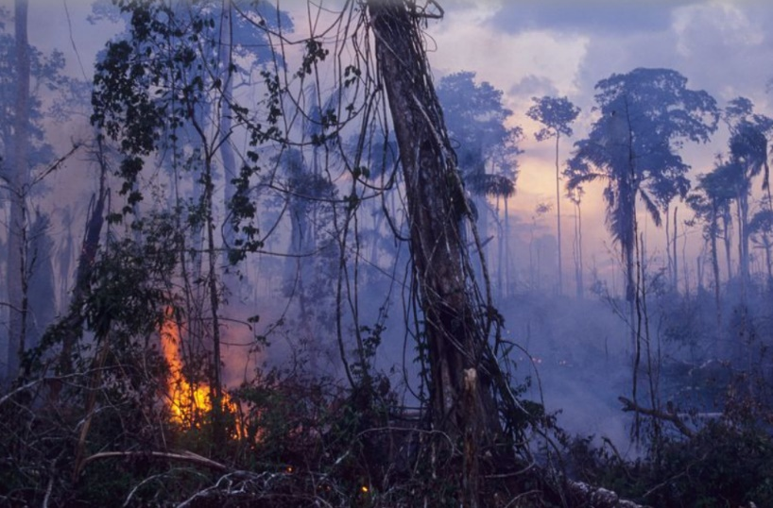
Supermarkets Threaten to Boycott Brazilian Foods over New Land Grab Laws

The Amazon is the world’s largest rainforest (6.7 million sq km) – 2/3rds in Brazil but also Bolivia, Colombia, Ecuador, French Guiana, Guyana, Peru, Suriname and Venezuela. It comprises nearly a third of all the tropical rainforests left on Earth and is home to 10% of all wildlife species. Around 17% of the Amazon rainforest has already been destroyed, often by burning off vegetation to use the land to raise cattle or grow soya. The rate of loss of rainforest has accelerated in recent years and there are fears that it may soon reach a tipping point at which temperature rise leads to drying and further fires, which will make the forest unsustainable. Between 2001 and 2012, deforestation of the Amazon averaged 1.4 million hectares ever year – equivalent to over 5,405 miles per year, or nearly 15 square miles every day. The rate of deforestation has now increased by some 30%.
While President Bolsonaro, once considered a climate change sceptic, has expressed Brazil’s commitment to tackling climate change, it is apparent that deforestation has risen rapidly during his presidency. And though he has said he was unwilling to accept aid in return for protection of the Amazon, he is currently negotiating a deal with Biden to reduce deforestation in return for $1 billion in aid. His administration is currently considering a bill, first introduced more than a year ago, that would permit settlers on public lands to claim ownership. The proposal before the Brazilian Congress – known as "land regularization" by the agriculture lobby and "the land speculation law" by environmentalists – will make it easier for those that settled on public land historically to obtain deeds for the lands they have occupied, under certain circumstances. It is feared that this will further accelerate the destruction and occupation of areas of the rainforests that were previously protected as conservation areas.
In response 40 UK and European food companies and retailers have written to the Members of the National Congress expressing their concern and indicating that they may feel forced to boycott Brazilian produce if the proposed bill is enacted (see article in Daily Mail here). This is a significant step in climate change as it shows support from the business sector, no doubt motivated by the concerns of their customers, taking decisive action on a climate change issue.
In Ecuador the Amazon rainforest is also threatened, this time by oil giant Texaco. While drilling in the Ecuadorian Amazon from 1964 to 1990, Texaco – which merged with Chevron in 2001 – deliberately dumped more than 16 billion gallons of toxic wastewater, spilled roughly 17 million gallons of crude oil, and left hazardous waste in hundreds of open pits dug out of the forest floor. This has been described as one of the worlds’ greatest ecological disasters see here. A court ordered Chevron to pay damages amounting to $9.5 billion, but this case has been contested and is the subject of a big money legal wrangle, which you can Google. Whatever, the outcome this clearly shows the need for stronger global laws and governance for our planet’s health.
SfGH groups may wish to consider how they can express support for these actions.
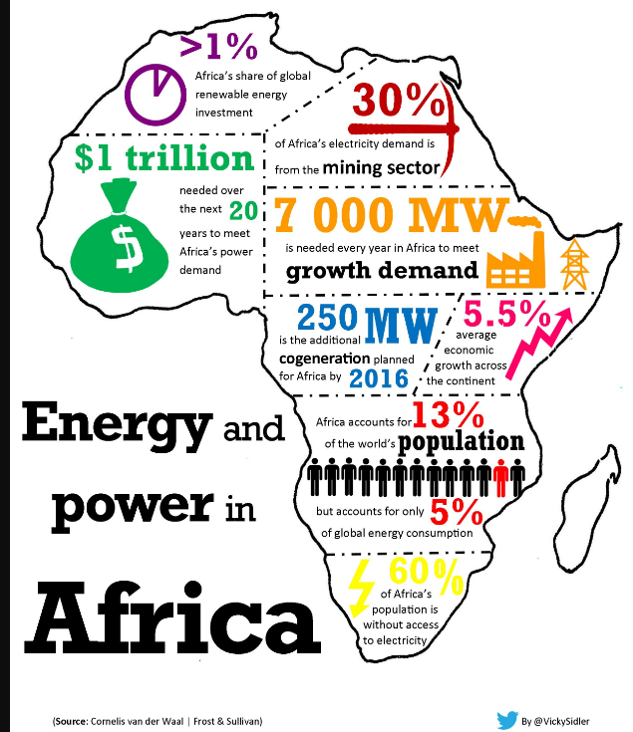
The Development of Africa’s Power Sector
Africa accounts for about 3% of global energy consumption, compared to 22% in North America and 23% in Europe/Eurasia. People throughout Africa aspire to living standards on a par with the high-income countries and that implies increased energy use and potentially much greater carbon emissions. But there may be ways for Africa to expand electricity output dramatically while relying almost exclusively on renewable resources. Africa could skip a generation of technology, in the same way it has with telecommunications and banking.
The cheapest sources of electricity generation nowadays are solar power (US$36 per MWh) and onshore wind (US$40 per MWh). Technological improvements are reducing the cost of solar power further. The opportunities to exploit solar power in Africa are huge, both on and off grid. In many areas, there is available land that is unsuitable for farming, for example in the Sahara and Kalahari. The shortcoming of solar power is that it is intermittent and batteries to store the power for periods of non-availability are very expensive. But there is an alternative. Africa already has numerous hydro electric plants, for example at Kariba and Cahora Bassa on the Zambezi, Aswan on the Nile and Lake Volta in Ghana. These plants could become the back-up resource to be run at times of peak demand and when solar or other renewable resources are not available. A similar arrangement is already in place in the UK, where an arrangement between the grid companies in the UK and Norway mean that Norwegian hydro-electric power helps to address peaks in UK demand.
Some initiatives are already in place that will help the development of these sorts of arrangements, such as the creation of regional power pools in East, West and Southern Africa to encourage regional power markets and trading. Formidable obstacles remain: levels of regional cooperation will have to be enhanced, generation plant will have to be reconfigured and extensive investments in transmission grid capacity will be needed. Perhaps there is a grand bargain to be made at COP 26. African countries could agree to enhance cooperation and eschew carbon emitting power plants and high-Income countries could guarantee the finance for investment in transmission grids, which are often difficult to finance.
The groundwork for this has been laid at the G7 meeting in Cornwall this week (12th June 2021) at which the "Build Back Better World" (B3W) project was unveiled see here. This seeks to begin to fund the estimated $40 trillion infra structure investment required to replace and extend low carbon alternative technologies in low and middle-income countries. Initial target of $100 billion support through the IMF has been promised. This initiative has also been promoted as a response to the Chinese $4 trillion Belt and Road Initiative which is providing finance for road rail and port infrastructure projects linking global markets with China. Across Africa some 40 of the 55 nations have signed some form of agreement relating to the Belt and Road and this has been seen as a major source of political influence. B3W is therefore both a humanitarian and a geopolitical move.
SfGH groups may wish to discuss environmentally sustainable power for Africa and B3W
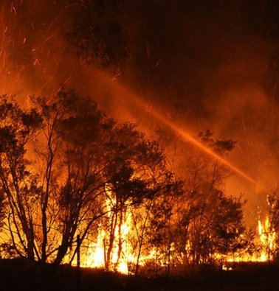
Are You Serious About Climate Change?
The latest report by the Intergovernmental Panel on Climate Change (IPCC) here provides stark evidence of the changes to climate, that are affecting our oceans, ice caps and forests and are a danger to the health and survival of humanity in the near future.
You may also wish to look at the World Meteorological Organization report on The State of the Global Climate 2020 here.
What is different now is that we are no longer debating the likelihood of damage to our planet for future generations, we are talking about a clear and present danger that is killing people and destroying habitats now.
The NASA: Fire Information for Resource Management System here provides maps of the current forest fires around the world which have increased by a third in recent years due to global warming. NASA also provides a range of evidence on climate change impacts here. You will shortly be able to show evidence of the impact of climate change using a new Google Earth Timelapse function which combines a series of satellite images of places and features to show the impact of climate change.
Urgent international action is essential and one key to this will be the UN Climate Change Conference of the Parties (COP26) in Glasgow on 31 October – 12 November 2021, see here. The serious intent of the hosts (UK and Italy) will be demonstrated by their own actions. For the UK the Independent Climate Change Committee’s report to parliament in June highlighted the gap between government commitments and promises and progress on the ground see here. Italy is particularly vulnerable to the impact of climate change and in 2015 the government adopted the Italian National Adaptation Strategy to Climate Change (NAS) but a clear plan for implementing and funding the plan has been slow to emerge. It seems both UK and Italy have yet to live up to their commitments.
One reason for this has been a failure to engage the public in political debate about climate change. Extinction Rebellion Ireland have recently made a serious attempt to address this by canvassing on doorsteps across Ireland. They provide an information leaflet and ask the public to support candidates of any party who will agree to reduce Ireland’s greenhouse gas emissions by more than 8 per cent per year, see here. This seems more productive than some of their protests in England.
You might also enjoy a light hearted but serious attempt to raise awareness by activists in Salla, the self-proclaimed coldest place in Finland located in Lapland just north of the Arctic Circle, which launched the international “Salla 2032 Summer Games Candidate City” campaign complete with a news conference and a promotional video on YouTube here.
SfGH groups may wish to discuss what they can do to raise public awareness and action on climate change.
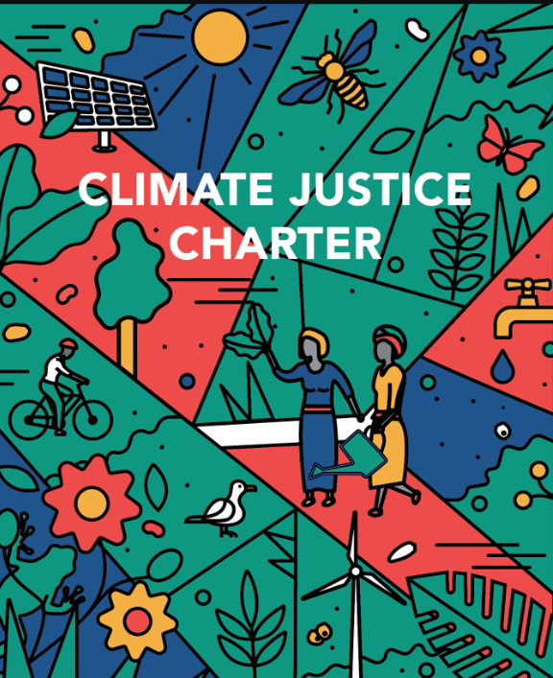
Climate Change Justice for All

SfGH are right to address climate change as an issue of social justice in its training toolkits here, here and here and online discussion here. Climate change is a threat to human health and survival that can only be met by global action to address the social and economic causes and consequences of hundreds of years of social injustice. It demands a new perspective and commitment as set out in the recent Climate Justice Charter here it will also require unprecedented levels of investment.
A simple introduction to Climate Justice is provided by a video from Daily Motion here. This underlines the point that climate change has been caused by generations of exploitation of our planet by what are now high-income countries which benefited from a legacy of abuse and colonial exploitation. The impact of climate disruption will have its most severe impact on the lowest income countries who have contributed the least to the crisis we now face. Within countries it will be the poorest and those disadvantaged by prejudice towards race, sex or disability who will suffer most. Those without voice in national and global politics such as the children of the future generation are ignored, yet it is they that will suffer see the UNICEF report showing 1.1 billion children at risk here.
The Independent Expert Group On Climate Finance reported in December 2020 see here that the agreements reached at the UN Conference of the Parties 16, that “developed country Parties commit, , to a goal of mobilizing jointly USD 100 billion per year by 2020 to address the needs of developing countries” should be considered as an absolute minimum starting point for the level of investment required from public and private financial sources. Yet this starting point which represents about 0.12% of global GDP seems unlikely to have been achieved and significantly less than 20% of investment has been funded by grant aid rather than debt. This means that low-income countries, many of which have been pushed into recession by the Covid-19 pandemic will face even greater financial instability in tackling a climate crisis, which was not of their making.
It is time to rethink global financing for climate change, not as a “gracious benefaction from rich countries to the poor” but as an issue of global justice, in which those countries which have damaged the global environment, are held to account, by all humanity and future generations. At the same time, we must rethink the scale of investment and action required at every level in society. While low-income countries hope high-income countries will meet at least their US$100 billion pledge made in 2009, the International Energy Agency together with the World Bank and World Economic Forum estimate that more than US$1 trillion dollars is needed by 2030 to undertake the energy transition in low-income countries. In the UK it has been estimated that current spending on measures to mitigate climate change account for some 0.01% of GDP, while the Climate Change Committee estimate that total spending per year required is some 100 times greater at 1% of GDP.
SfGH groups can work with Green New Deal UK here to demand action for climate change justice.
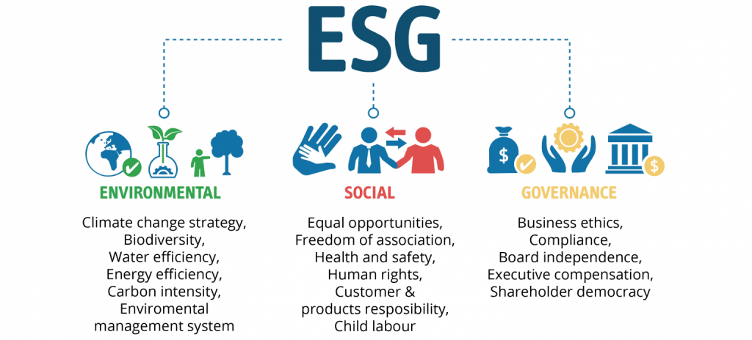
The Power of
E S G

The demand for ethical investment based on Environmental, Social and Governance standards can be traced back to UN Secretary-General Kofi Annan, who launched the U.N. Global Compact in 2000. This was a corporate citizenship initiative based on a set of human rights, labour, environmental, and anti-corruption principles. In 2006 this led to the U.N.-backed: “Principles for Responsible Investment”. This recognised that most of the major companies in the world are owned by shareholders through pensions and other investments. If investors can be informed and mobilised this can transform corporate behaviour, after all, what is the point of investing in a pension if climate change and social unrest make our world unsustainable by the time you reach retirement?
ESG factors can be viewed as ethical choices or risk factors and indicators of likely sustainable profitability. Investment advisors are increasingly noting that, even if investors are not themselves concerned with the impact on planetary health and society others are, and so the value of their investment might decline. Further they warn that there is a risk that governments might actually take action to protect the environment and regulate harmful health and social impacts and failures of ethical governance, again risking the value of any investment. Thus companies like S&P assess and monitor compliance with their interpretation of ESG standards see here and consulting companies such as McKinsey here and PwC here advise their clients on how to demonstrate high ESG standards. There are so many standards and sources of advice that the European Securities and Markets Authority, the EU’s securities markets regulator, has called for legislation to clarify and define ESG.
Some groups are taking positive action to apply ESG ethical standards. An example is shown by FAIRR (Farm Animal Investment Risk and Return) working with a network of investment companies managing $45 trillion of investments see here. They engaged with leading international restaurant chains to raise awareness of the risks posed by the factory farming of animals, used for 66% of farmed animals globally and 99% in the USA. Factory Farming is associated with intensive use of antibiotics (and hence AMR), deforestation of the Amazon for feed and emission of greenhouse gases. When made aware of the dangers posed by factory farming many international restaurant companies adopted standards to guard against the risk to their customers and their businesses. Another example of ESG standards is set out in the Alan Barlow’s book “Purpose Delivered” which shows how ethical governance can lead to both greater benefits to society and higher profitability.
As more investment funds, consultants and international firms jump on this bandwagon there is a danger of “greenwash” – that it becomes a public relations exercise, rather than positive action. Thus it is essential for civil society groups to monitor the performance rather than the empty words of investors and companies in adopting ESG standards.
SfGH groups may wish to consider their own definition of ethical ESG investment and how it can be applied in practice and monitored in public.
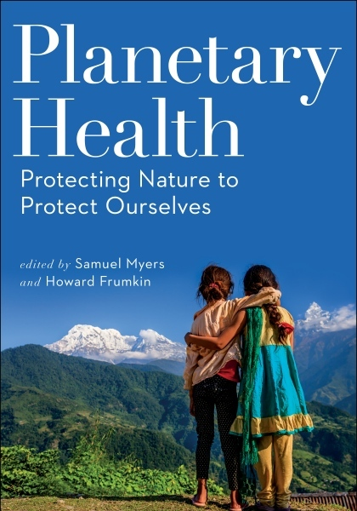
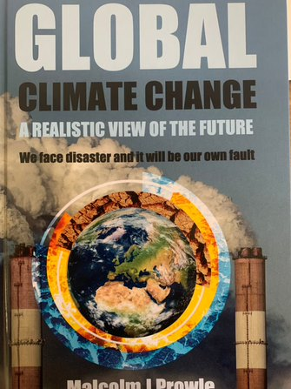

Taking responsibility for our Future
Planetary Health: Protecting Nature to Protect Ourselves, co-edited by Dr. Samuel Myers and Dr. Howard Frumkin with contributions from other experts here provides and introduction to all aspects of planetary health. While the science of climate change and other aspects of our planet’s health can be researched and debated at length there is clearly enough evidence to show that we must act now. This book sets out the evidence and makes a clear case for action
Climate Change: A Realistic View of the Future by Malcolm J Prowle (here) is a straightforward examination of the context, causes and consequences of climate change based on current evidence, It is important to understand the context because our response to this crisis is not a simple question of switching to electric cars, wind turbines and vegan sausages. The most likely future we face is a failure to meet the targeted temperature increase of 2⁰, this will have a devastating impact on future generations, causing uncontrolled climate changes, floods and famine, mass migration and conflict.
This will demand a wider transformation of global and national governance, and our social and economic way of life. Nations will need to act together to take responsibility as global citizens to protect our planet, as they have so far agreed in grand statements but failed to implement.
At national and community level the impact of every aspect of our behaviour will need to respect the cost we impose upon the health of our planet. The “greenwash” claims of international companies are not enough a new economic and social model is needed to protect the planet and future generations. Mass migration cannot be addressed by walls and wires, if large areas of the planet become uninhabitable due to flooding and aridity, where will their people go? Measures to reduce population growth by empowering women and protecting families are needed together with steps to mitigate the impact of climate changes and provide new food sources.
We face a huge task in preparing the next generations to face the future of fires floods and famine that the previous generation has bequeathed them. As Malcolm Prowle points out many of these issues were foreseen in the scriptures of our ancient religions, but who would believe them?
SfGH Trainers are urged to join with other groups in preparing students for this challenge. Taking these lessons to schools and colleges would be an excellent way to learn and share our future.

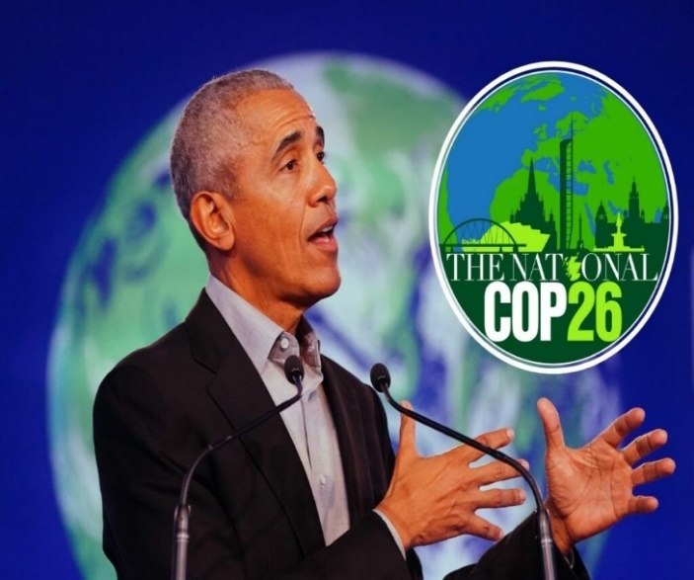
Obama at
COP26

Progress at the International Conference of the Parties, which draws representatives together from many countries has been disappointing since 2018 when President Trump withdrew USA from the agreement reached in Paris has been disappointing. While Biden recommitted to the CoP and some further steps have bee agreed there is little sign of the sort of transformative global action required to meet the target necessary to keep temperature rise below 2%.
Barack Obama at the Glasgow CoP in 2021 delivered a powerful message on climate change here. His summary of progress to date and the task ahead is a fitting conclusion to these pages on global and planetary health. You can of course find a wide range of YouTube videos of speakers at the conference but two key speeches seem most relevant for SfGH trainers the introduction by David Attenborough here and Obama’s conclusion. The “Health Argument for Climate Action” here was presented by the WHO, it outlines the threats to the health and livelihood to the most vulnerable communities who have contributed least to the current crisis. Meanwhile countries like China and India stake a claim to their continued development by the same fossil fuelled route followed by the USA and Europe. The truth that is often unspoken is that this world cannot sustain the population increase of the last 50 years or the current misuse of its resources.
The outcome of the conference(see here) was of course a compromise, while some progress was made in relation to deforestation, methane emission and resources to help lower income countries adapt to climate change, the goal of reducing fossil fuel use was watered down to a vague intention by 40 countries (not including Australia, India, China or the US), to reduce reliance on coal (oil and gas are not covered). And while better than previous agreements it seems unlikely the goal of limiting global temperature rise to 1.5C will be met. Agreement on joint action was reached between the USA and China – which amounts to the world’s biggest polluters agreeing to agree on somethings at some point. One of the most disappointing aspect of the conference was that all and any agreements are to be self-policed by national governments. There is no international system for sanctioning those destroying our planet. The fight continues!
SfGH trainers may wish to share these YouTube videos and hold a group discussion to reflect on his words and COP26 outcomes to consider what can be done to respond to this challenge. Trainers may also wish to develop their own teaching resources to help students at schools and colleges understand the issues facing their generation in addressing the threats to planetary health. I wish you every success in this vital task.

