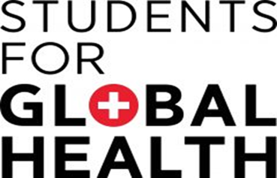

Graham Lister


Tra Dis Discovery Learning for Health in Sub Saharan Africa
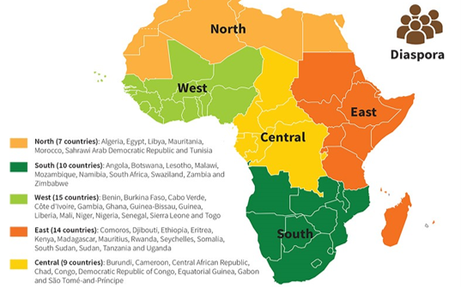
Discovery Learning for Health in Sub Saharan Africa

Sub Saharan Africa (SS A) has a population of 1.25 billion people, in 49 countries which form the West, Central, East and South Regions of the African Union. The rural population of Sub Saharan Africa is currently estimated at 725 m and there are 525 m people in urban areas, including over 200 m people in poor housing and unsanitary conditions (slums).
The people of SSA speak some 1,500- 2,00 different languages with different cultures and history, including colonial rule in most cases. Environments include rainforests, deserts, mountains and fertile plains, all at risk of climate change. Average income levels range from low to upper-middle-income with many areas of extreme poverty. Some countries are among the fastest-growing economies in the world, others are failing or fragile. Governments vary: Eswatini is an absolute monarchy, other countries are republics, such as Senegal, a presidential republic, and Botswana, a parliamentary republic. Some are, or have been, ruled by military regimes. Armed conflict in 20 SS A states resulted in some 25,000 deaths in 2023.
Countries of SS A face different health challenges shown by WHO Atlas of Health statistics see here. These pages cannot explore all SS A’s health issues but introduce some of the common problems and the innovative solutions found in Sub Saharan Africa and provide links to help discover more.
- Health in Sub Saharan Africa and its Determinants
  - Poverty and Communicable, and Zoonotic Diseases
  - Diet and Non-Communicable Diseases
  - Neglected Tropical Diseases and Fungal Infections
  - COVID-19 Impact and Lessons
- Rethinking Health Systems in Sub Saharan Africa
  - Health System Funding and Structure
  - Upgrading Health Facilities
  - Co-Producing Community Action for Health in Rural Areas
  - Co-Producing Community Action for Health in Slum Areas
  - Malaria Vaccine: Breakthrough
  - Ending the Neglect of Tropical Diseases
  - Strengthening the Health Workforce
  - Supply of Medicines and Medical Products
  - Transforming health with eHealth
  - Working with Public/Private Partners
  - Progress for Health and Development
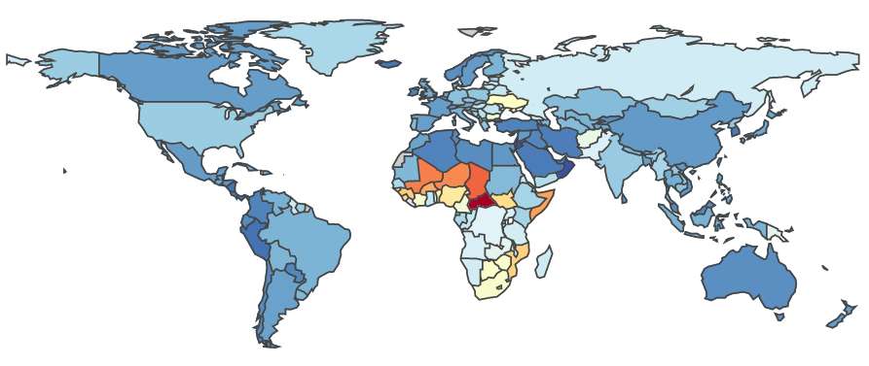
Health in Sub Saharan Africa and its Determinants
DALYs per 100,000 2019 from IHME
Sub Saharan Africa, bears a very heavy burden of disease, measured as Disability Adjusted Life Years Lost (DALYs).that is healthy life years lost due to illness and death, including early deaths and years spent with ill health, weighted according to disability. The diagram shows that for most of SS A the burden of disease is greater than for any other region, for more detailed data by country see here.
DALYs lost to Communicable Diseases in Africa were estimated at over 700 million in 2015 see here. The most common Communicable Diseases in SS A are: Malaria, Tuberculosis, HIV/AIDS, Cholera, Diarrhea and Lower Respiratory Tract Infection. Prevention and treatments are available for these diseases but can be difficult to access due to poverty and lack of health services and medicines.
20 infectious diseases affecting people in SS A are labeled Neglected Tropical Diseases (NTDs). Many are caused by a virus, bacterium, protozoon, or helminth. In total NTDs affect an estimated 650 million people in SS A and almost 2 billion people worldwide see here. NTDs mainly affect low/middle-income nations and people and health and death rates of children, their health and physical and cognitive development. Fungal Infections can also be contagious and are neglected.
They are called Neglected Diseases because in past years they have received less attention than other diseases, perhaps because they pose less threat of international transmission and certainly because they affect lower income populations. The prospect of low affordability deters research for NTD and Fungal Infection medicines resulting in what is known as the 10/90 gap. This means only 10% of research is devoted to conditions that cause 90% of the Global Burden of Disease There are, however, medicines and treatments developed for other conditions that proved useful.
It used to be assumed low-income countries suffered primarily from Communicable Diseases such as Malaria, HIV/AIDS, Tuberculosis and NTDs, while Non-Communicable Diseases were primarily a problem faced by higher income countries. But this is not the case. The WHO “Noncommunicable Diseases country profiles 2018” report here notes: that low and lower-middle-income countries have the highest proportion of deaths under 60 years from NCDs, which have grown faster in lower income countries and, since they generally impose a higher cost on health services, have had a disproportionate impact on their health systems. These countries face a double burden from both types of disease, as shown by the Institute of Health Metrics and Evaluation GBD analysis tool here.
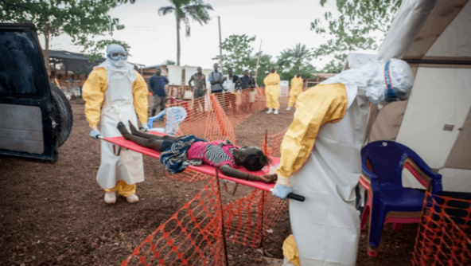
Poverty and Communicable, and Zoonotic Diseases

The United Nations 2015 Sustainable Development Goals (SDGs) include ending global poverty by 2030, improving: health, education, economic development, and environmental conditions for all. SS Africa is unlikely to meet these goals with 21 of the world’s 28 poorest countries, with extreme poverty (less than $1.9 per day) endured by over 30% of citizens. Causes of poverty are complex they include: overpopulation, climate, unemployment, corruption, poor education and health services.
The consequences include living in squalid conditions lacking access to clean water or healthcare, this gives rise to high levels of communicable diseases. These include: Malaria, HIV/AIDS, Tuberculosis, Cholera, Diarrhoea, Lower Respiratory Tract Infections, and Schistosomiasis see here. Poverty has been also a major factor in the neglect of many tropical diseases.
It is estimated that 60% of known infectious diseases and up to 75% of new or emerging infectious diseases are zoonotic. Covid 19 (which has been linked to over 7 million deaths worldwide), is a thought to be zoonotic disease passed from bats to humans in China. HIVAIDS, which was first detected in 1959 in Kinshasa, is another example of a zoonotic disease, it passed from primates to humans causing over 40 million deaths worldwide to date and now affects some 38 million people, 26 million of those living with HIV are in SSA see here.
Over the past 25 years 83 outbreaks of zoonotic diseases had been reported in 26 SS A countries. The most contagious zoonotic diseases were Rickettsiosis, Toxoplasmosis, and Q-fever, those causing most deaths included Marburg, Ebola, and Leptospirosis see here. In most cases outbreaks caused public health emergencies (consequences too severe for conventional service response) see here. If transmission from animals seems exotic remember that Influenza is also a zoonotic disease
Zoonotic diseases are a major threat to global health since they can mutate in animal or human hosts into different variants, which may be more transmissible and/or more deadly. They can be transmitted across borders by birds or mammals (as in the case of Influenza variants).or people. Some 300 million people cross national borders every year as visitors, migrants or refugees.
International aid in the health sector is often focussed on these diseases because failure to contain initial outbreaks can quickly lead to a global pandemic. This was reflected in the 1997 publication by the US Institute of Medicine “America’s Vital Interest in Global Health: Protecting our people, enhancing our economy, and advancing our national interests” see here. This seminal work sparked global debate on our global health. While is clear that infectious diseases transcend borders, it is also clear Non-Communicable Diseases are driven by global lifestyle/consumer trends and marketing. Health is essential to reduce poverty and improve the wellbeing and productive lives of all citizens Health also has a major impact on trade and economic development with global trade, health expenditure accounts for 10% of global GDP and trade in medicines and health related products is estimated at $500 billion. Health is also a major political issue at national and international level because communities, businesses and governments have to work together for common economic and social goals to address poverty and health.
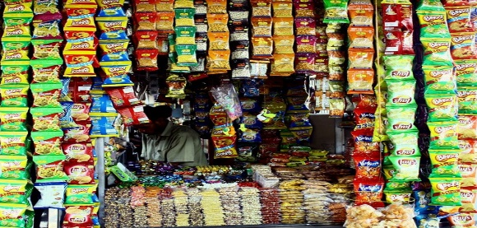
Diet and Non Communicable
Diseases

Ultra Processed Foods (Junk foods) with many added ingredients such as sugar, salt, fat, and artificial colours or preservatives. are usually associated with high-income countries, but are now also prevalent in many Sub Saharan African Countries see here. Consumption of these foods produced both by large scale manufacturers and small local producers offering traditional foods like “mandazi” (oily sugared donuts) that are highly processed. Consumption of these food together with inactive lifestyles leads to overweight and obesity causing many Non-Communicable Diseases and conditions, including diabetes, depression, asthma, heart disease, gastro-intestinal disorders and cancers.. At the same time many others suffer serious problems arising from under nutrition which causes child deaths, stunted growth and development, poor health, and educational and economic outcomes, and is a risk factor for overweight and NCDs in later life.
A WHO study in 2019 showed that in many African countries obesity is rising to 13.6% to 31% amongst adults, and to 5% to 16.5%. for children and adolescents. In 2019, the continent was home to 24% of the world’s overweight children aged under 5 see here . Poor diet is associated with urbanisation where the cost and convenience of junk food may be an important factor. It may also relate to the longstanding issue caused by the overuse of Formula Milk for babies as a substitute for breast milk, which is much healthier particularly in areas where water quality may be poor. This has been linked to a cultural perception that western products such as Formula Milk are more advanced. Undernutrition is also still a major concern in rural areas and slums, but is currently declining.
A 2017 study see here shows a substantial increase in estimates of disability-adjusted life-years (DALYs) due to NCDs in sub-Saharan Africa, from 90·6 million DALYs in 1990 to 151·3 million in 2017. It has recently been predicted that NCDs will overtake communicable, maternal, neonatal, and other nutritional diseases combined as the leading cause of mortality in sub-Saharan Africa by 2030. Rising incidence of NCDs is of particular concern because these diseases give rise to long term chronic conditions that require ongoing support with medicines and medical staff, both of which are in short supply. This will increase the cost of health service provision at a time of funding difficulty. Moreover aid funding for NCD is more difficult to obtain than funding for communicable diseases.
Management of NCDs is a further reason for a focus on the provision of Universal Health Coverage and requires governments to strengthen the management of health systems. It seems many SS A health service developments in past years have depended on available resources and overseas aid initiatives, often targeted at specific Communicable Diseases seen as major global health threats. In recent year SS A governments have developed longer term plans for Universal Health Coverage with the use of eHealth and private sector partnership to meet the needs of rural and slum areas. Governments are also considering how they can improve access to medicines by local or regional manufacture of basic medicines and products that could be funded by Foreign Direct Investment. Health promotion and educational measures are also being developed to increase awareness of the benefits of better diet and active lifestyles see here.
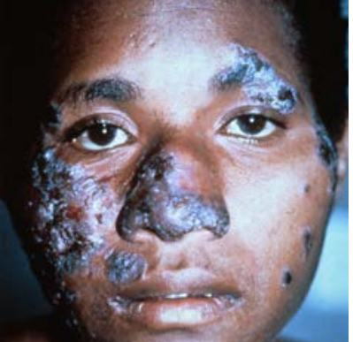
Neglected Tropical Diseases and Fungal Infections

There are some 20 diseases which are labelled Neglected Tropical Diseases (NTDs), they have been overlooked perhaps because they are seen as less of a threat to international health than diseases such as HIV/AIDS and Tuberculosis. But NTDs are the most common conditions affecting the poorest populations in rural areas and slums in lower income countries of Africa, Asia, and Latin America. Sub-Saharan Africa accounts for about 40% of the global burden of NTDs, with about 600 million individuals requiring treatment. see here. Because they affect poor communities and lower income countries who could not afford patent medicine, research to find medicines and treatments for NTDs has been very limited though some products developed for other conditions have proved useful.
Fungal infections have also been largely disregarded but not considered an NTD. Every hour 150 people die of fungal infections and many more suffer life changing conditions including blindness and disfigurement. Fungal diseases are particularly prevalent in rural areas of Lower Income Countries of SS A, where necessary diagnostic laboratory services and drug treatments are very often lacking. In total fungal diseases account for some 2 million deaths, making this the 5th largest cause of mortality, worldwide. However, this is largely unrecognized as they are usually masked by underlying conditions which are reported as the cause of death.
GAFFI (Global Action Fund for Fungal Infections) reports that almost half of those who die with fungal conditions associated with AIDS (770,000 in 2018), 3 million people with TB like infections, some 160,000 people with Leukaemia and Lung Cancer, over 1 million people with Fungal Keratitis and hundreds of thousands of those with Neglected Tropical Diseases, could be cured, if relatively simple diagnosis and treatments could be provided for fungal infections in Low and Lower Middle Income Countries. Their campaign to ensure that 95% of people with serious fungal disease are diagnosed and 95% treated by 2025 (95-95) can be viewed here.
The GAFFI campaign aims to persuade the WHO and governments to give greater priority to fungal diseases, to improve the skills and resources needed for diagnosis and treatment at local levels, to raise awareness and education about fungal diseases for health, community workers and the public and to monitor impact on health and wellbeing. A demonstration programme in Guatemala see here has shown the feasibility of this approach and is already proving its value.
Educational resources including guidance on laboratory procedures can be found on the web site of LIFE (Leading International Fungal Education) a partner organisation working with GAFFI see here. The GAFFI campaign is an example of how an international community action group can influence and support international action in respect of a major global health challenge. But it also shows how action focussed on specific diseases or conditions must also consider the wider impact on local community and their health services.
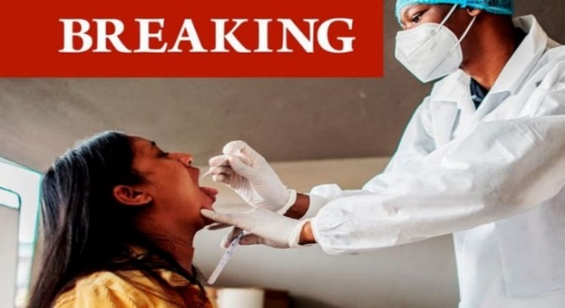
COVID-19 Impact and Lessons

This report published by the Mo Ibrahim Foundation can be found here, it outlines the impact on health systems and the economies of African countries of the Covid -19 pandemic. It notes that the direct health impacts of the first waves of the pandemic have been relatively less severe in many Central African countries, though countries in the North and South of the continent were more affected. But it also acknowledges that though most countries reacted quickly with containment and contact tracing measures, many Central African countries lack the systems necessary to record or analyse the incidence of infection and variants with confidence. . The main impacts noted have been on services addressing diseases such as malaria, TB and HIV/AIDS, which pose a greater threat to lives in Africa, and Mental Illness (particularly for young people), a major global health problem.
Researchers from the Kenyatta, Washington and Liverpool Universities here, suggest the low level of deaths in Africa from Covid-19 (as of 5th July 2021 less than 100,000, 2/3rd in South Africa) may be attributed to the younger age of populations, warmer climate, under reporting and possibly prior exposure to related diseases. A summary can be found on the Sky News service here.
Covid has also had a profound social and economic impacts on African countries, hindering education and gender equity, and increasing political instability. Many African countries have been pushed into recession for the first time in thirty years, increasing unemployment and poverty (so far it is reported that the number of people in extreme poverty has grown by 15 million). The report notes the need to seize the opportunity to “build back better”, by supporting pan African health organisation such as African Centre for Disease Control, see here and strengthening Africa’s ability to produce and purchase supplies such as vaccines and work together for a sustainable future.
In addressing the pandemic Africa has been hampered by being priced out of the market for PCR testing and waiting for the COVAX scheme to deliver promised vaccines. Although 400 million Johnson and Johnson single dose vaccine have been purchased for Africa relatively few have yet been administered leaving Africa with only 1.2% of its population fully vaccinated by 1st July 2021.
The impact of failure to address the health and socio-economic needs of much of Africa, is global. Poverty means that many people live in insanitary conditions, in close contact with a wide variety of wild and domestic animals, with poor access to healthcare services. These are conditions that greatly increase the likelihood of the emergence of new variants of Covid and indeed many other diseases particularly those affecting younger age groups. Low levels of infection in earlier waves may increase vulnerability. This nightmare scenario is emerging as Covid-19 cases arising from a range of new variants including Delta are surging by 25% per week and associated deaths are rising by 15% per week (01/07/21), as reported by Dr Matshidiso Moeti, WHO Regional Director for Africa here.
The Build Back a Better World (B3W) here and COVAX here initiatives offer hope that the high-income countries will at last accept their responsibility, but this seems certain to be another case of too little too late unless strong public support is mobilised across the world.
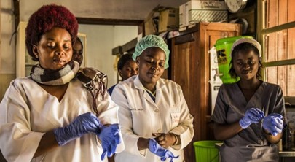
Rethinking SS A Health Systems

Most health systems of SS A developed during the colonial era, with Provincial/District Health Services focussed on urban hospitals. Rural communities were served by Missionary Hospitals (still providing up to 20-30% of services in some areas) and district health centres and local dispensaries. Post-colonial health systems continued to focus budgets on hospital-based care for some years. These systems have been rethought in recent decades to meet SS A populations’ health needs giving more attention to rural communities and slums where over 70% of people currently live.
The World Health Assembly 2016, “Framework on Integrated People-Centred Health Services” sets out goals for all healthcare services of: Equity of access, Quality, Safety, Responsiveness Community participation, Efficiency and cost-effectiveness, Resilience and Sustainability see here. . It notes that if a health system is to be sustainable in a low-income country, it must be part of an integrated service addressing, whole person health with the support of individuals and communities
WHO estimate that nearly 630 million years of healthy life were lost in 2015 across Africa due to diseases, which they equate to a potential annual loss of over $2.4 trillion to Africa’s GDP see here. Thus health reform can provide a vital contribution to economic and social development. The cost to Africa’s economy and the deficit in funding health infrastructure was recognised by the African Development Bank in its “Strategy for Quality Health Infrastructure in Africa 2022-2030” see here. Reports suggest potential loans of $3 billion for health infra structure and $3 billion for FDI in supplies are being considered as a contribution to rebuilding health services across Africa.
As all low-income country health systems are underfunded, it is also important to consider the financial impact of expenditure on any one element of health, that may divert resources from other fields. For a course on economic evaluation see here. The WHO One Health Tool is used to examine alternative health provision options see here.
While Universal Health Coverage demands access for all, this does not necessarily ignore private sector provision. Many SS A countries are beginning to work with their private sector as partners in provision of services and the production and supply of medicines and medical devices see here.
These pages consider some of the ways health systems are being rethought to meet SS A needs . The systems, facilities, ways of working and resources, for health in SS A are being reconsidered. Investment and training is needed to upgrade health facilities and resources in rural and slum areas. Supply of medicines and medical equipment can be an opportunity for Foreign Direct Investment. eHealth is another example where private sector investment can help transform health systems. Health system reform is a vital contribution to social and economic development. Progress towards UN Sustainable Development Goals show innovation in health care is leading in the way.

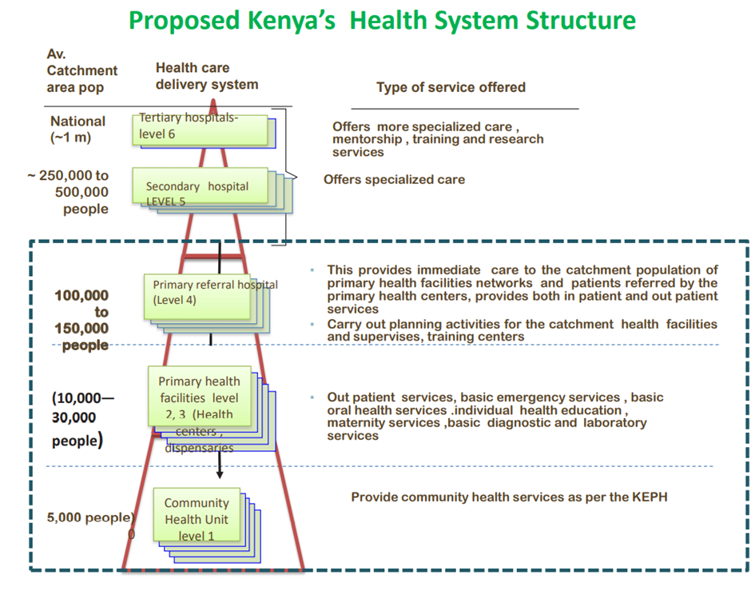
Health System Funding and Structure

A report by WHO in 2019, see here, shows total expenditure on health services constituted about 10% of the world's GDP. In SS Africa it was only 5% of GDP, ranging from less than $50 to over $500. The costs to users, for medicines, private services and “informal payments” to doctors and nurses, can be 30-40% of this, funding from governments is typically 25-35%, and aid donors or other external sources 20-30%. Estimates show 800 million people in SS A spend some 10% or more of household income on health. See Lancet Commission report on future of healthcare in SS A here.
While there have been many political upheavals, the Climate Crisis, Covid 19 and changing trade conditions Africa’s economy has recovered to achieve growth of some 3.8% in 2024. But only 3 African Union member states have increased government expenditure on health to 15% of national budgets as agreed in the 2001 Abuja Declaration. Over 30 AU member states remain below the 10% benchmark, with health expenditure as low as 5–7% of government spending see here.
Over the last 3 years there has been a dramatic decline in Official Development Aid (ODA)see here, an almost 20- 30% reduction in ODA between 2022 and 2025. This has increased financial pressures on health systems and out-of-pocket costs. ODA also changed in other ways, the “America First Global Health Strategy” launched in 2025 focusses aid on the provision of medicines and equipment supplied by US companies and concentrates on disease surveillance and specific diseases that could threaten health in America see here. This narrow focus fails to recognize the increasing costs of Non-Communicable Diseases (often related to Western junk foods) and the aftermath of Covid 19. It may also reduce the incentive for Foreign Direct Investment in health supply industries in SS Africa.
Many SS A countries are developing social or community insurance health funding schemes designed to meet their needs. These include Ghana, Nigeria, Rwanda, Cameroon and Algeria while South Africa still has an insurance scheme reflecting its apartheid era. Other state systems are tax funded.
At the same time SS A countries are redesigning health systems to meet the needs of previously underserved rural and slum area communities. The health system structure proposed for Kenya as shown above is typical of many other countries which recognise the need to focus on local services, facilities and community health workers accessible to all communities.
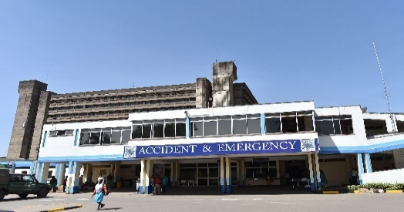
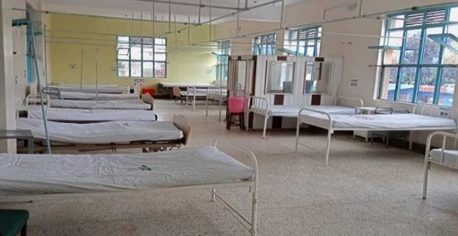
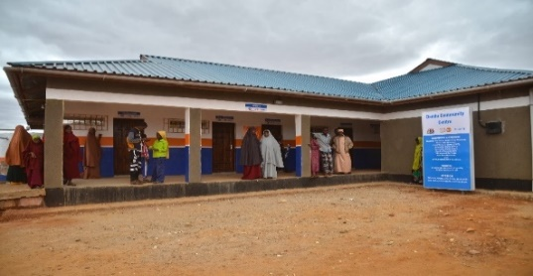
Upgrading Health Facilities

Kenyatta Teaching Hospital Machakos General Hospital

Mandera Community Life Centre

An essential starting point for planning health services in SS A is to assess health determinants and needs and availability of good quality staff, facilities and medical resources, for each community. Where such services are not available further training, facilities and logistics support are necessary. For an analysis of the state of health and health systems in Africa see the WHO Report here.
Reviews of the Kenyatta and other hospitals and rural health centres in the 1990s and 2000s showed that in most cases they lacked many of the resources one might expect. As examples at the time of a review the Kenyatta had only 1 of its 6 autoclaves working, while there were sufficient doctors in post, many seemed to leave a jacket on their chair and leave the hospital to work in private practices, the laundry was very intermittent, many patients had to use their own sheets, nurses expected payment for basic patient care and protective gloves had to be hand washed for reuse. Hospitals and Rural health centres were often very poorly maintained, so buildings showed signs of damp and decay, equipment was often unusable and facilities such as toilets could be dire.
The need to meet gaps in the provision of rural health services introduce further training and upgrade the quality of facilities in rural areas and secondary and tertiary hospitals and support services such as diagnostic laboratories is now recognized across SS A. The 2022 African Development Bank “Strategy For Quality Health Infrastructure In Africa” noted that the primary issue has been lack of available funding. It put forward proposals including: private and public health insurance systems, regional regulation and infra structure and greater use of eHealth see here.
It is clearly not sufficient to simply build local health centres, they must be sustainably funded to maintain buildings and equipment. In many cases this also requires provision of reliable electricity and clean water supply. Electricity is needed for lighting, bold storage and eHealth communication. An example is a pilot programme funded by the Shell Foundation, has supported six renewable energy companies to electrify 11 health facilities in Nigeria, Ghana, Benin, and the Democratic Republic of Congo, ranging from small clinics to hospitals, serving over 300,000 people see here. Electricity supply possibly from solar or other renewable sources is also vital for eHealth services.

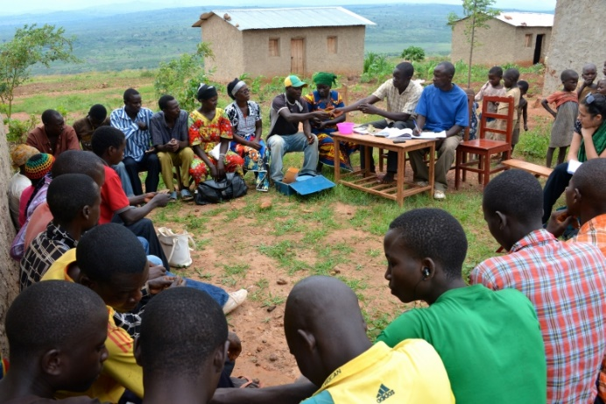
Co-Producing Community Action for Health in Rural Areas

Rural areas of Sub Saharan Africa, where 60% of the population live often lack health facilities 10-15% are estimated to live more than 3 hours from the nearest health post see here. They are also likely to have poor access to clean water or sanitation (estimates vary from 10-30%), access to electricity is also poor (estimates show only about 20% of rural communities have access) and while mobile phones are available, only about 12% of those in rural areas can access the internet.
Common health conditions faced by rural communities include HIVAIDS, Malaria, Tuberculosis (which can be an underlying issue) as well as Non-Communicable Diseases such as Diabetes caused by poor diet and undernutrition, which gives rise to stunting and child deaths. At the same time wellbeing issues include the need to fetch even dirty water from distant sources, lack of toilets and lack of electricity and online connectivity. These factors add to the problems of poor health services and require community action: as examples improving sexual behaviour and use of condoms, use of insecticide treated nets, avoiding contact with TB carriers, improving diet, digging for water and pit latrines, better diet and child care and shared community transport and communication resources.
A new approach to community health and wellbeing, for rural and urban slum areas has emerged reflecting the 1978 Alma-Ata commitment to primary care for all. This approach was developed by Dr Tedros Ghebreyesus (now Director General of WHO) for the Tigray Region of Ethiopia see here,. Health centres were established to serve each local community in Tigray led by nurses, supported by community extension workers. Community leaders were engaged to support healthy behaviour and collaborate with local services as co-production is fundamental to this model of community health.
This has been followed by many other African countries, see, for example, the 2019 Kenyan Primary Health Care Strategic Framework 2019-2024 here. WHO guidance on Community engagement for quality, integrated, people-centred and resilient health services can be found here and here. A health project in Namibia, includes Village Health Committees, as co producers see here.
An important aspect of such a relationship is to acknowledge faults in current arrangements and to recognize that any proposed improvements must be economically and financially sustainable. It is also essential to ensure transparency, so local groups can monitor services against promised targets. Consultations should set basic targets against which community groups can judge performance. Transparency International helps communities to monitor the local impact of aid projects, see here.
See the review here showing how training can help Community Health workers achieve health goals.

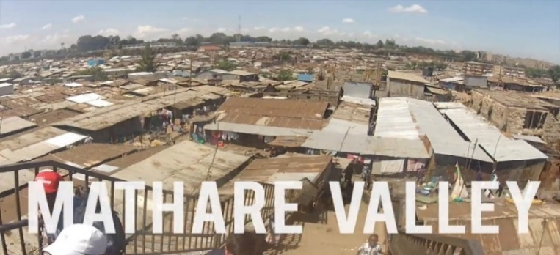
Co-Producing Community Action for Health in Slums

Globally, nearly 1 billion people live in slums, defined as urban areas with a lack of basic services (sanitation, potable water, electricity), substandard housing, overcrowding, unhealthy and hazardous locations, insecure tenure and social exclusion. In Sub Saharan Africa, over 200 million people live in slums such as Mathare Valley (the oldest) and Kibera, world’s largest slum in Nairobi.
Slums see here have high rates of mortality and morbidity particularly high for children: HIV/AIDs, TB, NTDs and infectious diseases as well as high rates of NCDs due to fast food and alcohol. Shared pit latrines and “flying toilets” (Google this) are common forms of sanitation, water is fetched from communal standpipes, most houses are overcrowded corrugated iron huts with earth floors here.
Many slum residents could access health facilities located in Tertiary or Secondary Hospitals near their area, but they often lack awareness of the early signs of diseases such as fungal infection. And many residents may not be able to afford medicines because they do not earn enough from informal sector employment. Doctors and other health staff are often reluctant to provide services in these areas due to lack of security. It is also apparent that in some slum areas criminal gangs control many aspects of life. This can make tenure and employment uncertain, for people who have left their village due to poverty.
For a glimpse of life in a Nairobi slum see here ,this article describes a project by the Umande Trust’s to improve sanitation in an ecological way, but more importantly it brings the community together in Kibera the world’s largest slum. Another hopeful initiative has been the proposed development of slum areas of Kigali by a public private partnership led by the Rwanda Initiative for Sustainable Development (RISD), a non-governmental, not-for-profit organization. Their approach, which has been successful in other areas of Rwanda, focuses on building social capital (links within and between communities and leadership) as a basis for joint action for sustainable, healthy redevelopment see here.
A meta study of projects to improve health and wellbeing in Africa’s slums by Lilford and Oyebode et al here shows an integrated approach to physical infrastructure and social development is needed to address the many interlinked issues that determine the health and wellbeing of people living in slums. An essential starting point is secure tenure of property, as without this, and security, coproduction is seldom possible. This requires listening and building trust with the community as well as investment by services including health and community workers, police, planners, water and sewerage departments.

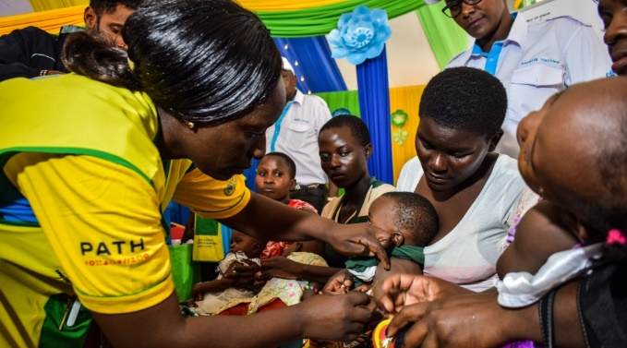
Malaria Vaccine:
Breakthrough

On October 6^{th,} 2021 Director-General Dr Tedros Adhanom Ghebreyesus announced WHO’s recommendation of widespread use of the RTS,S/AS01 (RTS,S) malaria vaccine among children in sub-Saharan Africa and in other regions with moderate to high levels of malaria transmission. He said “This is a historic moment. The long-awaited malaria vaccine for children is a breakthrough for science, child health and malaria control. Using this vaccine on top of existing tools to prevent malaria could save tens of thousands of young lives each year.”
Malaria is caused by five types of Plasmodium parasite which are spread to humans through the bites of infected mosquitos. In 2019, nearly half of the world's population was at risk of malaria, there were an estimated 229 million cases, and some 409,000 malaria deaths. Most cases and deaths occur in sub-Saharan Africa where Malaria is a major cause of childhood illness and death. More than 260 000 African children under the age of five die from malaria each year.
While the vaccine, trialed in Ghana, Kenya and Malawi RTS,S, which protects children against Plasmodium Falciparum, the most deadly malaria parasite and the most prevalent in Africa, is a huge step forward it is not a complete answer. It requires the vaccine be administered to children in 4 doses from the age of 5 months and protects against only 30% of infection and 40% of severe cases and deaths. The vaccine was developed by the British pharmaceutical company GlaxoSmithKline plc (GSK) which donated 10 million doses of the vaccine (see here). GSK worked in partnership with PATH (Program for Appropriate Technology in Health, see here), and with the support of a network of African research centres, and funding from the Bill and Melinda Gates Foundation, Gavi, the Vaccine Alliance; the Global Fund to Fight AIDS, Tuberculosis and Malaria; and Unitaid.
The next step will depend upon international funding and the decision of countries to prioritise the administration of the vaccine alongside other malaria prevention measures which include: the use of insecticide-treated mosquito nets and indoor spraying with insecticides every six months (called Indoor Residual Spraying) and use of anti-malarial drugs during the high transmission season.
Delivering vaccines to children across Sab Saharan Africa will be another huge challenge for Africa’s health systems, as acknowledged by Dr. Matshidiso Moeti, WHO regional director for Africa. Moreover, there is always the danger that malarial parasites will develop resistance to the drug. Previous breakthroughs have included the use of DDT, which proved to have disastrous effects on the environment and human health, the discovery and use of Artemisinin which is now discouraged as it appears malarial parasites are developing resistance. There are also programmes to reduce or eliminate mosquito larva, to release sterile male mosquitos and to genetically modify mosquitos.
The new drug could have a very positive impact but must be considered alongside other prevention and control measures and continued research. It is not a silver bullet.
Targets for action to reduce malaria globally, agreed at the 2015 World Health Assembly include reducing deaths by at least 90% and eliminating it in at least 35 further countries by 2030, see here.

Ending the Neglect of Tropical Diseases

More than 870 million people suffering from one or more of the 20 NTDs which cause some 500,000 deaths pa have benefited from large-scale treatment programmes of preventive chemotherapy by 2025. This was the world's largest public health intervention launched in 2010 by the WHO. This programme benefited from donations of drugs from pharmaceutical companies worth billions of dollars, see here.
In 2021 the WHO launched a new ten year strategy to address Neglected Tropical Diseases (NTDs). The plan was called “Ending the Neglect to Attain the Sustainable Development Goals” see here . Targets were set for action to prevent, control, eliminate or eradicate the 20 diseases listed above. Its theme was a shift away from a single disease focus to an integrated approach with improved coordination and collaboration with communities and between governments and the private sector.
Targets to be achieved by 2030 are: 90% reduction in people needing interventions against NTDs 75% reduction in DALYs due to NTDs, 100 countries to eliminate at least one NTD 2 NTDs eliminated Key elements of the strategy include: Clear accountability for targeted results for, health service delivery, research and development of drugs, delivery of medicines, advocacy and collaboration..An integrated approach to whole person universal health coverage, delivered by local health services and communities with national regional and global support. A change in the operation and culture of health services, led by countries with regional support, bringing together all parties see here,

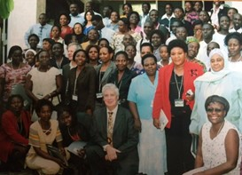
Strengthening the Health Workforce

Africa, bears an estimated 25 percent of the world’s disease burden but only 3 percent of global Health Care Workers (HCW) with only about 1.3 per 1,000 well below the WHO minimum of 4.5. WHO projects a 6.1 million HCW shortage in the African Region, based on needs of the population. At the same time a third of Health Care Workers in Sub Saharan Africa are unemployed see here .
Africa has only 2% of the world’s doctors. Europe has 1 doctor per 350 - 650 people, Africa has 1 doctor per 10,000 – 15,000 people. But most doctors work in urban areas, where they can earn from private practice. Most Rural areas of SS A have 1 doctor serving 50-60,000 people or more. While 10-11,000 doctors are trained in SS A every year, it is estimated 33%-50% of medical school graduates migrate to pursue a career in higher-income countries, with financial cost of $37 m for their training. In Kenya, it has been estimated that of 5,000 doctors registered to work in public hospitals, only 600 do so; the rest work in the private sector or migrate, see here.
In towns nurses provide care in hospitals and in community settings, in the past I have observed nurses demanding unofficial payments from patients but I hope this has reduced. And as in the case of doctors, many nurses also work part time or leave public sector posts to provide private services. It is also reported that many nurses are leaving their profession to take jobs in other sectors.
Rural services are managed by Nurses and Technical staff with limited training in diagnostic or specialist treatment options. The rate of migration of qualified Nursing Staff is almost 7 times that of doctors, for example, more than 180,000 Zimbabwean nurses work abroad. This is due to lack of recognition of roles of senior nurses, low pay and high unemployment see here.
To resolve these problems countries to which medical staff migrate should pay for their training. This is being piloted by the Global Skills Partnership enabling destination countries to pay countries of origin for training migrant workers and those who will work in the home country. By April 2025, the Philippines/ Germany Nursing Global Skill Partnership had trained or was in the process of training over 300 nurses. This includes nearly 200 nurses on the “home” track working or planning to work in the Philippines, and a combined total of nearly 100 nurses on the “abroad” track, of whom 44 were already working in Germany see here.
There are many other professions allied to medicine some are in short supply, some overprovided this points to the need for better planning for future human resource and training requirements. Changes to health systems to match SS A needs and resources and increasing use of eHealth and Artificial Intelligence for diagnosis, treatment planning and prescription is likely to redefine the skills required of all Health Care Workers in the future. A Sub Saharan review of HCW recruitment and training is needed to prepare for this future as noted in the Mckinsey and Company report see here.

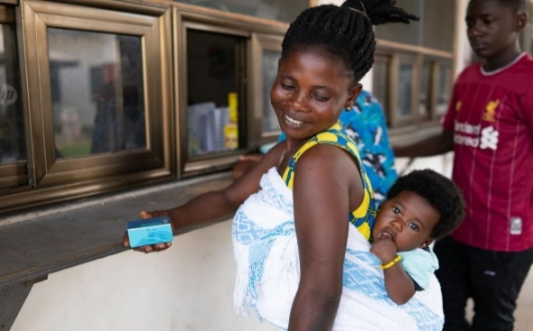
Supply of Medicines and Medical Products

500 medicines are classed as essential for health in low-income countries, 360 of these are for children. But in rural Sub -Saharan Africa (excluding South Africa) it is estimated that less than 10 percent of these may be available to patients through local and district health services see here. Essential medicines will be dispensed by staff in rural areas with basic training or hospital doctors. Other medicines prescribed by doctors may be available from private sector suppliers but are often expensive and of limited supply due to intermittent supply of generic drugs from India or China, poor distribution systems and lack of local storage facilities and/or electrical failures to refrigeration units
When, as often happens, medicines are unavailable due to supply, distribution or storage problems, patients may buy medicines from wayside pharmacies or illegal suppliers, which may sell a limited strip of an antibiotics, which patients take home and share with their family. Unregulated suppliers may also sell drugs close to or beyond their expiry date and/or fake medicines which are cheaper. The global market for counterfeit medicines is estimated at over $75 billion, 42% of this in Africa. This is a route to treatment failure and anti-microbial resistance, a major threat to global health and has been estimated to be the cause of over 500,000 deaths in Africa every year see here..
Simple medical devices are also in short supply and/or very expensive. In some cases, equipment (sometimes donated by NGO’s) is left unused due to lack of staff training, maintenance and spares.
Issues affecting the provision of medicines and medical devices are addressed in the 2024 report “Healing the Great Rift” by Jeremy Holmes see here. This explores the factors blocking the supply of medicines and devices in East Africa. It proposes measures to strengthen and simplify the regulation of medicines, and to target key subsectors for investment in domestic capacity. The report notes the need to harmonize the regulation of medicines and devices and of customs and trade incentives for local production of medicines and devices across the region, which have been objectives for the East African Community for the last decade with some limited progress see here. At the African Union level, the establishment of the African Medicines Agency to support the regulation and promote investment in research and manufacture is currently being established see here.
The report highlights the opportunities to promote Foreign Direct Investment (FDI) to develop the local manufacture and distribution of medicines and medical products in East Africa, particularly selected high volume products (e.g. antibiotics, antihypertensives antidiabetics) and simple intravenous (IV) infusions, eye drops, pharmaceutical packaging and other medical sundries and accessories, small scale diagnostic equipment like ophthalmoscopes and equipment maintenance/support services and logistics systems.
The emphasis upon FDI as a source of funding, rather than Official Development Assistance (ODA), in this report reflects a growing awareness that aid cannot be the main driver of development for low income countries see here. Studies indicate that FDI may have at least as much impact upon poverty reduction as aid, and if it is well embedded in the host economy it is more sustainable. It also illustrates the importance of considering the health industries of low-income countries as an important component of their economies both in terms of the resources required and its impact upon the employment, productivity and wellbeing of citizens. You can read the International Federation of Medical Student Association’s 2025 paper on the Trade and Health Agenda here
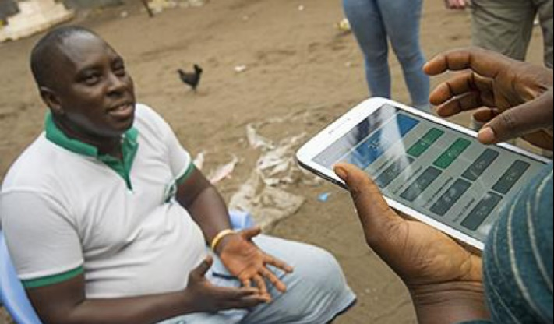
Transforming health with eHealth

The potential contribution of eHealth has long been recognized in Africa. The Pan African eNetwork Project (PAENP) was an information and communications technology project between India and the African Union to connect the 55 member states of the Union through a satellite and fibre-optic network to India and to each other. The project enabled access to and sharing of expertise in the fields of: tele-education, telemedicine, Voice over IP, infotainment, resource mapping, meteorological services, e-governance and e-commerce services. Investment in this $1billion project started in 2006. For healthcare, PAENP connects 5 regional Super Specialty Hospitals and 53 remote hospitals in all countries of Africa to Universities and hospitals in India, see the video here. The Education for Health Africa project, see here, is a further eHealth initiative with the potential to transform continuing education for health professionals and technicians.
African countries have embraced the potential of eHealth, see “Every African Country’s National eHealth Strategy or Digital Health Policy” here. Kenya has had a strategic plan for eHealth since 2011 see here, and there are now calls for a regional eHealth Strategy for East Africa see here. Proposals include national and regional centres that can develop and contextualise online resources including basic medical and public health knowledge, reference knowledge for specific diseases, diagnostic tools and AI algorithms, and logistics support see “African Strategies for Health” here.
Internet resources are used to support continuing clinical education and diagnostic and treatment protocols for health workers. For example, the “Jibu” (Swahili for “answer”) project supported by Amref Health Africa, provides training resources for Nurses in Kenya through mobile phones and tablets, this is called mLearning for mHealth see here. Other examples of mHealth technology include an app provided by the Kenyan Ministry of Health called “Integrated Management of Childhood Illness” and the “First Aid”, app offered by the Kenyan Red Cross. In Rwanda a UK provider called Babylon Health is developing a wide range of eHealth and mHealth services see here. There are also commercial phone apps used by the public to access and pay for medical advice and medicines including: mDaktari, Hello Doctor/ Sema Doc, mTiba and MyDawa.
eHealth algorithms show the potential to transform access to medicines in rural areas particularly when supported by drone delivery of medicines as shown by Ziplines, which operates in Rwanda, Ghana, Nigeria, Côte d’Ivoire and Kenya see here.
You may also wish to look at the National eHealth Strategy Toolkit see here produced by the WHO and the International Telecommunication Union.
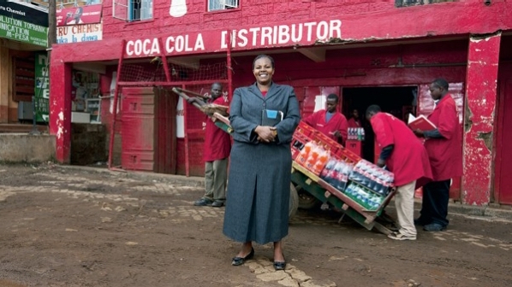
Working with Public/Private Partners

Public/Private Partnerships (PPPs) are an important element of healthcare provision in low-income countries. While they can improve services, they need to be carefully managed see here. so countries such as Kenya have specific policies frameworks and units to manage them see here.
Public Private Partnership with drug companies has been a feature of the response to Neglected Tropical Diseases (NTDs), as discussed here. Thirteen of the largest pharmaceutical companies have cooperated in the largest drug donation in history. To date they have contributed more than $17.8 billion as drugs and contributions towards the cost of distribution and prescription. They are often drugs developed for other purposes, which have proved useful for NTDs as little drug development is specifically targeted at NTDS. The Global Forum for Health Research, note “90% of health research expenditure is targeted at problems that affect only 10% of the world’s population” see here.
Partnerships also include global alliances which address specific diseases. Examples include: the Global Fund and Goodbye Malaria see here, the Sightsavers Global Trachoma Mapping project here, the Stop TB Partnership here and UNAIDS. While they are very important sources of health aid they can also bring a narrow focus on a specific disease or drug treatment at the expense of integrated national and local services, dealing with the full range of health and care needs of individuals and communities.
There are calls for partnerships to support E-Health and m-Health Knowledge Centres for Africa and other low-income countries see here. This could ensure that while sharing in global networks, health science and knowledge is developed relevant to local needs and reflects the language and resources available, addressing issues such as NTDs and Fungal Diseases. This also reflects a growing impatience with the provision of technical support from High-Income countries, which, though welcome, needs to recognize and support the development of in-country expertise.
PPPs have also assisted in meeting the logistic problem of drug delivery to rural locations. Coca-Cola and the Global Fund to Fight AIDS, Tuberculosis and Malaria have expanded a project which uses the beverages giant's “expansive global distribution system and core business expertise" to help deliver critical medicines to remote parts of the world, beginning in rural Africa see here.
Knowledge provided on-line, by mobile phones and other devices is a crucial resource for health in Low-Income countries, USAID and Orange telecommunications, have recently announced a new collaboration to find innovative ways to use mobile phone “mHealth” to accelerate access to health information and services in Africa see here.

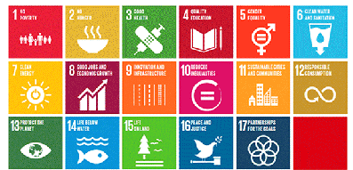
Progress for Health and Development
Sustainable Development Goals

While many reforms and innovations are evident at national level there seems to have been slower progress in developing joint initiatives for the South, West and East African Regional Communities and at the level of the African Union. Several of those we spoke to suggested that coordinated action could reduce regulation barriers for medicine and products and facilitate FDI for the production of basic medicines and goods for the African market. It has also been suggested that training of health workers to address the specific needs of Africa could be coordinated at this level. And that support and regulation for eHealth (which knows no boundaries) might also be targeted. The African CDC see here , African Medicines Agency, see here and calls for New Public Health Order show progress at the African Union. There has also been movement towards greater cooperation at regional levels.
A report by the WHO Regional Office for Africa 2018 examined progress towards UN Sustainable Development Goal 3 “Good Health and Well-Being,” which calls on countries to ensure healthy lives and promote well-being for all at all ages, in the context of all 17 goals see here . This shows how health is central to all aspects of development though it may also be the most costly public service provision. At a more detailed level the WHO provide an analysis of all aspects of SDGs relating to health and wellbeing and the progress achieved see here.
In the face of the challenge of: underfunding, lack of facilities, and insufficient health workers the United Nations Economic Commission for Africa assesses progress towards Sustainable Development Goal 3, as greater than that achieved for any other field see here.
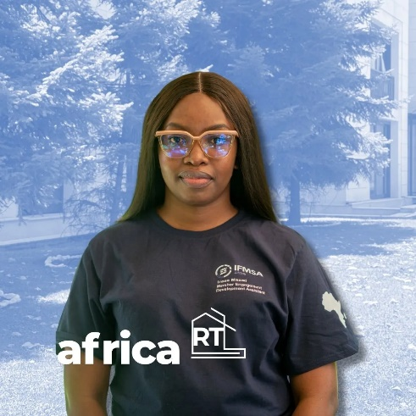
The level of progress achieved in Africa by 2024 in relation to each SDG is shown in the chart on the next page. The innovative reforms to health services in SS A are shown to have achieved better progress than shown in any other field.
You may wish to consult colleagues in the Africa Regional Team of the International Federation of Medical Student Associations (IFMSA), to share their understanding of health in SS A or to consider their Student Exchange Schemes
Irene Eliakim Maswi is the IFSMA Regional Director for Africa Elect 2025–26.
Itene’s contacts are: rdafrica.elect@ifmsa.org or WhatsApp at +255 758202974.

Sustainable Development Goals Africa
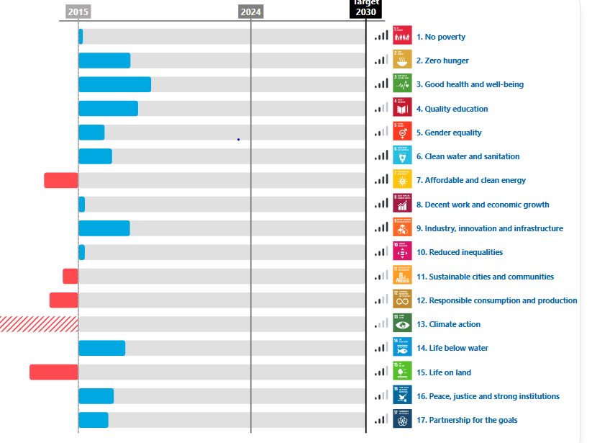
Progress by 2024 according to UNECA

