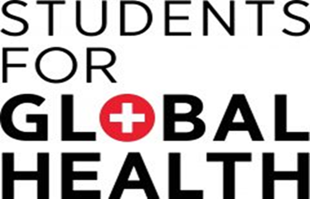

8

Graham Lister



Tra Dis Training Toolkit 8 Health in Sub Saharan Africa

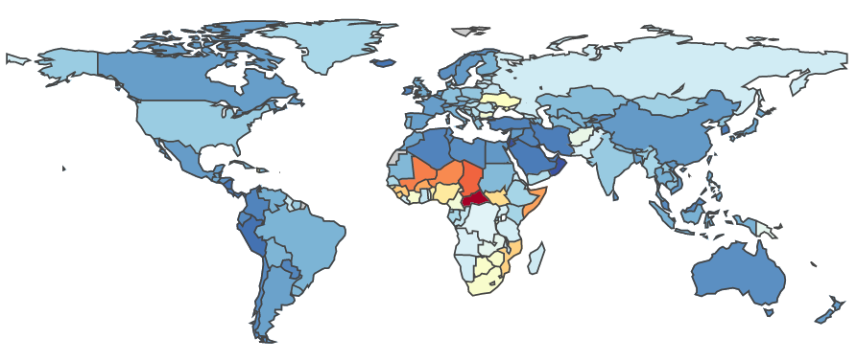**Health in Sub Saharan Africa**

DALYs per 100,000 2019 from IHME

Sub Saharan Africa bears a very heavy burden of disease, measured as Disability Adjusted Life Years Lost (healthy life years lost due to illness and death, including early deaths and years spent with ill health, weighted according to disability). The diagram shows that for most of SS Africa the burden of disease is greater than for any other region. It used to be assumed that low-income countries suffered primarily from Communicable diseases such as Malaria, HIV/AIDS and Tuberculosis, while Non-Communicable Diseases were primarily a problem faced by higher income countries. But this is not the case. The WHO “Noncommunicable Diseases country profiles 2018” report here notes: that low and lower-middle-income countries have the highest proportion of deaths under 60 years from NCDs which have grown faster in lower income countries and, since they generally impose a higher cost on health services, have had a disproportionate impact on their health systems. These countries face a double burden from both types of disease, as shown by the Institute of Health Metrics and Evaluation GBD analysis tool [here](http://ghdx.healthdata.org/gbd-results-tool).

These pages explore issues relating to health care provision in Sub Saharan Africa using examples of provision for Neglected Tropical Diseases (NTDs) and Fungal Infections. It is important to stress that measures to address these disease must be part of an integrated approach to all types of physical and mental illness, moreover health is part of the wider challenge of sustainable development. The following pages discuss:

1. Neglected Tropical Diseases and Access to Medicines,
2. Roadmap for Neglected Tropical Diseases
3. Fungal Infections: the Hidden Crisis
4. Covid-19 in Africa: One Year On: Impact and Prospects
5. Malaria Vaccine Breakthrough
6. Health Systems in Rural and Urban Areas,
7. Health Facilities in sub Saharan Africa
8. Co-Producing Community Action for Health in Rural Areas of sub Saharan Africa
9. Co-Producing Community Action for Health in sub Saharan Africa’s Slums
10. Attainability Resilience and Sustainability,
11. The Potential of E-Health for Africa
12. Working with Public/Private Partners,

**SfGH groups could consider these issues individually or review the pages together to discuss the problems faced by health systems in Sub Saharan Africa.**

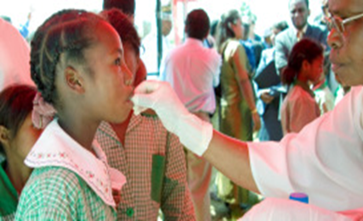**Neglected Tropical Diseases and Access to Medicines**

Access to medicines is limited for people with low incomes by four key factors. First medicines are often unaffordable because prices are set by rich country markets and may even be higher in low income countries. Second the prospect of low affordability deters the development of medicines for Neglected Tropical Diseases (NTD) resulting in what is known as the 10/90 gap. This means that only 10% of research funding is devoted to conditions that cause 90% of the global disease burden. Third lack of effective health systems, diagnostic and prescribing skills and logistics for delivery and control of medicines inhibits provision of medicines as one aspect of effective healthcare. And fourth lack of effective, uncorrupt governance may be a factor.

The global social contract with pharmaceutical companies embodied in WTO intellectual property agreement (TRIPS), provides global protection for 20 years for patented drugs. While patent protection starts from the filing of the patent application, which can be years before commercial availability, pharma companies extend this by introducing minor enhancements to drugs. The Doha declaration of 2001 provides exception in the case of health crises, allowing the provision of lower cost generic medicines, of which India is the largest producer. Some companies provide medicines at a lower price to low-income countries through intermediaries such as the Clinton Foundation. It has been suggested that the main obstacle to setting affordable prices for low-income countries (where prices are often higher) is the fear of, so called, parallel exporting (corruptly selling drugs back to high income markets) and counterfeit medicines (an estimated market of over $75 billion).

More than one billion people suffering from one or more of the 20 NTDs which cause some 500,000 deaths pa benefited from large-scale treatment programmes of preventive chemotherapy in 2014 as part of the world's largest public health intervention led by the WHO. This programme benefited from donations of drugs from pharmaceutical companies worth billions of dollars, see [here](http://www.who.int/neglected_diseases/news/Review_NTD_progress_towards_addressing_the_chronic_pandemic.pdf?ua=1) .

It is easy to blame pharmaceutical companies for neglecting drug development for diseases affecting low-income countries. But it might be more constructive to challenge the system of intellectual property rights that creates the incentives for investment. The same incentive structure also inhibits research and development for new antibiotics. It is also important to recognize the support that pharmaceutical companies provide for access to medicines that are found to be effective for NTDs, while acknowledging that this is not enough. The Access to Medicines Index, supported by UKAID, the Bill and Melinda Gates Foundation and the Netherlands Ministry of Foreign Affairs reviews the performance of 20 of the world’s largest research-based pharmaceutical companies view the index [here](http://accesstomedicineindex.org/media/atmi/Access-to-Medicine-Index-2016.pdf).

Fair access to medicine also reflects the overall quality of governance in each country to examine this aspect you may wish to review the Ibrahim Index of African Governance [here](https://mo.ibrahim.foundation/iiag).

**Discuss how SfGH can support positive action to improve global access to medicines.**



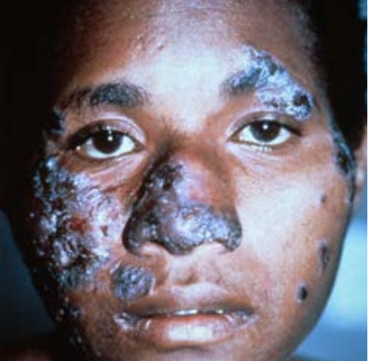**Fungal Infections: The Hidden Crisis**

Every hour 150 people die of fungal infections and many more suffer life changing conditions including blindness and disfigurement. Fungal diseases are particularly prevalent in rural areas of Lower Income Countries, where necessary diagnostic laboratory services and drug treatments are very often lacking. In total fungal diseases account for some 2 million deaths, making this the 5th largest cause of mortality, worldwide. However, this is largely unrecognized as they are usually masked by underlying conditions which are reported as the cause of death.

GAFFI (Global Action Fund for Fungal Infections) reports that almost half of those who die with fungal conditions associated with AIDS (770,000 in 2018), 3 million people with TB like infections, some 160,000 people with Leukaemia and Lung Cancer, over 1 million people with Fungal Keratitis and hundreds of thousands of those with Neglected Tropical Diseases, could be cured, if relatively simple diagnosis and treatments could be provided for fungal infections in Low and Lower Middle Income Countries. Their campaign to ensure that 95% of people with serious fungal disease are diagnosed and 95% treated by 2025 (95-95) can be viewed [here.](https://www.gaffi.org/wp-content/uploads/GAFFI-Final-Brochure-Aug-2017-pages.pdf)

The GAFFI campaign aims to persuade the WHO and governments to give greater priority to fungal diseases, to improve the skills and resources needed for diagnosis and treatment at local levels, to raise awareness and education about fungal diseases for health, community workers and the public and to monitor the impact on health and wellbeing. A demonstration programme in Guatemala (see [here](https://www.gaffi.org/where/Guatemala/)) has shown the feasibility of this approach and is already proving its value.

Educational resources including guidance on laboratory procedures can be found on the web site of LIFE (Leading International Fungal Education) a partner organisation working with GAFFI (see [here](http://www.life-worldwide.org/)).

Students for Global Health may wish to consider the GAFFI campaign as an example of how an international community action group can influence and support international action in respect of a major global health challenge.

**SfGH Trainers could lead a discussion of this campaign and in particular students who have experience of exchanges or volunteering in Lower Income Countries may wish to share their ideas of how fungal diseases could be addressed in the countries they have visited.**

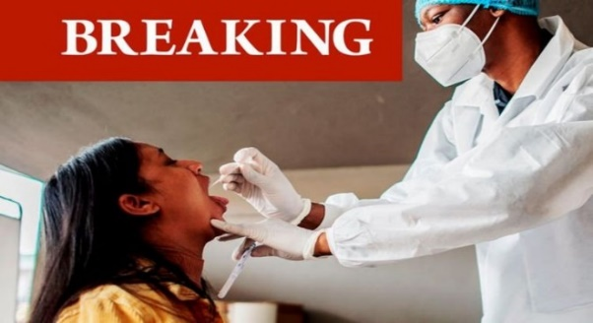**COVID-19 in Africa:**

**One year on:**

**Impact and Prospects**

This report published by the Mo Ibrahim Foundation can be found [here](https://mo.ibrahim.foundation/sites/default/files/2021-06/2021-forum-report.pdf), it outlines the impact on health systems and the economies of African countries of the Covid -19 pandemic. It notes that the direct health impacts of the first waves of the pandemic have been relatively less severe in many Central African countries, though countries in the North and South of the continent were more affected. But it also acknowledges that though most countries reacted quickly with containment and contact tracing measures, many Central African countries lack the systems necessary to record or analyse the incidence of infection and variants with confidence. . The main impacts noted have been on services addressing diseases such as malaria, TB and HIV/AIDS, which pose a greater threat to lives in Africa, and Mental Illness (particularly for young people), a major global health problem.

Researchers from the Kenyatta, Washington and Liverpool Universities [here](https://pubmed.ncbi.nlm.nih.gov/32484156/), suggest the low level of deaths in Africa from Covid-19 (as of 5th July 2021 less than 100,000, 2/3rd in South Africa) may be attributed to the younger age of populations, warmer climate, under reporting and possibly prior exposure to related diseases. A summary can be found on the Sky News service [here.](https://news.sky.com/story/covid-19-in-africa-why-is-the-death-rate-so-low-12236347)

Covid has also had a profound social and economic impacts on African countries, hindering education and gender equity, and increasing political instability. Many African countries have been pushed into recession for the first time in thirty years, increasing unemployment and poverty (so far it is reported that the number of people in extreme poverty has grown by 15 million). The report notes the need to seize the opportunity to “build back better”, by supporting pan African health organisation such as African Centre for Disease Control (see [here](https://africacdc.org/)) and strengthening Africa’s ability to produce and purchase supplies such as vaccines and work together for a sustainable future.

In addressing the pandemic Africa has been hampered by being priced out of the market for PCR testing and waiting for the COVAX scheme to deliver promised vaccines. Although 400 million Johnson and Johnson single dose vaccine have been purchased for Africa relatively few have yet been administered leaving Africa with only 1.2% of its population fully vaccinated by 1st July 2021.

The impact of failure to address the health and socio-economic needs of much of Africa, is global. Poverty means that many people live in insanitary conditions, in close contact with a wide variety of wild and domestic animals, with poor access to healthcare services. These are conditions that greatly increase the likelihood of the emergence of new variants of Covid and indeed many other diseases particularly those affecting younger age groups. Low levels of infection in earlier waves may increase vulnerability. This nightmare scenario is emerging as Covid-19 cases arising from a range of new variants including Delta are surging by 25% per week and associated deaths are rising by 15% per week (01/07/21), as reported by Dr Matshidiso Moeti, WHO Regional Director for Africa [here](https://www.afro.who.int/news/rife-covid-19-variants-fuel-africas-surging-wave).

The Build Back a Better World (B3W) [here](https://en.wikipedia.org/wiki/Build_Back_Better_World) and COVAX [here](https://www.who.int/initiatives/act-accelerator/covax) initiatives offer hope that the high-income countries will at last accept their responsibility, but this seems certain to be another case of too little too late unless strong public support is mobilised across the world.

**SfGH members are invited to share their experience of Covid-19 in Africa (send by email to** [**ghe@studentsforglobalhealth.org**](mailto:ghe@studentsforglobalhealth.org)

**Malaria Vaccine:**

**Breakthrough**

On October 6th, 2021 Director-General Dr Tedros Adhanom Ghebreyesus announced WHO’s recommendation of widespread use of the RTS,S/AS01 (RTS,S) malaria vaccine among children in sub-Saharan Africa and in other regions with moderate to high levels of malaria transmission. He said “This is a historic moment. The long-awaited malaria vaccine for children is a breakthrough for science, child health and malaria control. Using this vaccine on top of existing tools to prevent malaria could save tens of thousands of young lives each year.”

Malaria is caused by five types of Plasmodium parasite which are spread to humans through the bites of infected mosquitos. In 2019, nearly half of the world's population was at risk of malaria, there were an estimated 229 million cases, and some 409,000 malaria deaths. Most cases and deaths occur in sub-Saharan Africa where Malaria is a major cause of childhood illness and death. More than 260 000 African children under the age of five die from malaria each year.

While the vaccine, trialed in Ghana, Kenya and Malawi RTS,S, which protects children against Plasmodium Falciparum, the most deadly malaria parasite and the most prevalent in Africa, is a huge step forward it is not a complete answer. It requires the vaccine be administered to children in 4 doses from the age of 5 months and protects against only 30% of infection and 40% of severe cases and deaths. The vaccine was developed by the British pharmaceutical company GlaxoSmithKline plc (GSK) which donated 10 million doses of the vaccine (see [here](https://www.gsk.com/en-gb/responsibility/improving-health-globally/using-our-science-for-global-health/fighting-malaria-in-the-lab-and-on-the-ground/)). GSK worked in partnership with PATH (Program for Appropriate Technology in Health, see [here](https://www.path.org/)), and with the support of a network of African research centres, and funding from the Bill and Melinda Gates Foundation, Gavi, the Vaccine Alliance; the Global Fund to Fight AIDS, Tuberculosis and Malaria; and Unitaid.

The next step will depend upon international funding and the decision of countries to prioritise the administration of the vaccine alongside other malaria prevention measures which include: the use of insecticide-treated mosquito nets and indoor spraying with insecticides every six months (called Indoor Residual Spraying) and use of anti-malarial drugs during the high transmission season.

Delivering vaccines to children across Sab Saharan Africa will be another huge challenge for Africa’s health systems, as acknowledged by Dr. Matshidiso Moeti, WHO regional director for Africa. Moreover, there is always the danger that malarial parasites will develop resistance to the drug. Previous breakthroughs have included the use of DDT, which proved to have disastrous effects on the environment and human health, the discovery and use of Artemisinin which is now discouraged as it appears malarial parasites are developing resistance. There are also programmes to reduce or eliminate mosquito larva, to release sterile male mosquitos and to genetically modify mosquitos.

The new drug could have a very positive impact but must be considered alongside other prevention and control measures and continued research. It is not a silver bullet.

Targets for action to reduce malaria globally, agreed at the 2015 World Health Assembly include reducing deaths by at least 90% and eliminating it in at least 35 further countries by 2030, see [here](https://apps.who.int/gb/ebwha/pdf_files/WHA68/A68_R2-en.pdf?ua=1).

**SfGH groups may wish to consider supporting the UK Charity Malaria No More** [**here.**](https://malarianomore.org.uk/)

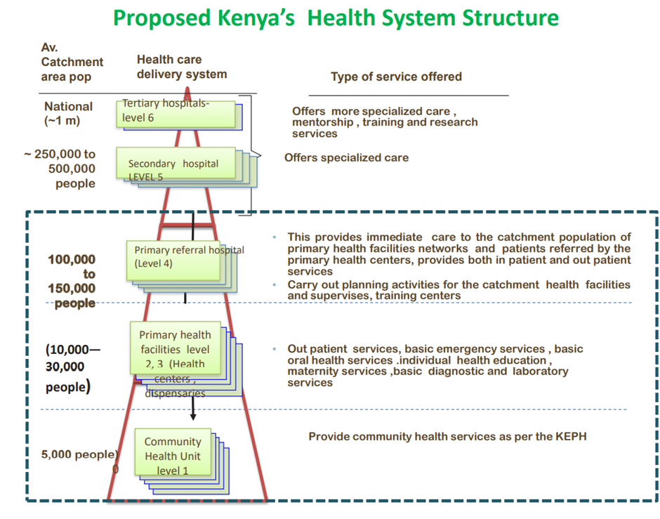**Health Systems in Rural and Urban SS Africa**

The health systems of most of the countries of Sub Saharan Africa developed during the colonial period, based on Provincial/District Health Services focussed on (town) hospitals, led by doctors supported by nurses. Rural health services, where 60-70% of people lived were served by Missionary Hospitals (which still provide 20-30% of services in some areas) and local dispensaries. Post-colonial health systems continued to reflect this focus on hospital-based care, which dominate their health care budgets. While some countries like Cameroon and Algeria have social insurance systems, most state systems are tax funded, with total annual costs per capita ranging from less than $50 to over $500. The costs to users, for medicines, private services and “informal payments” to doctors and nurses, can be 30-50% of this. See the Lancet Commission report on the future of healthcare in sub Saharan Africa [here](https://www.thelancet.com/commissions/future-health-Africa).

The rural population of Sub Saharan Africa is currently estimated at 650 m and there are 450 m people in urban areas, including 200 m people in poor housing and unsanitary conditions (slums).

A new model for African health systems has now emerged, focussed on primary and community health, in both rural and urban settings, reflecting the 1978 Alma-Ata commitment to primary care for all, and the 2015 SDG goal of Universal Health Coverage. The first practical model of this approach was Tedros Ghebreyesus’ plan [here](https://www.building-leadership-for-health.org.uk/cambridge-international-health-leader-s/case-studies-and-insights-from-delegates/), for the Tigray Region of Ethiopia. This introduced a cadre of community health workers and local health centres led by nurses and community health workers. This model has been followed by other African countries, see the 2019 Kenyan Primary Health Care Strategic Framework 2019-2024 [here](https://www.health.go.ke/wp-content/uploads/2020/07/Kenya-Primary-Healthcare-Strategic-Framework-Signed.pdf). Approaches to urban healthcare, particularly slum areas are more complex, see [here](https://www.who.int/bulletin/volumes/87/12/09-073445.pdf).

All African health systems are under financial stress, so staffing, skills and other resources are often far below the level proposed in plans. Even if immediate requirements can be met from aid sources there may be little prospect of continued provision unless sustainable finance is secured.

**SfGH groups may wish to share their experiences of health systems in Africa and/ or review reports of any country they plan to visit as volunteers or exchanges.**

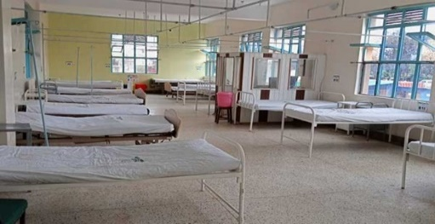**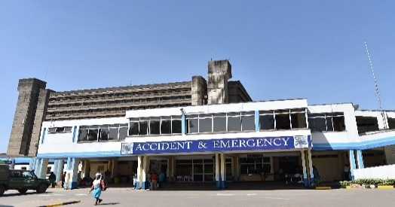Health Facilities in S S Africa**

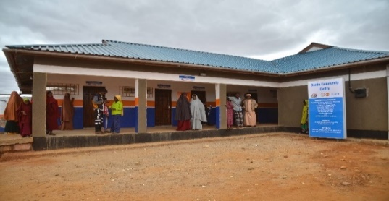**Kenyatta Teaching Hospital Machakos General Hospital**

**Mandera Community Life Centre**

An essential starting point for planning health service development in Sub Saharan Africa is to map the availability of relevant facilities and capability in the area targeted. Where services are not available additional facilities and training may be necessary. For an analysis of the state of health and health systems in Africa see the WHO Report [here](https://www.afro.who.int/sites/default/files/sessions/documents/State%20of%20health%20in%20the%20African%20Region.pdf).

My experience of reviews of the Kenyatta and other hospitals and rural health centres in the 1990s and 2000s was that in most cases they lacked many of the resources one might expect. As examples at the time of my review the Kenyatta had only 1 of its 6 autoclaves working, while there were sufficient doctors in post, many seemed to leave a jacket on their chair and leave the hospital to work in private practices, the laundry was very intermittent, many patients had to use their own sheets, nurses expected payment for basic patient care and protective gloves had to be reused. Rural health centres lacked basic hygiene facilities and skilled staff. I hope things have improved!

For many treatments requiring diagnostic tests it is not only important to have access to hospital laboratories but also to ensure good communication between the hospital and rural health centre. This is often a problem, both for people in rural communities and for those living in urban slums. In all these respects it is important to consider both physical resources and management capability. For an example of evaluation of specific resources see GAFFI Africa toolkit from Fungal Infections.

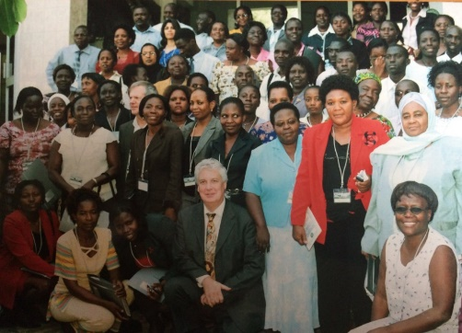At the time of my review of the Kenyatta I was greatly impressed by the impact made by a charismatic black American Nurse who succeeded in transforming the attitudes and behaviour of the nurses at the hospital. She led by encouragement and example, I can only hope her legacy remains. In rural health centres across East Africa I was impressed by the strength of character shown by the nurses who led rural services despite the frankly sexist attitudes that seemed institutionalized in health systems see my resources for nurse leadership in East Africa [here](https://www.building-leadership-for-health.org.uk/nurse-leadership-curriculum/).

**SfGH may wish to share their own experiences of health facilities in Africa.**

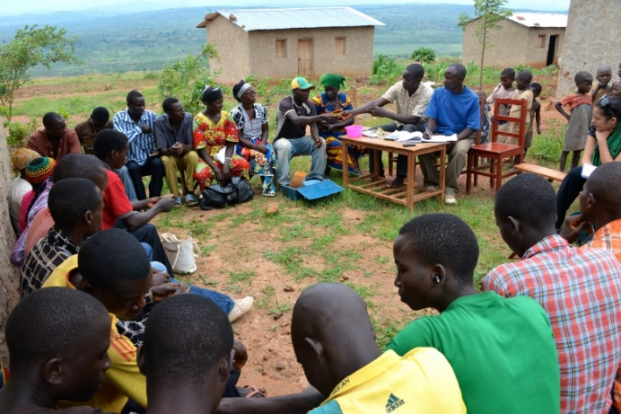**Co-Producing Community Action for Health in Rural SS Africa**

Co-production is fundamental to Community Health. Any health project must be based on the trust, understanding and commitment of communities. A course on Leading Healthy Communities, for WHO Euro, can be found [here](https://www.building-leadership-for-health.org.uk/building-leadership-for-health-course/leading-community-engagement-for-health/) and a practical example of co-production for health is [here](https://www.building-leadership-for-health.org.uk/co-producing-community-integration/). The article by Nick Goodwin [here](https://www.ijic.org/articles/10.5334/ijic.2492/) is also helpful. WHO guidance on Community engagement for quality, integrated, people-centred and resilient health services can be found [here](https://www.who.int/servicedeliverysafety/areas/qhc/community-engagement/en/) and [here](https://apps.who.int/gb/ebwha/pdf_files/WHA69/A69_39-en.pdf?ua=1&ua=1). A health project in Namibia, which follows these guidelines included Village Health Committees, as co producers see [here](https://www.afro.who.int/news/bringing-healthcare-rural-communities).

These examples demonstrate the importance of building trust through a process, described by Sherry Arnstein as a step-by-step approach to: improving information exchange, introducing better consultation processes, involving NGOs in decision making, developing joint action projects and supporting independent NGO action. This leads to the development of relationships between partners in the development process, from what social psychologist Eric Berne describes as a dysfunctional - “Parent/Child” relationship, to a mutually respectful “Adult/Adult” relationship.

An important aspect of such a relationship is to acknowledge faults in current arrangements and to recognize that any proposed improvements must be economically and financially sustainable. It is also essential to ensure transparency, so local groups can monitor services against promised targets. Consultations should set basic targets against which community groups can judge project performance. Transparency International can help communities to monitor the local impact of aid projects, see [here](https://www.transparency.org/en/).

One experience used by trainers to illustrate this is to ask trainees to grasp their neighbour’s hand and place it where they choose on the desk in front of them. Then ask the trainees how this feels - it is easy to do but for the person whose hand is grasped, it feels intrusive and aggressive. Now ask them to support their neighbour’s hand from below, while the neighbour decides where to put their hand, using this support. Again ask how it feels – actually it is rather difficult to support your neighbour’s hand as you need to respond to their clues, while having your hand guided should feel empowering.

See the review [here](https://www.ijic.org/articles/10.5334/ijic.3971/) showing how training can help Community Health workers achieve health goals.

**SfGH Groups may wish to discuss how they can develop personal skills in empathy and community empowerment that will help them to help others.**

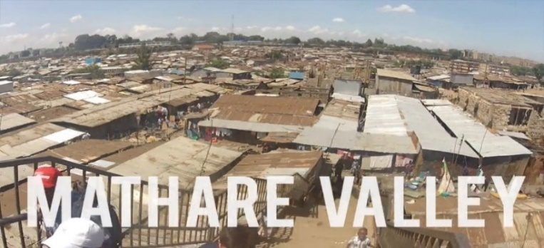**Co-Producing Community Action for Health in SS Africa’s Slums**

Globally, nearly 1 billion people live in slums, defined as urban areas with a lack of basic services (sanitation, potable water, electricity), substandard housing, overcrowding, unhealthy and hazardous locations, insecure tenure and social exclusion. In Sub Saharan Africa, some 200 million people live in slums such as Mathare Valley (the oldest) and Kibera, the world’s largest slum in Nairobi.

Slums ([here](https://www.tuko.co.ke/342125-10-biggest-slums-africa-2020.html)) have high rates of mortality and morbidity particularly high for children: HIV/AIDs, TB , NTDs and infectious diseases as well as high rates of NCDs due to fast food and alcohol. Shared pit latrines and “flying toilets” (Google this) are common forms of sanitation, water is fetched from communal standpipes, most houses are overcrowded corrugated iron huts with earth floors here.

Many slum residents could access health facilities located in Tertiary or Secondary Hospitals near their area, but they often lack awareness of the early signs of diseases such as fungal infection. And many residents may not be able to afford medicines because they do not earn enough from informal sector employment. Doctors and other health staff are often reluctant to provide services in these areas due to lack of security. It is also apparent that in some slum areas criminal gangs control many aspects of life. This can make tenure and employment uncertain, for people who have left their village due to poverty.

For a glimpse of life in a Nairobi slum see [here](https://world-habitat.org/news/our-blog/life-in-africas-biggest-slum/) ,this article describes a project by the Umande Trust’s to improve sanitation in an ecological way, but more importantly it brings the community together in Kibera the world’s largest slum. Another hopeful initiative has been the proposed development of slum areas of Kigali by a public private partnership led by the Rwanda Initiative for Sustainable Development (RISD), a non-governmental, not-for-profit organization. Their approach, which has been successful in other areas of Rwanda, focuses on building social capital (links within and between communities and leadership) as a basis for joint action for sustainable, healthy redevelopment see [here](http://risdrwanda.org/).

A meta study of projects to improve health and wellbeing in Africa’s slums by Lilford and Oyebode et al [here](https://core.ac.uk/download/pdf/154747917.pdf) shows an integrated approach to physical infrastructure and social development is needed to address the many interlinked issues that determine the health and wellbeing of people living in slums. An essential starting point is secure tenure of property, as without this, and security, coproduction is seldom possible. This requires listening and building trust with the community as well as investment by services including health and community workers, police, planners, water and sewerage departments.

**SfGH groups are asked to share their ideas on how to improve health and wellbeing for slum dwellers**

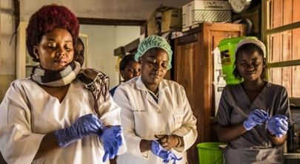**Attainability Resilience and**

**Sustainability**

If a healthcare project is to be sustainable in a low-income country, it must be an element of an integrated service addressing all aspects of whole person health, as set out in the World Health Assembly 2016, “Framework on integrated people-centred health services” see [here](https://www.who.int/servicedeliverysafety/areas/people-centred-care/framework/en/). This sets out goals for all healthcare services of: Equity of access, Quality and safety, Responsiveness and community participation, Efficiency and cost-effectiveness and Resilience and Sustainability.

Many diseases faced by low -income countries have consequences for issues including: complications such as fungal disease, end of life care, mental illness, poverty, stigmatisation and orphaned children. Such care needs must often be met by extended family and kinship support. Community Health Workers can help mobilise these resources and provide a link to clinical interventions where necessary, if they are included in a management framework encompassing all aspects of integrated care.

As all low-income country healthcare systems are underfunded, it is also important to consider the financial impact of expenditure on any one element of health, that may divert resources from other fields. Thus it is essential to evaluate the impact on total health, in terms of its cost effectiveness, usually as a cost per DALY (Disability Adjusted Life Year). For a course on economic evaluation see [here](https://www.building-leadership-for-health.org.uk/socio-economic-evaluation/). The WHO One Health Tool may be used to examine alternative health provision options see [here](https://www.who.int/choice/onehealthtool/en/).

Any development of health and care services must match the resources available in the locations served, this includes: the leadership and management of local services the skills of staff, physical resources such as laboratory equipment, electricity supply and internet connection. Moreover, as support by local community groups and organisations will be essential for many services, it is also important to consider community social capital. It is not only the immediate attainment of these resources that is important, it is the resilience and sustainability of such resources.

Thus as examples: the provision of skilled laboratory technicians may be achieved by training current staff, but when they move on or when technology changes it is essential to ensure the training programmes are in place for new staff. So too, if equipment is provided and its quality is assured, there must be a system for continued monitoring, repair and renewal to ensure its resilience. .

Health projects require continued funding from sustainable sources. For example, typically about a third of expenditure on healthcare in African countries is from government taxation, a third from international aid and a third from payments by users, (in 2013 for 20 African countries user payments made up over 40% of healthcare funding see [here](https://www.afro.who.int/sites/default/files/2017-06/state-of-health-financing-afro.pdf)). If a project requires user charges it will be essential to gain community understanding and support for this.

Planning for local service improvements should consider both the planned project and its benefits and unplanned consequences that might arise and what can be done to mitigate them. For example, what could be done if the local clinic were unable to cope with the additional demand created by the project.

**SfGH groups may wish to share their experience of healthcare initiatives in low-income countries**.

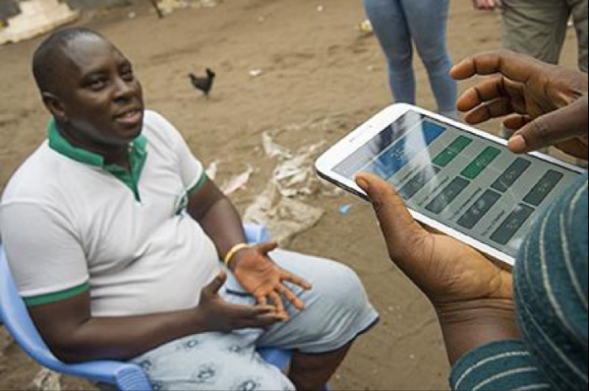

**The Potential of E Health for Africa**

Africa bears one-quarter of the global disease burden, yet has only 2% of the world’s doctors. In Europe there is 1 doctor per 350 - 650 people, in Africa there is 1 doctor per 10,000 – 15,000 people. But as most doctors work in urban areas, where they can earn from private practice, rural areas may have 1 doctor serving 50-60,000 people or more. Local services are managed by Nurses and Technical staff with limited training in diagnostic or specialist treatment options. E Health could transform this.

The potential contribution of E Health has long been recognized in Africa. The Pan African E Network Project (PAENP) was an information and communications technology project between India and the African Union to connect the 55 member states of the Union through a satellite and fibre-optic network to India and to each other. The project, was intended to enable access to and sharing of expertise in the fields of: tele-education, telemedicine, Voice over IP, infotainment, resource mapping, meteorological services, e-governance and e-commerce services. Investment in this $1billion project started in 2006. For healthcare, PAENP connects 5 regional Super Specialty Hospitals and 53 remote hospitals in all countries of Africa to Universities and hospitals in India, see the YouTube video [here](https://www.bing.com/videos/search?q=pan+african+e+network+project&docid=608031764695616031&mid=776D5B28EE986E6D3093776D5B28EE986E6D3093&view=detail&FORM=VIRE). Another example of a regional initiative for E-Health is the Education for Health Africa project, see [here](https://www.educationforhealth.africa/?v=edb5dc74af1c).

At national level African countries have embraced the potential of E-Health, see “Every African Country’s National eHealth Strategy or Digital Health Policy” [here](https://www.ictworks.org/african-national-ehealth-strategy-policy/). Kenya has had a strategic plan for E-Health since 2011 see [here](http://publications.universalhealth2030.org/uploads/kenyanation_ehealth_strategy.pdf), there are now calls for a regional E-Health Strategy for East Africa see [here](https://www.afrikatech.com/health/). Proposals include national and regional centres that can develop and contextualise online resources including basic medical and public health knowledge, reference knowledge for specific diseases, diagnostic tools and algorithms, and logistics support see “African Strategies for Health” [here](https://www.msh.org/sites/default/files/digital_health_in_depth_review_final.pdf).

Internet resources are also used to support continuing clinical education and diagnostic and treatment protocols for health workers. For example, the “Jibu” (Swahili for “answer”) project supported by Amref Health Africa, provides training resources for Nurses in Kenya through mobile phones and tablets, this is called m-Learning for m-Health see [here](https://www.elsevier.com/connect/m-learning-gives-kenyan-nurses-scalable-continuing-education). Other examples of m-Health technology include an app provided by the Kenyan Ministry of Health called “Integrated Management of Childhood Illness” and the “First Aid”, app offered by the Kenyan Red Cross. In Rwanda a UK provider called Babylon Health is developing a wide range of E-Health and m-Health services see [here](https://babyl.rw/). There are also commercial phone apps used by the public to access and pay for medical advice and medicines including: mDaktari, Hello Doctor/ Sema Doc, M-Tiba and MyDawa.

**SfGH may wish to look at the National eHealth Strategy Toolkit** [**here**](https://apps.who.int/iris/bitstream/handle/10665/75211/9789241548465_eng.pdf?sequence=1) **produced by the World Health Organization (WHO) and the International Telecommunication Union to assist Health Ministries in developing strategies to meet their countries’ needs and capabilities. SfGH groups may wish to consider lessons for both African countries and the UK.**

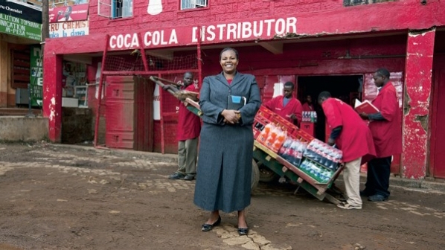**Working with Public/Private Partners**

Public/Private Partnerships (PPPs) are an important element of healthcare provision in low-income countries. While they can improve services, they need to be carefully managed see [here.](https://gh.bmj.com/content/bmjgh/4/2/e001217.full.pdf)  so countries such as Kenya have specific policies frameworks and units to manage them see [here](https://www.pppunit.go.ke/wp-content/uploads/2019/11/Overview-of-the-PPP-Process-in-Kenya-.pdf).

Public Private Partnership with drug companies has been a feature of the response to Neglected Tropical Diseases (NTDs), as discussed [here](https://www.sciencedirect.com/science/article/pii/S0001706X11000593). Thirteen of the largest pharmaceutical companies have cooperated in the largest drug donation in history. To date they have contributed more than $17.8 billion as drugs and contributions towards the cost of distribution and prescription. They are often drugs developed for other purposes, which have proved useful for NTDs as very little drug development is specifically targeted at NTDS. The Global Forum for Health Research, note “90% of health research expenditure is targeted at problems that affect only 10% of the world’s population” see [here](https://www.who.int/intellectualproperty/submissions/InternationalPolicyNetwork.pdf).

Partnerships also include global alliances which address specific diseases. Examples include: the Global Fund and Goodbye Malaria see [here](https://www.theglobalfund.org/media/8714/publication_privatesectorgoodbyemalaria_focuson_en.pdf?u=637146787910000000), the Sightsavers Global Trachoma Mapping project [here](https://www.sightsavers.org/wp-content/uploads/2017/09/Sightsavers-policy-brief-neglected-tropical-diseases.pdf#:~:text=Public%E2%80%93private%20partnerships%20for%20NTDs%20have%20driven%20scale,%20speed,base%20for%20the%20targeted%20interventions%20required%20for%20the), the Stop TB Partnership [here](http://stoptb.org/) and UNAIDS. While they are very important sources of health aid they can also bring a narrow focus on a specific disease or drug treatment at the expense of integrated national and local services, dealing with the full range of health and care needs of individuals and communities.

There are now calls for partnerships to support E-Health and m-Health Knowledge Centres for Africa and other low-income countries see [here](https://www.ehealthafrica.org/infrastructure/). This would ensure that while sharing in global networks, health science and knowledge is developed that is relevant to local needs and reflects the language and resources available, addressing issues such as Neglected Tropical Diseases and Fungal Diseases. This also reflects a growing impatience with the provision of technical support from High-Income countries, which, though welcome, needs to recognize and support the development of in-country expertise.

PPPs have also assisted in meeting the logistic problem of drug delivery to rural locations. Coca-Cola and the Global Fund to Fight AIDS, Tuberculosis and Malaria have expanded a project which uses the beverages giant's “expansive global distribution system and core business expertise" to help deliver critical medicines to remote parts of the world, beginning in rural Africa see [here.](http://www.pharmatimes.com/news/coca-cola_network_success_in_delivering_drugs_for_africa_976572)

Knowledge provided on-line, by mobile phones and other devices is also a crucial resource for health in Low-Income countries, USAID and Orange telecommunications, have recently announced a new collaboration to find innovative ways to use mobile phone “m-Health” to accelerate access to health information and services in Africa see [here](https://www.orange-business.com/en/press/orange-and-usaid-join-forces-to-boost-mhealth-innovations-across-africa).

**There are difficult issues to be addressed when working with Public/Private Partnerships but there are also significant advantages, as discussed in a report by my former firm PwC** [**here**](https://www.pwc.com/gx/en/industries/healthcare/publications/trends-for-the-future.html)**.SfGH groups may wish to discuss the pros and cons of Public/Private Partnerships for health.**