7
Graham Lister

7
Training Toolkit 6: Global Health Diplomacy and Advocacy

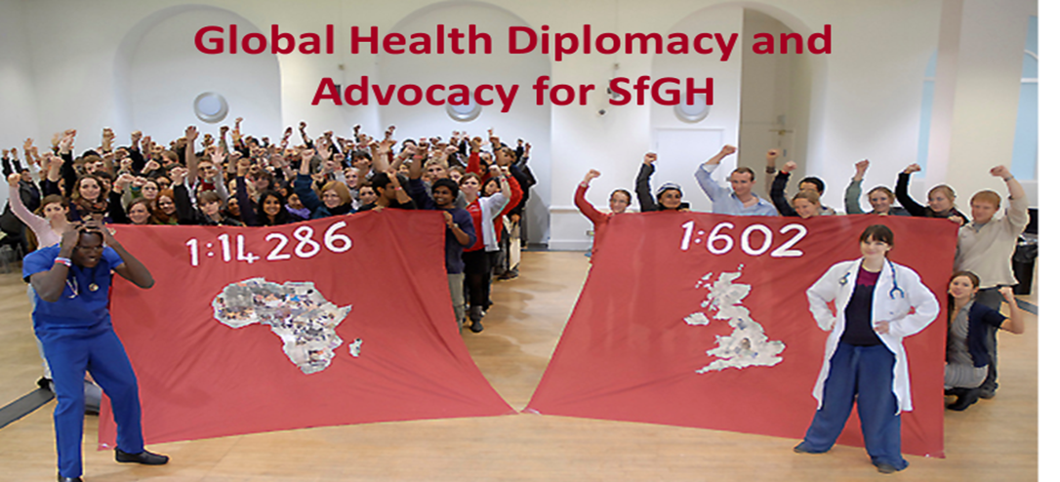
Students for Global Health brings together UK students who share a vision of a fair and just world in which equity in health is a reality for all. In the UK we are committed to take action to spread an understanding of global health threats and inequity as global, national and local issues that must be addressed if we are to survive on this planet. At international level we work with partner student groups from 133 countries brought together in the International Federation of Medical Student Associations to give voice to future generations at meetings such as the World Health Assembly.
Global Health Diplomacy and Advocacy is a complex, multifacetted field, in which we are still discovering new questions and sometimes new answers. Teaching and learning about this topic with WHO Heads of Country Offices, over a series of 10 week courses and IFMSA participants at Youth Pre- World Health Assembly Workshops*, has revealed new insights into the combination of “the science of public health” and the “art and practice” of diplomacy.
This course shares some of the ideas that have been most helpful. They are elements of a blended learning programme for SfGH, to help you develop your own advocacy strategies and make your case at National and International levels . This is a learner led programme which depends on your choice of issues to explore through the internet and to share through social media. I realise that you don’t have much time so you can simply look quickly through the slides, read the detailed points relevant to you or follow up the links suggested. This toolkit is more suitable for personal study but you can download and adapt parts as a basis for trainer led group sessions.
As a starting point for this topic I suggest you should discuss in your group some basic questions:
- What is meant by health and wellbeing and how does this relate to human development?
- What do you mean by ”Global Health”, does this differ from International Health?
- Does global health affect you and can you affect global health?
- What are the most common causes of poor health in low and middle income countries?
- What are the underlying causes of poor health and wellbeing in rich countries?
- How is the world run; how do we address issues that affect all our futures?
You can review this material, at your own pace following up issues you find interesting using the notes and links provided. You should consider how global health diplomacy – and advocacy applies to your chosen topic for advocacy and how you will develop and apply the skills identified.
*These courses, which I tutored, were developed and delivered with colleagues at the Global Health Programme of the Graduate Institute, Geneva, led by Ilona Kickbusch, supported by Michaela Told and Pascale Wyss, we are grateful to course participants from whom we learnt a great deal.

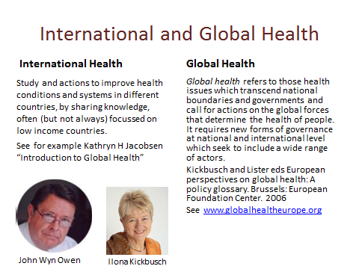
In 1997 the US Institute of Medicine published a report called “America’s Vital Interest in Global Health: Protecting Our People, Enhancing Our Economy, and Advancing Our International Interests”.
Hillary Clinton hosted an event to introduce the paper to an international audience, including John Wyn Owen, the Secretary of the Nuffield Trust. He brought the idea to England and, knowing my background in international health system reform, he asked me to coordinate a programme with Kelly Lee of the London School of Hygiene and Tropical Medicine. This produced 17 papers and a national symposium entitled “Global Health: a local Issue”. A year later we were contacted by Emily Spry of Medsin – UK who later took a leading role in IFMSA, we helped her develop a European student conference using some of the materials from our programme. Recognising the link between global health and foreign policy, we also hosted the first international symposium on this topic, chaired by Gro Brundtland (then Director of WHO) and John persuaded Liam Donaldson (then UK Chief Medical Officer) to initiate the programme that led to “Health is Global” the UK strategy for global health. I later became a Trustee of Medsin.
Ilona Kickbusch had moved from WHO Director Health Promotion, Education and Communication to Yale to become the first Professor of Global Health. In 2004 she moved back to Geneva, there I helped her edit a paper called “European Perspectives on Global Health: a policy glossary”. This and much more is set out in the web site of “Global Health Europe” at http://globalhealtheurope.org/ that we helped to develop - you will find in the resources section an updated glossary explaining the values, institutions and policies that underlie global health governance. This website is now supported by the University of Maastrict. Ilona became Professor of Global Health at the Graduate Institute of International and Development Studies, Geneva where until 2019 she led the Global Health Centre recognised by the WHO.
This does not mean “global health” has replaced international health (most of my work focussed on health system reform and leadership, see http://www.building-leadership-for-health.org.uk/ ). But these are different from issues of global health policy and governance addressed by the Global Health Centre. We work with WHO, NGOs and Government officials to improve skills in global health diplomacy and governance, see http://graduateinstitute.ch/globalhealth
SfGH groups may wish to advocate for both Global and International Health issues.

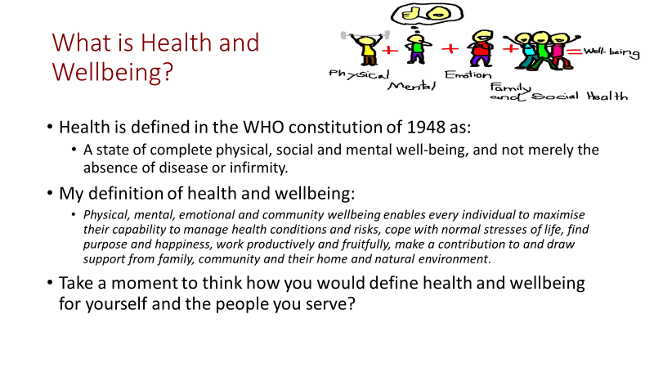
Physical and mental health improvement can be described and measured in terms of the years of life gained and the quality of life in those years as perceived by patients (through surveys) this is the basis for the Quality Adjusted Life Year (QALY) measure, commonly used to describe health gains. The WHO uses a similar (but inverse) measure of the Burden of Disease (loss of health). Disability Adjusted Life Years (DALYs) measure the Years of Life Lost (YLL) due to early deaths, plus Years Lived with Disability (YLD) weighted by an international panel, compared to the best attainable.
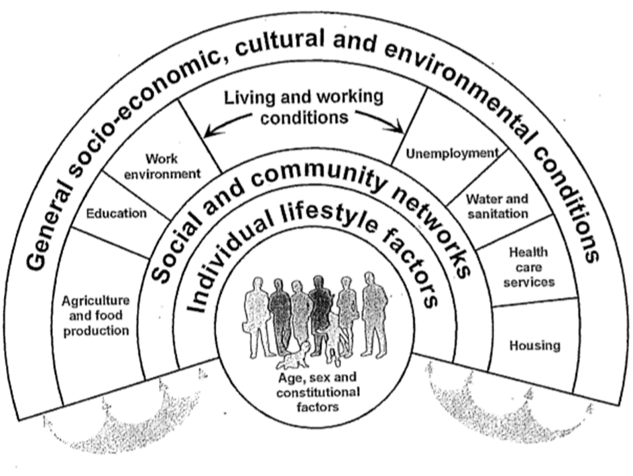
Wellbeing includes health and other factors that add to happiness, satisfaction, fulfilment and freedom. There is no universally agreed measure, it is a subjective response to the quality of life.
Things that improve health and wellbeing may include: a political system that is seen as fair and just, physical security, education, family and social support, community engagement, housing, environment, employment and financial security, music, art, culture and health and social care services.
These are judgements about the freedom to improve the quality of life, reflecting an approach to health and human development, based on Capability Theory set out by Martha Nussbaum and Amartya Sen in their 1993 book “The Quality of Life”. For an introduction to “A Capability Approach to Human Development”, see the presentation by Sabina Alkire of the Oxford Poverty and Human Development Initiative at http://www.ophi.org.uk/wp-content/uploads/OPHI-HDCA-SS11-Intro-to-the-Capability-Approach-SA.pdf .
Conditions that support health and wellbeing were identified by Dahlgren and Whitehead (1991) in “Policies and strategies to promote social equity in health” from which the diagram shown here is derived. A version of this paper provided by the Institute of Future Studies is available at https://core.ac.uk/download/pdf/6472456.pdf This recognizes that health and wellbeing are complex social constructs with multiple causes and consequences.
If you have not seen the Dahlgren and Whitehead paper, look through it and pick factors most relevant to health and wellbeing for the countries with which you are familiar, e.g. food security, access to water, gender equity. You should consider factors influenced by global as well as national governance.

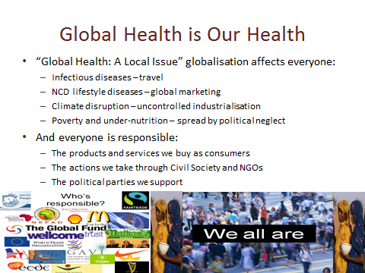
The Nuffield Trust Programme in 1999/2000 “Global Health: a local issue” and the subsequent UK Partnership for Global Health, stressed that globalisation affects everyone’s health security. This is apparent in threats from the rapid spread of zoonotic diseases such as Ebola, SARS and Influenza, the spread of NCDs resulting from global marketing of unhealthy lifestyles and products and the longer-term threat to health and sustainability from climate disruption.
This demands that we all take responsibility as both national and global citizens. Clare Short (the UK Secretary of State for International Development) pointed out that just as the industrial revolution, took work out of the home into factories, demanding a response from national society - leading to the creation of the welfare state; globalisation takes responsibility for multinational companies beyond national control and requires a new form of global governance, that has yet to emerge.
The UK strategy “Health is Global” made the link between UK interests and global health (see https://webarchive.nationalarchives.gov.uk/20130105191920/http://www.dh.gov.uk/en/Publicationsandstatistics/Publications/PublicationsPolicyAndGuidance/DH_088702 ) If you google this issue you will find global health strategies for the EU and many different countries including: USA, Switzerland, Germany, China, Japan, Thailand and Indonesia. Such strategies recognize, it is in their national interest to participate in the effective global governance of health “global public goods”, (from which all benefit, use by one party does not diminish its value to others and none can be excluded) e.g. out of patent antibiotics are global public goods threatened by uncontrolled misuse, leading to antimicrobial resistance. See “Global Public Goods” by Inge Kaul http://www.ingekaul.net/wp-content/uploads/2014/01/Internetfassung_DiscPaper_2_2013_Kaul.pdf .
Thus diplomats, health specialists and advocates must protect our interests as global as well as national citizens. National Governments are key players in global health, but they are not the only parties with power and responsibilities. Global, national and local decisions determine global health, you need to consider how SfGH can affect these decisions.

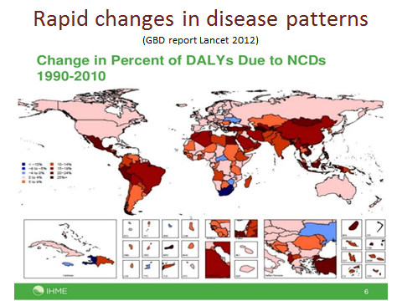
This PowerPoint is taken from a presentation given by Sir Andy Haines of the London School of Hygiene and Tropical Medicine. While it was true in the 1980s, that Non-Communicable Lifestyle diseases were more prevalent in high income countries and that infectious diseases were more prevalent in middle and low-income countries, patterns of disease are changing rapidly. The WHO Noncommunicable Diseases country profiles 2011 report notes: “Low and lower-middle-income countries have the highest proportion of deaths under 60 years from NCDs. Premature deaths under 60 years for high-income countries were 13% and 25% for upper-middle-income countries. In lower-middle-income countries the proportion of premature NCD deaths under 60 years rose to 28%, more than double the proportion in high-income countries. In low-income countries the proportion of premature NCD deaths under 60 years was 41%, three times the proportion in high-income countries”. See http://devpolicy.org/non-communicable-diseases-and-aid-an-update-20150205/ , http://www.who.int/gho/ncd/en/ and https://ncdalliance.org/ and UN https://www.youtube.com/watch?v=zquWpRnnsPA
In many middle and low-income countries high rates of NCDs associated with smoking, alcohol and other drug consumption and obesity are found alongside high rates of under-nutrition and infectious diseases. Highest rates of obesity related illness are found amongst urban populations.
Slum areas have the highest rates of all forms of disease. While a total 227 million people in the world have moved out of slums since 2000 the absolute number of slum dwellers has increased from 777 million in 2000 to 863 million in 2012 and is now estimated by some sources at over 1 billion people. My first experience of work in Africa was focused on site and service schemes and slum improvements I am sad to see this work is still needed. See http://www.ncbi.nlm.nih.gov/pmc/articles/PMC2039756/
In advocating for global health issues, it is essential to consider the social and political causes of poor health as well as the possible funding and technical solutions.

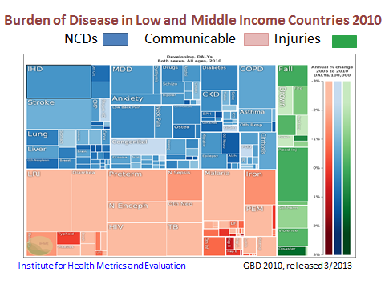
This data from the Institute of Health Metrics and Evaluation shows the burden of disease measured in Disability Adjusted Life Years (DALYs) for low and middle-income countries.
To investigate the impact on health by condition cause and country consult the IHME web site at http://www.healthdata.org/ . You will also benefit from the insightful You Tube video of the late Hans Rosling at https://www.youtube.com/watch?v=8gY5BSFPlME also try the book published by his son and daughter in law “Factfulness: Ten Reasons We're Wrong About the World – and Why Things Are Better Than You Think” it will cheer you up.
The latest Global Burden of Disease analysis from IHME, based on 2016 data, shows outcomes for low income countries. You will find that while deaths from Communicable diseases are higher in low income settings than those from NCDs, the extent of Years Lived with Disability arising from NCDs (and therefore the workload of the health system) is higher. This demonstrates the double burden of disease arising from both NCDs and Communicable disease. It also points to the fact that both access to health systems and action to enable people to live healthy lives is required in both low and middle-income countries. It is essential to address the global diplomatic, economic and trade systems that fail to protect citizens from conflict and violence and trap people in poverty, while supporting the promotion of grossly unhealthy products and lifestyles. This requires national, regional and global political action, see “The Lancet—University of Oslo Commission on Global Governance for Health” at http://www.thelancet.com/commissions/global-governance-for-health .
Advocacy for health must combine clear factual evidence with political arguments for action based on human rights and justice.

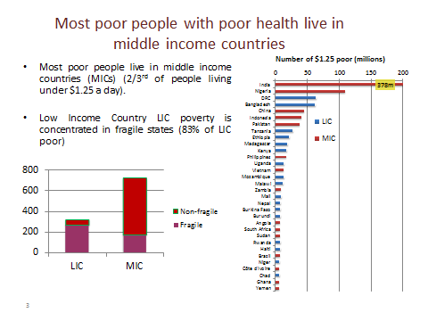
This is taken from a presentation by Dr Neil Squires, Head of Profession Health at the Department for International Development UK. It shows most poor people, living on less than $1.25 a day in purchasing power parity terms (2011 benchmark for absolute poverty) live in middle-income countries. Out of some 1.1 billion people (in 2011) living on less than $1.25 about 700 million live in middle-income countries, including India (378 m), Nigeria (110 m) China (45 m but falling rapidly), Indonesia (40m) and Pakistan (35m). The benchmark was raised to $1.9 ppp (purchasing power parity) in 2017, 700m people still live with incomes below this.
Most poor people in low income countries (83%) and many in middle income countries (25%) live in fragile or failing states, which the OECD defines as “Those failing to provide basic services to poor people because they are unwilling or unable to do so”. This often reflects a lack of trust between government and people, often because of conflict or lack of legitimacy due to corruption. Protecting the health security of its people is the first duty of a state, providing health security builds trust and legitimacy, failure to provide for health is a signal of a failing state. At national level it is apparent that health is always an intensely political issue. For international aid co-operation this poses difficult questions: can aid be provided to the poorest countries, without addressing the political conditions that create fragility and poor health? See http://www.theguardian.com/global-development/poverty-matters/2012/jan/02/aid-cuts-middle-income-countries .
A commitment for rich countries to spend 0.7% of GDP on Official Development Aid was agreed at the UN in 1970 and reconfirmed in 2000, but in 2016 OECD country ODA amounts to only 0.32% of GDP, only 6 countries meet the target. The Abuja Declaration of 2001 committed member states of the African Union to increase spending on health to 15% of government budgets, but only one country has met this target. Google to check on international trends and your country’s performance in aid giving or receipt try http://www.globalissues.org/article/35/foreign-aid-development-assistance as a start.
Discuss in your group the political causes of poverty and poor health. Why do many middle-income countries fail to provide healthcare for those in greatest need?

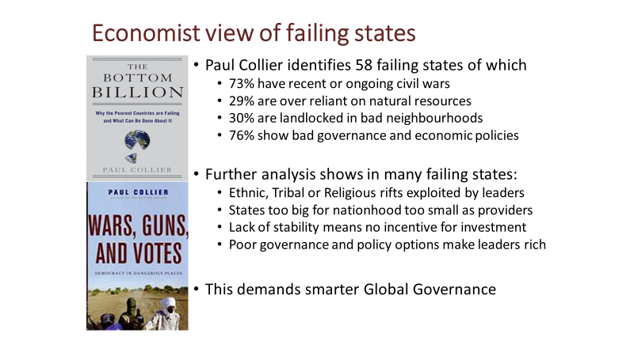
While many states with the poorest people have improved their health and economic performance over the past two decades, 58 have made little if any progress and fail to provide basic security and services to their people. Paul Collier and colleagues conducted a series of economic and social research programmes to identify the factors leading to, what he describes as “failing states”. You can find a summary and list of these states in the Wikipedia entry for the “Bottom Billion”.
Civil wars have a devastating impact on economic and social development of the country and its neighbours (estimated total cost at least $100 billion). They also make further wars and coups likely as combatants become entrenched, weapons become more available and their leaders profit from conflict. Over reliance on natural resources increases the cost of their currency, which reduces the opportunity for industrialisation. It provides a source of income for conflicting groups and corrupt politicians. And it reduces taxes which are more naturally transparent as people want to see how their money is spent. Land locked countries like Switzerland can readily trade with their rich neighbours, (while providing a tax haven) but being land locked by poor countries with poor infrastructure and no incentive to open trade barriers, limits the possibilities for economic growth through exports, other than by air freight. Governance issues, corruption is not only a cost to the country (Transparency International estimates the global cost of corruption at $1 trillion) it destroys trust between people, government and investors. Poor governance and economic policies incites conflict and reduces public or private investment.
Small countries may be too large to reduce rivalry between groups yet not large enough to offer public goods and services, such as security and health that bring people together. Political leaders could invest in long term development policies but too often seek to exploit the situation for personal gains.
Smarter global governance should: offer security guarantees to countries meeting good governance standards, focus efforts to support free trade, investment and aid on the needs of the bottom billion. Assistance to bottom billion countries that ignores the political, security and corruption issues that keep them poor, lacking basic services and security will fail to provide sustainable solutions to their needs.
Paul Collier is a professor of economics and public policy at Oxford, prior to this he was the Director of the Research Development Department of the World Bank. You can Google his talks on aspects of development economics and policy measures and read his books as noted in the reading list.
Consider how the issue you are advocating for affects the bottom billion.

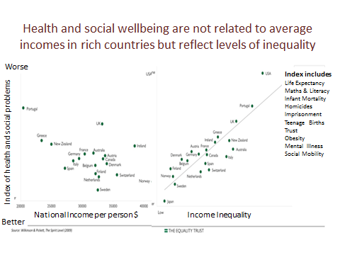
These PowerPoints are taken from a talk given by Richard Wilkinson, at a conference organized by Medsin UK in 2015, on the book he wrote with Kate Pickett in 2009, “The Spirit Level: Why Equality is Better for Everyone”. This uses measures of: Life Expectancy, Maths and Literacy, Infant Mortality, Homicide, Imprisonment, Teenage Births, Trust, Mental Illness (including drug and alcohol addiction), and Social Mobility, to show a statistical correlation between measures of health and wellbeing and levels of income inequality in 23 rich countries. A similar relationship is found in 50 States of the USA. However, comparisons between countries and states show no such relationship between average income levels and these outcomes, so it is equality rather than prosperity that leads to health and wellbeing in high income countries. To review this data and other reports visit The Equality Trust site at https://www.equalitytrust.org.uk/ . Note this work has been criticised as biased in its selection of countries and the conclusion its draws, in a study by Milos Simic of the University of Colorado in 2012.
Wilkinson and Pickett suggest that just as low and middle-income countries require global, regional and national political action to address the determinants of poverty and health, health and social wellbeing in rich countries are also a product of their political and socioeconomic systems. Simply getting richer does not resolve health and social wellbeing issues unless inequality is also addressed. This is one of the points made by Michael Marmot and Richard Wilkinson in their 2005 book “Social Determinants of Health” and in Michael Marmot’s 2015 book “The Health Gap: The Challenge of an Unequal World”. You can find Michael Marmot’s blog at http://marmot-review.blogspot.co.uk/ .
For SfGH this shows that health inequity at local and national levels is an aspect of wider international and global injustice, connecting local issues to the global determinants of health.
You may wish to compile your own list of the determinants of health that affect the advocacy issue on which you are focussed, what must be done to address them and how SfGH can contribute to this struggle both locally and globally.

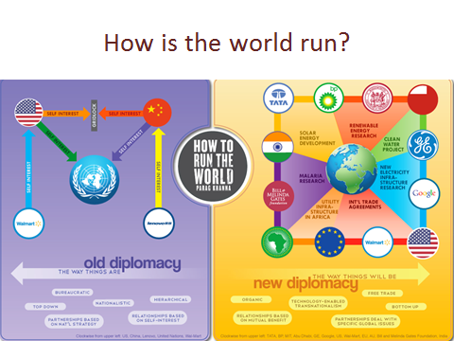
This diagram was produced by Rahul Kamath to illustrate Parag Khanna’s ideas set out in his 2011 book “How to run the world”. His view of modern diplomacy moves beyond the state centric world of the 1944 Bretton Woods system, to what he describes as mega diplomacy. This takes place in a “multi-polar” world, in which shifting coalitions of states, international NGOs, philanthropic foundations, multi-national businesses, cities, civil society groups and others influence the formation and application of partnership agreements to address national, regional and global concerns – such as global health.
In my view the current system combines elements of both the “old” and “new” global diplomacy. This view is echoed by Stewart Patrick of the US Council on Foreign Relations in his article “The Unruled World” (see http://www.foreignaffairs.com/articles/140343/stewart-patrick/the-unruled-world ). Stewart argues for “good enough” global governance, accepting the reality of a weak UN system, stymied by the diffusion of power across states and other actors with widely different interests that may coalesce to address specific issues. Both Parag Khanna and Stewart Patrick present views of “global governance” as a complex and difficult process, involving many different actors at national, regional and global levels. In this world there is no single view of justice but many different perspectives on what is equitable – as reflected in Amartya Sen’s “The Idea of Justice”. You may wish to Google some of the You Tube videos, in which Parag Khanna explains his view of the world.
If “the arrow of history” is moving us towards a global society as Yuval Noah Harari suggested in his 2011 book “Sapiens: A Brief History of Humankind” and his 2017 book “Homo Deus” it is not a simple or clear target. See his TED dialogue with Chris Anderson on nationalism versus globalism at: https://www.ted.com/talks/yuval_noah_harari_nationalism_vs_globalism_the_new_political_divide
NGOs play an important role in connecting individuals and communities to global issues creating a “whole society approach” see for example this talk on a global approach to Cancer by Trevor Hasssell https://www.youtube.com/watch?v=BAiY8-ZUuLk . This requires a renewed approach to coalition building and national and global levels encompassing state actors, the private sector and Civil Society Organisations.
You may wish to discuss in your group the role SfGH should play in running the world.

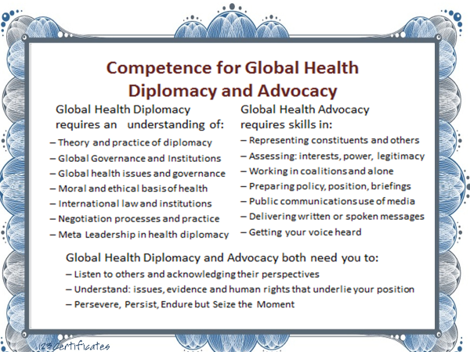

So what knowledge and skills do you need to participate in health diplomacy and to advocate for global health issues? This slide sets out some of the knowledge and skills as set out in Chapter 1 of “Global Health Diplomacy: Concepts, Issues, Actors, Instruments, Fora and Cases” edited by Ilona Kickbusch, Graham Lister, Michaela Told and Nick Drager Springer Books 2013. In the rest of this on-line material and in group discussions and exercises we will explore these issues and I hope you will find that both your knowledge of the issues increases and your ability and confidence to apply the necessary skills develop.
Inevitably this is a personal view of global health diplomacy that reflects my background and experience as a consultant from the UK, working in low and middle-income countries (as well as rich countries) on issues of health reform and leadership and with the Graduate Institute, Geneva, working on global health policy and education. You will need to develop your own understanding and perspective, perhaps adding further skills and knowledge.
You might like to consider the degree to which you currently feel you have sufficient knowledge and skills in these fields. At the end of the programme you can reassess your competence, but you should not expect to achieve mastery as a result of one short programme, I hope you will continue to learn and develop from your experience throughout your professional life. The extent and nature of the skills you will require depend upon your chosen career path e.g. if you hope to join an international agency or NGO, then an understanding of languages and history will be important not simply to facilitate communication but to understand other cultures.
If you decide that Diplomacy will be a central skill for your chosen career you may wish to take the online course published by the UK Foreign and Commonwealth Office and the Open University at https://www.futurelearn.com/courses/diplomacy-in-the-21st-century
Discuss the competence framework as described here and extend it to encompass all you hope to learn from this programme.

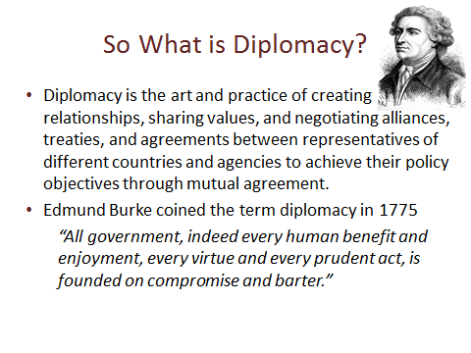
Diplomacy refers to both specific methods for reaching compromise and consensus, as well as a system of organisation for the negotiating process. It is essentially “a political activity for the adjustment of differences, through negotiation in a legitimate international order” (Kissinger H (1994) The New World Order. Chapter 1. In: Diplomacy. New York: Simon and Schuster). Diplomacy in the modern world is not confined to relationships between states, local groups, NGOs and businesses also engage in the process that can be simplified as “building networks of power and influence to achieve common goals”.
Diplomacy starts by listening, building relationships, developing shared values and mutual understanding and establishing coalitions of the willing. Moreover, it does not end once an agreement is signed, diplomatic negotiations continue throughout the implementation of agreements.
Since 1945 the environment within which diplomacy functions has changed completely, Google to see:
- Changing power balance from the cold war to the current multipolar world in which alliances of interest groups of nations and other actors coalesce on specific issues of interest to them.
- The growth in the number of States, about 60 in 1945 compared with 193 - 195 today.
- The rise of global trade, which accounted for 3% of global GDP in 1960, to 50% in 2012, by 1995 the top 200 Multi-National Corporations had a turnover of $7.1 trillion, 28.3 percent world GDP. Globalisation has brought shared health risks and knowledge but not achieved convergence.
- The rise of regional and sub-regional organisations including the EU, AU, ASEAN, UNASUR, but also many sub regional groups within regions and cross regional groups such as OIC.
- The engagement of new actors including, for health: Public Private Partnerships (~300), International Non-Government Organisations (~ 1,000), and Civil Society Groups (~ 250,000).
- The Information and Communications Revolution with 2 billion active internet users, enabling civil society groups to form and communicate across borders for good and sometimes bad ends.
- The changing nature of ideology, in some cases distorting religion as an opium of the vulnerable, supporting terrorism in a world of asymmetric power where military power is less relevant.
- Recognition of the need to address global threats and to manage global public goods.
- Rising nationalism and protectionism resulting from failure of politicians to address concerns over globalisation, migration and inequality see article by Michael Sandel at https://www.opendemocracy.net/michael-j-sandel/populism-trump-and-future-of-democracy
You might like to look at the You Tube interview with Jorge Heine, on the launch in 2013 of "The Oxford Handbook of Modern Diplomacy” , at https://www.youtube.com/watch?v=62QImLo20ak or Madeline Albright’s talk at https://www.youtube.com/watch?v=ihZOYltd9vI To read more on the history of diplomacy try “Making Diplomacy Work: Intelligent Innovation for the Modern World” by Paul Webster Hare, ”Naked Diplomacy” by Tom Fletcher, or “Diplomacy: a short introduction” by Joseph Siracusa.
Diplomacy is the process of global governance it must engage all these actors including SfGH.

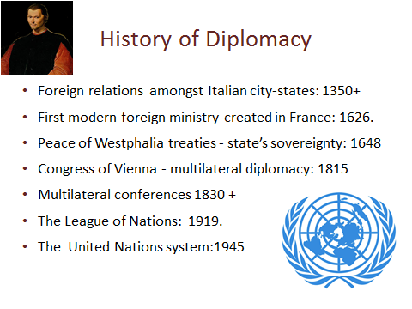
Fourteenth-sixteenth century: The first ministries of foreign relations were developed by Italian city-states. The political works, of Niccolò Machiavelli - “The Prince” and “Discourses” provide insights into exercise of state power, introducing a “realist” perspective now associated with Henry Kissinger.
Seventeenth century: The Peace of Westphalia treaties introduced a new political order in central Europe based on the concept of each state’s exclusive sovereignty. Thomas Hobbes, “Leviathan” sets out a philosophical case for a powerful state, to control the excesses of competition. Later John Locke argued for a contract between government and citizens with a constitution that both empowered and restrained it in” Two Treatises of Government”, introducing what is now called a “liberal” perspective.
Eighteenth century: European Great Powers constantly shifted alliances to maintain a balance of economic and military power. Adam Smith’s “The Wealth of Nations” foreshadowed the “economic structuralist” perspective, later used to support a diametrically different conclusion by Karl Marx.
Nineteenth century: After the Congress of Vienna, the Concert of Europe introduced a new multilateral system of diplomacy. Multilateral conferences allowed for simultaneous negotiation among states. Jeremy Bentham’s utilitarianism, a forerunner of “welfare economics”, has resonance with this.
Twentieth century: The diplomatic system was rapidly weakened due to political and economic rivalries leading to the First World War. The League of Nations, in 1919, was the first universal state membership organisation. The idea was to move to a ‘parliament of man’ with negotiations run by an international secretariat. Bertrand Russell’s logical positivism was a hopeful undercurrent.
The United Nations system was established following the Bretton Woods Conference of 1944, many international agencies, including the World Health Organization, were established. The Declaration for Human Rights (1948) established for the first time that other governments could be concerned with how a state treats its people, this may be said to be informed by Immanuel Kant’s Categorical Imperative and its implications (1785). The practice of UN diplomacy reflects John Rawls “A Theory of Justice” balancing freedom and justice, or fairness and focussed on human rights to basic goods and the institutions that support them with limited grounds for challenging sovereignty.
Current diplomatic theory (http://www.diplomacy.edu/courses/theory ) recognises the importance of freedom to develop human capability, as Amartya Sen notes, “The Idea of Justice” may have different meanings. See http://www.ediplomat.com/nd/history.htm or you might like to Google Three Minute Philosophy YouTube clips, or try the Stanford Encyclopaedia of Philosophy http://plato.stanford.edu/
These developments in European state diplomacy each emerged after a major war, you might like to examine similar developments in China (where 8 of the 11 bloodiest wars occurred) and elsewhere.
Listening to another viewpoint, think of the philosophical and religious underpinning of their ideas.

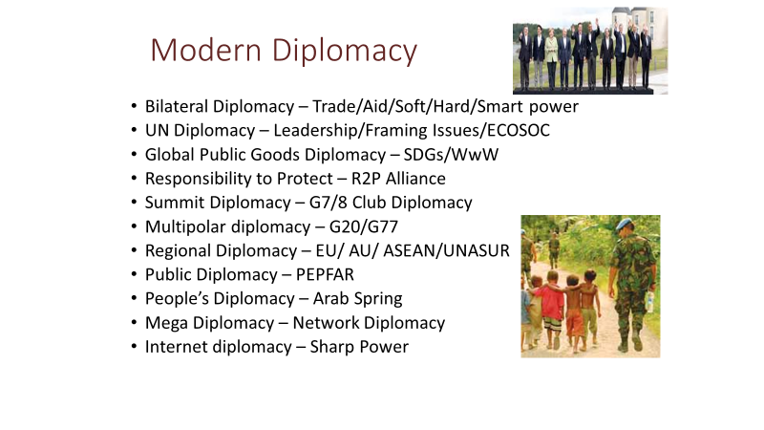
Diplomacy has developed in many different ways since the Vienna Convention on Diplomatic Relations (see http://legal.un.org/ilc/texts/instruments/english/conventions/9_1_1961.pdf ) which codified the etiquette and norms of modern diplomacy in 1961, and still has some relevance today. Bilateralism remains the prevalent form of relationship,70% of aid is provided through bilateral agreements between a donor country or group such as the EU and a recipient country.
Despite many efforts the UN has remained largely unreformed in its structure and membership of the Security Council. However, it has made some tentative advances. More than 50 informal groups of nations act as coalitions at the General Assembly. At national level UN Agencies are asked to “Deliver as One”. There have also been small steps to engage with the private sector through the “Global Compact”. The UN is increasingly focussing on global public goods for sustainable development and have been engaging Civil Society organisations, through ECOSOC, “The World we Want” (WwW) debate leading to post 2015 goals and in the “Responsibility to Protect” (R2P) Alliance (Google these).
‘Summit diplomacy’ was initially dominated by the G7 /G8 meetings, but, when faced with the global economic crisis of 2008, the locus of discussion moved to the G20 meeting of the Finance Ministers of the 20 leading economies, representing 80% of the global economy. The economies of China, India, and Brazil are now the second, third, and seventh largest by GDP. It was thought that G20 would take on some of the roles of G8, for example, in relation to the MDGs and SDGs (see later) but this has not so far been evident, perhaps because the sense of “club” responsibility has not emerged.
Regional Organisations and sub-regional co-operations have greatly increased in recent years and South-South and Triangular Co-operation has also grown. Google to find the wide range of regional and sub-regional organisations which work together for health in your region of the world.
Soft power is described by Joseph Nye as” getting people to want the things you want” through Public Diplomacy (which has a long history as propaganda) and measures that build trust and confidence. Smart power refers to clever use of diplomatic instruments ranging from persuasion to trade, aid and possible sanctions, backed by force, see https://www.youtube.com/watch?v=JsE_1sY0lfU More recently the term “Sharp Power” has been used to describe targeted efforts to influence specific decisions in other countries, including elections influenced by social media (Google to explore this).
Peoples Diplomacy is expression of public aims and rage, via social media – as during the Arab Spring. SfGH can enhance its power in peoples’ diplomacy through smart use of social media and the internet.
All are elements of mega-diplomacy; has your advocacy touched these levels?

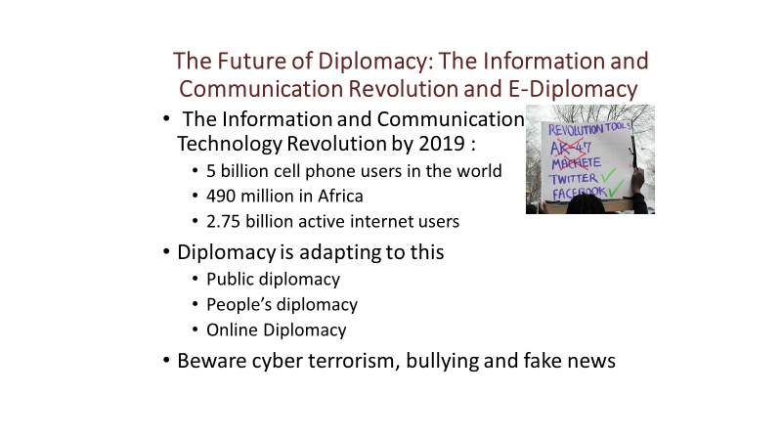
There is an increasing desire to participate in global issues, Parag Khanna notes in “How to Run the World”, that twenty Years ago 18% of US College Students said they wanted to get out and change the world but now 40% say this. IFMSA students from around the world must share this feeling. The Information and Communications Revolution (ICR) provides the opportunity to share views and actions online. This can have both positive results - 50% of US households contributed to the Haitian earthquake appeal and negatives. Some governments and ISIS also make extensive use of social media.
Both Paul Webster Hare and Tom Fletcher (see reading list) note that ICR has transformed the practice of diplomacy. Non-state actors have actively adopted these tools, and some at state level have seized this potential. Examples of the use and misuse of e-diplomacy to mobilise support can be seen in the use by President Trump in the USA and the Labour Party and its Momentum supporters in the UK. You will also find example of Ambassadors and other embassy staff using social media. No doubt you can find examples of the political use of social media in your country, whether you agree with them or not.
At the same time there has been a steady erosion of trust in government leaders and indeed all “authority” figures in most major economies. Many people feel victims of forces beyond their control, as a consequence of globalisation, these are equated with prevailing “establishments” and politicians’ failure to take action on a global or national level that acknowledges their concerns. This has been evident in the 2016 US presidential election and in the UK referendum on Europe, where voters rejected the advice of political leaders and “experts”. The 2016 Edelman Trust Barometer based on surveys in 28 countries show that government leaders are trusted by less than 50% of the general public in 6 out of 10 countries. See http://www.slideshare.net/EdelmanInsights/2016-edelman-trust-barometer-global-results?next_slideshow=1. The Freedom Index 2018 shows democracy in crisis (Google if possible).
Distrust may have been fuelled by the use of social media that tends to create identity silos in which people’s views are reinforced by exposure to narrow group thinking (estimated 62% of Americans get their news from social media). Belief in evidence or expertise is disregarded in favour of the views and feelings of “people like us” in what has been called “post-truth politics” (Google this phrase). The challenge for responsible public or people’s diplomacy, is to build trust by listening to fellow citizen’s on-line and in person, to develop a shared understanding and clear solutions supported by evidence. The basis for a whole society approach must be understanding and engagement with public concerns, listening to all sides of an argument, with respect for others’ right to be heard but also for the truth.
In your groups you may wish to discuss how SfGH can ensure they listen to members and gain understanding, trust and support for action to address their shared concerns.

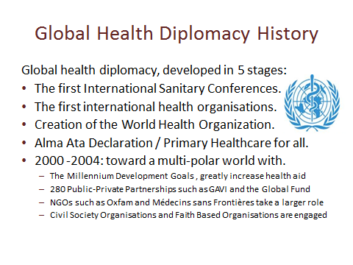
The first international body to control health was the 1839 Constantinople Supreme Council for Healthcare. The 1851 International Sanitary Conference held in Paris, was the first of 10 to consider infectious diseases and their impact on trade and shipping, bringing together at first 7 and then 12 countries. At the meetings doctors were later replaced by diplomats and last by doctor/diplomats.
There were no inter-governmental health agencies until the first half of the twentieth century. The Pan American Sanitary Bureau (PASB) was created in 1902, the International Office of Public Hygiene (OIHP) in 1903, and the League of Nations Health Organization (LNHO) in 1920.
The WHO was established in Geneva in June 1948. It resulted from the unification of the OIHP, the LNHO, PAHO and other regional bodies. By that time the regional PASB had been very active since its inception in 1902 and had become the Pan American Health Organization (PAHO). The diplomacy that led to the creation of the WHO was led by a Chinese health diplomat Dr Szeming Sze, read his story at http://whqlibdoc.who.int/analytics/WHForum_1988_9(1)_29-34.pdf .
In 1978, the international health agenda and diplomacy in general were taken a step further by an international conference on primary healthcare held in Alma Ata, Kazakhstan, bringing together countries across the divides of a world polarised by the Cold War. The success of this conference also paved the way for health to become a leading focus for international agreement and action, for example, at subsequent G7/8 meetings, at the UN and in the MDGs and SDGs.
With the end of the cold war, a more complex diplomatic environment emerged, this has introduced many more actors in global health diplomacy. Look at this presentation by Thomas L. Hall, Elisabeth T. Gundersen and Trevor P. Jensen, from the Consortium of Universities for Global Health: https://www.slideserve.com/seth/global-health-actors-and-their-programs
IFMSA and its member organisations are engaged in this complex process of diplomacy that loosely links global citizens to global concerns, it is important to recognize the other participants and to consider how you can work with them. See the Directory of Geneva Global Health Actors produced by the Global Health Centre this lists 90 organisations at http://graduateinstitute.ch/globalhealth/directory-geneva .
List the Public Private Partnerships, NGOs and other agencies relevant to SfGH concerns.

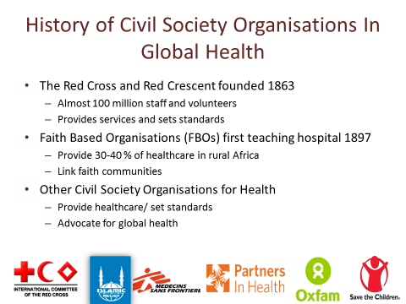

This information is from Sima Barmania and Graham Lister, “Civil Society Organisations, Global Health Governance and Public Diplomacy”, chapter 18 of “Global Health Diplomacy: Concepts, Issues, Actors, Instruments, Fora and Cases” edited by Ilona Kickbusch et al (see reading list).
The history of the International Committee of the Red Cross and Red Crescent can be found at https://www.icrc.org/eng/who-we-are/history/overview-section-history-icrc.htm . It is both a major health service provider and a leader in setting standards and norms for health. Most importantly it is the largest source of staff, volunteers and supporters for global health.
Faith based organisations (FBOs) have long played a role in uniting people of faith across the world. Missionary settlements spread Christianity, Islam and other faiths, from the first/eighth century, often providing some form of health and education. In the 19th century colonial powers encouraged the spread of Christianity with these services, perhaps an early example of “soft power”. By 1897 the first missionary teaching hospital was opened in India by a Canadian missionary. In the modern era FBOs still play a major role in engaging people across countries and have been estimated to provide some 30-40% of healthcare services in parts of rural Africa.
While in former times FBOs were seen as bringing charitable aid from rich countries, today Civil Society within countries and internationally are recognised as major partners in global health, as healthcare providers such as MSF (see http://www.msf.org/ ) and innovators such as Partners in Health (see http://www.pih.org/). As a result of the Communications and Information Technology Revolution they can bring local and global issues together (sometimes called “Glocalisation”). They can play a role in advocacy as Oxfam (see http://www.oxfam.org.uk/ ) and both advocates and providers as Save the Children (see https://www.savethechildren.net/ ). Organisations such as The People’s Health Movement (see http://www.phmovement.org/ ) bring local communities together to address local and global health issues at every level.
What lessons would SfGH wish to share with the People’s Health Movement?

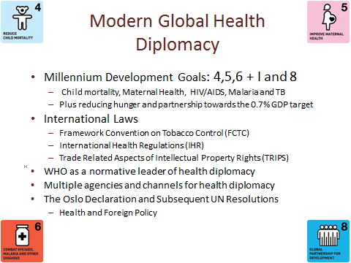
The MDGS were preceded by a consultation with representatives of over 1,000 non-governmental and civil society organizations from more than 100 countries. However, decision making at the Mexico Summit was dominated by G8 leaders. The MDGs introduced a new pattern of diplomacy for global development goals, with clear targets and commitments followed up by monitored results. They also reinforced the link between health and foreign policy https://www.youtube.com/watch?v=7IgrNuXBI-s
The FCTC adopted in 2005 represented a watershed for global public health; not only was the treaty the first to be adopted under WHO's Article 19, but it the first multilateral, binding agreements regarding a chronic, non-communicable disease (see the WHO constitution, a remarkable document, at http://www.who.int/governance/eb/who_constitution_en.pdf )
IHR was another step towards an international legal framework for global health. Diplomacy regarding the WTO TRIPS agreement is aimed at enabling low income countries to challenge the pricing of essential medicines, while still ensuring that there are incentives for research and development. This has been a longstanding dispute since the 2001 Doha Trade round began (Google).
The six core functions defined in the WHO 11th General Programme of Work underline WHOs role in health diplomacy:
1. Provide leadership on matters critical to health and engage in partnerships.
2. Shape the research agenda and stimulate knowledge.
3. Set norms and standards and promote and monitor their implementation.
4. Articulate ethical and evidence-based policy options.
5. Provide technical support, catalyse change and build institutional capacity.
- Monitor the health situation and assess health trends.
United Nations Resolutions on Global Health and Foreign Policy (UNGA, 2008, 2009 and 2010) stress the need to train diplomats and health officials in global health diplomacy. The Global Health Programme of the Graduate institute Geneva developed a range of courses, books, case studies and other resources to support global health diplomacy see http://graduateinstitute.ch/globalhealth .
But there is continuing pressure for reform of the UN and WHO, you may wish to consult http://graduateinstitute.ch/files/live/sites/iheid/files/sites/globalhealth/ghp-new/publications/wp/wp_0011_v6.pdf

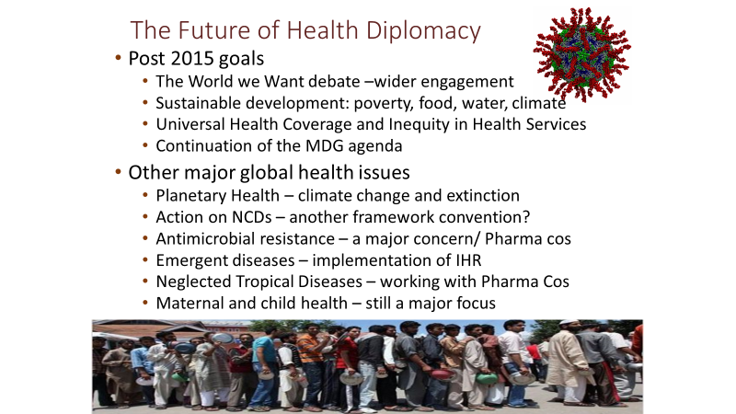
Efforts to improve global health may seem overshadowed by the threats to Planetary Health (see later) but these are closely linked issues that require an intensification of steps towards global governance.
Debate on the post 2015 Sustainable Development Goals has resulted in wider cross sector engagement of a million voices. See the SDG goals and progress towards them at https://sdg-tracker.org/ .
For health the focus of the proposed new post 2015 goal is to ensure healthy lives and promote well-being for all throughout lifetime. The 2014 report stresses the importance of engaging youth: http://www.un.org/en/ga/search/view_doc.asp?symbol=A/69/700&referer=http://www.un.org/en/documents/&Lang=E and http://www.copenhagenconsensus.com/sites/default/files/health_viewpoint_-_kickbusch.pdf also check the One Young World site
There is an increasing focus on NCDs, the question is, whether working with the food industry can be combined with regulatory action to protect against the market spread of threats to health such as the sugar rush to obesity and the rising tide of alcoholism.
The development of AntiMicrobial Resistant (AMR) strains of diseases, due to misuse of antibiotics for treating cattle and coughs in rich countries and uncontrolled sale in poor countries, is an urgent issue. Sir Alexander Fleming, who discovered Penicillin in 1928, warned of the dangers of its misuse in 1945 when he received the Nobel Prize. To illustrate this issue, I bought a single dose of Rocephin, a fourth-generation antibiotic, in a wayside shack in Cambodia, a country where AMR is fast growing.
Emergent and re-emergent diseases (particular zoonotic, including forms of Influenza) - pose a continuing threat to global health. The 2015 Ebola epidemic must be seen in the light of some 20 previous episodes of outbreak of strains of this disease, which led to complacency and neglect. Other issues include working with pharmaceutical companies and NGO/CSO to improve Access to Medicines (including those for HIV/AIDS and Neglected Tropical Diseases) and Maternal & Child Health – a soft power focus. See http://www.softpowerhealth.org/
There are increasing calls for the innovation of the system of global health diplomacy. It is important to consider whether the UN System and the WHO can be reformed to match the new challenges of global health governance - see Marco Schäferhoff et al (2015) “Rethinking the Global Health System” at https://www.chathamhouse.org/sites/files/chathamhouse/field/field_document/20150923GlobalHealthArchitectureSchaferhoffSuzukiAngelidesHoffman.pdf
Consider how the topic you are addressing in your advocacy strategy relates to the wider agenda of health and development in the post 2015 world and whether reform of the WHO will be required.

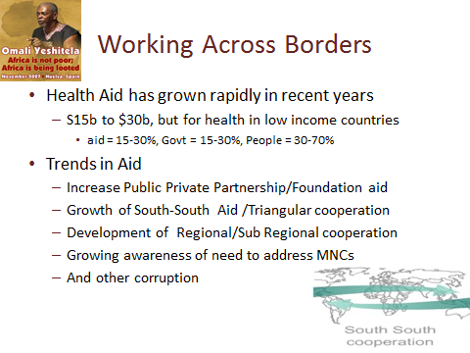
Total Official Development Aid (ODA) amounted to some $143 billion in 2016, OECD countries provide more than 90% of this, 70% of which is managed through bilateral agreements. In addition about $57 billion of aid is donated through non-governmental and private philanthropy. This is still less than half of the commitment of 1 % of Gross Domestic Product (now measures as Gross National Income (GNI)) made at the UN in 1970 (0.7% ODA plus 0.3% from private sources). Current levels of aid include ODA at 0.33% of the GNI of OECD countries and 0.13% of GNI from other sources. In 2014 the UK became one of the six countries meeting its commitment to the ODA target of 0.7% of GNI and is also a major source of NGO philanthropy. Total global aid flow of some $200 billion, can be compared with worker remittances to low and middle-income countries of some $326 billion.
Health aid doubled from 2002 to 2012 and now amounts to some $27–30 billion (12% of ODA and 22% of Foundation and other civil society aid), this is about a third of the agriculture subsidies paid by rich OECD countries to their farmers. See http://www.who.int/hdp/aid/en/ There are worrying signs that aid and health aid in particular may now decline. The Trump Administration “global gag” rule banning aid to any health organisation advising on aspects of abortion will reduce US health aid of $9 billion by $600 million and the proposed budget would cut total US ODA, (£32 b of total $132 b) by 28%.
Health aid is made up of: bilateral and EU aid, $12.5 billion; development banks $2 billion; UN agencies, $4 billion; global partnerships and programmes $5 billion; foundations about $2 billion; and NGOs about $2 billion. See Hilary Clinton’s talk at https://www.youtube.com/watch?v=OhsQ-tD25cY
But in low-income countries, health aid only accounts for about 15–30% of health expenditure, government expenditure making up a further 15–30%; out-of-pocket expenditure including co-payments, purchase of medicines, and informal payments make up 30–70% (Hsiao and Shaw, 2007). In total, low-income countries, which experience 56% of the burden of disease, take up less than 2% of total global health expenditure, $120 billion out of a total of $6.5 trillion (WHO 2012).
South-South Aid is growing but constitutes less than 5% of aid. It is claimed South-South aid is more empowering and less conditional, but does this address the problem of corruption or perhaps make this problem worse? Triangular aid is low income countries sharing expertise, with funding from a rich one.
Consider if the actions you propose will require aid support and how you might argue for this.

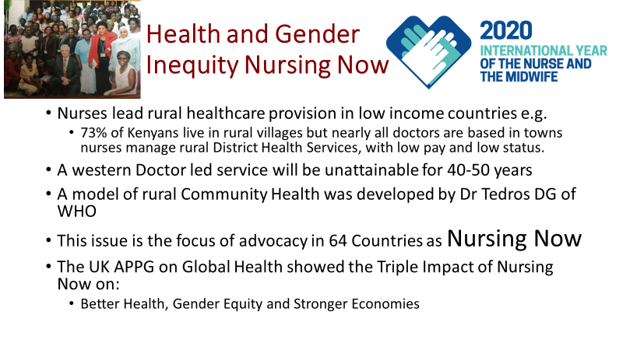
I am biased because I worked with the Aga Kahn Foundation and WHO on the INEPEA Programme (Improving Nurse Education and Practice in East Africa ) to developing courses for nurses and midwives in Kenya, Tanzania, Zanzibar and Uganda. My experience gave me great respect for the women who run healthcare services in rural East Africa. It also left me frustrated at the sexist attitudes of officials who saw nurses as simply assistants to (male) doctors even where there were no doctors. In some rural health centres there would be a room marked “Daktari” run by a man with two years training to prescribe 40 basic medicines, they had less training and responsibilities of nurses, but higher status. I also led a review of the Kenyatta Hospital (the largest training hospital in East Africa) where I found there were more Doctor posts than needed but many doctors spent little time in the hospital leaving their coats on their chairs to signify their presence but actually working for private patients.
It is often assumed that the answer to Africa’s health needs is to provide the same pattern of health services as is found in rich countries, with about 3 Doctors per 1000 patients. But sub Saharan Africa has less than a tenth of this (0.2 per 1,000) with less than half this number in rural areas. At current rates of training and doctor migration this will not meet health needs for at least 40 years and probably never.
The most promising approach was developed by Dr Tedros Adhanom Ghebreyesus, now the DG of WHO, but then responsible for healthcare in Tigray Province Ethiopia see his presentation here. His model is of a service provided by Community Health Workers. Later developments showed how this village-based approach could be enhanced by sharing medical knowledge and practice using information and communications technology. New resources can support this model including online diagnostics and drone delivery of medicines. The missing element in this development has been a failure to include these ideas in the training of Nurses, Midwives and Community Health Workers.
The Nursing Now programme started in 2015 it has been taken up in 64 countries and support is still growing for 2020 as the year of the Nurse and Midwife The relevant WHO page can be seen here and the Nursing Now web site here provides resources for advocacy (which provide some lessons for SfGH).
The UK All Party Parliamentary Group on Global Health has championed this issue and published a report on the triple impact on better health, gender equity and economic development see here . This group is co-chaired by Lord Nigel Crisp, who is of course a Patron of SfGH.
SfGH Groups should consider joining with student nurses to support Nursing Now

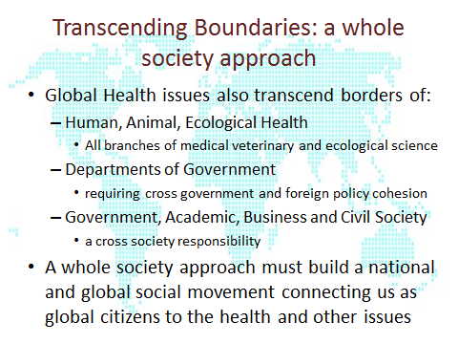
Global health not only transcends national borders it must also encompass all the elements that are required to improve health and well-being through the prevention of risks and the mitigation of the effects of crises that originate from humans, animals and their various environments see http://www.slideshare.net/GRFDavos/transcending-borders-a-wholeofsociety-approach-to-human-animal-and-ecosystem-health . The One Health network at http://www.onehealthglobal.net/ brings different agencies together to advocate for and take action on immediate and longer term health risks. You may wish to read the article on One Health by Stijntje Dijk and Sophie Albers of IFMSA at https://issuu.com/ifmsa_quebec/docs/bsm_-_mars_2014/10 they note that 75% of emerging infectious diseases are zoonotic.
Threats to health and wellbeing require cross departmental collaboration, engaging all elements of central and local government. In practice each department pursues its own goals and “joined up government” is more of an exception than a rule. Collaboration on cross cutting issues such as global health requires concerted effort as described by Boston and Gill (2011) “Working across organizational boundaries: The challenge of accountability.” Cross government collaboration usually requires the leadership of a senior politician or a committee of politicians e.g. the UK All Party Parliamentary Group on Global Health see http://www.appg-globalhealth.org.uk/ .
The challenge of reaching beyond government departments to work with academics, business and civil society requires a new form of diplomacy to engage with the many groups that may have many different interests and are independent. The WHO European Region’s strategy “Health2020” notes the importance of building cross sector partnerships for action to support action for health within and beyond the region. IFMSA has already noted that it welcomes a role in engaging young people and particularly medical students in a whole society approach to the implementation of Health 2020 see www.ifmsa.org/content/download/452427/5822385/version/1/file/IFMSA . To gain an understanding of the power of a whole society approach look for the TED talk by Mechai Viravaidya, who I met in 1981 when I worked in Thailand, he has been inspirational leader for sexual health known as “Mr Condom”.
Has UK has achieved a whole society approach to global health, if not how can SfGH promote this?

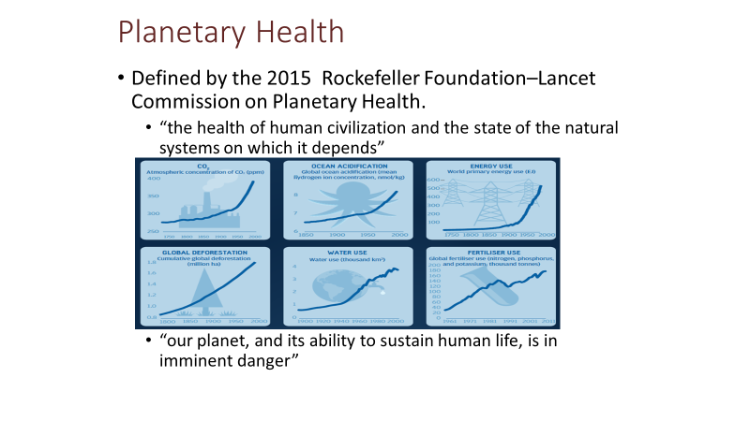
The idea that humans depend upon the health of the environment that sustains us and regulates the climate, air and sea quality and the 8.7 million species that live on our planet is not new. Charles Darwin observed both this dependence and the threat, for example, posed by the loss of coral reefs in 1842. But the last 50 years have seen imminent threats to human life and health posed by CO₂ emission, demand for energy, water and food, acidification of the oceans, deforestation and overuse of fertilisers.
Rachel Carson, author of “Silent Spring” (1962) raised concerns about the threat to marine and animal life posed by overuse of fertilisers and pesticides. The scientist James Lovelock developed a more radical view of the Earth, as a living organism that regulates the conditions that sustain life. His 2006 book – “The Revenge of Gaia”, points to the catastrophic consequences of failure to address global warming. In recent years the dangers of ocean acidification and plastic pollution have be highlighted. Every year oceans absorb ~ 2.8 billion tons of CO2 (25-40% of 8-9 b tons emissions), making seawater less alkaline and killing marine life. 12.7 million tons of plastic waste ends up in oceans each year killing marine life and entering our food chain, Google these issues, the science is as yet uncertain but the risks are clear.
Most ecologists believe that human impact on nature, is now comparable to five previous catastrophic events over the past 3.5 billion years, during which up to 95 percent of species disappeared. A 2015 study by Gerardo Ceballos et al https://advances.sciencemag.org/content/1/5/e1400253 estimated current extinction rates are up to 100 times higher than the natural background rates. A 2019 paper by Johannes Le Roux et al found that biological diversity is reducing at up to 350 times background rate https://theconversation.com/plants-are-going-extinct-up-to-350-times-faster-than-the-historical-norm-122255
The threat to human existence has a short fuse, the UN Intergovernmental Panel on Climate Change has warned there are only 12 years for global warming to be kept to a maximum of 1.5C, beyond which it may be irreversible. Similar danger signals are apparent for sea acidification and loss of rain forests.
Given such threats to the lives of all our grandchildren and future generations one might assume that global diplomacy would focus on this issue rather than petty national interests. This requires intelligent, well informed, ethically responsible global diplomacy. But as President Trump’s withdrawal from the Paris Agreement has shown, this is in short supply. A more enlightened approach can be seen at the Global Climate Action Summit and the recent Youth Summit on this issues, see https://www.un.org/en/climatechange/un-climate-summit-2019.shtml
The Rockefeller Foundation Page is at https://www.rockefellerfoundation.org/our-work/initiatives/planetary-health/ and the Lancet Planetary Health Journal is at https://www.thelancet.com/journals/lanplh/issue/current
What action can SfGH take to preserve Planetary Health?

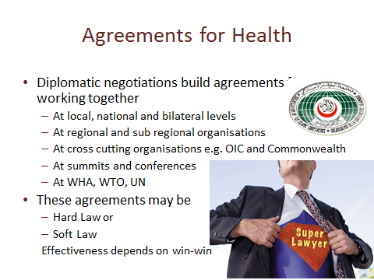
Agreements to collective action for health may be reached at many different levels, as examples: the European Union has established a Strategy for Global Health, and there are agreements at sub regional level including those of the South-eastern European Health Network and other sub regional groups.
International agreements include the Framework Convention on Tobacco Control, the International Health Regulations, the Codex Alimentarius Commission: Codex Guidelines for the Exchange of Information in Food Control Emergency Situations and many others, Google for more examples.
In international law a distinction is sometimes made between hard law and soft law agreements. The distinction indicates the extent to which agreements commit states which ratify the law and provide recourse to sanctions in international law if they are not complied with. Hard-law agreements are expressed in different forms including: Constitutions, Conventions, Framework conventions, Regulations and Protocols. Hard and soft laws may be used as a blend of measures to support action.
There is no rigid classification but soft law implies a general agreement with perhaps some mutually understood consequences in case of non-compliance but not a recourse to international courts. Soft law instruments are usually identified as: recommendations, including codes of conduct, strategies, nomenclatures, standards; advisory mechanisms, including advisory groups, impact assessment methods and commissions; and collaborative, operative, and normative instruments. These include memoranda of understanding (MoU), often used to express commitments to bilateral aid collaboration and agreements (or contracts) with NGOs and CSOs involved in implementing health projects.
These instruments may be formulated as resolutions, decisions, declarations, guidelines, or statements of the World Health Assembly or other bodies. Their binding nature varies according to the type and content of the instrument. International affairs and laws rely greatly on precedents. The systematic adoption of soft-law instruments on a given issue may create the momentum to create a more binding instrument in the longer term as public and political support develops. In practice a soft law supported by public action can be stronger than a hard law ignored. For a more detailed discussion of global health law see “Research Handbook on Global Health Law” by Gian Luca Burci et al at https://www.e-elgar.com/shop/research-handbook-on-global-health-law or Googlee the Greg Martin interview with Larry Gostin talking about his recent book “Global Health Law.
Are you advocating for a change in international laws or agreements? If so consider what sort of agreement you are seeking to promote.

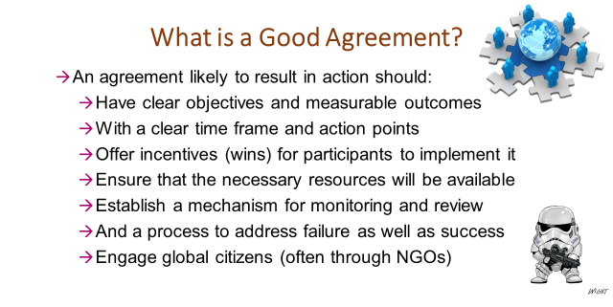
Global health diplomacy works towards agreements at national, regional and global levels to establish agreements for action to address important shared health issues. But agreements, however, they are framed in international law do not necessarily result in action. This is not “Star Wars” where disobedience will result in the “storm troopers” descending. Many agreements simply represent a vague intention to address common problems, without any clarity as to what should be achieved, by whom, when, with what resources. Such agreements may be intended to promote certain issues or national interests and even a weak agreement may have a role in preparing the ground for a more substantial commitment to action at a later stage. While national and sub regional agreements tend to be more focussed and action oriented, regional and international agreements often get watered down in order to achieve consensus, thus at WHA do not be surprised to hear many agreements which have little hope of producing substantial action.
In developing your approach to global health diplomacy IFMSA teams should consider carefully the nature of the agreements already established in their chosen area of advocacy. Go to the WHO site at http://www.who.int/en/ and search for existing agreements relating to your area of advocacy. Also see Larry Gostin’s proposals for a framework convention for global health based on the post 2015 agenda, http://scholarship.law.georgetown.edu/cgi/viewcontent.cgi?article=1972&context=facpub .
Try evaluating these agreements using the list above: do they have clear objectives, measurable outcomes, clear time lines, do they offer wins for all participants, are resources available to implement them including monitoring and review and a mechanism to address any failure to act and finally are the public kept informed and engaged? Agreements ratified by governments are supported by national laws and/or international courts or arbitration and may be supported by soft law agreements e. g. standards.
You should also look at any proposed agreements or recommendations at this year’s WHA in your chosen field, how will that improve the likelihood of action? You could also undertake a similar review of agreements at national and regional levels. And would a convention on global health be useful?
This provides an important target for your efforts in global health diplomacy, recognising that diplomacy is described as “the art of the possible” and that this often means the next step along a path. It also suggests a possible role for IFMSA and other NGOs, because in the absence of other mechanisms to monitor performance, civil organisations such as yours are the closest thing we have to storm troopers, raising your voice with others to protest and alert the public when global health and equity issues are ignored by governments and the private sector.
SfGH groups should consider their target for diplomacy, what would the next step look like in developing agreements that will lead to the actions you are advocating for?

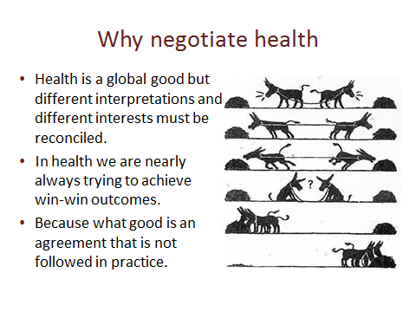
Negotiation is a key process of global health diplomacy. Negotiations can be formal or informal, local, national, international or global in scope. In some cases they will be of a win-lose nature, for example, in negotiating a commercial contract for the supply of medicines.
But where the parties to an agreement must implement the measures agreed upon themselves, there will be little point in negotiating an agreement that the parties have no intention of observing. In such cases a win-win approach is required so that all the parties are motivated to work together. See https://www.youtube.com/watch?v=ZKAbYEbnjeo
This applies to local agreements; for example, the owners of a new factory may agree with local community groups to ensure the environmental and health impacts of their plant will be minimised and that local people will have opportunities for employment and factory provided health facilities. A public health role may be to assist in both the negotiation and subsequent implementation of the terms agreed. See “Leading Negotiations for Health” at https://www.building-leadership-for-health.org.uk/global-health-diplomacy/global-health-and-negotiation/
At national level agreements will be negotiated with aid organisations and NGOs and CSOs involved in a health improvement. A public health role may be to support negotiations and monitor implementation based on the national health strategy. See http://www.who.int/trade/resource/negotiating/en/
At regional and sub-regional level states and other organisations may agree to joint action, for example, to monitor water quality in a river basin area. They may also agree to adopt a common regional approach to global health negotiations, whether at the WHA or WTO, a public health role may help to develop a common understanding of long-term interests in global health.
Diplomatic negotiation may require dialogue between groups with fundamentally conflicting aims, calling one side “bad hombres” or “deplorables” creates barriers to understanding, and may be a mistake. Google TED talk by Janos Gahr Støre, the Foreign Minister of Norway “In defence of dialogue”.
Global health diplomacy is not confined to international treaties it occurs at every level and in every situation in which joint action is required, this applies to all actions for global public health.
Consider how you could position the action you are advocating as a win–win outcome.

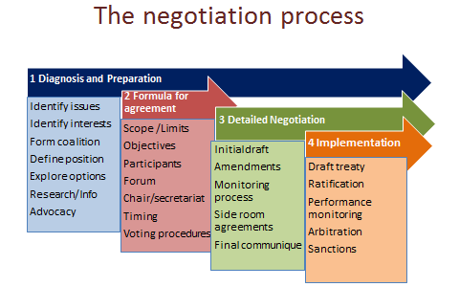

The process (based on Lister and Lee, (2013) “The process and practice of negotiation”, in Kickbusch, Lister et al. [eds] Textbook on Global Health Diplomacy. New York: Springer.) can be discerned in all negotiations, whether at local or global level, but clearly you need to interpret the stages in somewhat different ways.
Diagnosis and preparation is the most important phase; careful timing and selection of the issues to be addressed, identifying the interested parties and their interests, creation of “coalitions of the willing”, defining the coalition’s position, exploring the options for agreement and undertaking research and advocacy to build a case and create the conditions in which parties are open to negotiation are essential.
The formula for agreement phase defines the scope and limits of the agreement it is hoped to achieve and its legal form, the aims and objectives, who will participate and how negotiations will be conducted. A “heads of agreement” may be negotiated, setting out the main points at issue and the points of agreement about which detailed negotiation will take place. In some cases it may be possible to agree on general principles and to plot a path to an agreement to meet the interests and aims of all parties.
Detailed negotiation may involve different participants setting out their opening positions or may use an initial draft with points at which disagreement must be resolved identified. Parties to the negotiation then propose amendments and address issues such as: how the outcome is to be monitored and what should happen in case of default from the agreement. The main agreement may be encouraged by “side room” agreements to overcome obstacles.
But the final communiqué or written agreement is not the end of negotiation, it is the start of the implementation phase, which itself will often involve continuing negotiation of the acceptance, interpretation and performance of the agreement. For some tips on negotiation for health see http://www.healthknowledge.org.uk/public-health-textbook/organisation-management/5a-understanding-itd/negotiating-influencing
Review the progress of negotiations in relation to an issue of concern to SfGH.

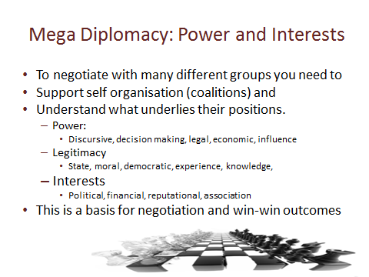
The modern world of mega diplomacy for health requires public health leaders to work with many different partners and sometimes opponents. A key starting point is to gain an understanding of the factors that underlie the position taken by each of the parties involved. It is important to understand the basis of their power, which may derive from: discursive power - being able to define the situation and set norms, decision making power – ability to take decisions without deferring to others, legal power – based on rights established by international and national laws, economic power – controlling the financial or other resources required, or influence – the ability to sway the behaviour and choices of others (the public or perhaps health professionals).
In practice it is often important to distinguish between the position and power of the organisations represented in a negotiation and the personal position and power of the individual in the room. Negotiators can be limited or empowered by the instructions they receive.
It is also essential to understand the factors that support the legitimacy of each party. These include: state legitimacy – the authority vested in a state institution to act on behalf of citizens, moral legitimacy – based on human rights and equity, democratic legitimacy – established through election, experience – patient groups may derive legitimacy because their members share direct experience of a condition, knowledge – the expertise derived from research or skills in providing treatment. Individuals will also build personal legitimacy, earning the trust and respect of others at the negotiation, though in some cases the reverse may happen.
The position taken by parties in negotiations may reflect, or sometimes hide, their underlying interests. These interests are the bedrock for any negotiation so a clear understanding of interests is essential. These may include: political interests – reflecting a national or local party position, financial interests –receiving income for service or from a private sector sponsor and sometimes receiving corrupt payments, reputational interests – protecting their good name and associational interests – their relationship with others. There is an app called Policy Maker 4 which some global health diplomats have found useful for policy setting see http://polimap.com/
Identify the actors involved with the topic on which you are advocating, map their interests, power and legitimacy and consider how SfGH can extend its own power and legitimacy in this sphere.

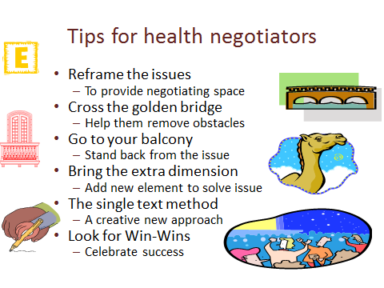
In negotiating for win-win outcomes for health we can learn from experience, most of these tips are taken from William Ury, the world leader in negotiation skills (you can find talks by him at http://www.ted.com/talks/william_ury.html . )
Reframing the issue means setting the issue in a different policy context, helping people to address the issue in a different way. Thus, while you may see an issue solely in health terms, it may be helpful to reframe it as a question of community solidarity. For example; smoking is a health issue but it can also be represented as exploitation by multinational companies, or an attack on family life and livelihood.
“Crossing the golden bridge” refers to the importance of helping your opponent to overcome the barriers that face them in reaching a compromise agreement acceptable to others, to do this you need to accept and work with “where they are coming from” and talk them through the obstacles they face.
“Going to your balcony” means not getting sucked into arguments, keeping a clear perspective on the aims of the negotiation and discussing issues not personalities. If someone attacks you on a personal level don’t react, take the discussion back to the underlying issues, it will make them look small.
In some negotiations it can be helpful to introduce an additional element so that everyone wins from the outcome. The story of 17 camels shows this see http://www.wussu.com/humour/camels.htm
The single text method was used to develop the road map for peace in the Middle East, both sides started from hard-line positions and would not give way, so the American chair of negotiations started afresh with a single text both sides could take or leave.
Negotiations often involve coalitions of those in favour or opposed to particular outcomes. It is vital to maintain the strength of the coalitions, as although the leading advocates may have a clear position, their strength in negotiation may depend on maintaining support from other coalition members. For this reason negotiators may attempt to appeal to the interests of opposing coalition members and thus undermine their support for the lead opposition advocates. Conversely coalition members may be best placed to offer compromise solutions, softening the position of their coalition in response to outcomes that meet their interests. Looking for win-wins has been stressed throughout, because if party feels they “lost” they are unlikely to be enthusiastic about the agreement. One way of reinforcing this is to encourage everyone to cheer each sign of progress. This may apply to a coalition or to all participants.
Advocating for a set of ideals or principles may make you feel good, but achieving progress towards action on issues requires you to understand the points of view and interests of other parties and to negotiate the best possible next step attainable. This is “the art of the possible” not “virtue signalling”.
Consider your negotiating strategy to promote an issue on which SfGH is advocating.

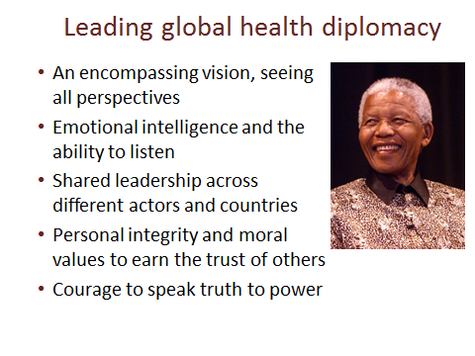
Leadership of global health diplomacy may be described as the art of “meta leadership” (see https://npli.sph.harvard.edu/meta-leadership-2/ ). This requires: an encompassing vision - understanding the perspectives that all the parties bring to an issue, but with a vision that transcends the differences they bring. It requires emotional intelligence and the ability to listen to others, which is a much under-rated skill in a world obsessed with gesture politics and grandstanding leadership. Global health leaders need to be able to prompt others to take the lead, recognising their skills and strengths and giving them support and encouragement rather than competing with them. Underlying these skills, global health leaders need personal integrity and moral values that earn respect and trust. Most of all a meta leader of health diplomacy must have the courage to speak truth to power and to act on their values.
Many books on leadership put forward simple “one size fits all” models of leadership. Hopefully you will learn to adapt to the needs of each issue and the situations you face, the people you represent, those you need to reach agreement with, and the steps you need to take to put ideas into action. As a starting point you might like to look at the Building Leadership for Health modules at https://www.building-leadership-for-health.org.uk/building-leadership-for-health-course/
Meta leadership combines and goes beyond elements of “servant leadership”, “leadership through constructive conversations” and “distributed leadership” (if you Google around these phrases you will find examples of the application of these ideas to health leadership). For me these values are best illustrated by a quotation from Nelson Mandela’s book “Long Walk to Freedom” (1995).
As a leader... I have always endeavoured to listen to what each and every person in a discussion had to say before venturing my own opinion. Oftentimes, my own opinion will simply represent a consensus of what I heard in the discussion. I always remember the axiom: a leader is like a shepherd. He stays behind the flock, letting the most nimble go out ahead, whereupon the others follow, not realizing that all along they are being directed from behind.
This quotation illustrates the importance of listening to others, summarizing – often framing issues in terms of underlying values and guiding the direction of others – all key attributes of diplomacy. For an example of Nelson Mandela’s leadership see http://news.bbc.co.uk/1/hi/world/africa/2156588.stm
Talk through these leadership qualities, which develop with experience for individuals and groups.

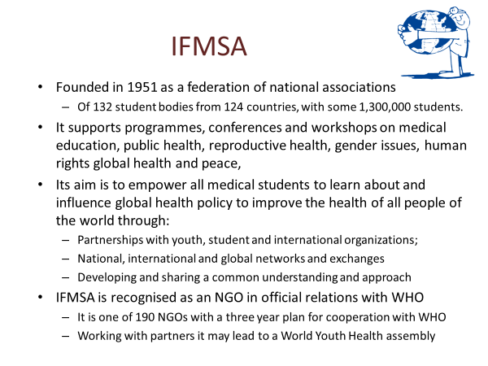
See https://prezi.com/2ix-prca0vk2/presentation-international-federation-of-medical-students-associations/?utm_campaign=share&utm_medium=copy
IFMSA official relations with WHO started in 1969, with the organization of a symposium on "Programmed Learning in Medical Education". In the following years, IFMSA and WHO collaborated in the organization of a number of workshops and training programs. Current collaborations include the “World Health Organization (WHO) Simulations” Transnational Project which aims to foster interest in global health and health policy, Google this.
Since 1971 IFMSA has also worked with UNESCO see https://ifmsa.wordpress.com/tag/unesco/ and now supports HIFA2015 (Health Information for All) see http://www.hifa.org/ .
In recent years a Youth Pre-World Health Assembly Workshop on Global Health Diplomacy, Governance and Advocacy has been organised with the support of the Global Health Programme of the Graduate Institute Geneva. This is open to IFMSA members as well as other youth organizations that attend the WHA. The event aims to develop a plan of action for youth participation at the World Health Assembly which follows the event. Participants prepared by working with this learner led material will meet in seminars and working teams to develop advocacy strategies on global health and humanitarian issues to be enacted at the WHA.
These workshops have also considered measures to develop further engagement in a World Youth Health Assembly to address issues of global concern including those identified in recent WHO reports and strategy documents see https://www.youtube.com/watch?v=za812NoMWQY.

Discuss how SfGH can improve relations with IFMSA to extend its influence in global health.

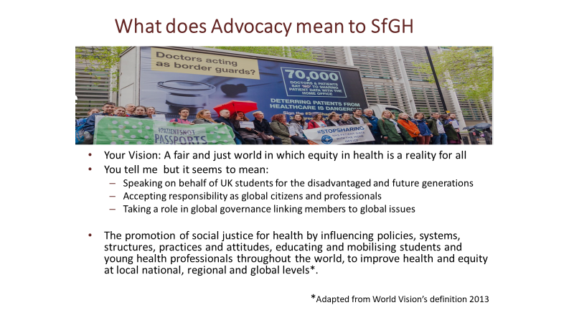

If, like me, you are fascinated by the origin of words, note that “Diplomacy” is derived from the Greek diploma, a folded parchment given, for example, to athletes winning a race. This was used by Romans to refer to a pass authorising travel on roads, so diplomacy represents views from other peoples. Negotiation comes from the Latin “negat otia” meaning no ease, so negotiation means business and is hard work as you will discover but it is the only way to achieve progress through compromise.
The word “professional” stems from the Latin “professionem”, meaning to declare a set of beliefs. This is reflected in the idea that professionals claim the right to govern themselves because of their special knowledge and the high ethical standards, to which they adhere. Any student aspiring to become a professional should think about the beliefs that they uphold. The Hippocratic Oath was the first professional oath. A modern version commits to serve all humanity, without discrimination – “The Declaration of Geneva” can be found at https://jamanetwork.com/journals/jama/fullarticle/2658261
The word advocacy comes from the Latin “ad vocare” meaning to give voice to, it was used in Roman times to refer to a witness who spoke for someone or some group. An essential starting point for advocacy is to consider who you speak for and why.
Advocacy requires a link with those whose rights and opinions you represent. You need to consider who this is for SfGH and how you inform and communicate with those you claim to represent. This might be members of SfGH organisations, all students, or even all young people, but how can you claim that you are speaking for them? You need to think about how local groups, individual members and maybe wider student groups have been informed and consulted (or surveyed) and how you keep in touch with them using social media and other means. If the targets of your advocacy action are disadvantaged people – for example those with poor access to health services or people from low income countries already affected by climate change, you also need to consider how you listen to and empower them. Consider how student placements can strengthen SfGH’s role in advocating for global health solutions.
Advocacy has an external purpose: to raise awareness of issues, informing the public, and an internal purpose in reinforcing knowledge and strength of ties within the organisation; sharing ideas and taking action together helps to build SfGH as a Transformative Organisation of Socially Committed Activists.
Consider SfGH’s advocacy how you define, communicate with and empower people you represent.

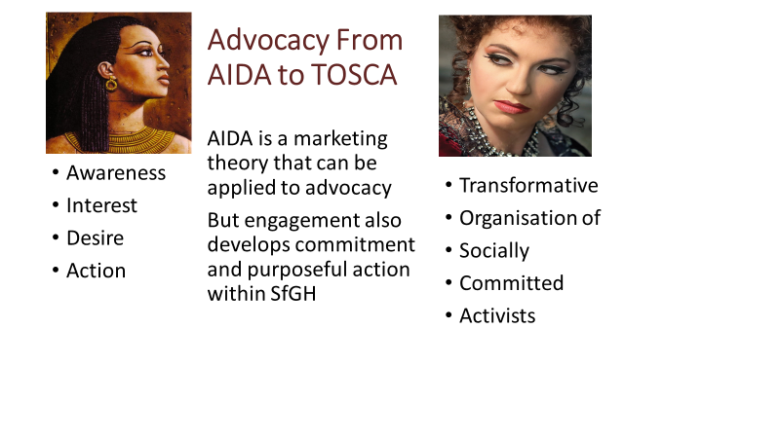
The well-known AIDA model expresses a simple approach to the aims of marketing – to raise awareness of a brand, promote interest in its products or services, building consumer desire to the point that they take action to buy the product. The same model can be applied to advocacy – raising awareness of social issues affecting global health, promoting interest in solutions to these problems, developing a desire for change and taking action to demand political change and altering their personal behaviour. You may wish to Google AIDA and apart from some enjoyable opera you may gather some insight into the application of the AIDA model to your approach to advocacy.
But beyond this, the experience of joining in group behaviour, to learn more about the causes and potential responses to global health issues and to participate in actions such training others or participating in protests or representation at national or international meetings can create a sense of identity and purpose. This provides a basis for the formation of a Transformative Organisation of Socially Committed Activists (TOSCA). It is therefore helpful to consider ways in which SfGH actions can both contribute to the external goals of social change and the internal goal of reinforcing the teamwork and commitment of members. Again you will find online insights into how to encourage the formation of effective teams - the best known model is Tuckman’s – Forming/Storming/Norming/ Performing.
Activism must be rooted in ideas developed through teamwork and a commitment to action at local level, but it also requires some cool-headed thought about the consequences for public reaction and for the general membership.
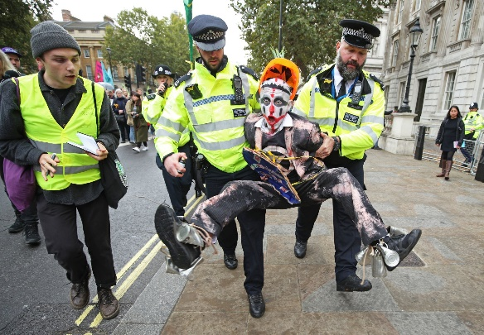
A realistic approach to advocacy must recognise that internal and external and aims may sometimes conflict, what feels right for members may not be an effective way of changing public opinions. For example, while the Extinction Rebellion protest no doubt reinforced the virtuous feelings of its membership, opinion polls suggested that their protest reduced public support for urgent action on climate change. In all cases it is important to listen to those you hope to influence and to think through the consequences of action, however well-intentioned they may be.
Compare Greta Thunberg’s call for rebellion ( https://www.youtube.com/watch?v=2rPC6oC_5rU )

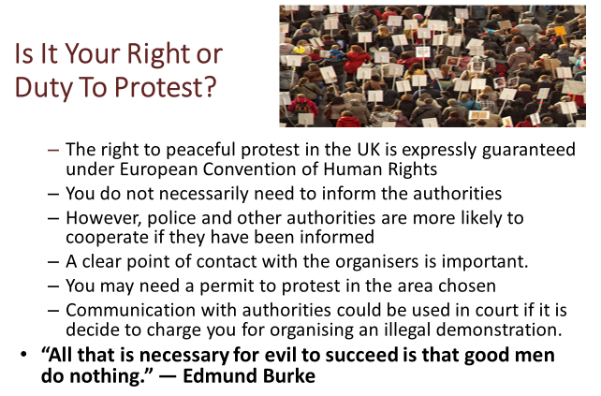
The right to protest can be seen as a duty when facing grave injustice, many would argue that the injustice of global health and the threats to planetary health demand that we take action. But before taking to the streets it is important to clarify the intentions and messages of the protest:
- What are the aims of the protest? Is it to raise awareness of an issue, to interest and inform, to show the strength of support for the protest or to promote specific actions?
- Who are you trying to influence? Are you targeting the general public, the politicians and decision makers, or are you building commitment for the protest participants?
- How might others interpret the image and message you communicate? Including most importantly those opposing or hesitant about your message and organisation?
- What support is there for the protest? Have you developed enough commitment amongst your supporters, have you cooperated with other groups, will you attract public support?
Careful thought about these issues should ensure that a protest is seen as a reasonable and legitimate response by participants and the public. It is important to make sure that, for example, a small protests is not attacked for showing a lack of support for the issue, that information conveyed on notices is clear and evidence based and that the behaviour of protestors does not give rise to negative responses from the people that you are trying to influence.
From a national perspective SfGH may wish to consider what protests can be supported, by for example displaying the SfGH logo and referring to national policies and decisions.
For Government advice on informing the Police about public marches see https://www.gov.uk/protests-and-marches-letting-the-police-know and The Law on the Web (though this is not being maintained) provides advice on rights see https://www.lawontheweb.co.uk/legal-help/right-to-peaceful-protest
How can SfGH support and guide local and national activism and protest as elements of advocacy.

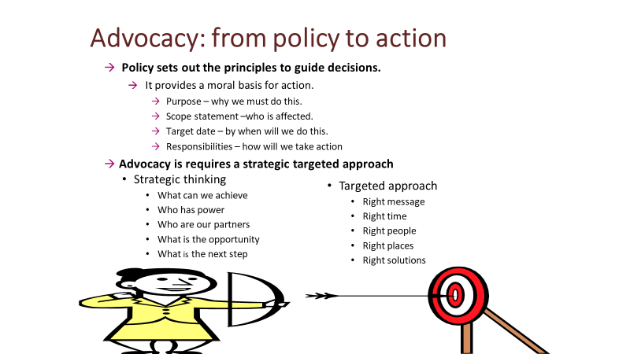
Policies represent the stance or position of Students for Global Health (SfGH) on key global health topics. Specific SfGH policy documents are set out here.
A policy statement or brief is often a useful starting point for developing an advocacy strategy. It sets out principals to guide subsequent decisions in a form that can generate or reflect the approval of the organisations and individuals represented. How such policy statements are ratified by the membership will depend upon circumstances but as it is an important moral basis for action, this should not be taken for granted. Generally a policy statement will present a case for action based on the fundamental beliefs of the organisation in human rights to health. It sets out the actions to be taken, empowering a group of representatives to act on its behalf with targeted outcomes, responsibilities and a deadline for action.
However, policy must also provide scope for creative strategic thinking by advocates so that they can respond to opportunities and challenges and focus actions on practical deliverable outcomes. Advocacy that simply results in intoning pre-formulated policy positions may result in righteous feelings but will achieve little, on the other hand an un-principled search for agreement at any cost is pointless.
SfGH advocates will need a clear but sufficiently flexible Policy Brief in each field and on this basis you need to assess the situation and research how you can best contribute to the dialogue. This will include assessing: the stakeholders and their interests, powers and legitimacy: the points at issue and evidence cited for action or inaction. Assess where there is possibility for progress and what arguments, evidence or public and professional support might advance your aims. You should also consider SfGH’s power and influence and how to promote and enhance it, for example resolutions of members show democratic legitimacy, social media contacts demonstrate and build “people power” and personal experiences of members are also sources of influence.
Discuss how you might develop a national advocacy strategy.

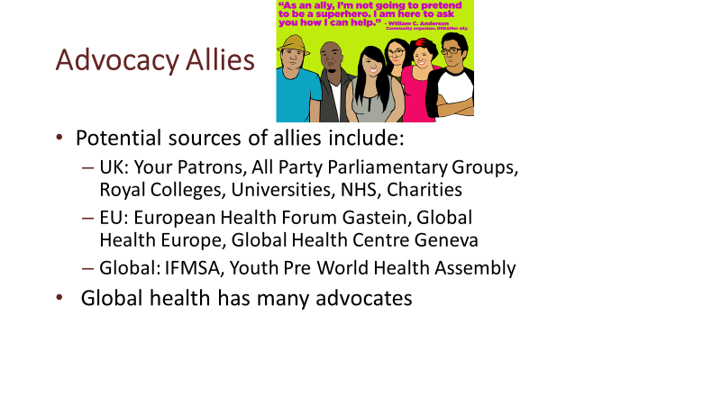
Global health has become an academic industry over the past 20 years, with countless organisations offering courses and undertaking research. It is therefore important to select partners carefully, your patrons: Sir Michael Marmot, Lord Nigel Crisp, Sir Andrew Haines and Professor Richard Horton are all leaders in their fields but very approachable and would I am sure be willing to help you choose allies.
All Party Parliamentary Groups are important points of contact between politicians of all parties, academics and NGOs on a wide range of issues such as Global Health, Climate Change and Lesbian Gay Bisexual and Transgender Rights. There are almost 500 APPGs so it is worth investigating see https://publications.parliament.uk/pa/cm/cmallparty/191105/register-191105.pdf .
Other bodies worth following include the Royal Colleges that lead medical and nursing specialties and play a role in setting international standards in medical education, most are members of the Academy of Medical Royal Colleges. Many universities provide courses in global health and some run conferences. The Department of Health and NHS bodies with a remit for global health include Public Health England which monitors UK strategy for global health as set out in Health is Global the Director of Global Health is Neil Squires, Charities with an interest in Global Health include: The Nuffield Trust, the King’s Fund and the Wellcome Foundation, which works with the National Institute of Health Research and many others. You should also consider working with charities such as: Oxfam, Save the Children, MSF, THET and HIFA.
The European Health Forum at Gastein is an important event bringing together European policy makers including those concerned with global health, the European Global Health web site managed by the University of Maastrict provides an update on EU policy and list of European bodies involved in global health. The Global Health Centre of the Graduate Institute Geneva is the WHO accredited centre for Global Health Diplomacy, see https://graduateinstitute.ch/globalhealth
The Global Health Centre (of which I am a senior associate) also runs a course for IFMSA at YPWHA. In recent years this has developed as a wider forum for engaging youth organisations in global health. This may be seen as reflecting SfGH’s extension to include all students. You may also find sites such as the “John Hopkins Bloomberg: Global Health Now” site useful for following developments.
Consider how SfGH should monitor and work with other potential partners in global health advocacy.

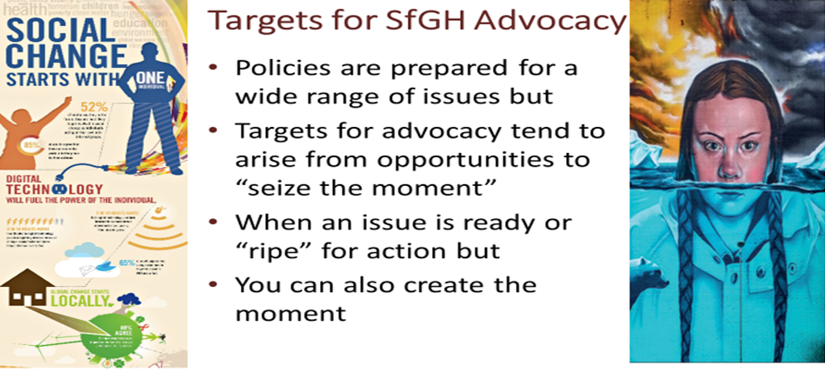
While it is important to clarify policy on a wide range of issues, progress is not achieved by simply stating your positions. You need to consider the opportunities available to achieve useful outcomes for those whose concerns you represent and those who are the targets for the action you support. You need to be aware of the ongoing dialogue on issue that are important to you, the specific perspective you bring, who you might work with and practical steps that can be taken. To explore the background to each topic, it is helpful to review current policy dialogue by searching the internet. You will often find agreements for action, which sound good but achieve little because they lack specific targets, measures or funding.
The agenda for global health is crowded with issues clamouring for attention, in a perfect world all would be considered and acted upon through a fair and effective systems of national and global governance. But we don’t live in such a world. Advocacy makes the case for action on specific issues, because of the needs they address and the possibilities for action. Timing is a crucial factor. An issue may be “ripe” for action because of events such as: health emergencies, public outcry or research findings. SfGH must react to such events to “seize the moment” and join the debate.
in some cases it can create the moment, perhaps building on a local or national issue of particular concern to students, for example the change of emphasis from medical students as implied by the name Medsin to a broader appeal to Students for Global Health would suggest an emphasis on the role of Nurses and other health professionals. This resonates with the with the Nursing Now! Initiative stressing the importance of nursing for global health and gender equity supported by the WHO Director General Tedros Adhanom and the All Party Parliamentary on Global Health co-chaired by Lord Nigel Crisp, one of your patrons, see http://www.appg-globalhealth.org.uk/home/4556655530 .
It is also clear that Planetary Health and Climate Disruption is an existential threat to future generations, in this case the momentum for action has been created by Greta Thunberg and David Attenborough. Again SfGH could take a role because it speaks for future generations of health professionals and others see https://www.parliament.uk/business/committees/committees-a-z/commons-select/environmental-audit-committee/news-parliament-2017/planetary-health-report-published-17-19/
To prepare for advocacy you need to find practical opportunities to use SfGH’s distinctive perspective.

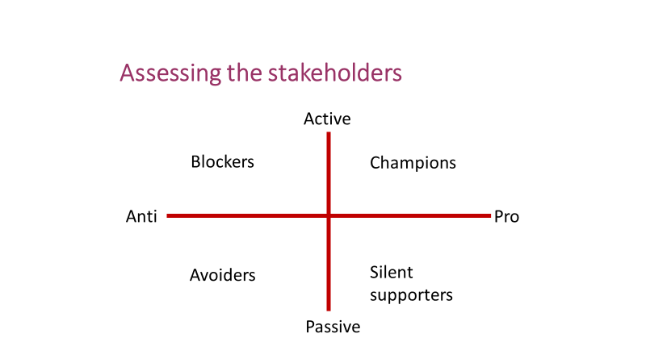
One of the most important decisions in developing an advocacy strategy is whether to work within a coalition. This depends on where other stakeholders stand on an issue. One way of assessing the position of other stakeholders is to consider those opposing and those supporting your aims for your advocacy issue. Some may be active in their support or opposition and others may be passively in favour or against progress. Sometimes the most difficult stakeholders to deal with are those passive opponents and those generally in favour but not prepared to take action.
In practice it often happens that these stakeholders are prepared to go some way towards the action you support but not as far as you would like. In such cases it is important to assess how much progress can be achieved and what factors are holding them back, this is rather like a training needs assessment. Your response may be compromise accepting the best that can be achieved for now or to oppose them.
You should also consider SfGH’s basis for advocacy and that of a coalition in terms of:
- Power:
  - Discursive power to define the situation – can you define the situation (e.g. for students)
  - Decision making – can you take decisions on behalf of members (legally binding or not)
  - Economic – can you raise funds or resources (such as student time) for specific actions
  - Influence – can you motivate students or others (and can you show evidence of views)
- Legitimacy:
  - Moral – can you make a case in terms of the human rights of those you represent
  - Democratic – can you demonstrate the support of members or students
  - Experience and knowledge – can you show evidence for your advocacy position
On this basis you may decide to join a coalition or alliance or take your own stand. The advantage of coalition is that you gain power and legitimacy for your position, the disadvantage is that your specific policy position may be compromised and the views of groups you represent may not be visible. In practice it is seldom the case that a coalition speaks with one voice – often there are many. You will therefore need to negotiate with other coalition members to achieve outcomes that meet both their aims and yours – this calls for what is known as – “Win- Win” negotiation.
You need to consider whether to align SfGH with others in relation to your advocacy positions.

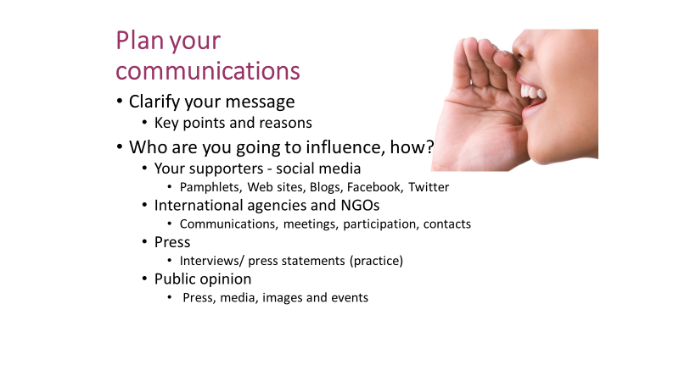
It is tempting to use a catchy phrase as a starting point for an advocacy programme but personally I would advise against this approach. You need to understand the ongoing dialogue, the evidence, the other stakeholder and the potential contribution your organisation can make before formulating your message. Once you have this understanding, of course a memorable way of getting your message across can be useful as part of a comprehensive communications plan.
Your communications plan should consider how you will keep in touch with your supporters and those you seek to empower by your advocacy. This will probably involve social media such as Facebook and Twitter. After all you will be advocating on their behalf so any SfGH protest group will need to plan how to keep followers engaged. As a start try looking at https://ctb.ku.edu/en/table-of-contents/advocacy/direct-action/electronic-advocacy/main Google to find tips and advice you find helpful and share with your group.
You also need to consider the agencies and people you are trying to influence, you should try to find names and if possible photos so that you can make contact. Think through the message you want to put across to these contacts and what the IFMSA and its member organisations can offer them, for example, contact with young people through social media. This may require you to butt into people’s conversations; be polite but assertive (try https://www.youtube.com/watch?v=ubSL1tFmgDc ) Some sort of brief pamphlet or visiting card may help and you may also be setting up longer term contacts, so a contact book is essential.
Making contact with the press is vital but dangerous, always remember they have their own agenda, so be careful, stick to your position and what you know. Make sure you control the message and are not part of someone else’s story. One useful exercise we could try is to practice making your case in a four-sided debate and responding to questions from the press, for tips on how to present your case try http://www.rogerdarlington.me.uk/Speech.html or Google to find advice you find helpful. You will also enjoy the opportunity to act as press reporters.
You may wish to prepare a press statement for your advocacy issue as part of a communications plan.

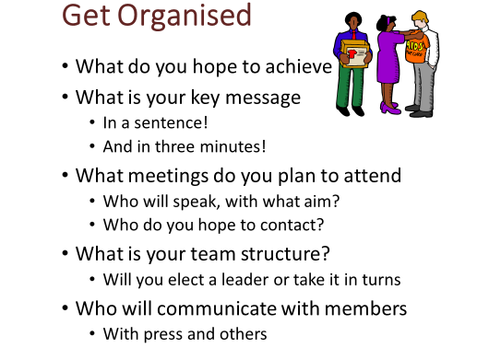
In summary, if you have thought through the points in this learning programme in relation to the specific issue you are addressing, you should now be able to get organised. This means sorting out your roles in the team and moving into action.
This material owes a great deal to Ilona Kickbusch, fellow Senior Associates and the team at the Global Health Centre of the Graduate Institute Geneva. I should also acknowledge the many people who contributed ideas and suggestions including: John Wyn Owen, Nigel Crisp, Neil Squires, Andy Haines and Paul Webster Hare, Paul Collier and the 120 WHO Heads of Country Office participants in our online course. I must also thank the many people I have worked with over 45 years including the inspirational women who lead the health services of rural East Africa and the late Beat Richner in Cambodia (see http://www.beat-richner.ch/ ) and Mechai Viravaidya in Thailand (see http://mechaifoundation.org/ ) .
I hope you will also look back at the competences listed and feel you have made progress, but you should also recognise that there is much more to discover, lessons and ideas you can continue to develop throughout your professional life. SfGH participates in many fora including regional and global conferences on health, climate change, and equity. These lessons are equally relevant to participation in all fields of global governance which link local and global action.
Do not expect this to be simple or easy – it is complex, difficult and slow moving. Moreover, health is probably the area on which there is greatest international agreement – progress in other areas of global governance – tackling poverty and sustainable development will be even greater challenges for your generation. I hope these notes have raised some of the questions, to which you will find your answers.
Consider your learning objectives for this programme and be prepared to share ideas.

Reading
Some useful books:
“Global Health Diplomacy: Concepts, Issues, Actors, Instruments, Fora and Cases.” Ilona Kickbusch, Graham Lister et al Springer Books, 2013
“Turning the world upside down - the search for global health in the 21st century” Nigel Crisp, Royal Society of Medicine Press, 2010
“How to Run the World” Parag Khanna, Random House, 2013
“Getting Past No” William Ury, Random House, 1991
“Making Diplomacy Work: Intelligent Innovation for the Modern World” Paul Webster Hare CQ Press, 2015
“Naked Diplomacy” Tom Fletcher, William Collins Books 2016
“Diplomacy: a very short introduction” Joseph Siracusa Oxford University Press 2010
“The Bottom Billion” Oxford University Press 2007 and “Wars, Guns and Votes” Vintage Books, 2009 by Paul Collier
Some web sites:
The IFMSA Policy Statements: https://ifmsa.org/statements/
Global Health Programme of the Graduate institute Geneva: http://graduateinstitute.ch/globalhealth
“The Lancet—University of Oslo Commission on Global Governance for Health” The Lancet 2014 or watch the launch online: http://www.thelancet.com/commissions/global-governance-for-health
Global Health Europe web site: http://globalhealtheurope.org/
Save the Children manual on advocacy: http://resourcecentre.savethechildren.se/sites/default/files/documents/1979.pdf
Graham Lister web site at http://www.building-leadership-for-health.org.uk
Institute for Health Metrics and Evaluation web site at http://www.healthdata.org/
Some articles:
Kickbusch, I (2014) A New Governance Space for Health, Global Health Action 2014, 7: 23507 at https://www.tandfonline.com/doi/full/10.3402/gha.v7.23507
Kickbusch, I (2011) Global health diplomacy: how foreign policy can influence health. London: British Medical Journal. https://www.diplomacy.edu/global-health-diplomacy-how-foreign-policy-can-influence-health
Støre, J. Norwegian Minister of Foreign Affairs (2012) Keynote address at the World Health Assembly. at http://www.regjeringen.no/en/archive/Stoltenbergs-2nd-Government/Ministry-of-Foreign-Affairs/taler-og-artikler/2012/keynote_wha.html?id=682761
Kickbusch, I and Kokény, M (2013) Global health Diplomacy: five years on. Bulletin of World Health Organization, Volume 91, March 2013. at http://www.who.int/bulletin/volumes/91/3/13-118596/en/index.html
Clift, C (2013) The Role of the World Health Organization in the International System. Centre on Global Health Security Working Group Papers, Chatham House. Working Group on Governance, Paper 1. at http://www.chathamhouse.org/publications/papers/view/189351
World Health Organization [WHO] (1948) Constitution of the World Health Organization at http://apps.who.int/gb/bd/PDF/bd47/EN/constitution-en.pdf

