Training Toolkit 6a: International Negotiation Exercises
6a
Graham Lister
1/12/2020

Negotiation Exercises
The following negotiation case studies are based on real situations, that have been simplified; health diplomacy is much more complex.
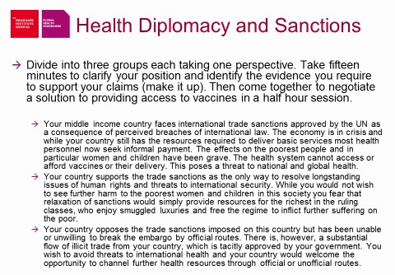

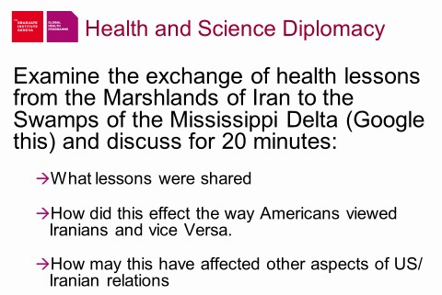
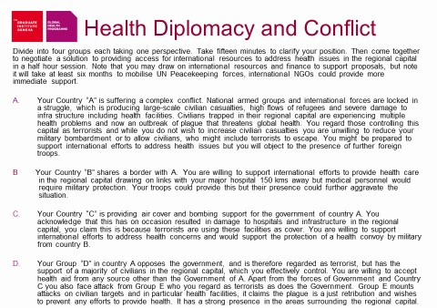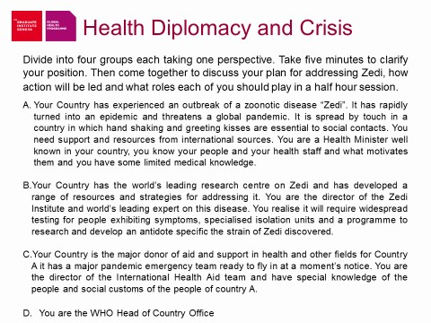

Negotiating a Global Health Agreement
This is a case study to give you the feel of global health diplomacy, based on a real case but simplified. Divide into teams and negotiate. Remember: Negotiations often involve coalitions of those in favour or opposed to particular outcomes. It is vital to maintain the strength of the coalitions, as although the leading advocates may have a clear position, their strength in negotiation depends on support from other coalition members. Negotiators may attempt to appeal to the interests of opposing coalition members and thus undermine their support for the lead opposition advocates. Conversely coalition members may be best placed to offer compromise solutions, softening the position of their coalition in response to outcomes that meet their interests. So if you think this is just a negotiation between two protagonists, think again! It is the coalition members and their interests that are the key to this negotiation and why it is so complex.
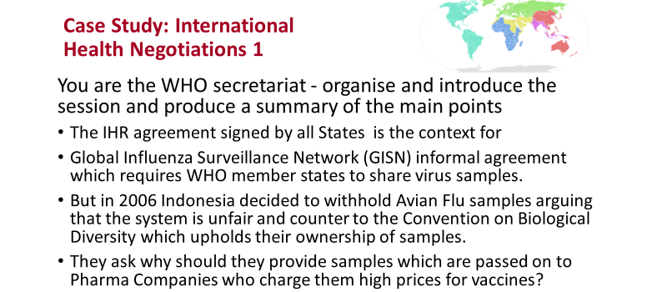

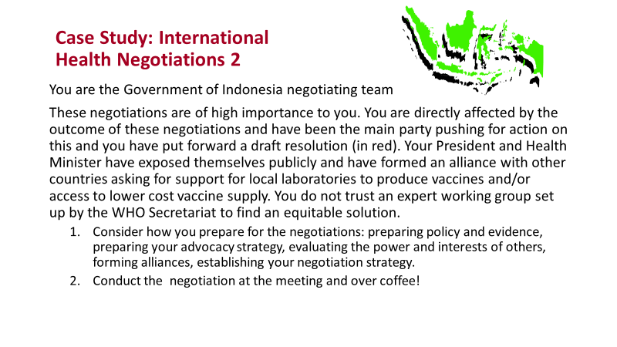

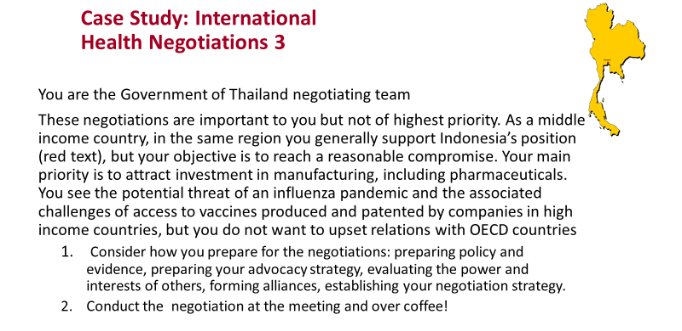

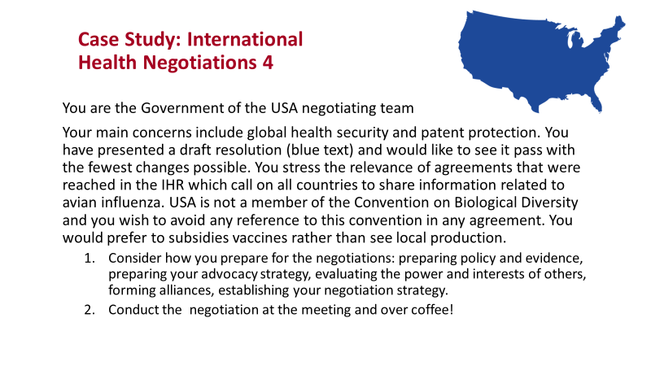

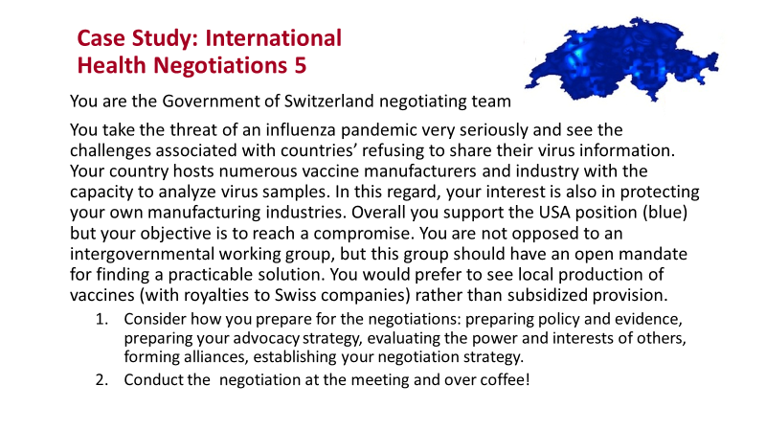

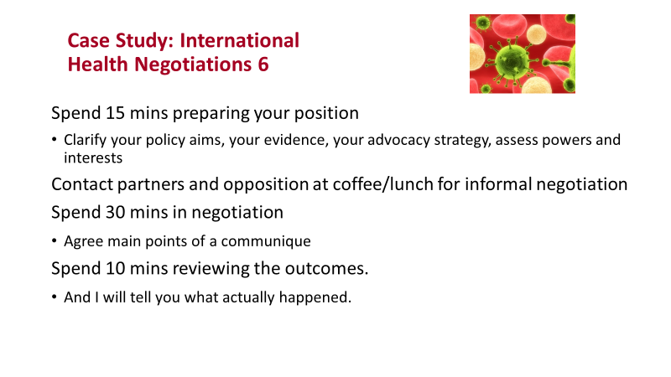

VIRUS SHARING DRAFT RESOLUTION TEXTS
Black Text is the original proposal from the WHO Secretariat (EB 120/R7)

Red Text is proposed by Algeria, Brunei Darussalam, Cuba, Democratic People’s Republic of Korea, Indonesia, Iran, Iraq, Lao People’s Democratic Republic, Malaysia, Myanmar, Maldives, Peru, Qatar, Saudi Arabia, Solomon Islands, Sudan, Thailand and Timor-Leste
Blue Text is proposed by United States of America with support of most European and OECD states
WHA Resolution
Avian and pandemic influenza preparedness:
sharing of influenza viruses and access to vaccines and other benefits
The Sixtieth World Health Assembly,
Having considered the report on avian and pandemic influenza: developments, response and follow-up;
Recalling resolutions WHA58.5 and WHA59.2, which expressed concern about the potential of
the H5N1 strain of Influenza virus A to cause a pandemic and urged Member States to disseminate to WHO collaborating centres information and relevant biological materials, including clinical specimens and viruses;
Recognizing, in particular, the importance of international sharing, with WHO collaborating
centres, of clinical specimens and viruses as a contribution to assessment of the pandemic risk, the development of pandemic vaccines, the updating of diagnostic reagents and test kits, and surveillance for resistance to antiviral medicines,
1. REQUESTS the Director-General:

(1) to establish an intergovernmental process in order to review the existing practices and mechanisms for sharing influenza viruses, to establish principles and guidelines for sharing influenza viruses and to review existing terms of reference of WHO collaborating centres based on the following principles:  - any international sharing of biological materials with WHO collaborating centres shall be conducted through agreements on mutually agreed terms, based on the principles of prior informed consent, and fair and equitable sharing of benefits;  - transfer of any virus and parts thereof by a receiving WHO collaborating centre to another WHO collaborating centre shall be effected on the same terms as the initial agreement between the country contributing the virus and the collaborating centre. The country contributing the virus and parts thereof shall be informed by way of a written notification prior to any such transfer; | (1) to continue to coordinate international surveillance of seasonal influenza viruses and viruses with pandemic  potential; | (1) to mobilize financial and technical  support from Member States, vaccine manufacturers, development banks, charitable organizations, and private donors to assist in constituting a safe and effective H5N1 influenza-vaccine stockpile;

- any vaccines, diagnostics, antiviral agents and other medical supplies arising from the use of the virus and parts thereof must be made available at an affordable price and in a timely manner to developing countries, particularly to those under the most serious threat of, or already experiencing a pandemic;
- no viruses or parts thereof shall be
distributed to any party outside the network of WHO collaborating centres without the written prior informed consent of the country contributing the virus;
- WHO collaborating centres, shall neither claim nor obtain any form of proprietary rights over the virus provided or any parts thereof; except with the explicit written prior informed consent of the country contributing the virus and parts thereof;
- the country contributing the virus and whose prior informed consent is required shall be entitled to establish conditions accompanying any decision on consent, which may include arrangements for sharing, of benefits, including access to sufficient quantities of vaccine supplies at affordable prices for itself and other developing countries, transfer of technology and knowhow to strengthen manufacturing capacity and other capacity-building activities;

(2) immediately to intensify, in a manner appropriate to the situation in each developing country and particularly in those countries affected by the H5N1 influenza viruses, capacitybuilding activities related but not limited to virus identification, virus characterization, identification of new virus strains, generation and interpretation of data on or related to influenza and avian influenza, and generation of seed virus for vaccine production; | (2) as appropriate, to identify, recommend and provide support for the implementation of possible options aimed at promoting the accessibility of pandemic influenza vaccine and antiviral medicines to all, for example by mobilizing adequate funding for research on, and development of, the pandemic influenza vaccine and antiviral  medicines; | (2) to develop mechanisms to promote increased access to influenza vaccine, in particular for developing countries without vaccine production capacity, including pandemic influenza vaccines, resulting from research on influenza viruses;
 | (3) to take appropriate action if WHO is notified by a Member State that believes that the viruses provided by that Member | (3) to appoint an ad hoc WHO Working Group to advise Member States and the Director-General on:

 | State were misused for research or commercial purposes in a manner that violates best practice by a  WHO collaborating centre | - the most appropriate size of a stockpile of candidate H5N1 vaccines;  - operational procedures, based on expert guidance and evidence, to address how to use most effectively such an H5N1 stockpile;  - mechanisms to promote access to safe and effective pandemic influenza vaccine;
(3) to seek the support of industrialized countries, and vaccine manufacturers in mobilizing financial and technical support for stockpiling safe and effective H5N1 and other potential pandemic-influenza vaccines that may be used in developing countries, particularly those that have been affected by influenza or have high risk due to geographical proximity; | (4) to facilitate broader and more equitable regional distribution of production capacity for influenza vaccine and increasing production capacity for pandemic vaccines by leading implementation of WHO's global pandemic influenza action plan to increase vaccine supply, emphasizing those activities that help to increase access to pandemic vaccines in developing countries and other countries that lack domestic manufacturing  capacity; | (4) to explore options to establish a stockpile of candidate H5N1 vaccines as an interim measure, pending completion of the report of the working group referred to above, to enable increased access to safe and effective H5N1 vaccine and maximum flexibility in its maintenance, monitoring and deployment;
(4) to seek additional support from developed countries, funding partners and vaccine manufacturers to facilitate the transfer to developing countries of the technology and know-how necessary to establish influenzavaccine production and to enable production capacity to be functional as soon as possible; |  | (5) to provide technical support to Member States, upon request, to increase capacity for vaccine development and production, and strengthen their regulatory pathways for licensing and approving safe and effective seasonal and pandemic influenza vaccines;
(5) to report on the implementation of this resolution and submit the outcome of the intergovernmental process to the Sixty-first World Health Assembly in May 2008, through the Executive Board. | (5) to report annually to the Health Assembly through the Executive Board on the situation of pandemic influenza and global preparedness. | (6) to report to the  Sixty-First World Health Assembly, through the Executive Board, on the results of the Working Group and the implementation of this resolution.

Outcome Summary

In real life the negotiations were very long and protracted, they failed at first but eventually produced an outcome that could be celebrated as a win-win for all parties. This set the scene for the current international response to the Coronavirus-19 pandemic. So you will see what went reasonably well and what failed. I hope you do better with your negotiations.

This negotiation lasted for 3 years and finally produced am outline agreement in 2009. However, the implementation of this general agreement was only finally agreed in 2011 and indeed there is still ongoing discussion of steps to be taken. You can Google the result and the history of the negotiations. We suggest you do this after you have tried to negotiate your own settlement. You will note that the key to success is to try to offer concessions to the opposition coalitions to reach an outcome more appealing than the hardline position initially taken by Indonesia and USA but making progress that suits all parties. Informal negotiations between coalition members in preparation for the formal negotiation can be very helpful. The role of WHO in setting the rules for negotiation and in summarizing and suggesting next steps is also crucial.
For details see http://www.cidrap.umn.edu/news-perspective/2011/04/who-group-finalizes-landmark-pandemic-virus-sharing-agreement

Presentation on Background and Outcome
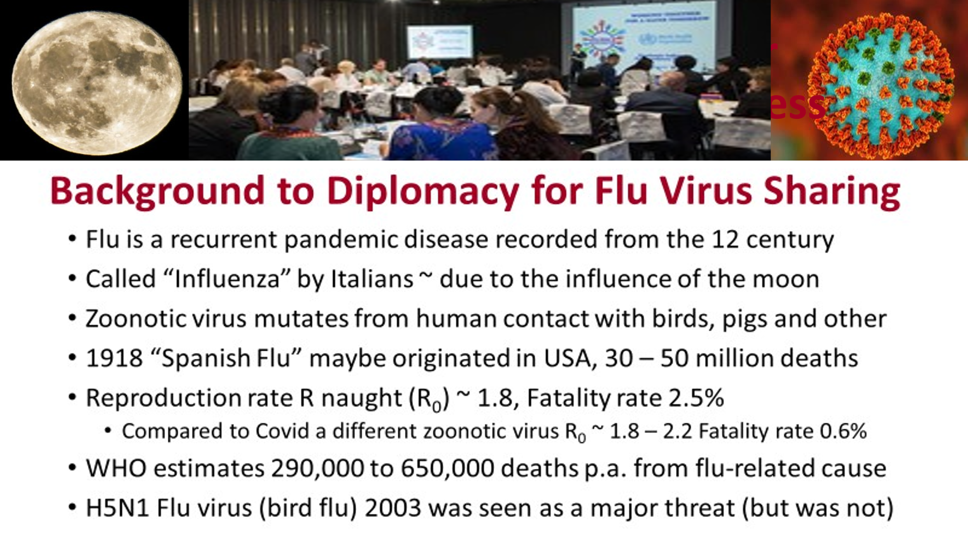
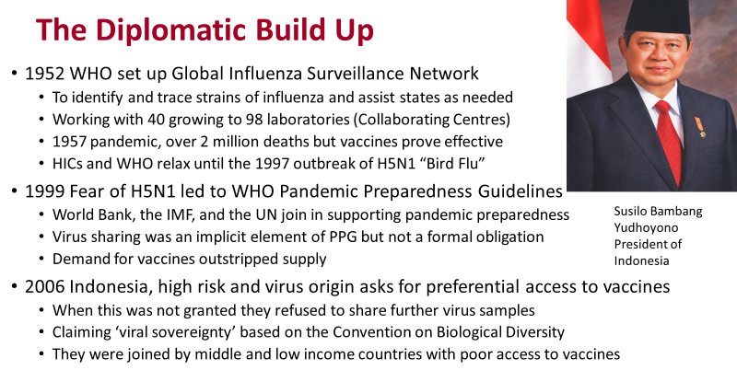
This provides the basis for a fuller discussion of the background and outcome as it happened in real life. Your trainer may use this as an introduction and then explanation of what happened and why it is so relevant to the COVID-19 Pandemic.

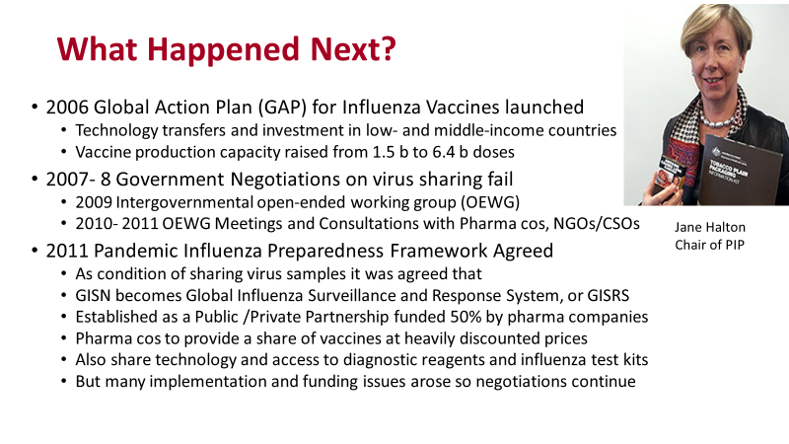
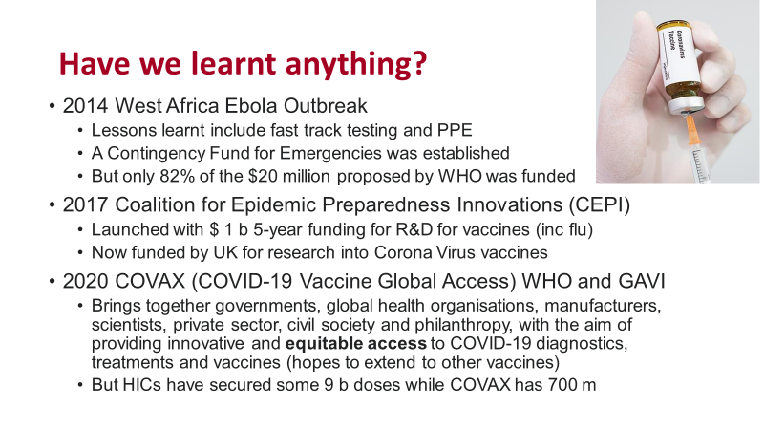
WHO Director General Dr Tedros Adhanom Ghebreyesus has called for coronavirus vaccines to be delivered equitably across the globe to prevent deaths in the poorest countries. He warned that world is on the brink of a catastrophic moral failure if Covid-19 vaccines are not distributed fairly to low-income countries. Moreover this would also leave the world at risk of further COVID pandemics as the virus mutates in neglected regions.

