6
Graham Lister

6
Training Toolkit 6 International Health Diplomacy
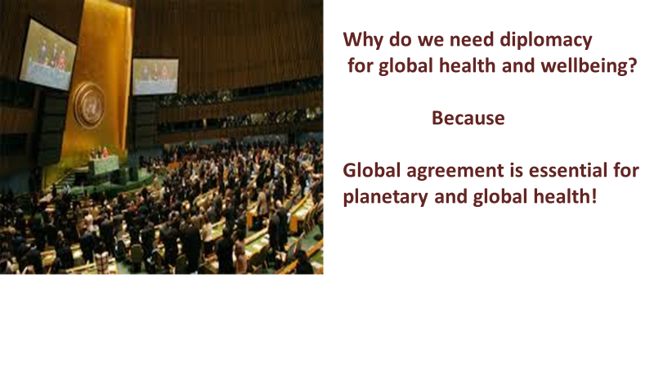
These are discovery learning tools intended to be quickly skimmed to provide an outline of ideas with online links that can be followed up so that can discover their own answers. The exercises are for groups of students and you are very welcome to update, improve, share and use the material as you like. Some of this material is repeated from other training toolkits and some of the other toolkits provide a different perspective on aspects like advocacy at global meetings or local negotiations for health.
The topics covered in this toolkit are:
- Why diplomacy is essential for public health.
- What is diplomacy?
- How diplomacy developed in modern times.
- Modern forms of diplomacy
- New Diplomacy – or how the world is run
- The History of Global Health Diplomacy
- Global Health Diplomacy 2000 - 2015
- The Future of Global Health Diplomacy
- Understanding International Law
- Agreements for Health
- What is a Good Agreement
- The Negotiation Process
- Negotiation: Preparation Power and Persistence
- Tips for Health Negotiators
- Formal and Informal Negotiations
- Leading Global Health Diplomacy
- Resources

A more extensive course on Global Health Diplomacy and Advocacy is available at Training Toolkit 6. Exercises that can be used to try out some of these learning points are at Toolkit 9a.

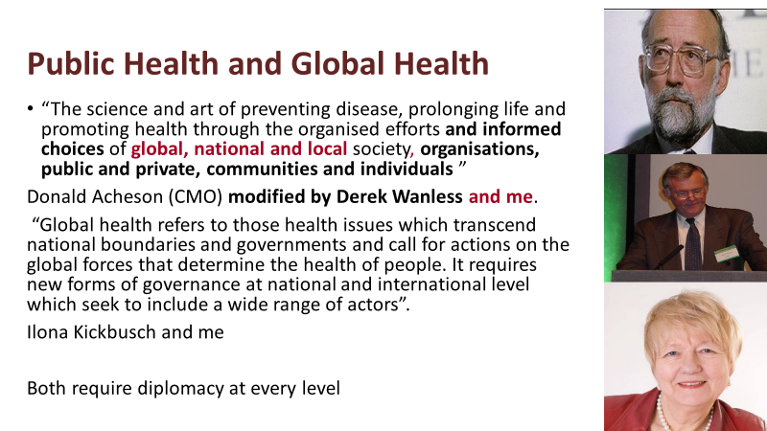
The US Institute of Medicine published a report in 1997 called “America’s Vital Interest in Global Health: Protecting Our People, Enhancing Our Economy, and Advancing Our International Interests”. Hillary Clinton hosted an event to introduce the paper to an international audience, including John Wyn Owen, the Secretary of the Nuffield Trust. He brought the idea to England and, he asked me to coordinate a programme with Kelly Lee of the London School of Hygiene and Tropical Medicine. This produced a national symposium entitled “Global Health: a local Issue” (later adopted as Medsin slogan). We also hosted the first international symposium on health and foreign policy, chaired by Gro Brundtland (Director of WHO) for which I was the raporteur and the first programme on global health at the European Health Forum at Gastein.
Ilona Kickbusch and I edited “European Perspectives on Global Health: a policy glossary” in 2004. This is set out in “Global Health Europe” Web site http://globalhealtheurope.org/. Ilona became Professor of Global Health at the Graduate Institute of International and Development Studies, Geneva where until 2019 she led the Global Health Centre recognised by the WHO as a collaborating centre for global health diplomacy see http://graduateinstitute.ch/globalhealth. The Global Health Centre Training programme for WHO Country Leaders which I tutored, recognised that diplomacy is an essential art of WHO leaders, from whom I learnt most of the lessons shared in this toolkit. We also teach diplomacy and advocacy to international Federation of Medical Student Association representatives to the World Health Assembly where global health laws are agreed. I later chaired the Board of Trustees for SfGH.
The Wanless Review of 2002, for which I prepared some of the forecasts, “Securing Our Future Health: Taking A Long-Term View” led to the conclusion that health and care would only be affordable if the public could be fully engaged. This suggests that diplomacy is an essential element of Public Health and Global Health, however they are defined.
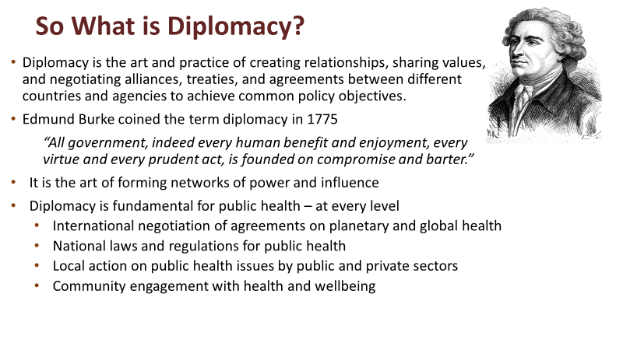
Diplomacy in the modern world is not confined to relationships between states, local groups, NGOs, CSOs and businesses must also be engaged in the process, that can be simplified as “building networks of power and influence to achieve common goals”.
Diplomacy starts by listening, building relationships, developing shared values and mutual understanding and establishing coalitions of the willing. It does not end once an agreement is signed, diplomatic negotiations continue throughout the implementation of agreements.
Since 1945 when the current UN system was established following the Bretton Woods meeting, the environment within which diplomacy functions has changed:
• To a multipolar world in which alliances of interest groups press for common interests.
• Growth in the number of States, about 60 in 1945 compared with 193 today.
• Rise of global trade, which accounted for 20% of global GDP in 1950, to 60% in 2008,
- The exercise of WHO’s role in international law, establishing global health laws.
• The rise of regional and sub-regional organisations including the EU, AU, ASEAN.
• Public Private Partnerships (~300), International NGOs (~ 1,000), and CSGs (~ 250,000).
• Information and Communications Revolution with 2 billion active internet users.
• Ideology and terrorism which weaponise religions.
• Recognition of the need to address global and planetary threats to our future.
• Rising nationalism and protectionism as a backlash against globalisation.

To read more on the history of diplomacy try “Making Diplomacy Work: Intelligent Innovation for the Modern World” by Paul Webster Hare, ”Naked Diplomacy” by Tom Fletcher, or “Diplomacy: a short introduction” by Joseph Siracusa.
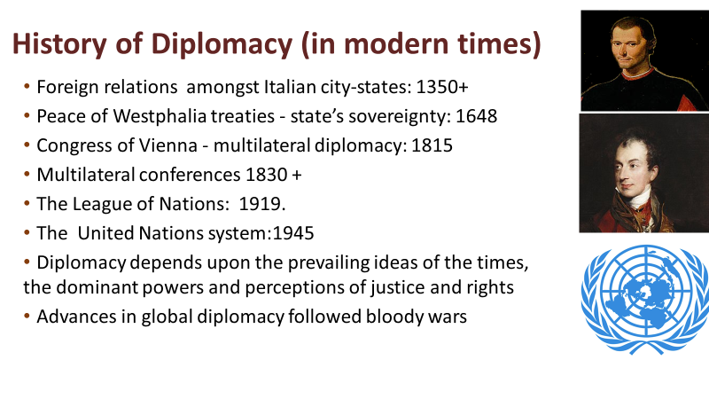
Fourteenth-sixteenth century: The political works, of Niccolò Machiavelli - “The Prince” and “Discourses” introduced a “realist” perspective now associated with Henry Kissinger.
Seventeenth century: The Peace of Westphalia introduced the concept of state sovereignty. Thomas Hobbes, “Leviathan” sets out a case for a powerful state, to control the excesses of competition. John Locke argued for a contract between government and citizens with a constitution to empower and restrain it, introducing what is now called a “liberal” perspective.
Eighteenth century: European Powers shifted alliances to maintain a balance of economic and military power. Adam Smith’s “The Wealth of Nations” shows the “economic structuralist” perspective, later used to support a diametrically different conclusion by Karl Marx.
Nineteenth century: At the Congress of Vienna, Metternich introduced a new multilateral system of diplomacy. Multilateral conferences allowed for simultaneous negotiation among states. Jeremy Bentham’s utilitarianism, a forerunner of “welfare economics”, has resonance.
Twentieth century: The diplomatic system was weakened by rivalries leading to the First World War. The League of Nations was the first universal state membership organisation. The idea was to move to a ‘parliament of man’. Bertrand Russell’s logical positivism is reflected in this.
The United Nations Declaration for Human Rights (1948) established for the first time that other governments could be concerned with how a state treats its people, this may be said to be informed by Immanuel Kant’s Categorical Imperative and its implications (1785). The practice of UN diplomacy reflects John Rawls “A Theory of Justice” balancing freedom and justice, or fairness and focussed on human rights to basic goods and the institutions that support them with limited grounds for challenging sovereignty.
Twenty first century: Current diplomatic theory (http://www.diplomacy.edu/courses/theory ) recognises the importance of freedom to develop human capability, as Amartya Sen notes, “The Idea of Justice” may have different meanings.
Diplomacy reflect the prevelant ideas of the times, ideas that only changed after bloody wars.
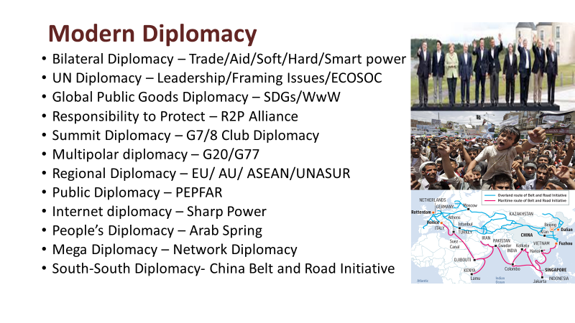
Bilateralism remains the prevalent form of relationship,70% of aid is provided through bilateral agreements between a donor country or group such as the EU and a recipient.
The UN is increasingly focussing on global public goods for sustainable development and have been engaging Civil Society organisations, through ECOSOC, “The World we Want” (WwW) debate on post 2015 goals and in the “Responsibility to Protect” (R2P) Alliance (Google these).
‘Summit diplomacy’ was initially dominated by the G7 /G8 meetings, but, when faced with the global economic crisis of 2008, the locus of discussion moved to the G20 meeting of the Finance Ministers of the 20 leading economies, representing 80% of the global economy.
Regional Organisations and sub-regional co-operations have greatly increased in recent years and South-South and Triangular Co-operation has also grown. Google to find the wide range of regional and sub-regional organisations which work together for health in your region.
Soft power is described by Joseph Nye as” getting people to want the things you want” through Public Diplomacy (propaganda). Smart power refers to clever use of diplomatic instruments ranging from persuasion to trade, aid and possible sanctions, backed by force. More recently “Sharp Power” has been used to describe targeted efforts to influence specific decisions in other countries, including elections.
Mega Diplomacy goes beyond inter-governmental relations to a new approach to global challenges that involves non state actors across the board
Peoples Diplomacy expresses public aims and rage, via social media – e.g. the Arab Spring.
South South Diplomacy – the growing ambition of what were once considered “developing” countries is evident in agreements on mutual aid and trade, sometimes including a high income country partner in “triangular aid cooperation”. China, now the second largest global economy, is the largest lender to African countries. Moreover its “Belt and Road Initiative” can be seen as introducing a further paradigm shift in diplomacy see here.
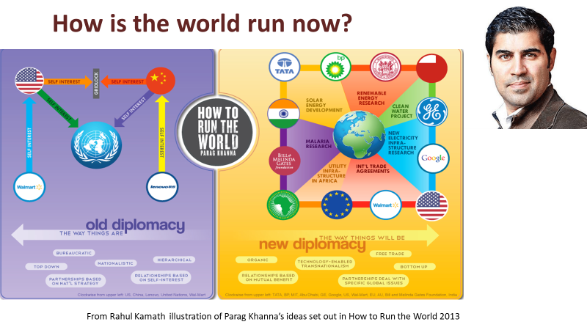
Parag Khanna’s ideas set out in his 2011 book “How to run the world”. are illustrated by this diagram produced by Rahul Kamath. His view of modern diplomacy moves beyond the state centric world of the 1944 Bretton Woods system, to what he describes as mega diplomacy. This takes place in a “multi-polar” world, in which shifting coalitions of states, international NGOs, philanthropic foundations, multi-national businesses, cities, civil society groups and others influence the formation and application of partnership agreements to address national, regional and global concerns – such as global health.
The current system may be said to combine elements of both the “old” and “new” global diplomacy. This view is echoed by Stewart Patrick of the US Council on Foreign Relations in his article “The Unruled World” (see http://www.foreignaffairs.com/articles/140343/stewart-patrick/the-unruled-world ). Stewart argues for “good enough” global governance, accepting the reality of a weak UN system, stymied by the diffusion of power across states and other actors with widely different interests that may coalesce to address specific issues. Both Parag Khanna and Stewart Patrick present views of “global governance” as a complex and difficult process, involving many different actors at national, regional and global levels. In this world there is no single view of justice but many different perspectives on what is equitable – as reflected in Amartya Sen’s “The Idea of Justice”. You may wish to Google some of the You Tube videos, in which Parag Khanna explains his view of the world.
NGOs and CSOs play an important role in connecting individuals and communities to global issues creating a “whole society approach” see for example this talk on a global approach to Cancer by Trevor Hasssell https://www.youtube.com/watch?v=BAiY8-ZUuLk . This requires a renewed approach to coalition building and national and global levels encompassing state actors, the private sector and Civil Society Organisations.

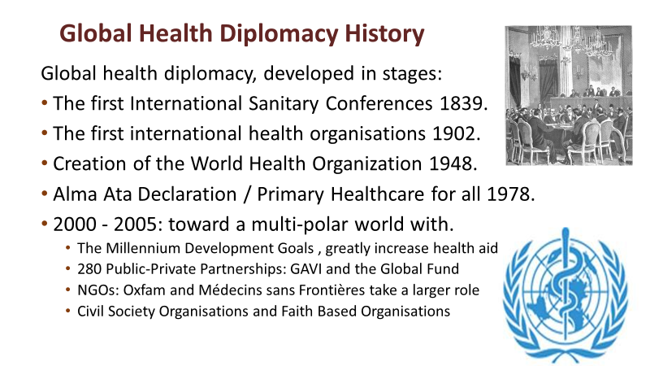
Constantinople Supreme Council for Healthcare 1839 was the first international body to control health. The 1851 International Sanitary Conference held in Paris, was the first of 10 to consider infectious diseases and their impact on trade and shipping, bringing together at first 7 and then 12 countries. Doctors were later replaced by diplomats and last by doctor/diplomats.
The Pan American Sanitary Bureau (PASB) was created in 1902, the International Office of Public Hygiene (OIHP) in 1903, and the League of Nations Health Organization (LNHO) in 1920.
The WHO resulted from the unification of the OIHP, the LNHO, PAHO and other regional bodies. By that time the regional PASB had been very active since its inception in 1902 and had become the Pan American Health Organization (PAHO). The diplomacy that led to the creation of the WHO was led by a Chinese health diplomat Dr Szeming Sze.
The Alma Ata Conference in Kazakhstan, brought together countries across the divides of the Cold War. The success of this conference also paved the way for health to become a leading focus for international agreement at G7/8 meetings, at the UN and the MDGs and SDGs.
A Multi-Polar World, with the end of the cold war, a more complex diplomatic environment emerged, this has introduced many more actors in global health diplomacy, including international NGOs and CSOs. See Toolkit 13 for a list of some 450 European Global Health Organisations.
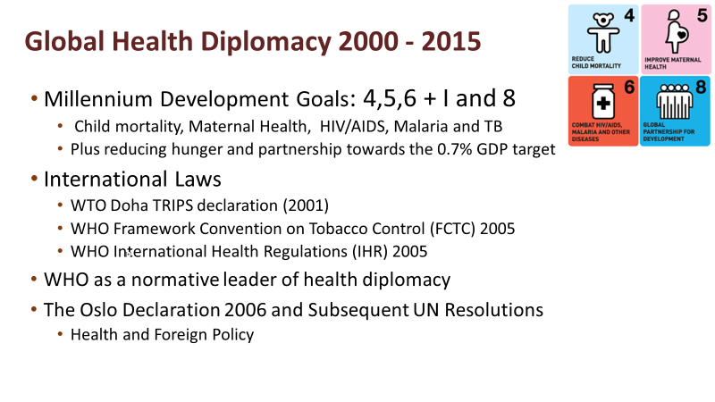
The MDGs introduced a new pattern of diplomacy for global development goals, with clear targets and commitments followed up by monitored results. They reinforced the link between health and foreign policy, see Hilary Clinton: https://www.youtube.com/watch?v=7IgrNuXBI-s
The WTO TRIPS agreement enables low income countries to use generic copies of patent protected essential medicines during a health crisis. This had been disputed since 1995.
The FCTC adopted at the World Health Assembly of 2005 was the first multilateral, binding agreements regarding a chronic, non-communicable disease.
IHR was another step towards an international legal framework for global health. Regulations were discussed for many years as a redefinition of a 1969 agreement based on mid 19th century laws. In 2003 the shock of the SARS Pandemic brought rapid agreement but insufficient funds
WHO’s core functions the 11th General Programme of Work set its role in health diplomacy:
1. Provide leadership on matters critical to health and engage in partnerships.
2. Shape the research agenda and stimulate knowledge.
3. Set norms and standards and promote and monitor their implementation.
4. Articulate ethical and evidence-based policy options.
5. Provide technical support, catalyse change and build institutional capacity.
6. Monitor the health situation and assess health trends.
WHO Triple Targets were clarified in 2018 as to show one billion more people benefiting from universal health coverage, one billion people better protected from health emergencies, and one billion people enjoying better health and well-being
The Oslo Declaration and United Nations Resolutions on Global Health and Foreign Policy (UNGA, 2008, 2009 and 2010) stress the need to train diplomats and health officials in global health diplomacy. The Global Health Programme of the Graduate institute Geneva developed a range of courses, books, and case studies to support global health diplomacy see http://graduateinstitute.ch/globalhealth .
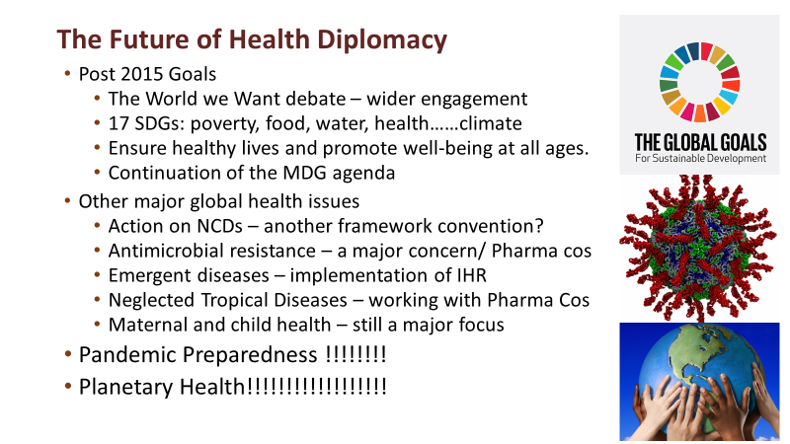
The SDG Debate on the post 2015 Sustainable Development Goals has resulted in wider cross sector engagement of a million voices. For health the focus of the proposed new post 2015 goal is to ensure healthy lives and promote well-being for all throughout lifetime.
NCDs, CSOs and Private Sector have been engaged, the question is, whether negotiations with the food industry can be combined with regulatory action and public awareness to protect against junk food, sugar consumption, alcohol, smoking, etc.
Antimicrobial Resistance (AMR) strains of diseases are developing due to misuse of antibiotics for treating cattle and coughs in rich countries and uncontrolled sale in poor countries, is an urgent issue. To illustrate this issue, I bought a single dose of Rocephin, a fourth-generation antibiotic, in a wayside shack in Cambodia, where AMR is fast growing.
Emergent and re-emergent diseases (particular zoonotic e.g. Covid and Influenza) pose a continuing threat to global health. The current pandemic has helped to change opinions:
- The pandemic has cost some 5% of Global GDP compared to 0.05% spent on health aid.
- International cooperation, sharing of knowledge, vaccines and tests has been essential.
- Community understanding and action has been central to control the spread of the virus
- New ways of delivering care have emerged e.g. Online Consultation, Test and Trace
- Barriers between medical treatment and social care have proved to be obstacles.
The Pandemic provides an opportunity to rethink and renegotiate the global governance of health and to take steps to strengthen global investment in public health, there are also signs of a growing trend towards a retreat to national and sectional interests. Diplomatic leadership is essential if the next generation is to be able to manage threats to planetary health posed by: Planetary Health Threats: of climate change, acidification of the oceans, plastic pollution, loss of biodiversity, deforestation, competition for water and food and over use of fertilisers.
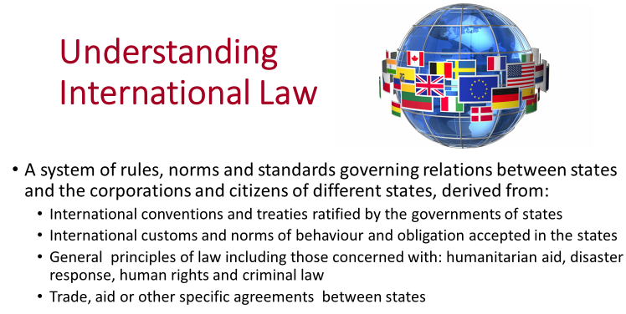
International laws relevant to health include the Framework Convention on Tobacco Control, the International Health Regulations, the Codex Alimentarius Commission: Codex Guidelines for the Exchange of Information in Food Control Emergency Situations. There are also many aspects of agreements on trade (e.g. TRIPS) and the environment (Paris Accord) that impact on health.
Hard and Soft Laws are term used to describe the extent to which agreements commit states which ratify the law to provide recourse to sanctions in international law if not complied with. Hard-laws are expressed in many forms including: Constitutions, Conventions, Framework Conventions, Regulations and Protocols.
Soft Laws implies a general agreement with perhaps some mutually understood consequences in case of non-compliance but not recourse to international courts. Soft law instruments are usually identified as: recommendations, codes of conduct, strategies, nomenclatures, standards; advisory mechanisms and collaborative, operative, and normative instruments. These include memoranda of understanding (MoU), often used to express commitments to bilateral aid collaboration. But there is no rigid classification of hard or soft laws.
A global health law, like other international laws, usually requires the agreement of all parties not only to introduce the law but also to apply it in practice. Even in cases such as genocide it has been be difficult to establish a strong enough coalition to enforce laws by international military action sanctioned by the UN Security Council (see Toolkit 7 for discussion of this example). In other fields international laws or agreements have been challenged because they are seen as conflicting with rights arising from other conventions. The dispute over the provision of influenza virus samples, in Toolkit 9a explores such a case.
International laws may evolve, from a resolution at the UN General Assembly where an issue is raised and general support is gathered. The issue may then be discussed at international conferences involving NGOs and CSOs, this stimulates research, advocacy and proposals. In some cases agreement for action may be reached first at national or regional level (e. g. the EU or AU). It may then be proposed as an international law at the World Health Assembly.
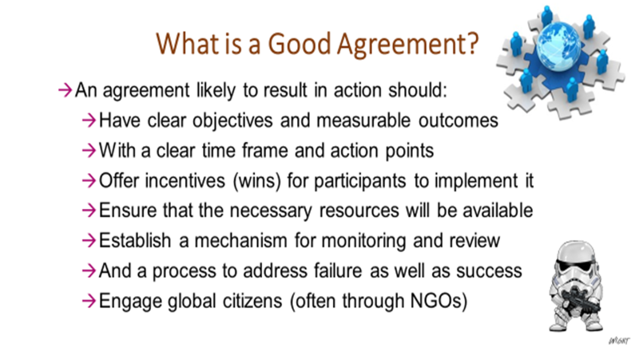
Global health agreements at national, regional and global levels are the goals of diplomacy. But agreements, do not necessarily result in action. This is not “Star Wars” where disobedience will result in the “storm troopers” descending. Many agreements simply represent an intention to address common problems, without clarity as to what should be achieved, by whom, when and with what resources. Such agreements may be intended to promote certain issues or national interests and even a weak agreement may have a role in preparing the ground for a more substantial commitment to action at a later stage.
Evaluate agreements using the list above: do they have clear objectives, measurable outcomes, clear time lines, do they offer wins for all participants, are resources available to implement them including monitoring and review and a mechanism to address any failure to act and finally are the public kept informed and engaged? Agreements ratified by governments are supported by national laws and/or international courts or arbitration and may be supported by soft law agreements e. g. standards.
Engaging global citizens through NGOs and CSOs is an essential part of this process because in the absence of other mechanisms to monitor performance, civil organisations are the closest thing we have to storm troopers, raising their voice with others to protest and alert the public when global health and equity issues are ignored by governments and the private sector.
Global health diplomacy occurs at every level and in every situation which requires joint action, it is not confined to international treaties diplomacy is needed for all actions for global health.

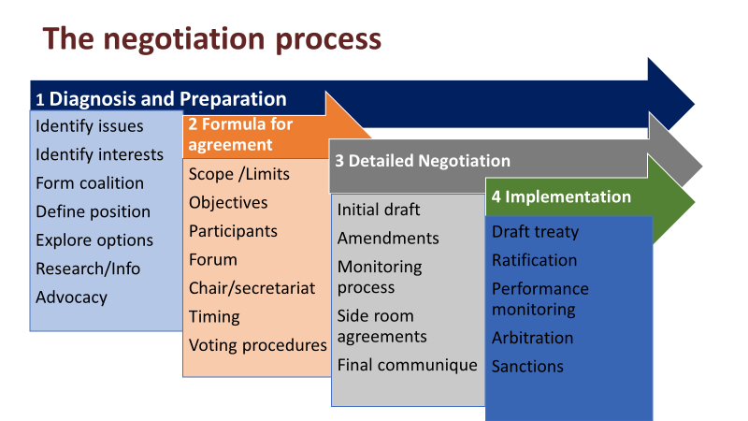
The process (based on Lister and Lee, (2013) “The process and practice of negotiation”, in Kickbusch, Lister et al. [eds] Textbook on Global Health Diplomacy. New York: Springer.) can be discerned in all negotiations, whether at local or global level, but clearly you need to interpret the stages in somewhat different ways.
Diagnosis and preparation is the most important phase; careful timing and selection of the issues to be addressed, identifying the interested parties and their interests, creation of “coalitions of the willing”, defining the coalition’s position, exploring the options for agreement and undertaking research and advocacy to build a case and create the conditions in which parties are open to negotiation are essential.
The formula for agreement phase defines the scope and limits of the agreement it is hoped to achieve and its legal form, the aims and objectives, who will participate and how negotiations will be conducted. A “heads of agreement” may be negotiated, setting out the main points at issue and the points of agreement about which detailed negotiation will take place. In some cases it may be possible to agree on general principles and to plot a path to an agreement to meet the interests and aims of all parties.
Detailed negotiation may involve different participants setting out their opening positions or may use an initial draft with points at which disagreement must be resolved identified. Parties to the negotiation then propose amendments and address issues such as: how the outcome is to be monitored and what should happen in case of default from the agreement. The main agreement may be encouraged by “side room” agreements to overcome obstacles.
The final communiqué or written agreement is not the end of negotiation, it is the start of the implementation phase, which itself will often involve continuing negotiation of the acceptance, interpretation and performance of the agreement. For some tips on negotiation for health see http://www.healthknowledge.org.uk/public-health-textbook/organisation-management/5a-understanding-itd/negotiating-influencing
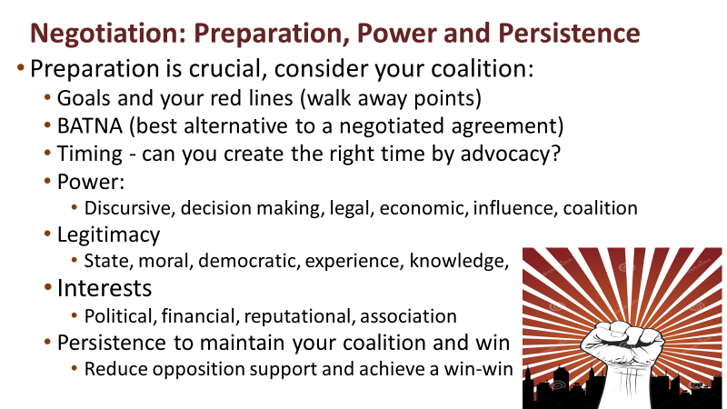
Preparation is crucial, you need to clarify (and perhaps negotiate) your position with other members of your coalition. The advantage of coalition is that you gain political power the disadvantage is that your specific position may be compromised. You will need to agree upon your goals (best or at least acceptable outcomes), red lines (unacceptable outcomes) and your BATNA (what action you would take rather than agree to an unacceptable outcome). The timing of negotiation is often critical, do news events make an issue “ripe” for negotiation.
The power of the opposing coalition(s) is important, you need to assess your own and their power, legitimacy and interests to spot what you can offer that will weaken their coalition.
- Power:
  - Discursive power to define the situation – e.g. based on research
  - Decision making power – e. g. votes by representative bodies
  - Economic – e. g. funds or other resources that are important to outcomes
  - Influence – e.g. to motivate consumers or health professionals
  - Coalition – e.g. the shared power of countries and agencies working together
- Legitimacy:
  - Moral – can you make a case in terms of the human rights of those you represent
  - Democratic – can you demonstrate the support of the public
  - Experience and knowledge – can you show evidence for your advocacy position
The Interests of all parties at a negotiation must be considered. Negotiations often appear to focus on the principle proponents and opponents to an agreement. In practice, the aim is more often to appeal to members of the opposing coalition that have only a weak interest in the outcome proposed or have other interests that can be brought into play. A compromise that appeals to the interests of a majority of all the parties at the negotiation will have the best chance of breaking down the opposition coalition to achieve a win-win outcome.
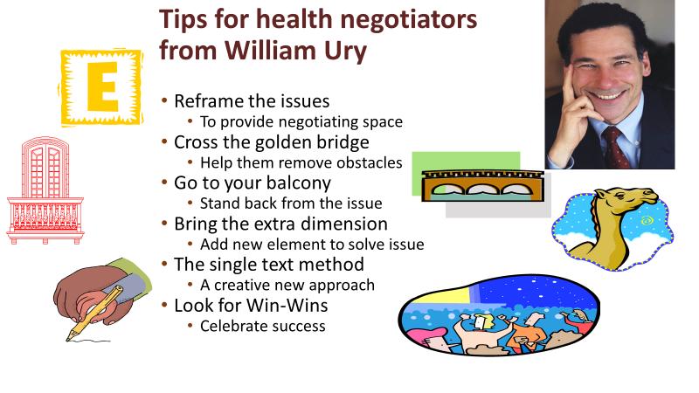
When negotiating for win-win outcomes for health we can learn from experience, most of these tips are taken from William Ury, the world leader in negotiation skills see here https://www.ted.com/talks/william_ury_the_walk_from_no_to_yes.
Reframing the issue means setting the issue in a different policy context, helping people to address the issue in a different way. Thus, while you may see an issue solely in health terms, it may be helpful to reframe it. For example; planetary health can be represented as exploitation by multinational companies, a threat to poor countries or a betrayal of future generations.
“Crossing the golden bridge” refers to the importance of helping your opponent to overcome the barriers they face in reaching a compromise agreement, to do this you need to accept and work with “where they are coming from” and talk them through the obstacles they face.
“Going to your balcony” means not getting into arguments, keeping a clear perspective on your goals and discussing issues not personalities. If someone attacks you on a personal level don’t react, take the discussion back to the underlying issues, it will make them look small.
The story of 17 camels shows how negotiations can be assisted by introducing an additional element Seventeen Camels - a 1000 year old mathematical conundrum (wussu.com)
The single text method was used to develop the road map for peace in the Middle East, both sides started from hard-line positions and would not give way, so the American chair of negotiations started afresh with a single text both sides could take or leave.
Coalitions of those in favour or opposed to particular outcomes need to maintain their alliance, as although the leading advocates may have a clear position, their strength in negotiation may depend on maintaining support from other coalition members. For this reason negotiators attempt to appeal to the interests of opposing coalition members and thus undermine their support for the opposition’s position.
Advocating for a set of ideals or principles may make you feel good, but achieving progress towards action on issues requires you to understand the points of view and interests of other parties and to negotiate the best possible next step. This is “the art of the possible”
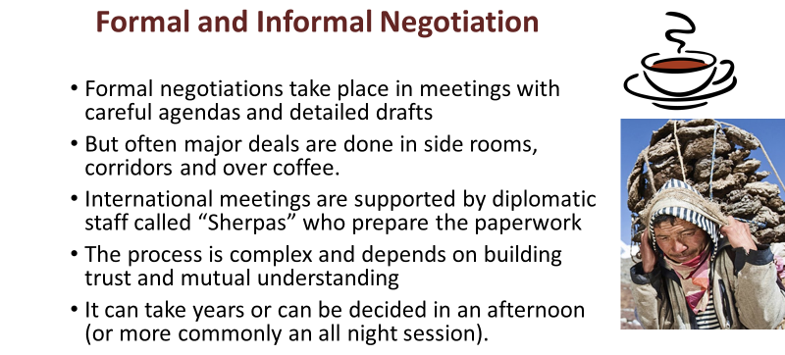
Formal International Meetings such as the World Health Assembly may agree hard or soft international laws but in many cases these are only considered after formal or informal meetings of the interested parties to negotiate the exact wording and conditions of proposed agreements and the funding and monitoring of any action required to implement them.
Other international meetings provide a forum for negotiating agreements and a market place for ideas. It is important to understand the formal agenda. But in practice the proceedings can be somewhat dull and predictable with very little scope for organizations to exert real influence. Side room events and meetings which happen at most international events tend to be more lively, they provide opportunities to influence future thinking and agreements.
At formal negotiation meetings agreements and compromises are often arranged not in the main meeting place but over coffee or dinner during pauses in the formal process.
Sherpas are senior diplomats who prepare for international meetings and can also be important in informal negotiations, as they may be able to understand what compromises would or would not be acceptable to members of an opposing coalition. They may also detect when members of a supporting coalition are likely to break ranks.
Why is it so difficult? Many international health agreements take years of negotiation and even when agreed they may not be ratified by many governments and often there are insufficient funds for implementation. And yet global health agreements address the common interests for all countries and people. In most cases the major obstacle is that each country has its own special interests that they are not prepared to compromise. Unless a better system of global diplomacy and global governance is established, future generations have little hope of resolving the existential crises of planetary health.
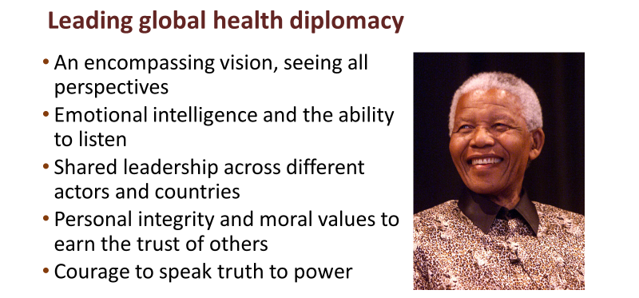 Leadership of global health diplomacy may be described as the art of “meta leadership” (see https://npli.sph.harvard.edu/meta-leadership-2/ ). This requires: an encompassing vision - understanding the perspectives that all the parties bring to an issue, but with a vision that transcends the differences they bring. It requires emotional intelligence and the ability to listen to others, which is a much under-rated skill in a world obsessed with gesture politics and grandstanding leadership. Global health leaders need to be able to prompt others to take the lead, recognising their skills and strengths and giving them support and encouragement rather than competing with them. Underlying these skills, global health leaders need personal integrity and moral values that earn respect and trust. Above all a leader of health diplomacy must have the courage to speak truth to power and to act on their values.
Meta leadership combines and goes beyond elements of “servant leadership”, “leadership through constructive conversations” and “distributed leadership” (if you Google around these phrases you will find examples of the application of these ideas to health leadership). For me these values are best illustrated by a quotation from Nelson Mandela’s book “Long Walk to Freedom” (1995).
As a leader... I have always endeavoured to listen to what each and every person in a discussion had to say before venturing my own opinion. Oftentimes, my own opinion will simply represent a consensus of what I heard in the discussion. I always remember the axiom: a leader is like a shepherd. He stays behind the flock, letting the most nimble go out ahead, whereupon the others follow, not realizing that all along they are being directed from behind.
Listening to others summarizing – often framing issues in terms of underlying values and guiding the direction of others are all key attributes of diplomacy. For an example of Nelson Mandela’s leadership in the fight against the application of the 1994 TRIPS Agreement (requiring patent protection for all medicines) by compulsory licensing of HIV medicines (and access to generics). And subsequently to ensure these medicines were delivered to all in need by the South African Health Service see http://news.bbc.co.uk/1/hi/world/africa/2156588.stm
