Training Toolkit 5 Advocacy at Global Meetings
5
Graham Lister

5
This Toolkit is focussed on the ways in which SfGH members can work with IFMSA partners and other coalitions to address issues of global health inequity
These are discovery learning tools intended to be quickly skimmed to provide an outline of ideas with online links that can be followed up so that can discover their own answers. The exercises are for groups of students and you are very welcome to update, improve, share and use the material as you like.
The topics covered in this toolkit are:
- Understanding International Law
- How is the World Run?
- IFMSA – your global coalition
- Global Health issues
- Assessing the Stakeholders - and building your power and influence.
- Tips for Health Negotiators – getting to Win- Win outcome with other global health advocates.
- Getting your voice heard at international meetings – some tips and practice.
- Plan your Communications
- Getting Organised
For a Toolkit focussed on engagement in advocacy see Toolkit 3, while Toolkit 4 provides a session on advocacy at the UK Parliament. But there are many lessons that are relevant to all levels of advocacy so it is suggested that you should at least skim all three of the Advocacy Toolkits. A more extensive course on Global Health Diplomacy and Advocacy is available at Training Toolkit 6.
It is suggested that Trainers introducing the session should ask the members of the group to briefly introduce themselves and explain what they hope to learn and why this is important to them.
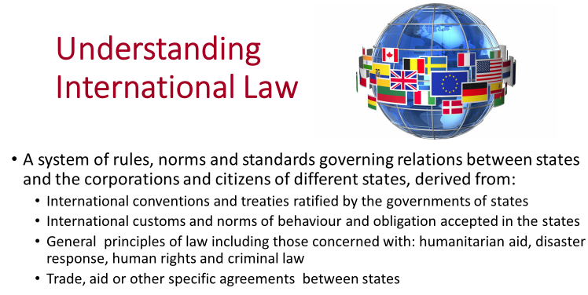
International laws relevant to health include the Framework Convention on Tobacco Control, the International Health Regulations, the Codex Alimentarius Commission: Codex Guidelines for the Exchange of Information in Food Control Emergency Situations. There are also many aspects of agreements on trade and the environment that have a direct impact on health.
In international law a distinction is sometimes made between hard and soft law indicating the extent to which agreements commit states which ratify the law to provide recourse to sanctions in international law if they are not complied with. Hard-laws are expressed in many forms including: Constitutions, Conventions, Framework Conventions, Regulations and Protocols.
There is no rigid classification but soft law implies a general agreement with perhaps some mutually understood consequences in case of non-compliance but not recourse to international courts. Soft law instruments are usually identified as: recommendations, codes of conduct, strategies, nomenclatures, standards; advisory mechanisms and collaborative, operative, and normative instruments. These include memoranda of understanding (MoU), often used to express commitments to bilateral aid collaboration.
For a more detailed discussion of global health law see “the Greg Martin interview with Larry Gostin talking about his book “Global Health Law” here.
Global Health Law like international law usually requires the agreement of all parties. Even in cases such as genocide it has been be difficult to establish a strong enough coalition to enforce laws by international military action sanctioned by the UN Security Council (see Toolkit 7 for discussion of this example). In other fields international laws or agreements have been challenged because they are seen as conflicting with rights arising from other conventions. The dispute over the provision of influenza virus samples, in Toolkit 9 explores such a case.
Trainers may wish to ask the group to view the interview with Larry Gostin and to consider his proposition that we need to make the right to health enforceable in international law.
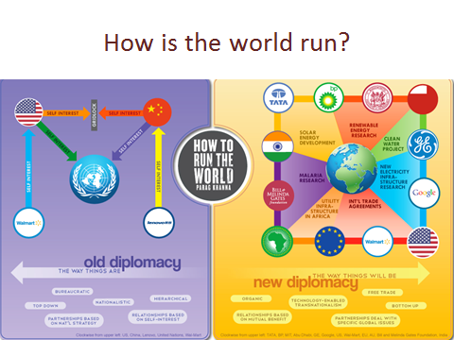
This diagram was produced by Rahul Kamath to illustrate Parag Khanna’s ideas set out in his 2011 book “How to run the world”. His view of international politics moves beyond the state centric world of the 1944 Bretton Woods system, to what he describes as mega diplomacy. This takes place in a “multi-polar” world, in which shifting coalitions of states, international NGOs, philanthropic foundations, multi-national businesses, cities, civil society groups and others influence agreements to address global concerns – such as global health.
The current system of global health governance reveals elements of both the “old” and “new” order. International Laws, rules, norms and accepted standards are established through UN processes such as the World Health Assembly and the FAO/WHO Codex Alimentarius and by non UN bodies such as the World Trade Organisation which enables countries to participate in reciprocal trade agreements. International meetings of Non Government Organisation (NGOs) influence the formation and acceptance of international laws because they represent the public.
The Bretton Woods system developed in response to the threat of international warfare, we now face different threats including: global health pandemics, climate change, terrorism, unregulated globalisation, antimicrobial resistance and many others. It is clear that global governance must be strengthened but with the consent and inclusion of all global citizens.
Parag Khanna points to the need for more decentralisation of power and responsibility to engage more organisations and people in global governance, recognising that centralised agencies will never be powerful enough to enforce the necessary changes from the top down.
NGOs such as SfGH must therefore play a crucial role in connecting individuals and communities to global issues This requires a renewed approach to advocacy and coalition building at national and global levels encompassing state actors, the private sector and Civil Society Organisations.
Trainers may lead discussion on how to run the world and introduce a Parag Khanna YouTube here.
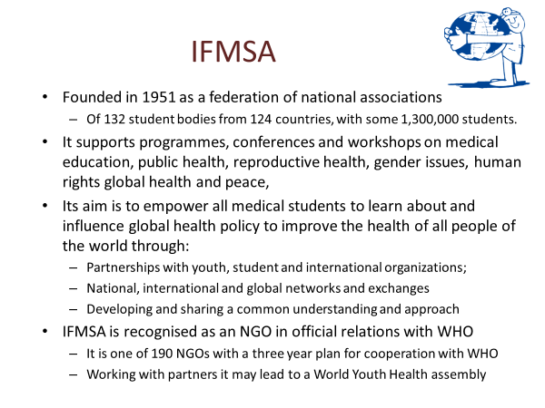

IFMSA official relations with WHO started in 1969, with the organization of a symposium on "Programmed Learning in Medical Education". In the following years, IFMSA and WHO collaborated in the organization of a number of workshops and training programs. Current collaborations include the “World Health Organization (WHO) Simulations” Transnational Project which aims to foster interest in global health and health policy, Google this.
Since 1971 IFMSA has also worked with UNESCO see here and now supports HIFA2015 (Health Information for All) see here.
In recent years a Youth Pre-World Health Assembly Workshop on Global Health Diplomacy, Governance and Advocacy has been organised with the support of the Global Health Programme of the Graduate Institute Geneva. This is open to IFMSA members as well as other youth organizations that attend the WHA. The event aims to develop a plan of action for youth participation at the World Health Assembly which follows the event. Participants prepared by working with this learner led material will meet in seminars and working teams to develop advocacy strategies on global health and humanitarian issues to be enacted at the WHA.
SfGH might also wish to consider measures to develop further engagement in the Youth Pre World Health Assembly to address issues of global concern including those identified in recent WHO reports and strategy documents see here

Trainers might lead a group discussion on how SfGH can influence global health policy by working with IFMSA at the World Health Assembly or other international meetings.
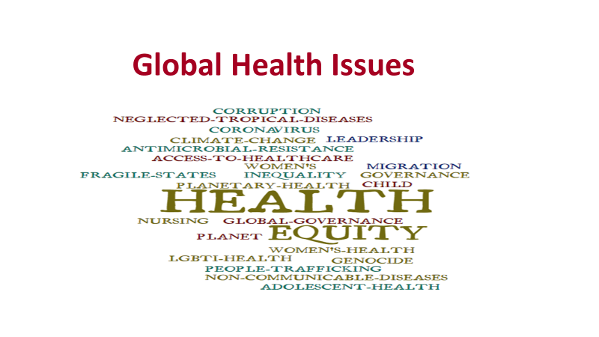
Global Health covers a vast range of issues which lead to health inequity between countries and people. Some of these issues are introduced in Toolkit 2 which considers the actions SfGH could take to address some of these injustices. Further topics are covered in Toolkit 7 which provides a basis for discussing issues and can be extended as further topics are highlighted.
For each international meeting attended it will be essential to study the proposed agenda as a basis for selecting and the topics on which to focus your advocacy efforts. Often these topics can be traced back through previous meetings or other debates to gain an understanding of the issues being debated and the possible next steps. This should also provide an indication of the position taken by possible allies and opposition at the meeting.
SfGH members attending an international meeting may wish to work with other IFMSA organisations to prepare a policy brief setting out the moral case for your position and your targets for advocacy at the meeting. Policy briefs should be succinct and clear as to the aims of advocacy but should provide scope for the team attending the meeting to negotiate with others to achieve an acceptable outcome.
In addition to the specific advocacy targets agreed for the team there may be other objectives, such as: raising awareness of SfGH and IFMSA and ensuring the organization is given a voice in future meetings and developing relationships with organisations which may be useful coalition partners at future events.
Trainers may wish to research the agenda of future meetings which might be attended by SfGH/IFMSA and use this as a basis for the group to pick out and research specific advocacy targets relevant to the meeting. The group might be asked to review the progress to date of discussions on the target topic, the position of SfGH/IFMSA and potential allies and opponents. On this basis the groups could set out the main points of a policy brief as a whiteboard list. If you don’t have the agenda for a relevant meeting you might use the agenda for the 2020 Global Health Summit here.
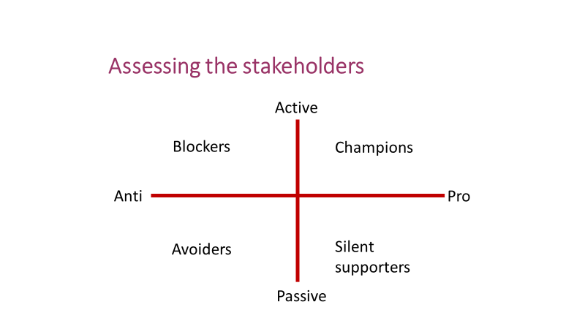
One of the most important decisions in developing an international advocacy strategy is whether to work within a coalition. This depends on where other stakeholders stand on an issue. One way of assessing the position of other stakeholders is to consider those opposing and those supporting your aims for your advocacy issue. Some may be active in their support or opposition and others may be passively in favour or against progress. Sometimes the most important stakeholders to deal with are passive opponents and those generally in favour but not prepared to take action. Persuading them to change sides or take action can be decisive.
In practice it often happens that some stakeholders are prepared to go some way towards the action you support but not as far as you would like. In such cases it is important to assess how much progress can be achieved and what factors are holding them back. Your response may be to compromise accepting the best that can be achieved for now or to stick to your position and not accept them as full coalition partners this can be a difficult political choice.
You should also consider SfGH’s basis for advocacy and that of a coalition in terms of:
- Power:
  - Discursive power to define the situation – e.g. for students or young people
  - Decision making – can you take decisions on behalf of members
  - Economic – can you raise funds or resources, such as student time
  - Influence – can you motivate students or others (and can you show evidence)
- Legitimacy:
  - Moral – can you make a case in terms of the human rights of those you represent
  - Democratic – can you demonstrate the support of members or students
  - Experience and knowledge – can you show evidence for your advocacy position
The advantage of coalition is that you gain political power and legitimacy for your position, the disadvantage is that your specific policy position may be compromised and the views of groups you represent and the values you stand for may not be visible..
Trainers might ask teams to research international NGOs relevant to a specific issue.
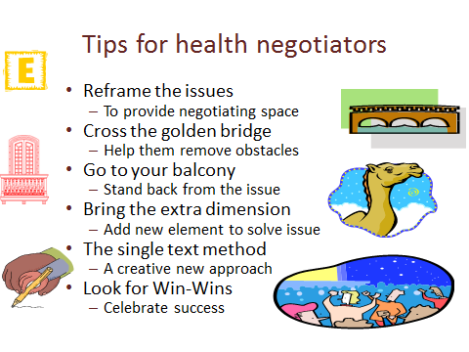
When negotiating for win-win outcomes for health we can learn from experience, most of these tips are taken from William Ury, the world leader in negotiation skills see here .
Reframing the issue means setting the issue in a different policy context, helping people to address the issue in a different way. Thus, while you may see an issue solely in health terms, it may be helpful to reframe it. For example; planetary health can be represented as exploitation by multinational companies, a threat to poor countries or a betrayal of future generations.
“Crossing the golden bridge” refers to the importance of helping your opponent to overcome the barriers they face in reaching a compromise agreement, to do this you need to accept and work with “where they are coming from” and talk them through the obstacles they face.
“Going to your balcony” means not getting into arguments, keeping a clear perspective on your goals and discussing issues not personalities. If someone attacks you on a personal level don’t react, take the discussion back to the underlying issues, it will make them look small.
In some negotiations it can be helpful to introduce an additional element so that everyone wins from the outcome. The story of 17 camels shows this see here.
The single text method was used to develop the road map for peace in the Middle East, both sides started from hard-line positions and would not give way, so the American chair of negotiations started afresh with a single text both sides could take or leave.
Negotiations often involve coalitions of those in favour or opposed to particular actions. It is vital to maintain the strength of the coalitions, as although the leading advocates may have a clear position, their strength in negotiation may depend on maintaining support from other coalition members. For this reason negotiators may attempt to appeal to the interests of opposing coalition members and thus undermine their support for the opposition’s position.
Advocating for a set of ideals or principles may make you feel good, but achieving progress towards action on issues requires you to understand the points of view and interests of other parties and to negotiate the best possible next step. This is “the art of the possible”
Trainers should be able to demonstrate examples of each of these negotiating strategies.
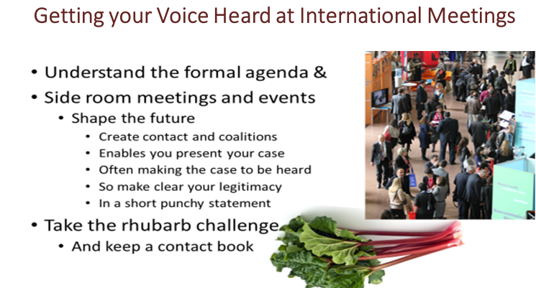
An international meeting provides both a forum for decision making and a market place for ideas. It is important to understand the formal agenda of the meeting. But in practice the proceedings can be somewhat dull and predictable with little scope for organizations like SfGH to exert influence. The side room events and meetings which happen at most international events tend to be more lively, they provide opportunities to influence future thinking and agreements. To prepare for this it is important to get in early, make contact with the organizers of the events and if possible secure an opportunity to present your views.
Early preparation is vital, email those you hope to meet, know what they look like, be prepared to edge into their conversation but above all be clear what message you hope to get across. So Google to keep track of both the formal and informal agenda and to identify those you hope to contact at the meeting. You should keep a notebook to record all important contacts and you should use social media to update other members of SfGH and IFMSA of progress.
You will not be able to give a long prepared speech, you will need to seize the moment to get across a few key points: who you are, who you speak for and what you propose. One exercise you may find useful in preparing to get your views across in a crowded room is the rhubarb challenge. Group members make a general noise (rhubarb…rhubarb) while one participant at the back of the room makes a brief statement putting across 3 key points.
Trainers should ask group members to prepare a very brief introduction to a particular global health issue and deliver this from the back of the room while the group murmur rhubarb. .
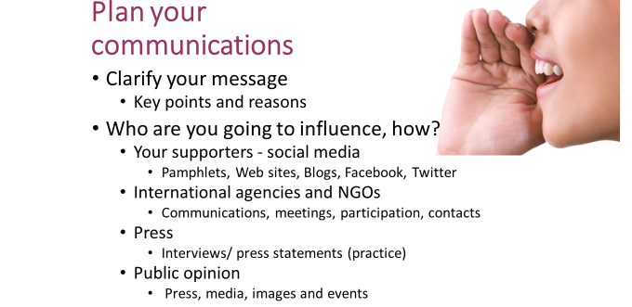
It is tempting to use a catchy phrase as a starting point for an advocacy programme but this is not advisable. You need to understand the ongoing dialogue, the evidence available, the position of other stakeholders and the contribution your organisation can make before formulating your message. Once you have this understanding, of course a memorable way of getting your message across can be useful as part of a comprehensive communications plan.
Your communications plan should consider how you will keep in touch with your supporters and those you seek to empower through your advocacy. This will probably involve social media such as Facebook and Twitter. After all you will be attending the meeting on their behalf so you will need to plan how to keep your followers engaged. As a start try looking at the video here.
You need to consider the agencies and people you are trying to influence, you should try to find names and if possible photos so that you can make contact. Think through the message you want to put across to these contacts and what the SfGH and IFMSA can offer them, for example, contact with young people through social media. This may require you to butt into people’s conversations; be polite but assertive see here. And don’t worry, these people expect to get lobbied. Some sort of brief pamphlet or visiting card may help and you may also be setting up longer term contacts, so a contact book is essential.
Making contact with the press is vital but dangerous, always remember they have their own agenda, so be careful, stick to your position and what you know. Make sure you control the message and are not part of someone else’s story. One useful exercise is included in Toolkit1 it involves making a case for action and responding to questions from the press, for tips on how to present your case see here or Google to find advice you find helpful.
Trainers may wish to use the exercise in Toolkit 1 which requires 4 trainees to argue the case for action on different global health issues and respond to press questioning.
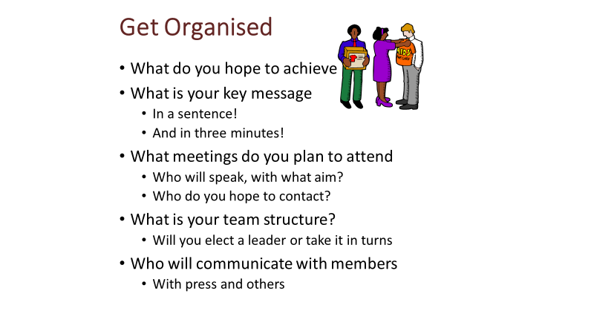
This is a chance for you to reflect on what you have discussed and to make plans for your next steps. Topics you might like to consider include:
- What changes in International Law will you advocate for?
- How can you strengthen the influence of SfGH in global health?
- How will SfGH work with IFMSA
- What Global Health issues will you focus on?
- Which key stakeholders will you work with?
- How will you improve your negotiating skills?
- How will you get your message across at international meetings?
- How will you engage SfGH members when you represent them?
- How will you work as a team at international meetings?
Trainers could lead a group discussion of the topics covered addressing these questions and conclude by asking what members have learnt from the meeting and how they will use the lessons in future.

