Training Toolkit 3 Advocacy and Engagement
3
Graham Lister

3
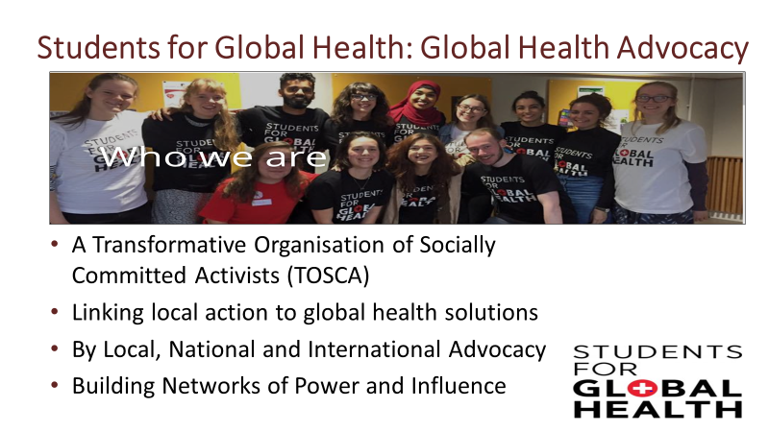

This Toolkit is focussed on the ways in which SfGH members and other students can be engaged in the political process of advocating for global and local health equity
These are discovery learning tools intended to be quickly skimmed to provide an outline of ideas with online links that can be followed up so that you can discover your own answers. The exercises are for groups of students and you are very welcome to share and use the material as you like, let me know if there are further topics you would like to see covered.
The topics covered are:
- What does Advocacy mean to Students for Global Health.
- From AIDA to TOSCA – from a marketing approach to developing a transformative organisation
- Building Online Community Engagement
- Targets for SfGH Action – how do you seize the moment or create a time for change.
- Advocacy Allies – working with the many other groups advocating for global health issues.
- Is it your right or your duty to protest? As part of a national advocacy strategy.
- Advocacy from Policy to Action – why advocacy is more than simply intoning policies.
For a Toolkit focussed on advocacy at the UK Parliament see Toolkit 4, while Toolkit 5 provides a session on International advocacy, selecting issues ripe for action, forming alliances and negotiating for change. But there are many lessons that are relevant to all levels of advocacy so it is suggested that you should at least skim all three of the Advocacy Toolkits. A more extensive course on Global Health Diplomacy and Advocacy is available at Training Toolkit 6. You are welcome to download and adapt any of these.
Suggestions for Trainers leading the session are set out in bold type.
At the start Trainers should introduce the topics and ask the group members to introduce themselves and explain their personal learning objectives for the session.
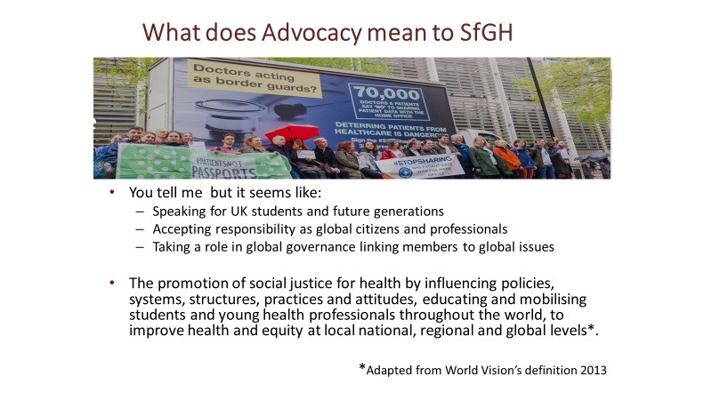
Latin root of the word 'politics' means 'of the people.' Politics is about something bigger than electoral politics; it is about engagement as local, national and global citizens . “Diplomacy” is derived from the Greek diploma, a folded parchment given, to athletes winning a race. This was used by Romans to refer to a pass authorising travel, so diplomacy means representing views from other peoples. Negotiation comes from the Latin “negat otia” meaning no ease, so negotiation means business and is the hard work that is necessary to achieve political progress through compromise.
The word “professional” stems from the Latin “professionem”, meaning to declare a set of beliefs. This is reflected in the idea that professionals claim the right to govern themselves because of their special knowledge and the high ethical standards, to which they adhere. Any student aspiring to become a professional should think about the beliefs that they uphold. The Hippocratic Oath was the first professional oath. A modern version commits to serve all humanity, without discrimination – “The Declaration of Geneva” can be found here
The word advocacy comes from the Latin “ad vocare” meaning to give voice to, it was used in Roman times to refer to a witness who spoke for someone or some group. An essential starting point for advocacy is to consider who you speak for and why.
Advocacy requires a link with those whose rights and opinions you represent. You need to consider who this is for SfGH and how you inform and communicate with those you claim to represent. This might be members of SfGH organisations, all students, or even all young people, but how can you claim that you are speaking for them? You need to think about how local groups, individual members and maybe wider student groups have been informed and consulted (or surveyed) and how you keep in touch with them using social media and other means. If the targets of your advocacy action are disadvantaged people – e.g. those with poor access to health services in UK or people from low income countries already affected by climate change. You need to consider how you listen to and empower them.
Advocacy has an external purpose: to raise political awareness, informing and engaging the public, and an internal purpose in reinforcing knowledge and ties within the organisation; sharing ideas and taking action together helps to build SfGH as a Transformative Organisation of Socially Committed Activists.
Trainers may split the group into teams and ask them to briefly discuss the issues raised here. It can be helpful to get each team to focus on a specific global health equity issue see Toolkit 7.
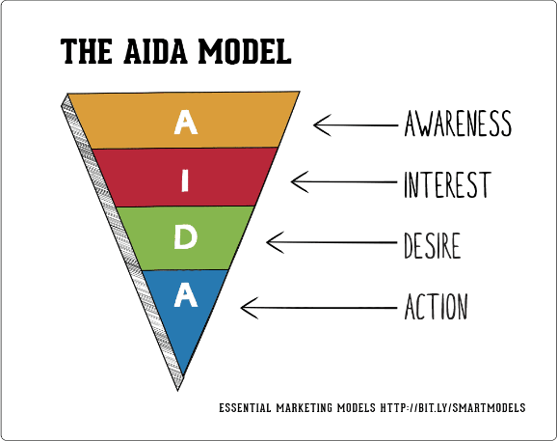
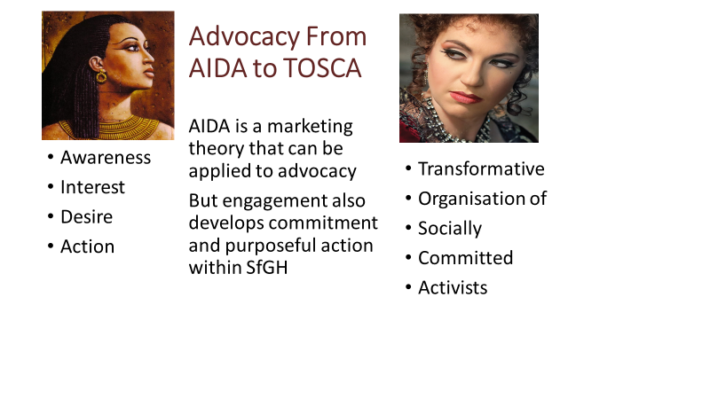
The well-known AIDA model expresses a simple approach to the aims of marketing – to raise awareness of a brand, promote interest in its products or services, building consumer desire to the point that they take action to buy the product. The same model can be applied to advocacy – raising awareness of political issues affecting global health, promoting interest in solutions to these problems, developing a desire for change and taking action to demand political change and altering personal behaviour. You may wish to Google AIDA and apart from some enjoyable opera you may gather some insight into the application of the AIDA model to your approach to advocacy.
But beyond this, the experience of joining in group behaviour, to learn more about the causes and potential responses to global health issues and to participate in actions such training others or participating in protests or representation at national or international meetings can create a sense of identity and purpose. This provides a basis for the formation of a Transformative Organisation of Socially Committed Activists (TOSCA). It is therefore helpful to consider ways in which SfGH actions can both contribute to the external goals of social change and the internal goal of reinforcing the teamwork and commitment of members. You will find online insights into how to build effective teams - the best known model is Tuckman’s – Forming/Storming/Norming/ Performing see Toolkit 1.
Political activism must be rooted in ideas developed through teamwork and a commitment to action at local level. Training together in groups can be an effective way of building commitment to shared values and ideas, it communicates both the facts of global health inequity and the belief that change can be achieved if we work together to transform society. Training is also the best way of learning both about the causes and consequences of global injustice and developing your own abilities as a leader of change
Trainers may wish to take this opportunity to encourage other members of the group to consider looking through Toolkit 0 and signing on as a Trainer for SfGH
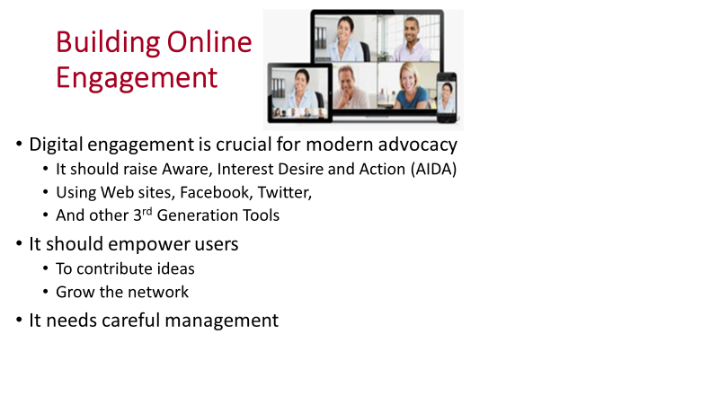
In the past marketing, for commercial products or advocacy for political causes, was focussed on communicating messages to passive consumers or voters but recent years have brought a digital revolution. Effective advocacy is now focussed on engaging the public as active participants in the process, who contribute ideas and preferences, spreading their enthusiasm and contributing to the message. Online engagement is an essential element of modern political action. It can use a wide range of tools including those currently operated by SfGH but it requires careful management in a digital engagement strategy. The advice provided by the US Community Toolbox might help see here.
The group should review SfGH online tools and the messages and image conveyed and ask:
- What are the key messages you take from SfGH’s online presence?
  - Are the messages clear to you 1 - 10
- What impression is given of the nature of SfGH:
  - Does it seem inviting 1 - 10
  - Does it inspire you 1 - 10
  - Does it feel like your community 1 – 10
- Do you feel encouraged to
  - Contribute your ideas and experience 1 – 10
  - Participate in SfGH action 1 10
  - Become a trainer or help in other ways 1 10
- What are the strengths and weaknesses of SfGH online?
Trainers may wish to ask members of the group to complete these questions and then meet together in a group to discuss and prepare a brief report for the National Committee on how SfGH can improve its online communications (and how members of the group might assist this)
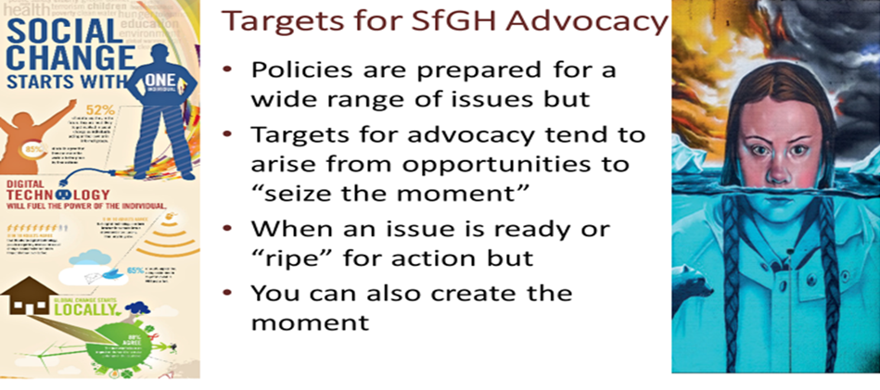
While it is important to clarify policy on a wide range of issues, progress is not achieved by simply stating your positions. You need to consider the opportunities available to achieve useful outcomes for those whose concerns you represent and those who are the targets for the action you support. You need to be aware of the ongoing dialogue on issue that are important to you, the specific perspective you bring, who you might work with and practical steps that can be taken. To explore the background to each topic, it is helpful to review current political dialogue by searching the internet. You will often find agreements for action, which sound good but achieve little because they lack specific targets, measures or funding.
The agenda for global health is crowded with issues clamouring for attention, in a perfect world all would be considered and acted upon through a fair and effective systems of national and global governance. But we don’t live in such a world. Advocacy makes the case for action on specific issues, because of the needs they address and the possibilities for action. Timing is a crucial factor. An issue may be “ripe” for action because of events such as: health emergencies, public outcry or research findings. SfGH must react to such events to “seize the moment” and join the debate.
In some cases you can create the moment, perhaps building on a local or national political issue of particular concern to students, for example the change of emphasis from medical students as implied by the name Medsin to a broader appeal to Students for Global Health would suggest an emphasis on the role of Nurses and other health professionals. This resonates with the with the Nursing Now! Initiative stressing the importance of nursing for global health and gender equity supported by the WHO Director General Tedros Adhanom and the All Party Parliamentary on Global Health co-chaired by Lord Nigel Crisp, one of your patrons, see here.
It is also clear that Planetary Health and Climate Disruption is an existential threat to future generations, in this case political momentum for action has been created by Greta Thunberg and David Attenborough. Again SfGH could take a role because it speaks for future generations of health professionals and others see the report of the House of Commons Select Committee here
Trainers might lead a discussion of the issues “ripe” for advocacy because of current events or reports. You might also show Greta Thunberg’s Youtube call for rebellion for climate change see here.
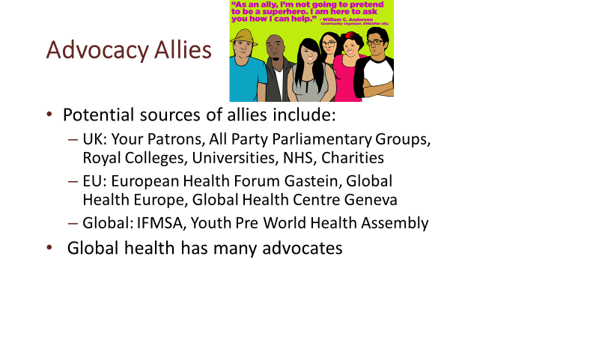
Global health has become an academic industry over the past 20 years, with countless organisations offering courses and undertaking research. It is therefore important to select partners carefully, your patrons: Sir Michael Marmot, Lord Nigel Crisp, Sir Andrew Haines and Professor Richard Horton are all leaders in their fields but very approachable and would I am sure be willing to help you choose allies.
All Party Parliamentary Groups are important points of contact between politicians of all parties, academics and NGOs on a wide range of issues such as Global Health, Climate Change and Lesbian Gay Bisexual and Transgender Rights. There are almost 850 APPGs so it is worth investigating see here .
Other bodies worth following include the Royal Colleges that lead medical and nursing specialties and play a role in setting international standards in medical education, most are members of the Academy of Medical Royal Colleges. Many universities provide courses in global health and some run conferences. The Department of Health and NHS bodies with a remit for global health include Public Health England which monitors UK strategy for global health as set out in Health is Global the Director of Global Health is Neil Squires, Charities with an interest in Global Health include: The Nuffield Trust, the King’s Fund and the Wellcome Foundation, which works with the National Institute of Health Research and many others. You should also consider working with charities such as: Oxfam, Save the Children, MSF, THET and HIFA.
The European Health Forum at Gastein is an important event bringing together European policy makers including those concerned with global health, the European Global Health web site managed by the University of Maastrict provides an update on EU policy and list of European bodies involved in global health. The Global Health Centre of the Graduate Institute Geneva is the WHO accredited centre for Global Health Diplomacy, see here.
The Global Health Centre also runs a course for IFMSA at the Youth World Health Assembly (YPWHA). In recent years this has developed as a wider forum for engaging youth organisations in global health. This may also be seen as reflecting SfGH’s extension to include all students. You may also find sites such as the “John Hopkins Bloomberg: Global Health Now” site here useful for following developments.
Trainers could ask teams to develop proposals for how SfGH could work with other potential partners in relation to their specific advocacy topic.
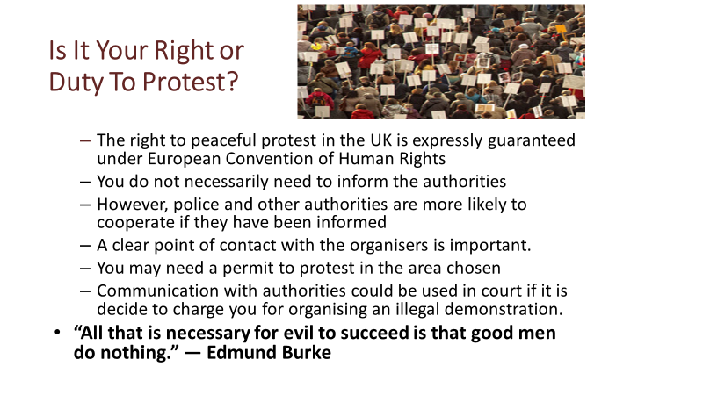
The right to protest can be seen as a duty when facing grave injustice, many would argue that the injustice of global health and the threats to planetary health demand that we take action. But before taking to the streets it is important to clarify the intentions and messages of the protest:
- What are the aims of the protest? Is it to raise awareness of an issue, to interest and inform, to show the strength of support for the protest or to promote specific actions?
- Who are you trying to influence? Are you targeting the general public, the politicians and decision makers, or are you building commitment for the protest participants?
- How might others interpret the image and message you communicate? Including most importantly those opposing or hesitant about your message and organisation?
- What support is there for the protest? Have you developed enough commitment amongst your supporters, have you cooperated with other groups, will you attract public support?
Careful thought about these issues should ensure that a protest is seen as a reasonable and legitimate response by participants and the public. A realistic approach must recognise that internal and external aims of protests may sometimes conflict, what feels right for members may not be an effective way of changing public opinions. For example, while the Extinction Rebellion protest no doubt reinforced the virtuous feelings of its membership, but opinion polls suggested that their protest reduced public support for urgent action on climate change. In all cases it is important to listen to those you hope to influence and to think through the consequences of action, however well-intentioned they may be.
For Government advice on informing the Police about public marches see here The Law on the Web (though this is not being maintained) provides advice on rights see here.
Trainers might ask the group to consider what protests SfGH may wish to support, by for example allowing the use of the SfGH logo and referring to national policies and decisions
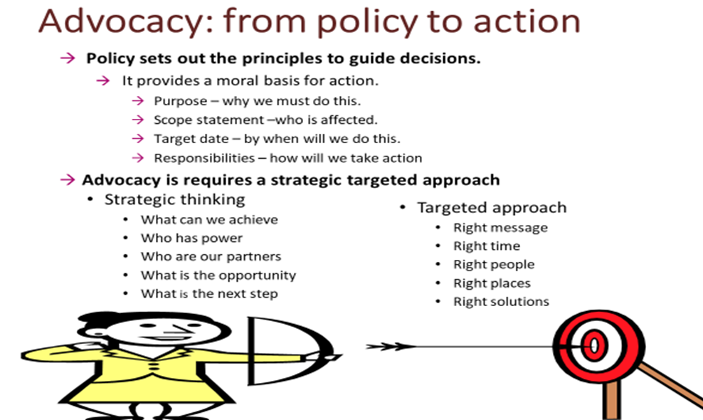
A policy statement or brief is often a useful starting point for developing an advocacy strategy. It sets out principals to guide subsequent decisions in a form that can generate or reflect the approval of the organisations and individuals represented. How such policy statements are ratified by the membership will depend upon circumstances but as it is an important moral basis for action, this should not be taken for granted. Generally a policy statement will present a case for action based on the fundamental beliefs of the organisation in human rights to health. It sets out the actions to be taken, empowering a group of representatives to act on its behalf with targeted outcomes, responsibilities and a deadline for action.
However, policy must also provide scope for creative strategic thinking by advocates so that they can respond to opportunities and challenges and focus actions on practical deliverable outcomes. Advocacy that simply results in intoning pre-formulated policy positions may result in righteous feelings but will achieve little, on the other hand an un-principled search for agreement at any cost is pointless.
SfGH advocates will need a clear but sufficiently flexible Policy Brief in each field and on this basis you need to assess the situation and research how you can best contribute to the dialogue. This will include assessing: the stakeholders and their interests, powers and legitimacy: the points at issue and evidence cited for action or inaction. Assess where there is possibility for progress and what arguments, evidence or public and professional support might advance your aims. You should also consider SfGH’s power and influence and how to promote and enhance it, for example resolutions of members show democratic legitimacy, social media contacts demonstrate and build “people power” and personal experiences of members are also sources of influence. This includes expanding membership to engage more people.
Trainers might lead a discussion of how SfGH could develop a national advocacy strategy. They should also lead a reflection on what members of the group have learnt at the session.

