1
Graham Lister

4/10/2020
Training Toolkit 1: Global Health Equity..
Discovery Learning Pages for Global Health Equity
These pages are intended to provide an introduction to aspects of global health equity. They provide links that you can follow up to gain further insights, but they are not intended to impose one view of these issues, rather they are intended to enable Students for Global Health to discover their own answers and to decide what action they should take. Please feel free to adapt or add to these pages as necessary and as new information becomes available. The pages include:
- How do you start a career in Global Health?
- Equity in Health and Wellbeing : What is Health and Wellbeing
  - A Capability Theory of Equity
  - Developing, Emerging or Low Income and the 99%
  - The Bottom Billion
  - Corruption in Health
  - Fragile States
  - Health in Sub Saharan Africa
  - Ultra Processed Food In Brazil and Worldwide
  - Health and Wealth Inequality in High and Low Income Countries
  - Health Inequity in England
  - Migration of Health Professionals and Health Equity
  - Noncommunicable Diseases and Global Health Equity
  - Neglected Tropical Diseases and Access to Medicines
  - Fungal Infections: The Hidden Crisis
  - Global Equity and Mental Health
  - Global Child Health Equity
  - Is Global Corporate Social Responsibility a Step Towards Equity or Just Greenwash?
  - The End of Antibiotics and its impact on Health Equity
  - Climate Change and Inequity: Justice for All
- Women in Global Health
  - International Women’s Day 2020: Towards a more Gender Equal World
  - Traditional Beliefs and Women’s Health
  - Nursing Now
  - International Nurses Day marks Florence Nightingale’s birthday
  - Modern Slavery and Women’s Health
  - Celebrate the Reversing of the Global Gag Rule
- Targets for Development and Aid
  - Act now to ensure the UK keeps its word to the UN and the World
  - Can we Afford Global Health?
  - The Wellbeing of Future Generations Bill
  - Impact of Successive Crises
- Prejudice and Health: Holocaust Memorial Day:
  - Ageism and Health Equity
  - Adolescent LGBTI Health and Confidence in Who We Are
  - Prejudice Institutional Racism and Health
  - White Privilege and Rich Advantage
  - Damage to Democracy and Equity: Lessons from the Trump Riots

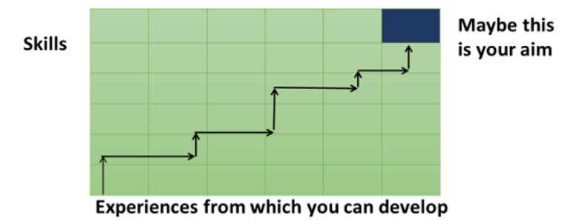
How do you start a career in Global Health?

By way of introduction I have tried to answer a question put to me during an online session with SfGH students. They asked how I got started and how they might get into Global Health, so here goes.
I set out as a student of sociology and economics with the aim of improving public service management, which I saw as improving welfare and equity for all. I started work in a London Borough introducing a new system of management based on public involvement in setting targets for improving equity and efficiency. I then discovered that people listen to you better if they pay for your advice, so I went to work for an international consulting firm. There I started work on reforming the public sector in the UK and in low-income countries. The most complex area of public service management is the health sector, so when I became a partner of the consulting firm I concentrated my efforts on the reform of healthcare with a team of doctors, nurses, economists, IT experts and accountants. I eventually worked in 50 different countries on aspects of public sector and health reform. This was my training ground when I was asked to lead the first UK programme on Global Health in 1999/2000. This was when I first worked with Medsin. I now focus on Global Health Diplomacy as the key to improving global governance, with the Global Health Centre, Geneva, running training for WHO Heads of Country Office and IFMSA.
So how do you get into this field? You must all find your own route, I found it helpful to plot out the skills I needed and the experiences from which I can develop these abilities (see above). Of course, you cannot plan your life with any certainty, but it helps you think about opportunities to progress and the sort of life goals you want to achieve. There are many different starting points, as examples: a clinical or management role in the NHS, public health, the diplomatic service, DfID or international aid agencies. You may wish to find a more direct route, the WHO offers an internship programme here and you will find similar opportunities at GAVI here and many other agencies. These agencies are difficult to get into as I know because I was on an advisory panel helping to develop leadership training for WHO interns. There are also more limited commercial overseas internships available, but these have mixed reviews.
My training kit for SfGH provides some basic understand of global health issues and there is a list of European Global Health Organisations here. If you look through the other parts of my web site you will find material on leadership and socio-economic evaluation developed in different countries from Australia to Zanzibar, which I hope might help. If you are thinking of making a start in the UK diplomatic service you might also consider using the FCO Online learning resource here . You might also consider the courses available at the Graduate Institute Geneva see here ranging from short summer courses to Masters and PhDs. And you should also consider participation through SfGH and IFMSA in meetings like the Youth Pre World Health Assembly here and the Change Maker Scholarship Program here.
My advice is to do something, start a local initiative, protest, write a policy, contact people you want to help, use this training material to train others, just do something. If it turns out this is not for you, that is fine, but you could discover your unique talent and aim in life and that will change your life.

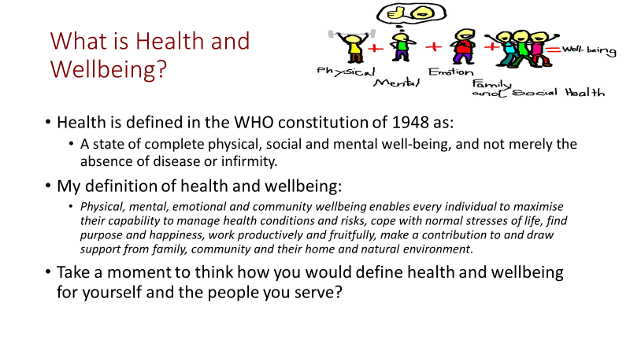
Equity in Health and Wellbeing
Physical and mental health improvement can be described and measured in terms of the years of life gained and the quality of life in those years as perceived by patients (through surveys) this is the basis for the Quality Adjusted Life Year (QALY) measure, most commonly used in England to describe health gains. The WHO uses a similar (but inverse) measure of the Burden of Disease (loss of health) at national level. Disability Adjusted Life Years (DALY) is a measure of the Years of Life Lost (YLL) due to early deaths plus Years Lived with Disability (YLD) weighted by an international panel, compared to the best attainable.
Wellbeing includes health and other factors that add to happiness, satisfaction, fulfillment and freedom, there is no universally agreed measure, it is a subjective response to our quality of life, see DH view here.
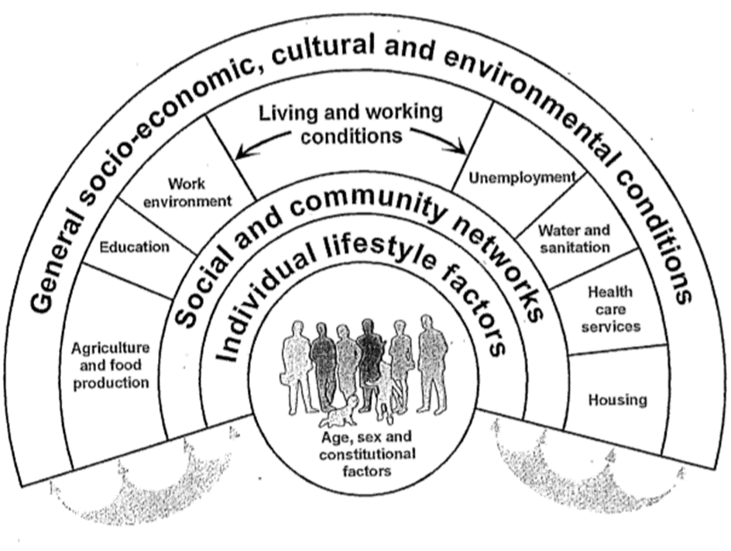
In 2010 UK Prime Minister David Cameron launched the National Wellbeing Programme to “start measuring our progress as a country, not just by how our economy is growing, but by how our lives are improving; not just by our standard of living, but by our quality of life.” See reports and analysis here.
Things that improve health and wellbeing may include: a political system that is seen as fair and just, physical security, education, family and social support, community engagement, housing, environment, employment and financial security, music, art, culture and health and social care services.
These are personal and social judgements about freedom to improve the quality of life. For an introduction to capability theory, on which this is based see here. It is important to think through goals with individuals and communities to assess the health, social wellbeing and cultural factors that are valued. It may not be possible to measure all aspects but we can at least acknowledge and describe them from the perspective of participants, this is a part of a socio-economic evaluation process.
Conditions that support health and wellbeing were identified by Dahlgren and Whitehead (1991) see here. in “Policies and strategies to promote social equity in health” from which the diagram is derived. This recognizes that health and wellbeing are complex, with multiple causes and consequences.
These 14 pages provide a range of insights into aspects of health and wellbeing equity.
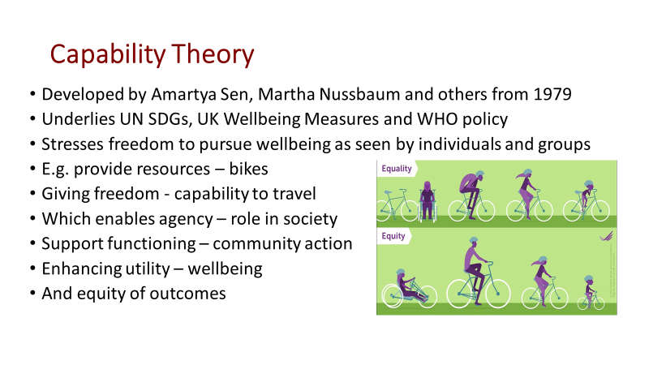
A Capability Theory of Equity
Capability theory underlies much of current thinking about wellbeing, including the UN Sustainable Development Goals and UK attempts to measure quality of life. The ideas were developed by the Nobel prize winning economist and philosopher Amartya Sen in his 1979 book “Equality of What”, his editing of “Quality of Life” in 1992 with Martha Nussbaum, his 2009 book “The Idea of Justice” and his contribution to the 2009 Stiglitz, Sen and Fitoussi “Commission on the Measurement of Economic Performance and Social Progress” set up by French President Nicholas Sarkozy, see here.
John Rawls’ theory of justice, as a state that would be seen as fair by someone unaware of their place in society (race, wealth, education etc), was a starting point for this more complex idea of equity. Capability theory moves away from the idea of economic growth, as the prime measure of social development in rich and poor countries. Becoming richer enables some people to live more comfortably but does not reflect the many complex factors that enhance or constrain the lives of individuals and communities. Capability theory stresses the role of the state in ensuring freedom of individuals and groups to enhance their wellbeing in a sustainable and equitable way, while recognizing their choices and obstacles.
A capability approach suggests that when measuring wellbeing it is essential to recognize and value the freedom of peoples’ roles in society (agency), and their action (functions) that lead to enhanced equity and wellbeing (utility), provided that this respects the rights of others and the physical and social environment. This recognizes that people have different needs and demands so justice and freedom may have different meanings for each person and group in society. Measures of wellbeing at individual or community level should evaluate the extent to which people achieve their aims in terms of:
- Material living standards (income, consumption and wealth);
- Health;
- Education;
- Personal activities including work;
- Political voice and governance;
- Social connections and relationships;
- Environment (present and future conditions);
- Insecurity, of an economic as well as a physical nature.
Capability theory points to the need for personalised and community-based care, enabling each person and each community to define their own health and wellbeing goals and helping them to address and overcome the obstacles they face see here. It shows the need to address local needs rather than imposing top down solutions or ideas of equity. For WHO resources on health equity see here.

What factors would you include in a Community Care Plan to enhance the quality and equity of health and wellbeing in your community or in a community (however defined) that you know?
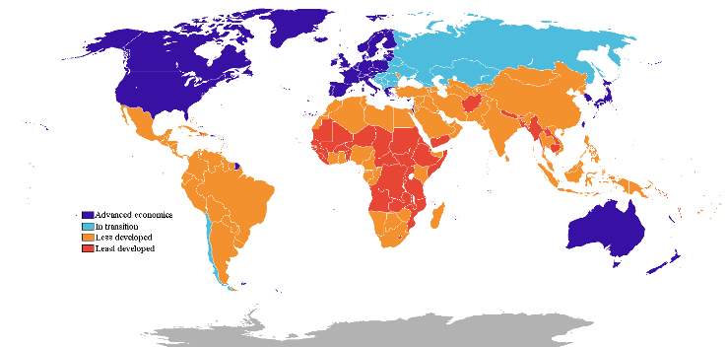
Developing, Emerging or Low Income and the 99%

Map of low, lower-middle, upper middle and high-income countries
In the 2016 edition of its World Development Indicators here, the World Bank decided to stop using the terms “developing” and “developed” to describe countries. This is because there is no clear definition of such terms, they seem to imply that all nations will chose a similar path to “emerge” from traditional society to an industrial economy and that “developed” countries are superior because they are richer. While there have been various attempts to introduce a “Human Development Index” see here, it is notable that the most “developed” nations included a country which does not allow women basic rights, and one which sees the deaths of thousands of people each year because it cannot agree gun controls.
The World Bank 2017 Indicator Tool can be used to show: population, health and poverty by income levels based on annual GNI (Gross National Income) per capita, at average exchange rates (Atlas method) in US dollars, and poverty levels based on $1.9 per day (at PPP) in 2012. This analysis can be extended to show a variety of health related outcomes by income level or by country, for example:
- Low income countries $1,045 or less, 0.64 billion people, of whom 46.2% live in Absolute Poverty, Life Expectancy at Birth 60.2 years, Deaths from Communicable diseases 58.2%, Deaths from NCDs 31.6%, Access to Improved Water 63.5%, Access to Improved Sanitation 27%, Total Health Expenditure per Capita $85.5, Out of Pocket Spend as % Health 38.3%, Physicians (per 1000) 0.1.
- Lower middle income $1,046 -$4125, 3 billion people 16.4% living in Absolute Poverty, Life Expectancy at Birth 66.7 year, Deaths from Communicable diseases 32.5%, Deaths from NCDs 56.7%, Access to Improved Water 87.1%, Access to Improved Sanitation 49.8%, Total Health Expenditure per Capita $233.5, Out of Pocket Spend as % Health 55.5%, Physicians (per 1000) 0.8.
- Upper middle income $4,126-$12,735, 2.6 billion people 2.7% living in Absolute Poverty, Life Expectancy at Birth 74 years, Deaths from Communicable diseases 9.9%, Deaths from NCDs 81.4%, Access to Improved Water 93.6%, Access to Improved Sanitation 77.8%, Total Health Expenditure per Capita $813.5, Out of Pocket Spend as % Health 32.8%, Physicians (per 1000) 2.
- High Income $12,736 or more, 1.2 billion people 0.4% living in Absolute Poverty, Life Expectancy at Birth 80.2 years, Deaths from Communicable diseases 6.5%, Deaths from NCDs 87.5%, Access to Improved Water 99.4%, Access to Improved Sanitation 99.3%, Total Health Expenditure per Capita $4,899.6, Out of Pocket Spend as % Health 13.7%, Physicians (per 1000) 2.9.
At global level the overall trend show a decline in the numbers of people in Absolute Poverty by about 35-45 million per year. This might suggest that poverty could be eliminated in about 20 years. While there has been slow progress in reducing absolute poverty, the report from Oxfam published at the WEF Davos meeting in January 2017 “An Economy for the 99%” showed rapidly rising inequality in 7 out of 10 countries. The report on this issue can be accessed here . It shows that the 8 richest men own as much wealth as the 3.6 billion poorest people on the planet. And the world’s 10 biggest corporations together have revenue greater than that of the government revenue of 180 countries combined. The increasing concentration of wealth as capital has been highlighted by Noam Chomsky and Thomas Piketty see his Ted talk here. In 2021 it was estimated that the world’s 10 richest people own $1.15 trillion and the combined wealth of all the billionaires in the world amounts to over $13 trillion. A 10% tax increase on this wealth could meet most of the funding required for sustainable development.
Discuss how SfGH should advocate for equity in health (SfGH may also wish to update these figures)
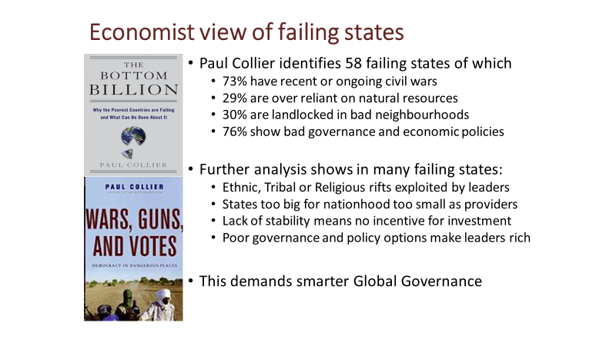
The Bottom Billion

While many states with the poorest people have improved their health and economic performance over the past two decades, 58 have made little if any progress and fail to provide basic security and services to their people. Paul Collier and colleagues conducted a series of economic and social research programmes to identify the factors leading to, what he describes as “failing states”. You can find a summary and list of these states in the Wikipedia entry for the “Bottom Billion”.
Civil wars have a devastating impact on economic and social development of the country and its neighbours (estimated total cost at least $100 billion). They also make further wars and coups likely as combatants become entrenched, weapons become more available and their leaders profit from conflict. Over reliance on natural resources increases the cost of their currency, which reduces the opportunity for industrialisation. It provides a source of income for conflicting groups and corrupt politicians. And it reduces taxes which are more naturally transparent as people want to see how their money is spent. Land locked countries like Switzerland can readily trade with their rich neighbours, (while providing a tax haven) but being land locked by poor countries with poor infrastructure and no incentive to open trade barriers, limits the possibilities for economic growth through exports, other than by air freight. Governance issues, corruption is not only a cost to the country (Transparency International estimates the global cost of corruption at $1 trillion) it destroys trust between people, government and investors. Poor governance and economic policies incites conflict and reduces public or private investment.
Small countries may be too large to reduce rivalry between groups yet not large enough to offer public goods and services, such as security and health that bring people together. Political leaders could invest in long term development policies but too often seek to exploit the situation for personal gains.
Smarter global governance should: offer security guarantees to countries meeting good governance standards, focus efforts to support free trade, investment and aid on the needs of the bottom billion. Assistance to bottom billion countries that ignores the political, security and corruption issues that keep them poor, lacking basic services and security will fail to provide sustainable solutions to their needs.
Paul Collier is a professor of economics and public policy at Oxford, prior to this he was the Director of the Research Development Department of the World Bank. You can Google his talks on aspects of development economics and policy measures and read his books.
Consider how the issue you are advocating for affects the bottom billion.
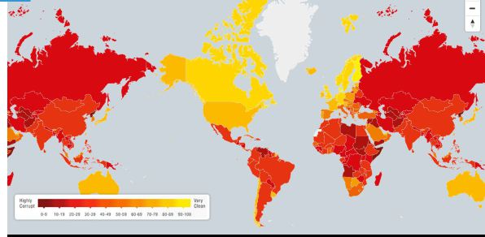
Corruption in Health

Map showing global levels of corruption
Corruption arises in many different forms and situations in both rich and poor countries and health is no exception. It is a major obstacle to development as it breaks down trust between the people and government at all levels and it penalises the poor and powerless. Low-income countries are estimated to lose more than a 1$ trillion per year to corruption. The low pay of medical staff, tax laws and havens, lack of regulation and sometimes lax control of aid monies all contribute to the problems.
Transparency International is a movement dedicated to fighting corruption with chapters in 100 countries including the UK. You can visit their web site here . They provide an annual Corruption Perceptions Index which calibrates levels of corruption as shown in above map where deep red indicates most perceived corruption. Their 2017 report noted the link between corruption and inequality in both rich and poor countries see here.
The scale of corruption varies from petty demands for cash by police or other officials (including public health inspectors, doctors and nurses) to "grand scale", which can include presidential or ministry level profiteering from trade and aid. In many countries corruption can be described as “systemic” meaning that it is seen as “the way the system works”. This was certainly true for health systems in some of the countries in which I have worked.
Corruption can be fueled by global corporations such as BAE and Rolls Royce, who offer bribes through third parties. Manipulation of trade and interfirm accounts to hide profits in tax havens is morally corrupt but legal due to the weakness of global governance. A discussion of global corruption can be found at the Global Issues page here also look at Charmian Gooch’s Ted talk here.
In 2016 TI produced a report on “Diagnosing Corruption in Healthcare” here. This identified 8 areas of healthcare and pharmaceuticals vulnerable to corruption. This includes "informal" payments to medical staff and for medicines which results in poor families in poor countries paying some 30-40% of the cost of their healthcare from their own pockets far more than would be acceptable in rich countries.
A more recent TI report of African Citizens’ views on corruption can be found here , you can find many other surveys and reports on developments in Africa on the Afro Barometer site and the Mo Ibrahim Foundation web site including the African Governance Report here.
Many SfGH members may find some evidence of corruption while undertaking an exchange or elective. My advice would be to handle the situation with care. Gather evidence and report what you find to the National Exchange Officer and perhaps contact TI through them but be aware it is important to understand the full context of the situation and you may be dealing with a dangerous situation. At organizational level I would encourage SfGH to develop links with Transparency international and to see the fight against corruption as an issue of global equity in health and development.
Discuss the steps SfGH can take to counter corruption in Global Health as a source of inequity.

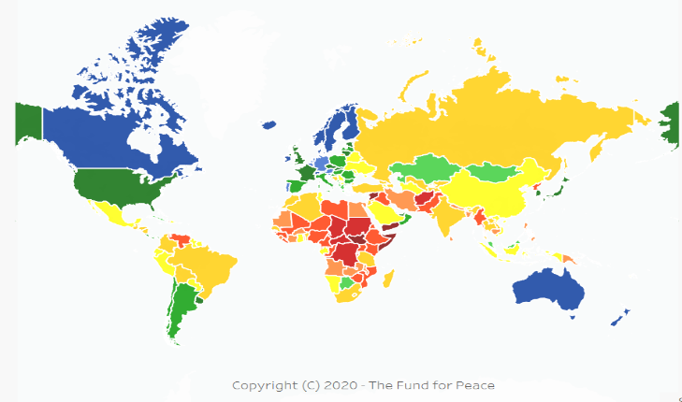
Fragile States

Map of fragility in 2020 from the Fund for Peace

The OECD defines Fragile States as “Those failing to provide basic services to poor people because they are unwilling or unable to do so”. This often reflects a lack of trust between government and people, because of conflict or lack of legitimacy due to corruption. See the Fragile States Index for 2020 produced by the Fund for Peace here and a brief introduction to this topic by Professor Collier here.
Protecting the health security of its people is the first duty of a state, providing health security builds peace, trust and legitimacy, failure to provide for health is a signal of a failing state. It is estimated that out of the world's 7.5 billion people, 26% live in fragile states, and this is where one-third of all people surviving on less than US$1.9 per day live, half of the world's children who die before the age of five, and one-third of maternal deaths. The number of fragile states has grown from 14 in 2000 to 31 in 2020.
At national level it is apparent that health can be an intensely political issue, that can be exploited for corruption and political ends. For international aid this poses difficult questions: should aid be provided to the poorest countries, without addressing political conditions that create fragility and poor health?
A report setting out guidelines for justifiable intervention in fragile states was published in 2001 by the International Commission on Intervention and State Sovereignty see here. The “Responsibility to Protect” (R2P) was unanimously adopted in 2005 at the UN World Summit. It set out international agreement as to the conditions under which intervention could be necessary to protect human rights. An international alliance of NGOS nations and others was established to support this concept.
The aims elements of R2P are defined as:
- The protection of responsibilities of the state;
- International assistance and capacity-building;
- Timely and decisive response.
Direct intervention by military force would be justified if large scale loss of life or genocide was threatened. Intervention should have clear aims supported by regional and international opinions, military force should be a last resort, it should be proportionate to the threat and have a reasonable chance of succeeding. Every effort should be made to work with local communities and NGOs.
R2P has been invoked in more than 80 UN Security Council resolutions concerning interventions in Central African Republic, Côte d’Ivoire, Democratic Republic of the Congo, Liberia, Libya, Mali, Somalia, South Sudan, Syria, Yemen and elsewhere. However, despite support from the African Union there has been some opposition to the concept, some countries opposed R2P as a revived form of colonialism and interference with bilateral trade or agreements, they point out that the consequences of intervention can make the situation worse.
Fragile states are unable or unwilling to provide equitable health services.
SfGH groups are invited to identify a fragile state and to debate the case for and against intervention.
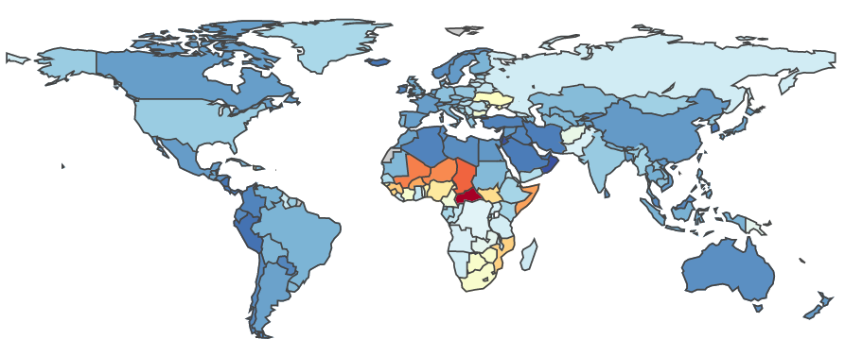
Health in Sub Saharan Africa

Sub

DALYs per 100,000 2019 from IHME
Saharan Africa bears a very heavy burden of disease, measured as Disability Adjusted Life Years Lost (healthy life years lost due to illness and death, including early deaths and years spent with ill health, weighted according to disability). The diagram shows that for most of SS Africa the burden of disease is greater than for any other region. It used to be assumed that low-income countries suffered primarily from Communicable diseases such as Malaria, HIV/AIDS and Tuberculosis, while Non-Communicable Diseases were primarily a problem faced by higher income countries. But this is not the case. The WHO “Noncommunicable Diseases country profiles 2018” report here notes: that low and lower-middle-income countries have the highest proportion of deaths under 60 years from NCDs which have grown faster in lower income countries and, since they generally impose a higher cost on health services, have had a disproportionate impact on their health systems. These countries face a double burden from both types of disease, as shown by the Institute of Health Metrics and Evaluation GBD analysis tool here.
Training toolkit 8 explores issues relating to health care provision in Sub Saharan Africa in greater depth focussing on low income households living in urban slums and rural communities, using examples of provision for Neglected Tropical Diseases (NTDs) and Fungal Infections. It is important to stress that measures to address these types of disease must be part of an integrated approach to all types of physical and mental illness, moreover health is part of the wider challenge of sustainable development.
SfGH groups could consider these issues individually or review the pages together to discuss the problems faced by health systems in Sub Saharan Africa.

Ultra Processed Food in Brazil & Worldwide
Ultra Processed Foods, as defined by the NOVA classification system, have many added ingredients such as sugar, salt, fat, and artificial colours or preservatives. Ultra-processed foods are mostly made in factories from substances extracted from foods such as soya, fats, starches, added sugars, and hydrogenated fats. They may also contain additives like artificial colors and flavors, emulsifiers and stabilizers. These foods include soft drinks, hot dogs and cold cuts, fast food, cookies, cakes, and salty snacks. The additives can also be called “addictives” as they encourage greater consumption.
While such “junk food” is usually associated with the USA and other high-income countries, it is now also prevalent in many low-and middle-income countries such as Brazil, where levels of adult obesity more than doubled from 2002 to 2013. The spread of UPF in Brazil was driven by international companies through advertising and local marketing, including, barges on the Amazon providing floating junk food supermarkets to remote locations. Concerns at the impact on public health raised by a doctor named Carlos Monteiro led the Brazilian government to target consumption of UPF as the single most important public health issue for Brazil. A large-scale study (and similar studies in France, the US and Spain) showed that high consumption of UPFs was associated with higher rates of obesity, linked to a range of conditions, including diabetes, depression, asthma, heart disease, gastro-intestinal disorders and cancers. Government campaigns encouraged the public to avoid highly processed food. It also applied the NOVA system here to identify 4 levels of food processing.
While this is a useful classification system it is difficult to identify exactly what additives of UPF lead to obesity or specific health issues. For this reason the Multinational Companies that are the main producers and distributors of such foods have been able to persuade national and international food regulatory bodies that their products are harmless. This has been facilitated by the fact that in many cases the bodies responsible, such as the USA Food and Drug Administration, the European Food Safety Authority and the United Nations Codex Alimentarius Commission often rely on advice from experts drawn from international food companies. Moreover, they focus on the safety of products rather than the cumulative impact of advertising and over consumption. A broader approach to these factors could lead, at least, to better labelling of products to denote their UPF status and controls on advertising to limit the exposure of children to harmful products and control the use of direct or implied false claims of benefits to health.
Labelling is currently a national issue with very little legislative force. For example, in the UK food companies are encouraged to use a “Traffic Light System” showing levels of Calories, Fat, Saturates, Sugar and Salt per 100grammes. Many companies ignore this recommendation and may even apply their own version, without colours and perhaps showing the level per “Serving” or per “Spoonful”.
Many UPF products are based on Soy beans or extracts, the farming of which in tropical countries such as Brazil raises serious concerns at the environmental damage caused see here..
For a quick introduction to UPF read the Guardian article here for a more detailed understanding refer to the book “Ultra-Processed People” by Chris van Tulleken here
Health and Wealth Inequality in High and Low Income Countries
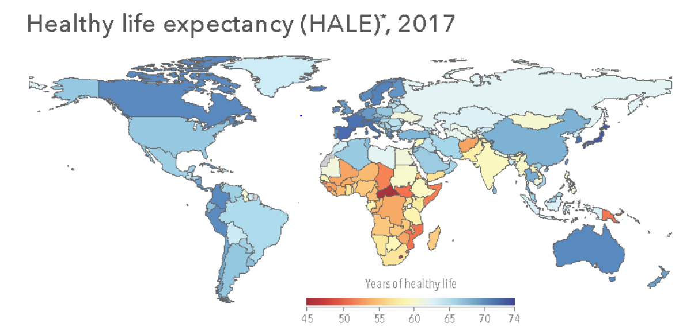

Healthy Life Expectancy at Birth from IHME see here
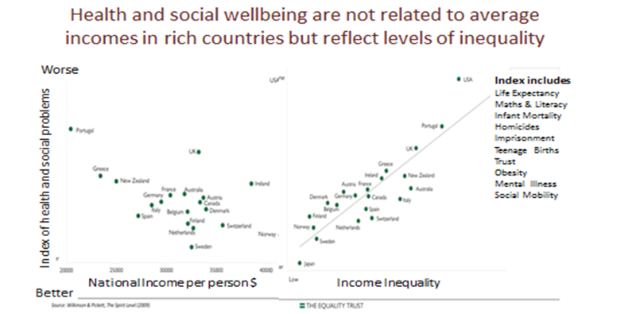
Health in low-income countries is generally much worse than in high-income countries, but middle income countries vary greatly due to the quality of health systems and national social determinants.

In high-income countries health and wellbeing outcomes are not simply a product of health and care systems or average incomes, but are a product of the social determinants affecting health in each country. One of the clearest indicators of failure to address the social determinants of health and wellbeing is the level of income inequality that is tolerated by different governments.
In 2007 Richard Wilkinson and Kate Pickett wrote, “The Spirit Level: Why Equality is Better for Everyone”. This uses measures of problems of: Life Expectancy, Maths and Literacy, Infant Mortality, Homicide, Imprisonment, Teenage Births, Trust, Mental Illness (including drug and alcohol addiction), and Social Mobility, to show a correlation between measures of health and wellbeing problems and levels of income inequality in 23 high-income countries. A similar comparison shows no relationship between average income levels in these countries and levels of health and wellbeing, see here.
Discuss the factors determining health and wellbeing in high, middle and low-income countries.
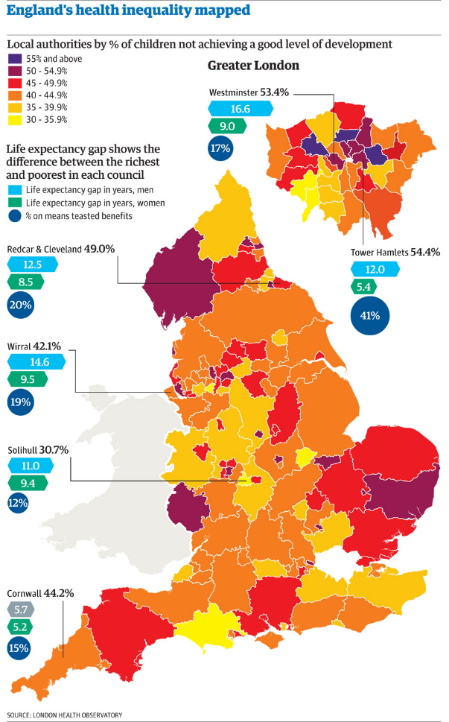
Health Inequity in England

The prime objectives of the NHS as set out in: the Health and Social Care Act 2012, the Public Services (Social Value Act) 2012 and Care Act (2014) include:
- Increasing Life Expectance at Birth (LEB),
- Reducing inequality in health
- Improving the Value for Money of Services
- Improving the quality of care provided
Progress towards Increasing Life Expectancy at Birth (LEB) increased by 2 years every 10 years over about 50 years but this has slowed in recent years and has stopped for some. Moreover, years spent in “poor health” have increased by about 0.5 - 0.7 years over the last 10 years.
Publication of “Health Equity in England: The Marmot Review 10 Years on” in February2020 see here has refocused attention on the objective of reducing health inequality. The gap in LEB between the most advantaged and least advantaged quintile of the population (as measured by the Index of Multiple Deprivation see here) reduced in the years 2003-2012 by almost 1 year for men and six months for women. During this period the 2003 national strategy “Tackling Health Inequalities: A Programme for Action” and the 2010 strategy “Healthy Lives, Healthy People” were implemented, influenced by the Marmot report on the Social Determinants of Health in 2008 “Closing the Gap in a Generation” and the 2010 review “Fair Society Healthy Lives”. However, as the current Marmot report shows this progress has largely been reversed since 2013. Currently the gap in LEB between people living in the most advantaged and least advantaged areas has widened to 9.5 years for men and 7.7 years for women. The figure above shows that in some areas this gap is even more extreme.
While it is not possible to show cause and effect in detail the report clearly blames austerity measures that have had greatest impact on areas of high deprivation and services of most relevance to disadvantaged people. The report shows that health inequality is not inevitable, case studies in this country and elsewhere give examples of local and national measures that can reduce inequality, moreover this could be good value for money, reducing costs to employers, NHS and social care. This could be achieved by implementing a national strategy to: give every child the best start in life, and enable them to maximise their capability, create fair employment conditions and good work for all, to ensure a healthy standard of living for all and create healthy and sustainable communities.
Review detailed proposals of this report (summarized in the last chapter) and consider how SfGH could advocate for their implementation. Report back to Sir Michael Marmot, as Patron of SfGH.

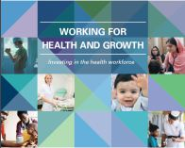
Migration of Health Professionals and Health Equity

The 2016 WHO “Working for Health and Growth: Investing in the Health Workforce” here noted that “Changing populations will generate a demand for 40 million new health worker jobs by 2030. However, most of these jobs will be created in wealthier countries. Without action, there will be a global shortfall of 18 million health workers needed to achieve and sustain universal health coverage, primarily in low- and lower-middle-income countries”.
The conclusion of the report is that investment in health staff training and development is good for economic and social development and is essential to the Sustainable Development Goals. Ten recommendations are proposed on what needs to be changed in health employment, health education and health service delivery to maximize future returns on investment and how to enable change. I certainly agree that in many low-income countries the problem of retaining health professionals is compounded by a lack of adequate health sector employment and advancement opportunities outside the major towns. However, I suggest that this review assumes a traditional pattern of healthcare delivery for all low income countries similar to that of high income countries now.
Hospital care often dominates the budget of low-income country health systems and this is too often confined to large towns with poor links to community care. ICT could transform the delivery of health services, but only if used as an element of an integrated transformation of health worker training and integrated community health service delivery. It is not clear to me that the model offered by health professional bodies based in high income countries is most relevant to low-income countries, where doctors are unlikely to be based outside major towns, where they can access private patients. The potential of ICT to transform healthcare in low-income settings could be constrained by traditional professional roles and education. There have been various models of integrated community based healthcare, I find the Health Extension Package approach developed in Ethiopia by Tedros Ghebreyesus most relevant see here.
In recent years the NHS has recruited up to 3,000 doctors and 6,000 nurses per year trained in other countries. Most are from low-income countries where health worker shortages limit the provision of services and hamper human development. While some return to their country of origin with enhanced skills and experience, most do not. This problem has been recognised and various International Agreements and Memoranda of Understanding have been established to try to ensure responsible recruitment. But in practice it is not easy to limit recruitment, workers have the right to use their skills wherever they choose and if they are not recruited directly to the UK they may move to another country and displace workers who then migrate to UK. A simple answer to this problem would be an international agreement for the recipient country to repay the cost of training. This should not be a direct employment cost but a parallel payment that would both enable the provider country to train more workers and encourage the recipient country to increase its health education budget.
Discuss what can be done to improve equity both for the countries losing trained health professionals due to migration and for the health workers who choose to take their skills to other countries.

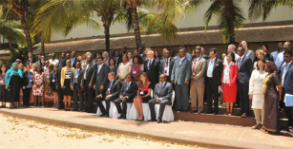
Noncommunicable Diseases and Global Health Equity

Noncommunicable Diseases (NCDs) attributable to factors such as: poor diet, smoking, alcohol and other drug consumption are the leading causes of death (~70%) and poor health (~60%) globally. To address their impact, action is required to improve the regulation of global corporations that promote unhealthy products and lifestyles, to reduce illegal trade in drugs, cigarettes and alcohol and to increase awareness and community action to protect our health. This calls for both strengthened global governance and whole society action for health.
It used to be assumed that low-income countries suffered primarily from communicable diseases such as Malaria and Tuberculosis, while NCDs were primarily a problem faced by higher income countries. But this is not at all the case. The WHO Noncommunicable Diseases country profiles 2011 report notes: “Low and lower-middle-income countries have the highest proportion of deaths under 60 years from NCDs which have grown faster in lower income countries and, since they generally impose a higher cost on health services, have had a disproportionate impact on their health systems.
SfGH is engaged in this movement through IFMSA, which is a participant in the WHO Global Dialogue on the role of non-State actors in supporting Member States in their national efforts to tackle noncommunicable diseases (NCDs) as part of the 2030 Agenda for Sustainable Development. A report of their meeting in October 2016 can be viewed here.
The statement by the co-chairs of the WHO Global Dialogue on NCDs called for NGOs to redouble their efforts to advocate for action at global, national and local levels, but their conclusion on progress to date was frankly depressing: “Nearly three-quarters of all countries showed very poor or no progress”.
To understand the causes and consequences of NCDs in total or for individual diseases, globally, for individual countries and even regions of the UK, the best source is the Institute of Health Metrics and Evaluation, Results page here. The Global Burden of Disease Tool, Data Visualisations, Country Profiles and research reports are all very useful. They show expert estimates of the impact of the main behavioural and environmental risk factors associated with diseases and their outcomes, in terms of Deaths, Disability Adjusted Life Years (DALYS), Years of Life Lost due to premature Deaths (YLL) and Years Lived with Disability, weighted for disability (YLD), note that DALYs=YLL+YLD.
Discuss this issue as an example of a global issue that is also a local issue.

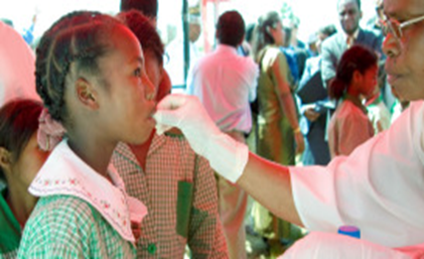
Neglected Tropical Diseases and Access to Medicines

Access to medicines is limited for people with low incomes by three key factors. First medicines are often unaffordable because prices are set by rich country markets and may even be higher in low income countries. Second the prospect of low affordability deters the development of medicines for Neglected Tropical Diseases (NTD) resulting in what is known as the 10/90 gap. This means that only 10% of research funding is devoted to conditions that cause 90% of the global disease burden. Third the lack of effective health systems, diagnostic and prescribing skills and logistics for the delivery and control of medicines inhibits the provision of medicines as one aspect of effective healthcare.
The global social contract with pharmaceutical companies embodied in WTO intellectual property agreement (TRIPS), provides global protection for 20 years for patented drugs. While patent protection starts from the filing of the patent application, which can be years before commercial availability, pharma companies extend this by introducing minor enhancements to drugs. The Doha declaration of 2001 provides exception in the case of health crises, allowing the provision of lower cost generic medicines, of which India is the largest producer. Some companies provide medicines at a lower price to low-income countries through intermediaries such as the Clinton Foundation. It has been suggested that the main obstacle to setting affordable prices for low-income countries (where prices are often higher) is the fear of, so called, parallel exporting (corruptly selling drugs back to high income markets) and counterfeit medicines (an estimated market of over $75 billion).
More than one billion people suffering from one or more of the 20 NTDs which cause some 500,000 deaths pa benefited from large-scale treatment programmes of preventive chemotherapy in 2014 as part of the world's largest public health intervention led by the WHO. This programme benefited from donations of drugs from pharmaceutical companies worth billions of dollars, see here .
It is easy to blame pharmaceutical companies for neglecting drug development for diseases affecting low-income countries. But it might be more constructive to challenge the system of intellectual property rights that creates the incentives for investment. The same incentive structure also inhibits research and development for new antibiotics. It is also important to recognize the support that pharmaceutical companies provide for access to medicines that are found to be effective for NTDs, while acknowledging that this is not enough. The Access to Medicines Index, supported by UKAID, the Bill and Melinda Gates Foundation and the Netherlands Ministry of Foreign Affairs reviews the performance of 20 of the world’s largest research-based pharmaceutical companies view the index here.
Discuss how SfGH can support positive action to improve global access to medicines.

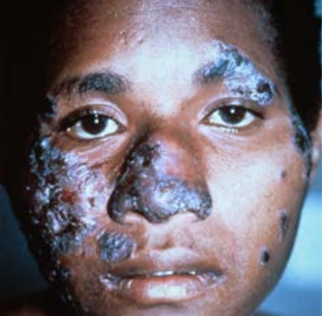
Fungal Infections: The Hidden Crisis

Every hour 150 people die of fungal infections and many more suffer life changing conditions including blindness and disfigurement. Fungal diseases are particularly prevalent in rural areas of Lower Income Countries, where necessary diagnostic laboratory services and drug treatments are very often lacking. In total fungal diseases account for some 2 million deaths, making this the 5th largest cause of mortality, worldwide. However, this is largely unrecognized as they are usually masked by underlying conditions which are reported as the cause of death.
GAFFI (Global Action Fund for Fungal Infections) reports that almost half of those who die with fungal conditions associated with AIDS (770,000 in 2018), 3 million people with TB like infections, some 160,000 people with Leukaemia and Lung Cancer, over 1 million people with Fungal Keratitis and hundreds of thousands of those with Neglected Tropical Diseases, could be cured, if relatively simple diagnosis and treatments could be provided for fungal infections in Low and Lower Middle Income Countries. Their campaign to ensure that 95% of people with serious fungal disease are diagnosed and 95% treated by 2025 (95-95) can be viewed here.
The GAFFI campaign aims to persuade the WHO and governments to give greater priority to fungal diseases, to improve the skills and resources needed for diagnosis and treatment at local levels, to raise awareness and education about fungal diseases for health, community workers and the public and to monitor the impact on health and wellbeing. A demonstration programme in Guatemala (see here) has shown the feasibility of this approach and is already proving its value.
Educational resources including guidance on laboratory procedures can be found on the web site of LIFE (Leading International Fungal Education) a partner organisation working with GAFFI (see here).
Students for Global Health may wish to consider the GAFFI campaign as an example of how an international community action group can influence and support international action in respect of a major global health challenge.
SfGH Trainers could lead a discussion of this campaign and in particular students who have experience of exchanges or volunteering in Lower Income Countries may wish to share their ideas of how fungal diseases could be addressed in the countries they have visited.

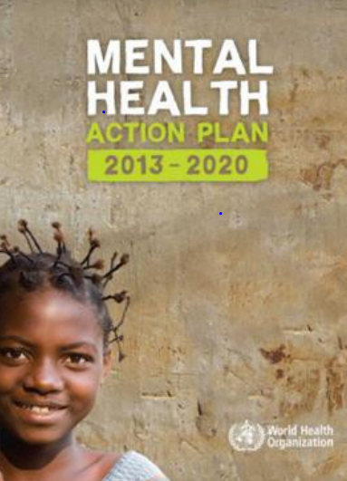
Global Equity and Mental Health
2030

Mental health in low and middle-income countries is central to addressing issues of global health concern, such as violence, dislocation and women's health. Most mental disorders begin in childhood or young adulthood and could be addressed by low-cost prevention and care measures in the community and at schools. However, research suggests that this is seldom available see here.
In the past mental health has often been overlooked as a global health issue. One reason for this is that it, has been treated as a long-term care issue rather than one that is central to population health and socio-economic development. But globally mental illness accounts for more years lived with disability (32.4%) than any other health condition and nearly as many disability-adjusted life-years (13.0%) as cardiovascular disease (13.5%). Every year over 12 billion working days are lost due to mental illness at a cost estimated at some $1 trillion per year in lost economic output— more than cancer, diabetes, and respiratory diseases combined see here. In 2013 WHO estimated that low-income countries spent less than US$ 0.25 per capita per year on mental health (from a total health spend per capita of some $80), 67% of mental health spending was allocated to stand-alone mental hospitals, despite their association with poor health and social outcomes.
Another possible reason for neglect is that mental health has been seen as a national issue rather than one reflecting global trends or causes that transcend borders. But there can be little doubt that mental health is profoundly influenced by global factors, such as the alienation arising from depictions of rich lifestyles to people in poverty, promotion of unhealthy lifestyles and products by Multi-National Companies, global economic depression and now social isolation in response to the pandemic.
In the last ten years more attention has begun to be focussed on global mental health issues, the 2013-2020 WHO “Mental Health Action Plan” see here called for improvements in the leadership and management of mental health services as elements of a community based approach to universal health coverage, and prevention service, as a human right at all stages of life, involving all sectors (health, social care, justice, education), drawing on the best available evidence to empower those with mental illness or disorders to live their best life. This plan achieved some progress, by 2019, more than 70 countries had prioritized coverage of mental health conditions. These countries developed and sometimes implemented plans, but outcome improvement has been slow. So the planned target date was extended in 2019 from 2020 to 2030, with further targets see here.
In 2019 Tedros Ghebreyesus introduced the WHO Special Initiative for Mental Health (2019-2023) to refocus attention on the need for action for “Universal Health Coverage for Mental Health” see here. This set the goal of achieving universal health coverage (UHC) with access to quality and affordable care for mental health conditions in 12 priority countries for 100 million more people. It called for an allocation of S$ 60 million in aid over five years. This is of course a very small investment given the scale of the issues faced, but it is not yet clear that this funding has been forthcoming see here.
Students for Global Health are invited to try to imagine the pressures on the mental health of young people in low and middle-income countries and to promote greater focus on this inequity.

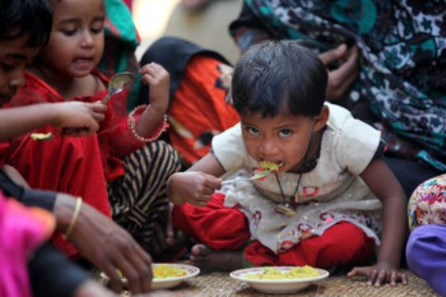
Global Child Health Equity

“A Future for the World's Children?” a WHO–UNICEF–Lancet Commission report published on 18th February 2020 draws attention to the uncertain future faced by today’s children due to the threats to health posed by climate change, the uncontrolled marketing of unhealthy foods, the neglect and undermining of parenting skills and child health education and failure to provide adequate governance of child health at global and national levels. You can download the report here.
The report calls for Children’s health to be placed at the centre of SDG Goals and specifically calls for:
- Better coordination of child health policy and action at national level.
- Monitoring of national support for child health and wellbeing especially for poor children.
- Improve data reporting for SDG indicators of child wellbeing, equity, and carbon emissions.
- Coordination of local action for child health and wellbeing, involving civil society and children.
- Global children's advocates to mobilise governments and communities to adopt child-friendly wellbeing and sustainability policies, and advocate for rapid reductions in carbon emissions.
- Reframing SDGs for children, and threats from climate change, mainly by high-income countries
- Children should be given high-level platforms to share their concerns and ideas.
- Apply UN Convention on Rights of the Child to protect them from harmful commercial practices.
- A multisectoral UN approach to reduce fragmentation with action for children central to SDGs.
- WHO, UNICEF and other agencies to plan coordinated action to support countries to enact effective policies to achieve the SDGs for children, and share progress and best practices.
The report notes that progress has been made in relation to the delivery of health treatment services in many parts of the world but it also underlines the failure to address some of the causes of poor health and wellbeing that affect children in both high and low income countries. It is a call for better global, national and local action on the threats to global health for children.
Children’s health and wellbeing should be central to the SDGs, protecting them and future generations from threats that are apparent now. Sustainability is for and about children. When they asked children what was important to them in thinking about their health and wellbeing, family came first but they also looked for: safety from violence, clean environments, and access to culture and education, as most important for their happiness. The report also notes that action on child health and wellbeing could be shown to be cost effective over the life of the child and indeed their children.
SfGH may wish to review the report and consider its support for global child health equity.
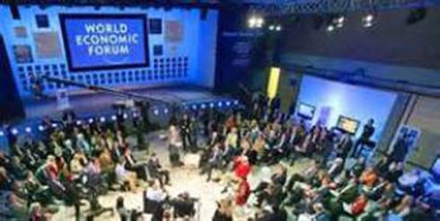
Is Global Corporate Social Responsibility a Step Towards Equity or Just Greenwash?

The WEF’s Inclusive Growth and Development Report 2017 available here points to growing income disparity within both rich and poor countries. It suggests measures of the impact of globalisation on equity and even questions whether the current model of global capitalism can survive. But do global corporations’ hand wringing and expressions of social responsibility have any reality or are they just a new version of “greenwash”? Can SfGH make global corporate social responsibility for health a reality?
Corporate social responsibility has long been a favoured page on corporate web sites, usually focused on commitment to environmental standards and seldom mentioning global health. In 1999 Kofi Annan introduced the UN Global Compact, which encouraged some 9,250 companies to sign up to a set of values, which are now linked to the Sustainable Development Goals. This also provides a framework by which adherence to the global compact may be assessed, but it is unclear who should apply this.
Another way of looking at GCSR is that it relies on voluntary commitments, to values and codes of conduct, avoiding any form of global governance of business by the UN. The current process for agreeing trade tariffs and regulations resulted from US objections to the proposal for a UN International Trade Organisation. The General Agreement on Trade and Tariffs (GATT) was established in 1948 and reformulated as the World Trade Organisation (WTO) in 1995. It is not a UN organization but a forum for international agreements between governments. It has been open to discussions with NGOs on Corporate Social Responsibility issues but does not monitor or regulate such matters.
Is GCSR a step in the right direction? At first glance it seems only positive that corporate leaders should address economic inequity and other social impacts of globalisation, but this cannot replace global governance and regulation. It seems perverse that global companies should be the bodies that choose how they should be judged and to select whether or not they will accept regulation. At present global companies are free to setup complex structures and internal pricing mechanisms so that, for example, value generated by mining operations in Zambia are taxed at a favourable rate in tax havens see here.
While some companies may choose to provide healthcare for their workforce in South East Asia, others avoid such costs and outsource their production to low cost sweat shops operating in unsafe conditions (a sweatshop is defined as an establishment breaking two or more labour laws). One way forward is to raise customer awareness of the global corporations, which produced goods ethically and denounce those that fail to meet acceptable standards. This has been effective in changing the behaviour of some producers such as Nike see here.
But many global companies do not produce consumer goods and are difficult to pin down. I remember a vast copper mine in southern Africa which paid no corporate taxes there, claiming all its profits came from a small trading team based in Switzerland. The 2021 proposals by President Biden for global taxation of corporations based on a minimum profit tax allocated to countries according to turnover would begin to addressing the injustice of the current tax regime which allows global corporations such as internet giants to hide their profits in tax havens. Self-regulation is not a substitute for the governance required for this new era of globalisation see the article by Arnel Karnani here.
SfGH should consider how they can promote ethical production and denounce the unethical.
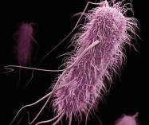
The End of Antibiotics and its impacts on Health Equity

September 2016 saw the death in Reno of a woman in her 70s whose condition proved to be resistant to all 26 antibiotics available in US hospitals. She developed a rare infection after treatment in an Indian hospital for a broken femur and was hospitalised with sepsis after returning to Nevada. The news, has raised fears that the era of total antibiotic resistance has begun.
This could fundamentally affect the future of medicine, threatening the lives of hundreds of millions across the globe. Experts have warned of the danger of rising antibiotic resistance for several years, due to their misuse in human medicine and animal husbandry and the lack of controlled distribution in many countries. I I found I was able to purchase a single dose of a fourth-generation antibiotic in a wayside shack near Phnom Penh. SfGH members will understand that this is a recipe for developing antimicrobial resistance. While there are a limited number of new antibiotics being researched, it is claimed that the economics of drug development no longer work. New antibiotics are increasingly expensive to develop and require years of clinical trial, and the speed at which antibiotic resistance develops and spreads to making them useless, has increased alarmingly.
In 2016 the UK government published a review with the support of the Wellcome Trust entitled “Tackling Drug-Resistant Infections Globally: The Review on Antimicrobial Resistance”. In introducing the review David Cameron underlined the gravity of this issue: “If we fail to act, we are looking at an almost unthinkable scenario where antibiotics no longer work and we are cast back into the dark ages of medicine". The report, which is available here , put forward ten recommendations, estimated to cost $40 billion over ten years:
- A massive global public awareness campaign
- Improve hygiene and prevent the spread of infection
- Reduce unnecessary use of antimicrobials in agriculture and their dissemination into the environment.
- Improve global surveillance of drug resistance and antimicrobial consumption in humans and animals.
- Promote new, rapid diagnostics to cut unnecessary use of antibiotics
- Promote development and use of vaccines and alternatives
- Improve the numbers, pay and recognition of people working in infectious disease
- Establish a Global Innovation Fund for early-stage and non-commercial research
- Better incentives to promote investment for new drugs and improving existing ones
- Build a global coalition for real action – via the G20 and the UN
This is an issue that affects global health across all national boundaries and it is also an intergenerational issue, as antimicrobial resistance will have greatest impact on SfGH members’ millennial generation and beyond. It also raises issues of global health equity, because as effective antimicrobials become rarer, there is little doubt who will be last in line for them. SfGH may wish to consider how to stimulate decisive action on this issue see for example “Six Grand Ideas to Fight the End of Antibiotics” here.
What action can SfGH take to advocate for action on Antimicrobial Resistance?
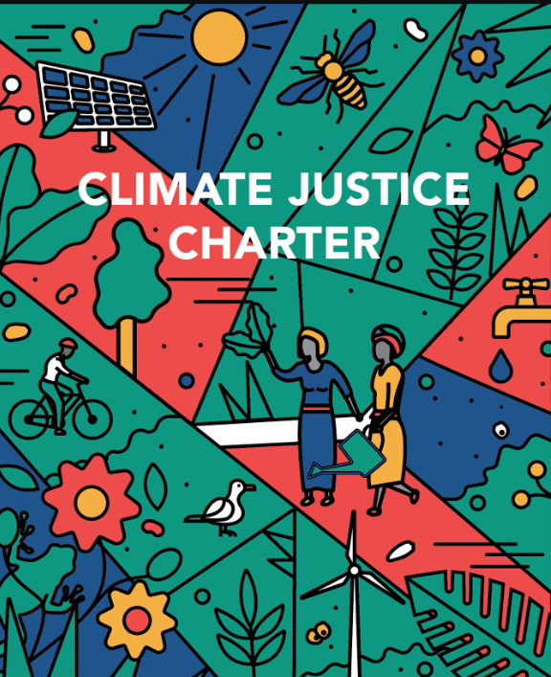
Climate Change and Equity:Justice for All
SfGH are right to address climate change as an issue of social justice in its training toolkits here, here and here and online discussion here. Climate change is a threat to human health and survival that can only be met by global action to address the social and economic causes and consequences of hundreds of years of social injustice. It demands a new perspective and commitment as set out in the recent Climate Justice Charter here it will also require unprecedented levels of investment.
A simple introduction to Climate Justice is provided by a video from Daily Motion here. This underlines the point that climate change has been caused by generations of exploitation of our planet by what are now high-income countries which benefited from a legacy of abuse and colonial exploitation. The impact of climate disruption will have its most severe impact on the lowest income countries who have contributed the least to the crisis we now face. Within countries it will be the poorest and those disadvantaged by prejudice towards race, sex or disability who will suffer most. Those without voice in national and global politics such as the children of the future generation are ignored, yet it is they that will suffer see the UNICEF report showing 1.1 billion children at risk from climate change here
The Independent Expert Group On Climate Finance reported in December 2020 see here that the agreements reached at the UN Conference of the Parties 16, that “developed country Parties commit, , to a goal of mobilizing jointly USD 100 billion per year by 2020 to address the needs of developing countries” should be considered as an absolute minimum starting point for the level of investment required from public and private financial sources. Yet this starting point which represents about 0.12% of global GDP seems unlikely to have been achieved and significantly less than 20% of investment has been funded by grant aid rather than debt. This means that low-income countries, many of which have been pushed into recession by the Covid-19 pandemic will face even greater financial instability in tackling a climate crisis, which was not of their making.
It is time to rethink global financing for climate change, not as a “gracious benefaction from rich countries to the poor” but as an issue of global justice, in which those countries which have damaged the global environment, are held to account, by all humanity and future generations. At the same time, we must rethink the scale of investment and action required at every level in society. While low-income countries hope high-income countries will meet at least their US$100 billion pledge made in 2009, the International Energy Agency together with the World Bank and World Economic Forum estimate that more than US$1 trillion dollars is needed by 2030 to undertake the energy transition in low-income countries. In the UK it has been estimated that current spending on measures to mitigate climate change account for some 0.01% of GDP, while the Climate Change Committee estimate that total spending per year required is some 100 times greater at 1% of GDP.
SfGH groups can work with Green New Deal UK here to demand action for climate change justice.
Women in Global Health

The 2009 report by the WHO “Women and Health” here provides evidence of the widespread and persistent inequities that harm women’s health and hold back the development of services, such as sexual and reproductive health services, particularly in low-income countries. The report notes that many of the physical and mental health problems faced by adult women have their origins in childhood neglect of issues including poor female nutrition and child abuse. Global estimates published by WHO indicate that about 1 in 3 (35%) of women worldwide have experienced either physical and/or sexual intimate partner violence or non-partner sexual violence in their lifetime. Access to services may be constrained by factors such as user fees for maternal health service, a lower priority accorded to female health needs, and lack of recognition of sexual violence, due to traditional attitudes and beliefs.
Reforms of healthcare must recognise that women’s health is both an important driver and an indicator of socio economic development, as discussed by Ana Langer et al in the report of the 2015 Lancet Commission “Women and Health: the key for sustainable development” here
Women are the main providers of health in the home and in health systems where they make up 70% of the workforce. But as Amina J. Mohammed Deputy Director General of the UN noted at the 2020 “Women Leaders in Global Health Virtual Conference” – “Seven out of 10 global health leaders are men. At the current rate of change, it will take over half a century to reach gender parity in senior management roles in global health”. A 2020 report by WHO “Women's health and rights: 25 years of progress” adds a question mark to this title, see here.
Working with WHO some 20 years ago, I was struck by the relatively low representation of nurses and nursing issues and the relatively high proportion of white male experts (including me). I understand that the situation has improved and there is now a greater focus on nursing and women’s health. The latest forecast from WHO is that by 2030 there will be a need for some 9 million more nurses.
The following pages attempt to provide some further insights into:
- Progress towards a more gender equal world
- Traditional beliefs and women’s health
- Nursing Now for better health, gender equity and socio-economic development
- Florence Nightingale and the male prejudice she faced.
- Modern slavery and women’s health
- The Global Gag rule and women’s health
SfGH groups are invited to add their own thoughts and comments either discussing specific pages or taking a view of all 7 pages. And please do not think that this is only an issue faced by “other countries” research levels of domestic violence and gender based health inequality in the UK.
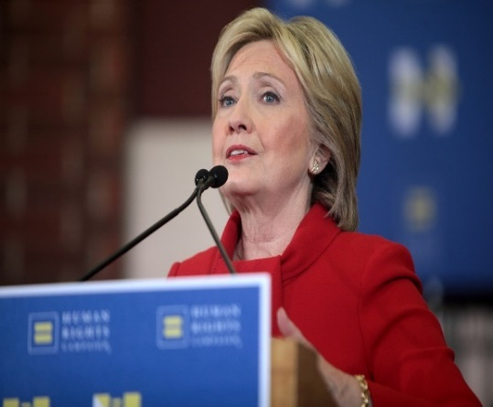
International Women’s Day 2020:
This Photo by Unknown Author is licensed under CC BY-SA
Towards a more Gender Equal World

‘What exactly does maternal health, or immunizations, or the fight against HIV and AIDS have to do with foreign policy? Well, my answer is everything.’ (Hillary Clinton, 2010)
Hillary Clinton has long recognized the importance of global health for foreign and domestic policy. In 1998 she hosted an international meeting to spread awareness of the American Institute of Medicine’s paper “America's Vital Interest in Global Health: Protecting Our People, Enhancing Our Economy, and Advancing Our International Interests”. She is also a strong advocate for the rights of women see here and has identified women’s health as a central to a safer, more prosperous and more just world.
On International Women’s Day March 8th 2020 it is important to take the time to consider the steps that can be taken to move towards a more gender equal world, see the guidance and resources here. We should reflect on our failures. Examples discussed in the following pages include: the restriction of women’s health rights on religious or other pretexts, the “Global Gag rule”. And the sexist attitudes that limit the status of the nurses who lead health services in many rural health centres across Africa.
We should recognise that the variation in Maternal Mortality (women dying within 42 days of childbirth) - from less than 10 per 100,000 births to more than 1,000 - is a gross injustice to women. That annual trafficking of 600,000 to 800,000 people, mostly women, often minors for sexual exploitation each year, is an obscenity. And that the exploitation of some 25 million women in sweatshops (defined as those breaking two or more labour laws) and those without employment rights in export processing zones must not be tolerated, by our consumption of “fast fashion”.
Women are crucial to family and community health, wellbeing and prosperity. Melanne Verveer, U.S. Ambassador-at-Large for Global Women’s Issues has declared that investing in women is critical to any country struggling to climb out of poverty. None of the major economic, security, governance, and environmental challenges of our time can be solved without the participation of women at all levels of society. Empowering women is one of the most effective and positive forces for improving conditions around the globe. Indeed, no country can prosper if half its people are left behind.
Action on these and many other cases of the lack of gender equity in global health are championed by the Women in Global Health Campaign see here.
SfGH members are invited to consider how they can work with other organisations in this field towards the empowerment of women and gender equity in global health.

Traditional Beliefs and Women’s Health

Beliefs, including religions and local customs can be a source of inspiration for action to improve the health of others in local communities and across the world. Religions provide a route to contemplation on issues which will affect the health of the planet and future generations and on personal issues of mental health and wellbeing. See the Drew University Religion and Global Health Forum here.
Faith based organisations (FBOs) have long played a role in uniting people of faith across the world. Missionary settlements spread Christianity, Islam and other faiths, often providing health and education. By 1897 the first missionary teaching hospital was opened in India by a Canadian missionary. Today FBOs still play a major role in engaging people across countries and have been estimated to provide some 20-40% of healthcare services in parts of rural Africa.
Religious leaders are often powerful advocates for or against public health interventions, with strong links to the most vulnerable people. There have been examples of leaders using religion to oppose public health practices, such as the use of condoms, vaccination and most recently isolation measures to reduce the spread of Covid-19. However, working with religious leaders can be a very productive way of engaging communities in positive action for health as discussed by Sima Barmania and Michael J. Reiss in a recent online article “How religion can aid public health messaging during a pandemic” see here.
Traditional medicine typically involves diviners, midwives, and herbalists, often invoking mystic customs. In the past such practices were ignored or even banned, but a more understanding approach may be to encourage practitioners to work with modern health services in a regulated system see here.
Some traditional practices such as Female Genital Mutilation are clearly both dangerous to women’s health and a gross violation of their rights to sexuality see here. Yet FGM, in different forms is practiced in some 30 African countries. It is also inflicted on children taken from their homes in other countries to be subjected to this disgusting practice, which has no religious basis.
Traditional beliefs can be harmful or helpful, whether sanctioned by religion or not. In many cases beliefs reflect the power structure of a prior era, in which women were considered subordinate to men. While traditions and beliefs must be respected and understood they must also be challenged see here.
In 2005 I was invited to present a paper at the Harvard Divinity School discussing how ethical beliefs shape our response to global health issues. Each speaker at the conference was asked to state their personal beliefs as a basis for their talk, I introduced myself as a humanist atheist my talk on Values for Global Health Governance is the last item on the page here.
SfGH groups are invited to share how personal beliefs whether religious, humanist or other guide their commitment to global health.
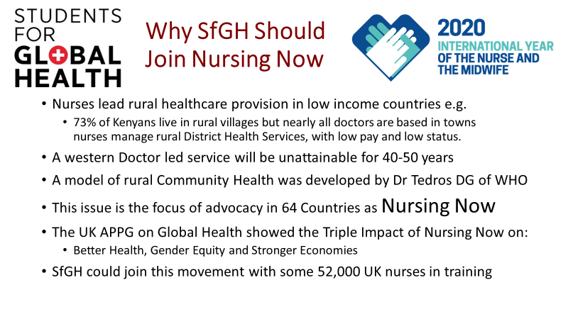
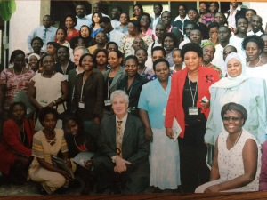
Nursing Now
Working with the Aga Kahn Foundation, Nottingham University School of Health Sciences and WHO to develop Masters Level courses for nurses and midwives in Kenya, Tanzania, Zanzibar and Uganda, taught me great respect for the women who run healthcare services in rural East Africa (where 60% of people live). It also left me frustrated at the sexist attitudes of senior officials who saw nurses as simply assistants to (male) doctors even where there were no doctors. In some rural health centres there would be a room marked “Daktari” run by a man with two years training to prescribe some 40 basic medicines, less than the training and responsibilities of nurses, but higher status.
It is often assumed that the answer to Africa’s health needs is to provide the same pattern of health services as is found in rich countries, with about 3 Doctors per 1000 patients. But Sub Saharan Africa has less than a tenth of this (0.2 per 1,000) with less than half this number in rural areas. At current rates of training and doctor migration this will not meet health needs for at least 40 years and probably never.
A promising approach was developed by Dr Tedros Adhanom Ghebreyesus, now the DG of WHO, but then responsible for healthcare in Tigray Province Ethiopia see here. This village based programme relied on community health workers, who were mostly women. Later developments showed how this village-based approach could be enhanced by sharing medical knowledge and practice using information and communications technology. There are now great resources being produced for this, including online diagnostics and drone delivery of medicines. The missing element in this development has been a failure to include these ideas in the training of Nurses, Midwives and Community Health Workers.
The Nursing Now programme started in 2015 has been taken up in 64 countries and support is still growing for 2020 as the year of the Nurse and Midwife (in some countries Midwifery is a branch of Nursing and in others it is separate). The relevant WHO page can be seen here and the Nursing Now web site here provides resources for advocacy (which provide some lessons for SfGH).
The UK All Party Parliamentary Group on Global Health has championed this issue and published a report on the triple impact on better health, gender equity and socio-economic development see here . This group is co-chaired by Lord Nigel Crisp, who is a Patron of SfGH.
Join the Nursing Now initiative for better health, gender equity and socio-economic development and send a note of support to Nigel Crisp.

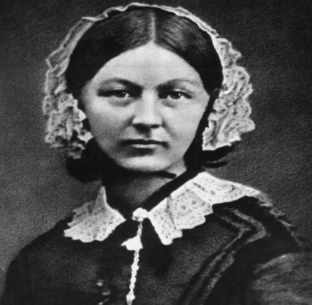
International Nurses Day marks Florence Nightingale’s birthday

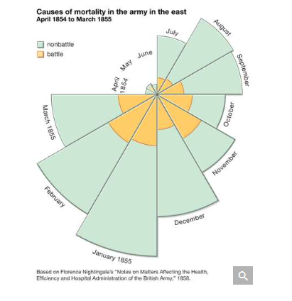
May the 12th 2020 marks the bicentenary of Florence Nightingale in this Year of The Nurse and Midwife. She is regarded as the founder of modern nursing practice and can also be seen as a forerunner of public health and hospital management. Born into a wealthy family she was a studious girl who studied the classics and mathematics. She wanted to study nursing but her family, regarded this as a lowly occupation unfit for a woman of her standing. All her life she faced male prejudice against nursing as unskilled woman’s work and care of the disadvantaged as a “futile attempt to redress the natural order”. She traveled widely including a visit to Germany where she observed the work of a Lutheran pastor and deaconess caring for the sick and poor. She gained her first training in nursing there and wrote about this in her first publication. Returning to London she took a post as the superintendent at the Institute for the Care of Sick Gentlewomen in Harley Street.
In 1854 she was asked by Sidney Herbert, the Secretary of State for War, to help improve the condition of British Military Hospitals in Crimea. With a company of 38 women volunteers she was at first treated with some suspicion and had to work hard to gain acceptance. She was insistent upon 5 key elements to improve health outcomes: fresh air, pure water, efficient drainage, cleanliness/sanitation and light/direct sunlight.
Her “secret weapon” was the use of statistical analysis to show the improvement that was achieved by better nursing care. The diagram shows the type of diagram she used to prove her case.
On returning to London after the war she was treated as the heroine “Lady of the Lamp” and funds were raised that allowed her to open the Nightingale School of Nursing at St Thomas’ and later a school for the education of midwives at King’s College Hospital and a school for the education of district nurses to care for the sick and deprived in their homes. Her best-known publication “Notes on Nursing: What It Is and What It Is Not” was published in 1859. Her influence is global, she mentored Linda Richards, who founded American nursing schools and her statistical methods were used by a Royal Commission examining health in India, where her name is revered.
As we are asked to shine a light for nurses on 12 May in recognition of their service and sacrifice during the Coronavirus Pandemic we should remember that nurses, midwives and community health workers are the frontline of health services in every continent and country. They are our global health workers.
SfGH might wish to consider how Florence Nightingale challenged male stereotypes of nursing care.
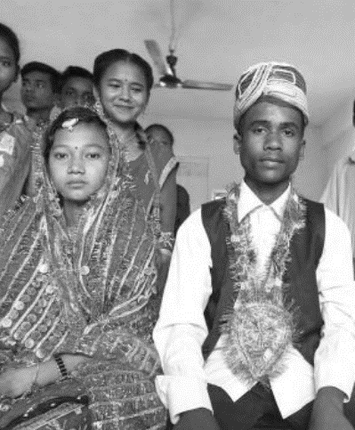
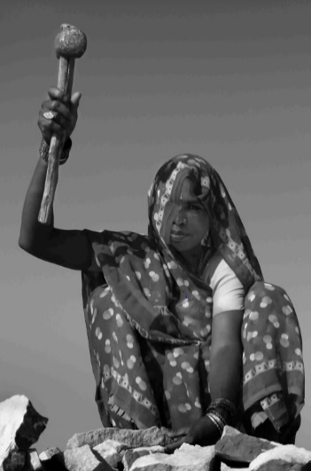
Modern Slavery and Women’s Health
Estimates of forced labour, sex trafficking and forced marriage are difficult, because they are now illegal in most parts of the world. Alliance 87 published its findings here, they report that in 2016 some 40 million people were victims of modern slavery, including 25 million in forced labour and 15 million in forced marriages. Women and girls account for over 70% of modern slaves and 25% are children. They note that over the preceding 5 years some 90 million people had spent time as slaves.
The most common instrument for forced labour is debt bondage, in which personal debt is used to forcibly obtain labour. Debt bondage affecting half of adults in forced labour, could arise for different reasons including the price imposed for human trafficking. An estimated 3.8 million adults and 1.0 million children were victims of sexual exploitation, 99% of these were women and girls.
For a more detailed, country by country assessment of human trafficking (though without clear estimates of cases) see the “Trafficking in Persons Report” of 2020 here.
Victims of forced marriages were almost 90% women and girls, who had not consented to marriage. In 2016 15.4 million people were living in a forced marriage. Of this total, 6.5 million cases had occurred in the previous five years, more than a third of victims were under 18 years of age at the time of the marriage and of these, more than 40% were forced to marry before the age of 15 years.
The effects of trafficking and forced marriage on violence against women and children and physical and mental health consequences are difficult to quantify but the WHO Information Sheet on Violence against Women sets out the typical impacts see here.
Sweatshops, are defined as factories breaking two or more labour laws. They may not use slave labour but they often employ women on piecework rates, forcing them to work long hours with earnings below minimum wage levels. In 2020 it was revealed that some 250 workshops in Leicester could be described as sweatshops. Andrew Bridgen a local MP claimed that this was an open secret and that "there are probably 10,000 modern slaves in Leicester". The fast fashion industry is notorious for sweatshops, a list of fashion brands that are said to use sweatshop labour is here.
This is not the only field in which modern slavery is manifest, consider as examples: child labour in the chocolate industry, illegal drug distribution and exploitation of women in nail bars, export processing zones and as domestic servants, Google these and other forms of exploitation.
SfGH groups are asked to consider modern slavery in all its settings and to raise public awareness of international, national and consumer action that can help to counter this global health issue.
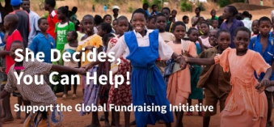
Celebrate the Reversing of the Global Gag Rule

One week after taking office, President Joe Biden reversed a policy widely known as the global gag rule, which restricted access to advice on safe abortion around the world.
On average around 55million abortions are performed each year, it is estimated that almost half of these – 25 million can be classified as unsafe abortions and 8 million of these are carried out in least safe or dangerous conditions. Virtually all unsafe abortions are in low and middle income countries, almost half are in Asia. In Africa and South America 75% of abortions are unsafe. Unsafe abortion is the cause of some 14,000 – 400,00 maternal deaths per year and is a major cost to health systems, see the WHO Evidence Brief here.
The Global Gag Rule, which withheld US health AID from any organisation making any sort of reference to or advice on abortion, had a devastating effect on the lives and health of millions of people, as explained in the Guardian article here. This rule has been applied by Republican Administrations since it was first introduced by Ronald Regan in 1984. This time the restriction was applied by Trump not only to $595m for Family Planning Services but all $9.5 billion US health aid. This meant any health service making mention of safe abortion services could expect a sudden funding cut. This disrupted the provision of family planning services, condom provision, HIV/AIDs services, health support for LGBT+ people and many other basic health services. As a consequence it increased unplanned pregnancy and unsafe abortion rates.
The reason for the Gag Rule lies in US domestic politics, the “Roe vs Wade” ruling by the US Supreme Court in 1973, that legalised access to safe abortion services, is still contentious. Abortion came back into the news with the death of the original “Jane Roe” – Norma McCorvey, who changed sides on this issue following her religious conversion. Currently polls suggest only 19% of Americans believe abortion should be illegal in all circumstances in US, 50% say it should be legal in some circumstances, 29% say it should be legal in all circumstances. But those opposed to all abortion remain a powerful minority within the Republican Party.
In response to the Global Gag Rule the Netherlands Government led a coalition of more than 20 countries, to establish a safe abortion fund, to plug the estimated $600 million gap in aid funding and to send a message of support for countries and agencies that need this support. They sought the widest possible support for this initiative.
My experience of working with the IPPF and health services and communities in Africa and Asia suggests that messages of support and solidarity really are felt even in remote communities. Abortion is not an easy option in any circumstance and to withhold advice and support at this critical time, for purely domestic political reasons is heartless.
Discuss what action SfGH can take to mark the reversal of the Global Gaga Rule.
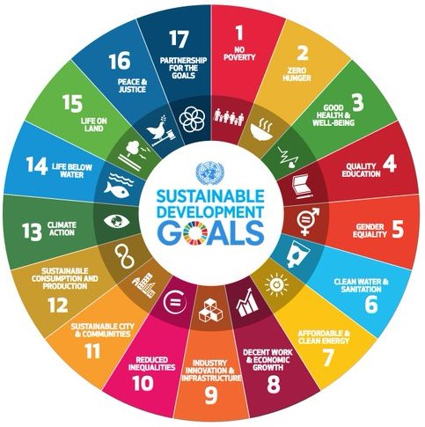
Targets for Development and Aid

In 1969 Lester Bowles Pearson, former Canadian premier led a World Bank Review called “Partners in Development”. This report, formed the basis for an agreement at the UN in 1970. It set targets for measures to achieve sustained development in trade, science, health and education, child and youth development, to be taken by all nations and by public and private sectors. It called for high income countries to donate 0.7% of GDP to Official Development Aid (ODA) and charitable aid to provide 0.3% of GDP (Gross Domestic Product, later replaced by Gross National Income GNI). The target was to be reached “by 1975 and in no case later than 1980.”
The Development Assistance Committee (DAC - high income countries providing aid) accepted the targets, with the exception of USA and Switzerland. However, only 7 countries have ever met this obligation and currently ODA from DAC countries only amounts to 0.3% of their GNI.
From 1980 a further series of reviews led by Willie Brandt, former Chancellor of West Germany, (see here), pointed to the need for an integrated approach to global trade, aid and poverty as a key to prosperity in both north and south. He called for international cooperation in aid and a focus on issues such as women’s health and development as critical to socio economic development.
The Millennium Development Goals (MDGs) were preceded by a consultation with over 1,000 non-governmental and civil society organizations from more than 100 countries. However, decision making at the Mexico Summit was dominated by G8 leaders. The MDGs introduced a new pattern of diplomacy for global development, with 8 clear Goals and targets followed up by indicators of outcomes. These included the 0.7 GNI target as a component of Global Partnership see here.
The UN Sustainable Development Goals (SDGs) agreed in 2015 were developed following much wider consultation, see the Million Voices report here. The SDGs introduced a wider range of Goals for development and aid. As illustrated above targets were set in 17 fields covering all aspects of sustainable development. Though it could be argued only one Goal is specifically focused on health, all 17 Goals address determinants of health and wellbeing. The Health Goal to “Ensure healthy lives and promote well-being for all at all ages” is amplified by 13 targets that can be monitored see here.
These 5 pages discuss aspects of global targets for development and aid.
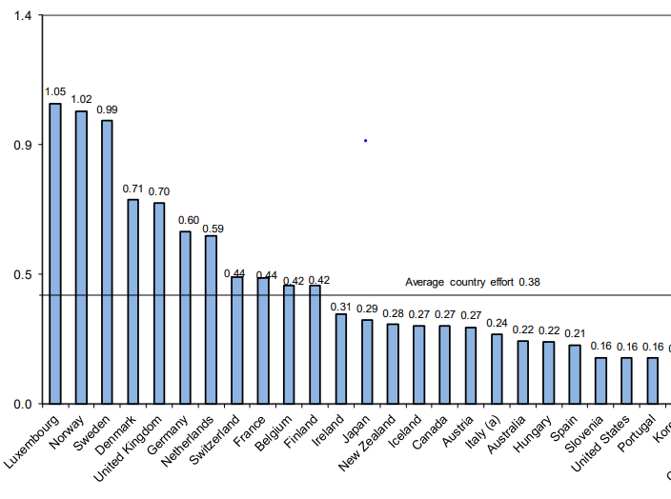
Act now to ensure the UK keeps its
word to the UN and the World

The resolution reached at the United Nations in 1970 was far more than a simple promise by high income OECD countries to allocate 0.7% of their national income to Official Development Aid see here. Called the “International Development Strategy for the Second United Nations Development Decade”, it set targets for measures to achieve sustained development in trade, science, health and education, child and youth development, to be taken by all nations and by public and private sectors. But only 7 countries have ever met the ODA target as shown in the chart of commitments as % of GNI in 2019.
In a 2004 Spending Review, the UK’s Labour government set a target date of 2013 for achieving the 0.7% target, earlier than the pledge by EU member states of 2015. This was reaffirmed by the UK’s Coalition government elected in 2010, and was achieved in 2013, becoming a legal obligation from 2015. In 2019 the UK allocated some £15 billion to ODA, 64% as bilateral aid for projects in low-income countries and 36% as multilateral aid through agencies such as the World Health Organisation.
The current UK government is proposing measures that will reduce national commitment to aid. Three steps have led to this position. In 2017 the UK Department for International Development (DfID) gained the agreement of other donor nations to modify the rules applied by the Development Assistance Committee of OECD that define Official Development Aid see here. Then on 2nd September, the Department for International Development was merged with the Foreign Office to create the Foreign, Commonwealth and Development Office further underlining the link between aid and UK interests. In July it was announced that ODA would be reduced in line with the reduction in UK Gross National Income due to Covid-19 but the 0.7% commitment would still be met. On the 25 November 2020 -the Chancellor announced that UK commitment to 0.7% would be reduced to 0.5% of GNI. His position may have been influenced by a public petition calling for the abolition of the target see here.
Since this was posted SfGH have issued a statement and joined with Action for Global Health see here
SfGH should consider starting their own petition supporting UK commitment to the 0.7% target as a key to equitable and sustainable development and health and wellbeing for all. See Training Toolkit 4
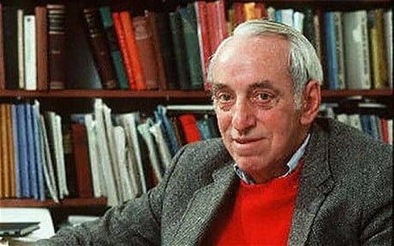
Can we Afford Global Health?

James Tobin Nobel Prize Winning Economist
Achieving the sustainable goals for global health and wellbeing set out in the UN 2030 Sustainable Development Agenda see here will require a massive increase in investment particularly in low income countries. A concept paper presented to the UN ECOSOC committee in 2018 here estimated that a total of $5-7 trillion of annual investment would be required across all sectors and countries. This is equivalent to 7-10% of global GDP and 25-40% of annual global investment. Low and middle income countries will require additional investment of some $1.6 trillion per year from public and private sectors and aid. This is more than double current levels ($1.4 trillion).
Total financial flows to low and middle income countries may be broadly estimated as:
- Personal remittances from people working in other countries, about $450 billion.
- Private investment and NGO Aid, mainly to middle income countries, about $ 650 billion.
- Official Development Aid from OECD countries, about $150 billion
- South-South investment, aid and loans, (mainly China) about $100 billion.
The 2020 Sustainable Development Report here shows that while progress is being made towards many of the SDG targets, the impact of the COVID-19 pandemic will be negative for most targets, it is also likely to reduce all forms of financial flow to low and middle income countries.
OECD countries currently allocate some 0.3% of GDP to ODA and even if they meet their agreement made in 1970 to allocate 0.7% of GDP to ODA this would only increase financial flows by $290 billion.
A more radical proposal is to generate global funding for SDGs from a tax on financial currency transactions, sometimes called a “Tobin Tax” after the US economist James Tobin who proposed such a tax as a means of reducing the harmful effects of currency speculation. Financial Transaction Taxes (FTTs) are already applied by 40 countries including the UK but the proceeds are retained in country. It is now proposed that an FTT should be used as a global resource perhaps to fund the SDGs.
Trading in foreign exchange markets reached $6.6 trillion per day in April 2019, a level over 20 times the size of Global GDP. While some “hedging” is normal to avoid trade shocks due to currency fluctuations, it is argued that this level of speculative trading is harmful and should be mitigated by taxing such transactions at a rate of say 0.1%. Even assuming that this would reduce FX speculation by half, this could generate revenue of about $1.6 trillion, enough to meet the addition cost of SDGs.
This idea has already gained cross party support in the UK Parliament during Gordon Brown’s premiership. Bill Gates expressed his support for a global Tobin Tax in 2011 to the G20 meeting. And In 2014 Lionel Jospin the French Prime Minister put forward proposals for a Tobin tax at the meeting of European finance ministers. A civil society group called ATTAC (Association pour la Taxation des Transactions financière et l'Aide aux Citoyens’) campaigns for a Tobin tax in, 40 countries, with over a thousand local groups and hundreds of organizations supporting their network see here.
SfGH groups should consider whether and how they would support a Tobin Tax to fund SDGs.
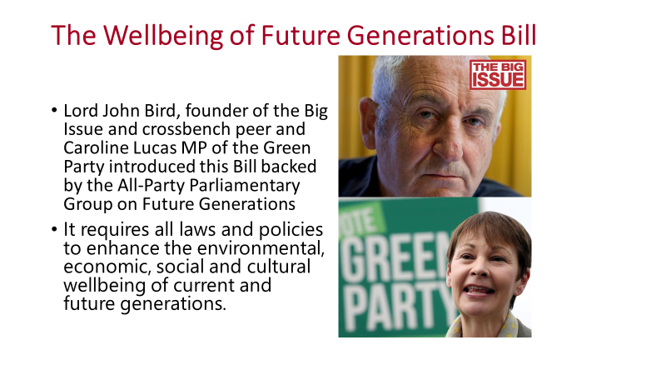
The Wellbeing of Future Generations Bill(2019-2021) is an example of the way in which legislation based on international and local policy can be brought to parliament as a Private Members Bill. The Bill is based on a similar Act passed by the Welsh Parliament in 2015. It requires all government departments and agencies to apply the UN’s 17 sustainable development goals to their policies and spending. It aims to enshrine in law the creation of an independent UK Commissioner for Future Generations and a requirement on (non-devolved) public bodies, including the UK government, to balance the needs of the present with the needs of the future in their decision making see here.
Lord John Bird who initiated the Bill and Caroline Lucas, the Green Party MP who is the co-sponsor see this as a step towards a wider social movement to dismantle poverty by laying the groundwork for a more equal society for the generations who follow. It is also hoped that other countries may adopt this approach in looking towards a sustainable, equitable future, see the Big Issue here. This requires a wider view of social progress not simply in terms of growth in GDP, but as progress towards social wellbeing.
Wellbeing is the product of the equitable political, community and cultural support that enables every individual according to their needs, to manage their physical, mental and emotional health conditions and needs, cope with normal stresses of life, find purpose and happiness, work productively and fruitfully, make a contribution to and draw support from family, community and their culture, home and natural environment. To consider how this might be assessed see here.
The impact of the 2007/9 Financial Crisis has left the country with a government debt of 80% of GDP, the current Covid-19 Pandemic will increase this debt to over 100% of GDP and the coming crises of Climate Change will increase this debt again. Future generations will be left with unsustainable debt, public services hollowed out by austerity, very high levels of unemployment (particularly for younger people), increasing levels of inequality and existential threats to the health of our planet (see Toolkit 18). For these reasons SfGH may wish to show support for the Wellbeing of Future Generations Bill.
Trainers may wish to lead a group discussion of how SfGH can register its support for this legislation that will have a direct bearing on the health, wellbeing and equity of future generations. You could also contact the All Party Parliamentary Committee on the Wellbeing of Future Generations here.
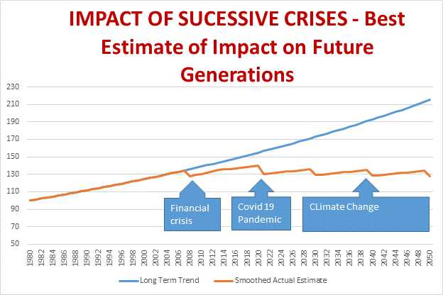
In March 2021 estimates suggest the UK economy will reduce by 11.3%, the biggest fall in 300 years. This will inevitably have a profound impact on employment and future growth. While some economists have forecast a V shaped recovery (fast return to growth as normal) most are now predicting a longer term-impact, characterized as: W-shaped (double dip), U-shaped (slower recovery), or L-shaped (return at a lower level). It has been noted that recessions tend to have most severe affect on disadvantaged and low income people and countries while benefiting the wealthy, this has been described as a K shaped recession.
A long-term view must consider the Covid-19 crisis in the context of the 2007/9 Financial crisis, and the coming crisis of climate change. The Financial Crisis is estimated to have reduced GDP by about 5% and also resulted in increased national, business and household debt. Austerity measures that followed further reduced the income of the poorest households. Measures necessary to respond to climate change were estimated by the Stern Review of 2006 to be in the order of 1 to 2% of GDP and the impact of unmanaged climate change was estimated at up to 20% of Global GDP. More recent predictions, taking into account how little has been done, have estimated the global impact will be even greater. The three crises taken together suggest that very limited growth can be expected for the next 30 years as shown in the estimate above from Roger Latham (see Training Toolkit 18).
This calls for a radical reimagining of conventional Neoliberal Economics, which assume continuing economic growth. A new economic regime will be required for the wellbeing of future generations.
Students for Global Health may wish to consider the suggestions set out in Training Toolkit 18 and press for measures to be taken under the Wellbeing of Future Generations Bill (see TT 4)
Prejudice and Health: Holocaust Memorial Day

The Anne Frank Trust celebration of her life, 75 years after her death at Auschwitz, reminds us both how much one person can do to change the world and how much there is still left to do. The Trust, see here , takes Anne Frank’s Diary as a starting point for educating and empowering young people to stand up against all forms of discrimination.
The concept of race entered the English language in the early 16th century from the French word “rasse” denoting people of different ancestry speaking different languages. Some 6,500 languages are now spoken, but of these 2,000 are spoken by groups of less than 1,000 people. There is no scientific definition of race it is just a way of picking on people with perhaps different skin colour, religion, dress or other characteristics. In other words it is a way of emphasizing minor differences amongst people of the same human race.
In 2000 a study showed that that there is more genetic diversity in one remote social group of chimpanzees than in the entire human population. This has since been confirmed by many other studies see here. For a more detailed discussion of the flaws in the pseudo-science of racism, see the book by Adam Rutherford “How to Argue with a Racist” or listen to his podcasts here.
The Nazi Holocaust focused hatred on people who were said to be of “inferior races” or with other differences, including Jews, Romani, people with disabilities, homosexuals and political opponents murdering some 6 million people. The use of differences to allocate blame and encourage: prejudice, bullying, persecution and genocide (see here) is still a source of countless deaths and is a shameful reminder of our failure to learn from history.
International response to the Holocaust led to agreement to the Genocide Convention of 1948 which makes it a crime to commit certain acts “with intent to destroy, in whole or in part, a national, ethnical, racial, or religious group.” The Convention on the Prevention and Punishment of the Crime of Genocide which was finally ratified at the UN in 1951 see here , has shown the weakness of international laws relying on global agreement. It is estimated that 55 million civilians have died in 89 genocides since 1951 see here. Only three have been legally recognized and led to trials under the convention: Rwanda in 1994, Bosnia (and the 1995 Srebrenica massacre), and Cambodia under the 1975-9 Pol Pot regime. The first person ever convicted of genocide was Jean-Paul Akayesu a politician from Rwanda in 1998.
The widespread killing and displacement of Yazidi by IS and Rohingya in Myanmar are ongoing and recognised by the UN as a whole, but have yet to be officially recognised as genocides by some individual states. Similarly, 13 years after atrocities took place in the Sudanese region of Darfur, criminal investigations continue but no official charges of genocide have been made under the convention. Most recently a group of UK lawyers have claimed China's treatment of Muslim Uighurs amounts to genocide. But international law is only as strong as the public demand for action see here.
These 6 pages provider insights into aspects of prejudice and its impact on health
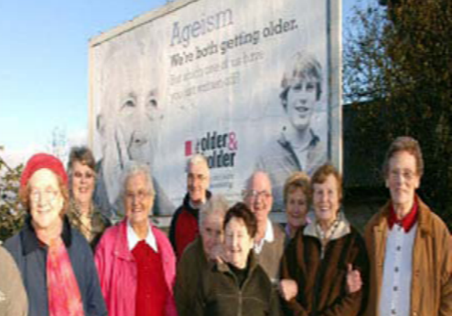
Ageism and Health Equity

On March 16, 2021 the UN published the WHO “Global Report on Ageism” see here, this defines ageism as: the stereotypes (how we think), prejudice (how we feel) and discrimination (how we act) directed towards people on the basis of their age. It can be institutional (affecting the rules and norms of organizational behaviour), interpersonal (how people react to and refer to others) or self-directed (how people feel about themselves).
While the report is largely focused on attitudes towards older people, it also notes that ageism can affect the perception of younger people, drawing on a European survey showing that people aged between 15 and 24 were more likely to feel they were treated badly (abused or insulted) or with a lack of respect (ignored or patronized). In Europe 1 in 3 people, particularly younger people are reported to have felt targeted by ageism.
Globally ageism is said to be evident in the attitude and behaviour towards older people of 1 in 2 people. Experience of ageism can impact on both mental and physical health. Globally depression is estimated to be associated with ageism for about 6.33 million people per year and is also thought to be a major factor accelerating cognitive impairment for older people. Physical health is affected by self-perception driven by ageism, resulting in older people with such attitudes being less likely to recover from physical impairment, more likely to continue in unhealthy behaviour and less likely to enjoy a healthy sex life or social wellbeing. Ageism is also recorded as a major factor in determining access to health services. A systematic review in 2020 showed that in 85% of 149 studies, age determined who received certain medical procedures or treatments.
The African Union Protocol on the rights of older persons was adopted in 2016 (but not yet ratified). This prohibits all forms of discrimination against older persons and covers a range of rights including access to health services, rights to employment, social protection and education. But it is also clear that the population of older people in Sub Saharan Africa is growing very rapidly and this will greatly increase the need for and cost of health and social care. The Abuja Declaration of 2000 set a target of allocating at least 15% of government expenditure to health, yet 10 years later only one country had met this target. This is another example of the gap between political declarations and action.
The report also provides an interesting insight into how discrimination and other issues emerge in global health discussions. The issue was raised in 2002 by the UN “Political Declaration and Madrid International Plan of Action on Ageing”, in 2015 the WHO reported on “Ageing and Health”, which provided a basis for the “UN Decade of Healthy Ageing 2021-2030”, supported by the research referenced by the WHO “Global Report on Ageism”. It is also notable that this report is framed as an element in the SDG goal of “Universal Health Coverage” and is accompanied by toolkits and guides to encourage and support community attitude change and action to counter ageism in all its forms.
In the UK the increasing demand for health and social care services due to our ageing population requires a reexamination of how such services are provided see the discussion here.
SfGH are invited to consider their own experience of ageism in health.

Adolescent LGBTI Health and Confidence in Who We Are

The WHO report "Health for the World’s Adolescents" published in 2014 highlights the fact that worldwide, for those between 10 and 19, depression is the predominant cause of illness and disability and suicide is one of the top three causes of deaths. In the countries surveyed, 5% to 15% of younger adolescents (ages 13–15) reported a suicide attempt in the 12 months before the survey. Adolescence is a period of exploration and discovery when we develop our understanding of and hopefully confidence in, our sexuality. The SfGH affiliate, Sexpression: UK here empowers young people to make decisions about sex and relationships by engaging students in running informal but comprehensive sex and relationship education sessions.
The UK Office for National Statistics report that in 2017, 4.2% of people aged 16 to 24, identifying as LGB, the largest percentage within any age group. This survey seems to assume that sexuality is binary, which it clearly is not. Even in the Kinsey Report of 1948 sexuality was measured on a six-point spectrum. A 2015 YouGov poll found 49% of young people between the ages of 18 and 24 defined themselves as something other than completely heterosexual.
In some countries anxiety about sexual identity is reinforced by national laws, 84 countries still outlaw homosexuality (since I first wrote this in 2017 this has reduced to 73 countries, I am not sure whether to cheer or cry). The UN Human Rights Commission (UNHRC) recognised LGBT rights in 2011 and the following year published a report documenting violations of these rights, urging all countries to enact laws that would protect them. In 2016 the UNHRC passed a resolution to appoint an "independent expert" to find the causes of violence and discrimination against people due to their gender identity and sexual orientation, and discuss with governments about how to protect those people. This milestone resolution has been seen as the UN's "most overt expression of gay rights as human rights”.
WHO still faces obstacles in addressing this issue, until 1992 it classified homosexuality as a “mental illness". As recently as 2013, Egypt blocked a WHO discussion on LGBT health. And there are ongoing discussions on the classification of transgender sexual identity. It therefore remains important for SfGH to raise LGBTQI health rights as a crucial aspect of Youth and Global Health.
Each of these dimensions of identity development can be the focus of bullying at schools. Stonewall estimated in 2012 that two thirds of lesbian, gay and bisexual young people reported experiencing homophobic bullying at school. Bullying is not only a significant cause of mental anguish, it is also a portent of social discrimination and bias at work and in our communities.
Discuss the steps SfGH can take to counter LGBTI discrimination in the UK and Globally.
Prejudice Institutional Racism and Health
Prejudice affects how we judge people, influenced by factors such as their gender, or race. It may be said to be institutionalized if the formal or informal rules and norms of behaviour of an organisation are based on judgements about people based on such factors. There can be no doubt that the contrast between the response to Black Lives Matter protests (against institutionalized racism) and the Trump Rioters (against reality) illustrates clearly the extent and impact of institutionalized racism in US policing.
Prejudice is an issue we all face as individuals and as organisations or groups. It is not true that it only affects privileged white males, we must all learn to deal with our own prejudices in our own way. It can be helpful to face up to any pre-judgements based on: race, gender, class (accent), religion or physical characteristics such as obesity, age or youth. Bringing prejudice into the light helps to deal with it in a realistic way: what evidence or experience supports it?, Is it relevant to the person and the issue at hand? And what are you going to do about it?
In a similar way organisations and groups need to address institutionalized prejudices that affect their behaviour. In this case, police and other law enforcement agencies should explore why they responded in a different way to these demonstrators and explain this to the public they protect. Perhaps this would help initiate an honest discussion of racism in the USA and what all citizens can do to address it.
Racism and other forms of prejudice are also a key issue in global health and access to services. The current Coronavirus pandemic has shown that both in the USA and in UK, the health and economic impacts on minority groups has been significantly worse than for others, listen to the Kings Fund Podcast “Covid-19, racism and the roots of health inequality” here.
SfGH may wish to explore their own prejudices as individuals and as groups. And before excluding any possibility of your prejudice, consider how you react to Trump supporters. While they may be considered as simply unintelligent and racist, it is important to overcome prejudices to help understand and address what motivates them and what can be done to develop unity in a divided country.
It is not easy to find Trump supporters in Europe, but there are groups who hold views that you (and I) would not countenance. It is a useful exercise to consider how you could overcome preconceptions on both sides to build dialogue. Reasoning with those with whom we disagree helps develop confidence in rational argument and is more constructive for democratic society than “no platforming”
.SfGH trainers may wish to lead a discussion of institutionalized racism and/or to conduct an exercise to help group members address their own prejudices (there are online resources that might help).

White Privilege and Rich Advantage

There can be little doubt that there is white privilege at work in health. In the USA, where this term has been used a lot more since the murder of George Floyd, babies born to black women die at more than double the rate of babies born to white women. Black people are twice as likely to develop Alzheimer's disease as white people and black Americans are dying from the COVID-19 virus at 2.4 times the rate of white people. White privilege is more than individual or even institutional racism, it is an implicit cultural bias that can permeate society, including people of colour who are oppressed by it see here. For broader review of racism and topics such as Racial Trauma, Decolonial Theory and Critical Race Theory, listen to the Anti-Racist Educator podcasts available online here.
White privilege does not preclude other sources of bias and disadvantage, including gender or wealth it is one among a list of factors set out in a letter signed by over 6,000 US doctors who felt compelled to act and advocate against any threat to their patients well-being posed by Trump’s election in 2016. Their letter affirmed their belief that :
- Health is a human right.
- Health practice and policy must be evidence-based.
- There is no health without mental health.
- Women’s health must be protected.
- All deserve access to healthcare and freedom from violence, no matter their immigration status.
- The oppressive structures which harm people of color must be dismantled.
- All irrespective of gender identity or sexual orientation, deserve dignity and respect.
- Torture and human rights violations have no place in society.
They concluded “We declare these eight beliefs as fundamental principles that we will advocate for in our daily work as we care for Americans of all classes, genders, colors, faiths, and sexual orientations”.
While supporting this view, we must also question the oppressive structures that assume the health and wellbeing of the citizens of high-income countries is so much more important than those in lower-income countries. Why do they have privileged access to healthcare, water and sanitation, while billions of people in low income country must wait in vain for such services? Why are vaccines for COVID-19 now available for high-income countries but not for many low-income countries, which wait for the left-overs? Of course the answer is money, which may make the world go around but can it be more important than basic human rights? WHO resources for considering global health equity are here
SfGH groups are invited to consider how they would state their beliefs regarding global health.
Damage to Democracy and Equity: Lessons from the Trump Riots

The riots instigated by Trump and his cohort of sycophants have done terrible damage to democracy. The damage includes breaking down the trust of Americans in their democratic and judicial processes. Polls suggest that some 61% of Americans believe the vote was free and fair, but this still leaves 39% believing Trump’s repeated claims of fraud, despite lack of evidence and the findings of 62 court cases. We hope President Joe Biden and Vice President Kamala Harris will be able to restore trust by listening to all the people they now lead and rebuilding public confidence.
It is not helpful to draw parallels with “Black Lives Matter” protests, organized by ordinary citizens, though in some cases they were exploited by looters and others. This violence was not incited by the President or senior representatives of a major national political party. And though senior politicians from the Democratic party supported the BLM cause, they did not condone law breaking.
From a global perspective the harm done is far more serious. More than a billion people live under oppressive regimes which pay little attention to truth, democracy or equity. Scenes of chaos in Washington and the undermining of democracy provide the pretext for the claims of the despots of such nations to crush the hopes of their people, that democracy can offer them a better future. These consequences can now be seen in Russia, Belarus, China and Myanmar.
It shows that a leader “creating truth” by repeating claims without foundation can fool some of the people, at least for some time. We now look back on such leaders throughout history, wondering how and why they succeeded. It appears to be that comforting beliefs created by offering simplistic solutions to complex issues can indoctrinate unquestioning followers, who abandon reason for hope.
In health terms similar unfounded beliefs support claims for fake medicines and cures such as those promoted by Trump or claims for homeopathy and other unproven remedies. Beliefs that can be manipulated by unscrupulous leaders include rejection of public health measures relating to the current pandemic such as: vaccination, mask wearing and social distancing. For example, the “Supreme Leader” of Iraq, Ayatollah Ali Khamenei has banned vaccines developed in USA and UK, offered by COVAX and Kim Jong-un the “Supreme Leader” of North Korea has requested vaccines after claiming there were no cases in his “Democratic People's Republic of Korea".
Students for Global Health may wish to consider the extent to which behaviour is guided not simply by reasoned evaluation but by instant emotional responses, drawing on and feeding prejudices that are later rationalised. It is more comforting to believe messages from the internet, that there are simple answers to every problem and to blame other people, rather than face the realities of a complex world. This tendency has been explored by Daniel Kahneman, a psychologist who won the Nobel Prize for introducing what is now called Behavioural Economics, read his book “Thinking, Fast and Slow” or view my presentation applying this approach to health see here.
Students for Global Health may wish to discuss the damage Trump has done to global health equity and democracy, or debate Behavioral (Health) Economics and how prejudices are used.

