Training Toolkit 0a Exercises for Trainers
0a
Graham Lister

0a
Students for Global Health Training Toolkit
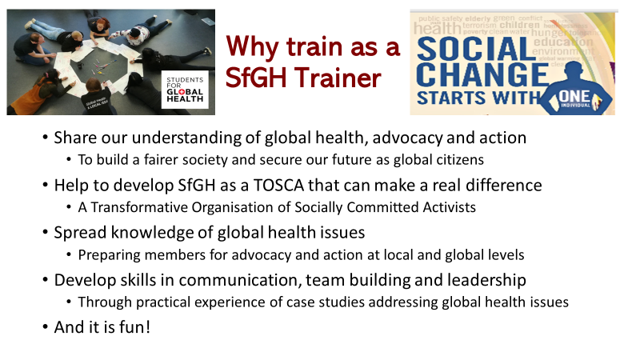
Students for Global Health brings together UK students who share a vision of a fair and just world in which equity in health is a reality for all. In the UK we are committed to take action to spread an understanding of global health threats and inequity as global, national and local issues that must be addressed. At international level we work with partner student groups from 133 countries brought together in the International Federation of Medical Student Associations to give voice to future generations at meetings such as the World Health Assembly.
Our aim is to develop SfGH as a network of students empowered to effect tangible social and political change in health on a local, national and global level through education, advocacy and community action. We do not underestimate the task we face in developing as what we call TOSCA – a transformative organization of socially committed activists, but neither do we despair of the future – a great many significant social changes started with one person and one organization and we have many allies. This is not simply an academic issue but a real and present danger to the health and wellbeing of global citizens and future generations, we must act now!
Our training programmes are designed to prepare our members by spreading an understanding of issues, such as: global health inequity of wealth, health and gender, threats to planetary health, the need to reform health governance at national and international levels and the action that can be taken by local communities, businesses and individuals. SfGH Trainers will be assisted to understand these issues through training sessions and the provision of online “discovery learning resources” which provide a framework of ideas and current SfGH Policy with links to current online sources that will enable participants to find their own answers. Training will also provide guidance to help pass on knowledge to other members, cascading and developing a shared understanding. But understanding without action is pointless, so training will prepare members to take a role in advocacy and action at community, national and global levels.
The experience of training others is not only a great way to learn but also helps develops skills in communications, team building and leadership, which are essential life skills. For this reason the training sessions and resources include exercises and reflections on these aspects of personal development. Finally it is worth noting that training sessions can be great fun, specially if you are leading them!

Training Toolkit Exercises
Material from this toolkit can be copied for the topics you have chosen. Online course material, test questions and practice sessions are also available for you to choose. Once you have delivered training please help others pass on the messages as Cascade Training.

Motivation and values
“Speed Dating” to get to know one another in 3 minutes.
Trainer introduces themselves and answers the questions then organizes the sessions

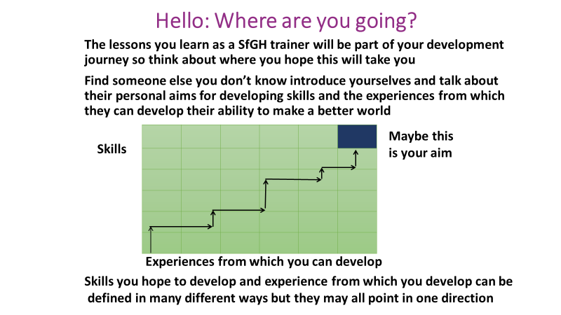

You can also use this model of career development by yourself to think through the skills you want to develop and the experiences you seek in order to achieve your aims in life. You could include further education but of course most lessons in life are learnt from reflecting on your experience of practical action and work. If you find yourself seeking a certain direction whatever way you define your skills and those you want to develop and however you define the situations in which you hope to work then maybe you have found your aims and purpose in life. And this is the most important discovery you can make about yourself.

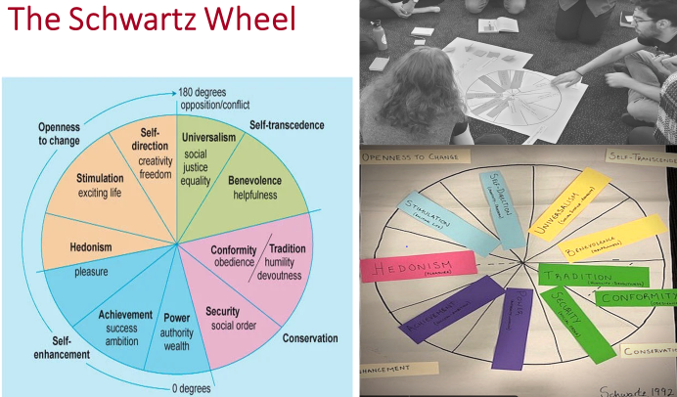
Ask participants to write down their personal motivation for joining this training session (or use the speed dating session. Share with each other and temporarily park those reasons. Then give participants a set of stickers on which to write the Schwartz values and ask them to arrange in the circle as a spectrum, to try to recreate their version of the Schwarz's model. Then discuss and make corrections and add their personal motivations on the diagram to create a link between the two - essentially how do their motivations matched the values? Following this go on to discuss experiences of conflicts of opinions we all have and try to identify how each party's motivation/personal values clashed and led to that conflict.

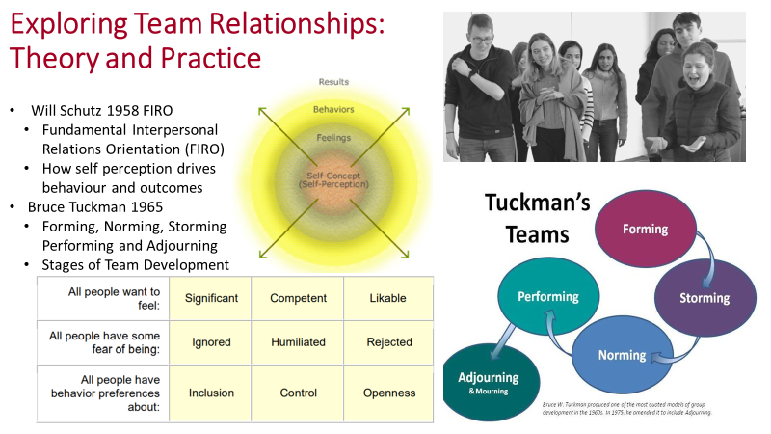
To understand how teams develop you need both theory and practice. Theories include FIRO developed in 1958, later extended by Schutz to FIRO B by a tool to assess team interactions. The theory identifies three basic needs: the need to feel significant, competent and likable these are evident in peoples’ behavior, feelings and self-conception. At each level people seek inclusion, control and openness and fear being ignored, humiliated or rejected. Individuals and teams will work better together, achieve higher levels of performance and satisfaction in their work if their needs are met. Teams may wish to discuss how this theory applies to their own self perceptions, aims and motivation and their ability to work together.
Tuckman’s theory of how teams evolve was first published in 1965 the final element “Adjourn” was added in 1970. It is a model of how teams:
- Form - meeting and sizing each other up, applying common standards of behaviour
- Storm – often clashing on points of principle, objective, roles and other differences
- Norm – establish by compromise their common aims and how they work together
- Perform – work effectively and creatively together as a coherent unified team.
- Adjourn – part as friends and colleagues with a better appreciation of one another.
Once again the TNT team may wish to discuss how this might apply to their experience. However, this will be more meaningful once the team has some experience of working together on team building exercises.
Team Building Games for Face to Face Groups
A wide range of Team Building Games are provided by the European Youth Parliament here
Examples of games which have been used at our SfGH TNT sessions include:
Skittles - An introduction game is provided by the skittles activity. First asked everyone to pick as many skittles from the bag as they want and as soon as everyone picked, ask everyone to give as many pieces of information about themselves as they have skittles.
Gordian Knot - A basic problem solving game that enables the group to discover how they interact with each other to solve a problem. Ask everyone to stand in a circle, close their eyes. make a fist with the right hand and stretch out the left. Then ask them to start walking with their eyes closed towards the centre of the circle until they match up their fists with an outstretched hand. As soon as everyone is connected, they may open their eyes and try to untangle themselves. After some time, you may introduce rules such as only X person can tell you when and how to move, or nobody talks. This allows to engage the quieter people, or the entire group and watch how they respect one another. Time limits increase pressure and stress the group which is also a useful element. After the activity debrief by discussing the experience (one key question is: how involved did you feel?)
Improvisation: A game that builds teamwork and trust. Members of the group improvise a story each taking it in turn to add one sentence to a story. At the same time two other group members act out the story as it is told. This is great fun but has a serious purpose, a well functioning team will make this activity relatively easy for one another a less well functioning team is liable to trip one another up.
Secret Friend: To help develop mutual supporting relationships pair team members asking one member to keep an eye out for the wellbeing of another, without the other person knowing. This also helps to develop relationship skills.
Team Building Games for Online Groups
Due to the Covid-19 Pandemic TNT may need to adapt the team games suggested above so that they can be played online. Alternatively you may wish to use online games such as:
Two Truths and a Lie: After meeting in online breakout rooms pairs of participants are asked to introduce each other to the main group, explaining why their partner will be a fabulous trainer. In their introduction they must include two truths and one lie about the person they are introducing. The group then use the Chat facility to spot the lies for each participant. Points for lies not spotted and for the funniest truth thought to be a lie. This is a good fun introductory game. This also tests listening and presentation skills.
The TNT Heraldic Shield: Groups of 3-5 team members meet in a breakout room to design a heraldic shield representing their aims, values and strengths and weaknesses as a team. Sub group members discuss what should be included and why. One member draws the coat of arms, depending on time this might include symbols in 2-4 quarters, animals holding it up, a crest on top and maybe a motto. The shields are then shared and teams are invited to interpret the shields produced by other groups using the chat facility. This is fun and helps develop reflection, cooperation and mutual understanding.
My Culture My Way: Each member of the team posts anonymously on the Chat facility 7 words describing their cultural background and personal traits including what they are good at and what they find difficult. Members of the team comment on these words and guess who posted them. This is a good way of opening up a conversation about culture and traits.
These games can also be played by face to face groups. You will find more training exercises on addressing cultural differences available from Culturewise here.

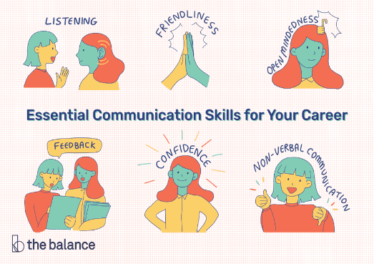
Communication Exercises
The exercises on the previous pages can also be used to test communication skills including listening, friendliness, open mindedness, feedback, confidence and body language which are a basic requirement for leadership. Use this summary chart to give feedback to each member of the TNT group.

Guide Don’t Pull

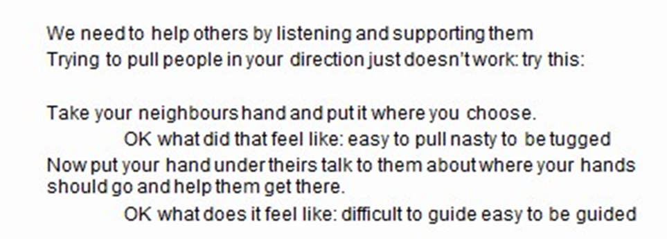

For this exercise get the group sitting together to take their neighbour’s hand and take it first to a place they choose. Then ask them to reflect on what this feels like. Then ask them to agree where their hands should go and one person guides while the other simply rests their hand on the other. Get feedback on what this feels like and ask them to reflect on what this tells them about training other people or guiding people in making choices. This exercise was first introduced to help development workers understand the importance of listening but it has a powerful message for all leadership situations.

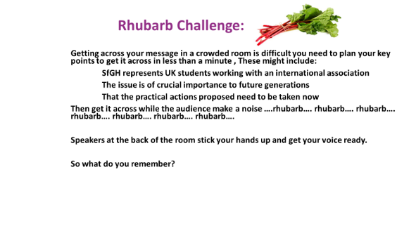
Public Speaking

Debate and Dealing with Challenges
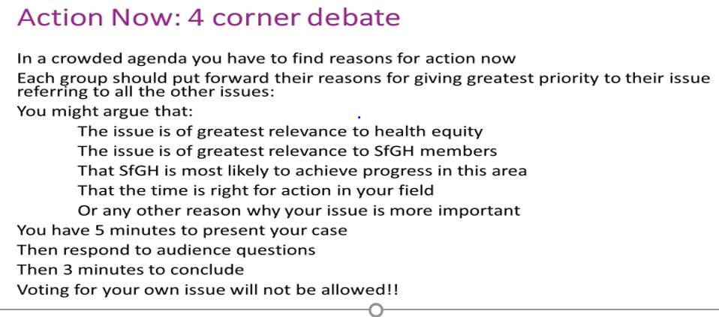

Prepare for this session by splitting the trainees into 4 groups each of which should focus on a particular aspect of SfGH policy. Then after a group discussion of their policy issue ask a member of each group to consider how they would make the case for the policy position at a crowded meeting, where they will only have a minute to get across the key points of SfGH’s policy and why it should be taken seriously.
Don’t tell them but prepare some of the trainees to act as press representatives to bring down, distort or confuse the messages. As a trainer you could also play the role of press representative (Nasty is the most fun to play). These will include a Nasty press person determined to show the speakers as stupid, ill-informed hypocrites. Another will be Too Nice probably making positive comments but mis-interpreting the speakers where possible. A third press person will be On A Different Planet focused on entirely different issues (for example animal welfare or cost saving).
All press should try to use quotations from the speakers to make their own case. The point to reflect upon is that in many cases the press tell their own story and you have to be careful not to give them ammunition that can be used against you. A further exercise is to get groups to think up the worst headlines possible to attack SfGH policies (the Daily Mxxl Challenge) then plan how to counter such attacks by presenting the policy in different ways.
Discussion
The Universal Declaration of Human Rights
As Students for Global Health we support Human Rights based on the Universal Declaration of Human Rights signed by 48 of the 58 members of the United Nations in 1948. This provides a basis for discussing examples of the record of nations respect for human rights (see the Human Rights Watch Annual Report for 2017 here.) A simplified version of the UDHR provided by Amnesty International is:

1 We are all born free. We all have our own thoughts and ideas. We should all be treated in the same way.
2 These rights belong to everybody; whether we are rich or poor, whatever country we live in, whatever sex or whatever colour we are, whatever language we speak, whatever we think or whatever we believe.
3 We all have the right to life, and to live in freedom and safety.
4 Nobody has any right to make us a slave. We cannot make anyone else our slave.
5 Nobody has any right to hurt us or to torture us.
6 We all have the same right to use the law.
7 The law is the same for everyone. It must treat us all fairly.
8 We can all ask for the law to help us when we are not treated fairly.
9 Nobody has the right to put us in prison without a good reason, to keep us there or to send us away from our country.
10 If someone is accused of breaking the law they have the right to a fair and public trial.
11 Nobody should be blamed for doing something until it has been proved that they did it. If people say we did something bad, we have the right to show this was not true. Nobody should punish us for something that we did not do, or for doing something which was not against the law when we did it.
12 Nobody should try to harm our good name. Nobody has the right to come into our home, open our letters, or bother us or our family without a very good reason.
13 We all have the right to go where we want to in our own country and to travel abroad as we wish.
14 If we are frightened of being badly treated in our own country, we all have the right to run away to another country to be safe.
15 We all have the right to belong to a country.
16 Every grown up has the right to marry and have a family if they want to. Men and women have the same rights when they are married, and when they are separated.
17 Everyone has the right to own things or share them. Nobody should take our things from us without a good reason.
18 We all have the right to believe in what we want to believe, to have a religion, or to change it if we want.
19 We all have the right to make up our own minds, to think what we like, to say what we think, and to share our ideas with other people wherever they live, through books, radio, television and in other ways.
20 We all have the right to meet our friends and to work together in peace to defend our rights. Nobody can make us join a group if we don’t want to.
21 We all have the right to take part in the government of our country. Every grown up should be allowed to choose their own leaders from time to time and should have a vote which should be made in secret.
22 We all have the right to a home, to have enough money to live on and medical help if we are ill. We should all be allowed to enjoy music, art, craft, sport and to make use of our skills.
23 Every grown up has the right to a job, to get a fair wage for their work, and to join a trade union. 24 We all have the right to rest from work and relax.
25 We all have the right to a good life, with enough food, clothing, housing, and healthcare. Mothers and children, people without work, old and disabled people all have the right to help.
26 We all have the right to an education, and to finish primary school, which should be free. We should be able learn a career, or to make use of all our skills. We should learn about the United Nations and about how to get on with other people and respect their rights. Our parents have the right to choose how and what we will learn.
27 We all have the right to our own way of life, and to enjoy the good things that science and learning bring.
28 We have a right to peace and order so we can all enjoy rights and freedoms in our own country and all over the world.
29 We have a duty to other people, and we should protect their rights and freedoms.
30 Nobody can take away these rights and freedoms from us

Reflection
We hope the Workshop and Study Material will provide a basis for you to learn from your experience of training students as trainers and advocates for SfGH, either in an international setting or in addressing national or local concerns. We also hope that you will be inspired to share some of what you are learning with others. You should feel free to use the material and exercises as a basis for running your own sessions with fellow students and health professionals. Please let me know how you get on with this and in particular any innovations or new additions to this repertoire.

In this final exercise we ask you to share your reflections on your experience of global health or advocacy for the issues it raises. Students who have experience of working in low income countries or who have experienced unfair treatment of minorities in the UK are asked to share their experience and help others learn from it. You can also use this opportunity to prepare to learn throughout your professional life.

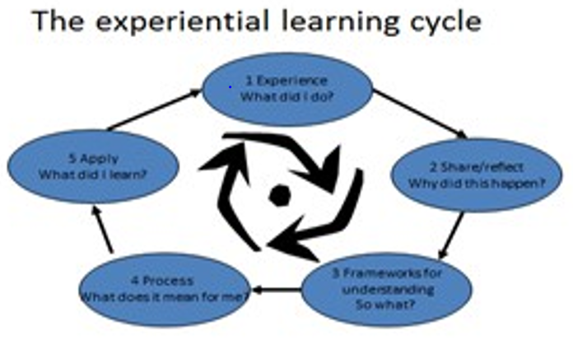
- Training is an art learnt from experience
- Throughout your student and working life
- It helps to keep a diary or learning log
- To remind yourself of your aims
- And record and reflect on your experience

You will find an example of a learning log at Training Toolkit 7. This can be a helpful way of learning from success and failure. Failure is painful but holds more valuable lessons. As Thomas Edison said “I have not failed. I've just found 10,000 ways that won't work”
SfGH Toolkits are provided for you to download and adapt to your needs. If you develop a new or revised Toolkit please send a copy to the SfGH Training Director so that it can be made available to future trainers.

