

0

0

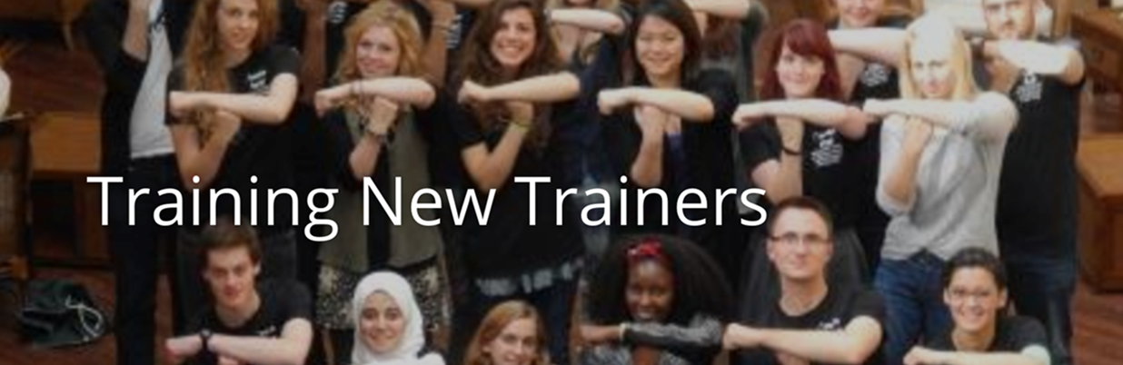

Training for New Trainers

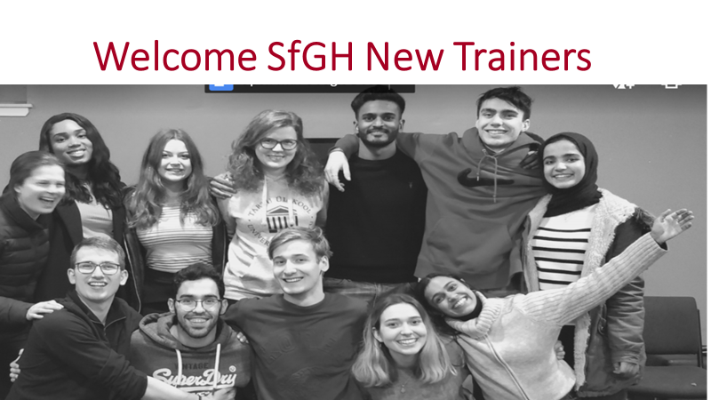This note is based on the Training for New Trainers report developed by Antonis Tofias (SfGH) and Piotr Kurzyna (IFMSA - Poland) with the participants in the TNT 2020 Edinburgh Programme. As the Covid – 19 pandemic may hinder face to face group training we have attempted to capture key lessons from our programme as the basis for online Zoom sessions. You are invited to read the TNT Impact Report [here.](https://issuu.com/training-studentsforglobalheal/docs/tnt_impact_report)

The training sessions proposed (in groups or online) to prepare New Trainers are:

1. Setting training objectives for yourself and for the people you help to train.
2. How we learn in non-formal education programmes
3. Leading teams: intercultural learning, team roles and the process of team building
4. Communication: creative conversations for coaching and conflict resolution
5. Presentation, preparation and delivery
6. Project Management: Preparing and running a training session
7. Feedback and evaluation, what have you discovered and how will you use this.

Your participation in this training will help us create a network of students empowered to effect tangible social and political change in health on a local, national and global level through education, advocacy and community action. You will also develop your confidence and skills in leadership, learning and communication. And you will enjoy the experience and the friendship of other members of SfGH.

If meeting in person your trainer will organise a session to introduce you and help you discuss your personal values and how these have led you to becoming a Trainer for SfGH see Schwartz et al 1992 [here.](https://scholarworks.gvsu.edu/cgi/viewcontent.cgi?article=1116&context=orpc) And for a practical guide to values in health see the NHS Wales report [here.](http://www.nwssp.wales.nhs.uk/sitesplus/documents/1178/Developing%20and%20Embedding%20Organisational%20Values%20and%20Behaviours.pdf)

If you are meeting online take turns to introduce yourself in two minutes and explain why you would like to become a SfGH Trainer – see the exercises in Training Toolkit 1.

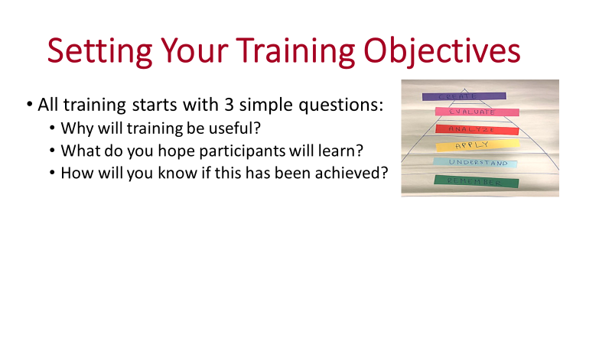

Training must have a purpose, for society, for the organisation and for the individual. This is set out in a Training Needs Assessment (TNA) defining the knowledge skills and abilities that individuals and teams currently have and how this might be developed to fulfil the roles that it is hoped they will play in the future of the organisation. In other words - how training can help people and organisations achieve their full potential. Assessment should consider the personal goals and capabilities of individual participants in training. For a more detailed view guidance on how to prepare a TNA you may wish to look at HR Survey [here.](https://hr-survey.com/TrainingNeeds.htm) And either online or as a group you may wish to discuss your personal training needs.

The purpose and training objectives for New Trainers are set out in the TNT Impact Report as a series of indicators showing the knowledge, skills and abilities it is hoped New Trainers will learn and how their attainment can be assessed by practical measures at the start and end point of training. Take a moment to read through and apply these measures, discussing what they mean for you as a team and personally.

Training objectives and measures of their attainment must recognise current strengths and limitations of participants, the aim is to stretch them but not induce exasperation or panic, which is demotivating. The aim is provide a basis for lifelong learning, as most worthwhile skills and abilities are developed through continuing reflection and learning from experience.

Learning objectives can be classified in a hierarchy developed by Bloom in 1956, (see [here](https://www.teachthought.com/learning/what-is-blooms-taxonomy-a-definition-for-teachers/)) addressing:

1. What information do you need to **remember**?
2. What do you need to **understand**?
3. How can you **apply** this knowledge and understanding in practice?
4. How can you **analyse** a situation to show relationships causes and consequences?
5. How can you **evaluate** options to justify a preferred stand or position?
6. How can you **create** a new option based on what you have learnt?

Online or face to face groups are invited to discuss how these categories apply to their learning objectives. Note that while remembering information is an important base, in the age of Google it is more vital to understand its significance and to be able to use information to analyse, evaluate and create new solutions.

Sub-Groups of three participants are invited to make use of online or real world breakout rooms to propose and present learning objectives and outcome indicators for training modules focussed on leading SfGH action on one of the issues introduced by a one page summary in Training Toolkit 7 Discussion Topics.

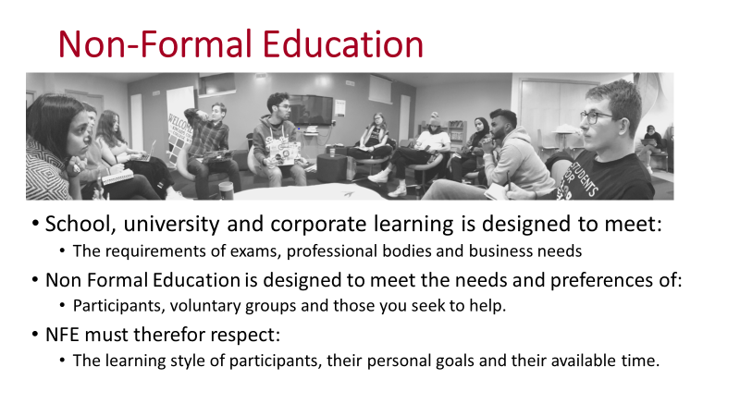

Non Formal Education for SfGH is a form of “Cascade Training” sharing lessons and values between students which are passed on from one team of trainers to the next. This does not assume that trainers are in some way superior in knowledge or values to their trainees, they are also learning from the process. Nor should they alone decide what trainees should learn they should ask and respond to the trainee group. Training events must match the available time of trainees, for SfGH this may include group meetings and perhaps 10 minutes slots spent Googling an issue of interest to them. SfGH training should provide a basis for “Discovery Learning” (see [here](https://www.learning-theories.com/discovery-learning-bruner.html)) providing a basis for participants to explore ideas and formulate their own understanding and values.

The role of an SfGH Trainer is therefore not that of a formal teacher but a facilitator of learning and communications. The temptation is to say and do too much; Training Toolkit11a Leadership Thoughts includes the quote from Lao Tsu “The great leader is he of whom the people say, "We did it ourselves." Trainers need to recognise and respond to the learning styles of trainees. One way of distinguishing these is provided by the 4MAT Model developed by Bernice McCarthy in 1980 see [here](https://4mat4learning.com.au/what-is-4mat/#:~:text=The%204MAT%20model%20was%20originally%20developed%20by%20Bernice,within%20four%20distinct%20phases%20of%20the%20learning%20cycle%E2%80%A6..). This identifies 4 phases of learning, which may also be seen as styles of learning, favoured by different trainees:

**1 → Experiencing, 2. → Conceptualising 3 →. Applying 4. →Refining**

In SfGH training a shared experience helps trainees respond to a situation. Experience may include group games and activities but also first-hand accounts or perhaps a video. They may then find it useful to use a conceptual model to explore the ideas and values that provoked their response to the issue being explored. They may then wish to consider how to apply the ideas, so at this point can be helpful to introduce a practical exercise, which will allow them to try out their ideas. Finally they will learn from reflecting on their experience, the conceptual framework they used to understand it and their attempt to put the ideas into practice. This can be seen as the refinement phase of learning.

Face to face groups will benefit from a range of experience trainer sessions see Trainer Toolkits 1 and 9.

Online and face to face sub-groups should then meet in breakout rooms to plan how to use the 4MAT Model to achieve the training outcomes they have previously set (or they may wish to revise) for presentation to the group.

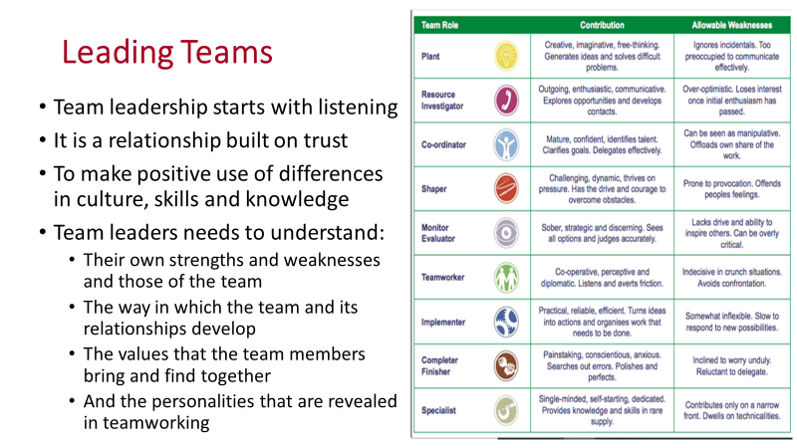

There are countless books and training courses on leadership in healthcare see, for example, the Kings Fund programmes [here](https://www.kingsfund.org.uk/courses#leadership-development-programmes) and the Building Leadership for Health guides [here](https://www.building-leadership-for-health.org.uk/building-leadership-for-health-course/leadership-development/), a common theme is that leadership skills start with listening to the team you hope to lead and is learnt by reflecting on practical experience. It is a relationship that develops as the leader and team grow mutual respect and trust.

This relationship helps overcome cultural barriers, not by ignoring differences of values, preferences and interpretation but by recognising them and using these differences to bring new perspectives to the team. For a deeper understanding you will find the training exercises available from Culturewise [here](https://www.ambitia.eu/wp-content/uploads/2019/02/2%20Intercultural%20Trainig%20Exercise%20Pack.pdf).

Team leaders and members need to understand their individual and collective strengths and weaknesses, one way of achieving this is by applying the Johari Window as shown in Training Toolkit 11. You may find it helpful to use the FIRO model see [here](https://www.thesweden.se/files/FIRO-a_brief_summary_of_firo_theory.pdf) and the Belbin Model see [here](http://www.rbspm.weebly.com/uploads/6/9/9/9/6999800/belbintest.pdf) she identified 9 potential team roles and associated personal traits and their potential contributions and weaknesses in a team. There is limited proof of these frameworks but they provide useful basis for discussion.

When establishing a team, it helps to think about the process of team building. In 1965 Bruce Tuckman suggested a simple 4 stage model, which, like the Belbin model is a very useful thinking tool. His model identifies the stages of team development as: **Forming – Storming – Norming – Performing** later in 1970 he added **Adjourning**, as a 5th stage. Thinking about the way a team develops helps a team leader to guide the process. At the **Forming** stage this may mean helping members get to know one another and become familiar with their common objectives. The **Storming** stage requires management of differences between team members such as conflict over their roles and perspectives, without leadership this can be destructive but with guidance it can be a source of creativity. **Norming** is the stage at which the team can be helped to recognise that this is the way we do things together. **Performing** is the productive phase during which the team should require less guidance and more encouragement. **Adjourning** is the stage after task completion during which a team leader may play a role by keeping contacts.

Face to face and online group members should take the Culturewise and Belbin Tests as linked above as a basis for discussion of (1) how they can best address cultural differences and (2) how they add value to the team.

Sub groups should plan how they would build teamwork amongst their trainee team.

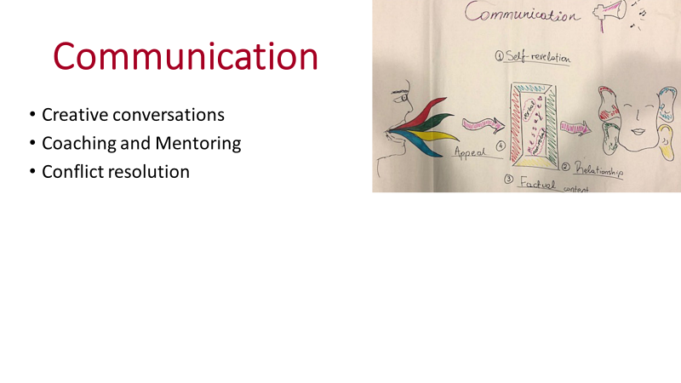

Training is obviously a communication process, that can be described as a creative conversation. Jim Ware stresses the importance of approaching every creative teaching conversation with an open mind, he describes the process of leading a conversation as being like the conductor of an orchestra supporting and encouraging players. See his Nine Rules for creative conversations [here](https://thefutureofwork.net/nine-rules-for-leading-a-constructive-conversation/).

Raising questions with trainees and helping them to find answers requires an approach called open questioning. An open question such as – What do you think of the training programme?” can reveal a lot more than a closed question such as- Has the training programme met your needs? Open questioning, has the aim of providing an opportunity for the trainee to take the conversation in the direction they choose so it is important for coaching and mentoring as well as for addressing potential conflicts. A simple introduction to open and closed questioning, with examples, is provided by the RCN [here](https://rcni.com/hosted-content/rcn/first-steps/questioning).

Creative conversations are also key to coaching and mentoring, which may also be an element of the role of trainers in SfGH, though in this case the model is more appropriately defined as “Buddying”. This describes a relationship between two equals who help one another address common issues. It can be helpful to establish buddying relationships with other trainers and within the teams you are training. For a simple guide to Mentoring and Coaching you may use the Building Leadership for Health modules [here](https://www.building-leadership-for-health.org.uk/building-leadership-for-health-course/a-guide-to-mentoring-and-coaching/).

Conflicting ideas and opinions can be disruptive to any team, but can also be a source of creativity if carefully managed. For SfGH teams conflict can arise for several reasons for example:

1. When discussing whether to compromise ideal aims in order to achieve practical progress
2. If views on appropriate behaviour and language differ
3. Challenges to current organisations and process from demands for innovation and change
4. Collective interests that do not accord with individual interests or views.
5. Simple personality clashes, feeling ignored, belittled or snubbed.

Addressing such conflicts is a key skill for the trainer as group facilitator. It is important not to ignore any signs of conflict but to address and seek to resolve them at an early stage. One important first step in addressing interpersonal conflict is described by William Ury as “going to your balcony” which means dealing with the wider issue beyond interpersonal wrangling to help people see common ground. The Sandler Blog provides 7 key steps to resolving team conflict posted by Dave Mattson [here](https://www.sandler.com/blog/professional-development-blog/ways-to-deal-with-team-conflict-effectively/)

Go to breakout rooms. Two members of each sub groups are asked to act out a conflict over their work as a team. The third should then act as the team leader to help them resolve their issues.

If possible video or record online the resolution meeting to share with the group.

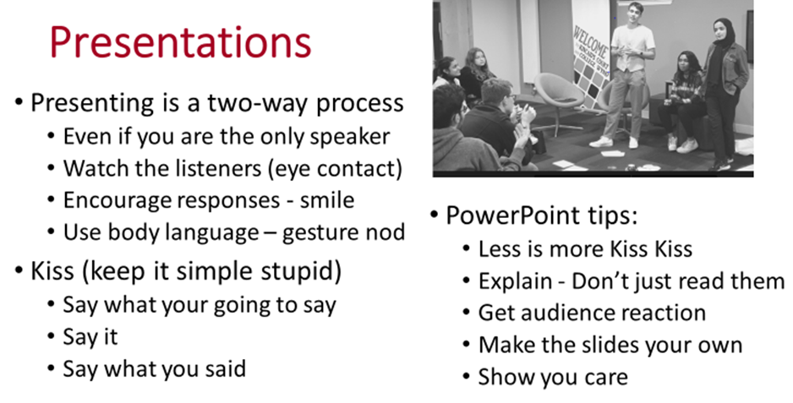

Presentation is a two way communication process . It can be a rather nerve jangling process but actually some degree of stage fright is helpful, it keeps you on your toes and encourages you to watch for reactions. So if yours is a nervous smile don’t worry, at least it’s a smile. SfGH training is not simply about conveying facts, it is about the values of global health and why we should take action, so don’t be afraid to show your passion for the issue. This is conveyed by your tone of voice and your body language: how you look at the listeners, how you move and use your arm and hand gestures. Actually you can’t really practice this stuff without it coming across as rather contrived you just have to let your enthusiasm show on the day. See the YouTube from Stanford Business School students [here](https://www.youtube.com/watch?v=cFLjudWTuGQ).

In most cases you will have researched far more than you can get across in a speech or PowerPoint presentation so one tip is that you should spend as much time simplifying what you are going to present as you do preparing it the first time round. Another tip is to introduce what you are going to say, giving a sort of brief agenda, then make your points and finally summarise your main messages. You can find 5 more tips from Deva Training Kilmarnock [here](https://www.bing.com/videos/search?q=presenting+skills+training&&view=detail&mid=B3190851F766559D1F94B3190851F766559D1F94&&FORM=VRDGAR&ru=%2Fvideos%2Fsearch%3Fq%3Dpresenting%2Bskills%2Btraining%26FORM%3DVDVVXX).

PowerPoints need to be kept simple and easy for the trainees to read, but don’t just read them out, a trainer’s job is to help explain the context and meaning behind the PowerPoints not to read them out. Encourage feedback and questions at intervals throughout the presentation. This does not work unless you warn the listeners that you want their questions and allow time for this to happen, but if you do manage this it makes for a far more engaging conversation.

The Training Toolkits provide some examples of PowerPoint presentations, you could of course simply show these and share your and the other trainee responses. But it would be better to use these and other presentations which you can find on the Web as a starting point for your own presentations. It is always more effective and more convincing to present your own thoughts in your own way.

Face to face and online group members should have an opportunity to make a presentation to what we can now call the TNT Team, practicing your communications skills. If possible it can be helpful to video or create an online recording of each speaker to help them reflect on their own performance.

Sub groups should meet to design a PowerPoint presentation or some other means as your own Training Tool addressing the issue you have chosen.

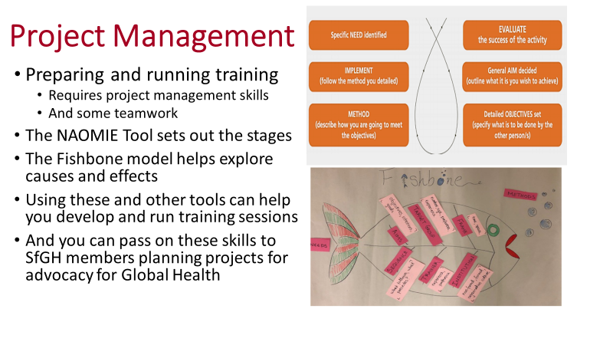

Project management is the art of getting people from different professional and cultural backgrounds to share their knowledge and effort to work together to achieve an agreed common goal within a limited budget and timescale. NAOMIE is a tool to help you think through the steps required to plan and implement a project such as delivery of a training programme. It identifies 6 steps:

N – Needs – what are the training needs of the group? How were these needs identified?

A – Aim what general aim do you have for the session. What purpose do you want to achieve?

O – Objectives – what specific objectives will you set for the training session?

M – Methods – what learning/training methods will you use to meet your objectives?

I – Implementation –how will you run the session. And how will you deal with the unexpected?

E – Evaluation – how will you know the objectives have been met? What methods will you use?

You may wish to take a more in depth look at project management tools and techniques as part of your own professional development and as a basis for training others. The NHS Improvement training resources on all aspects of project management can be found [here](https://improvement.nhs.uk/documents/2147/20190501_project-management-overview.pdf) and the Building Leadership for Health course material can be downloaded from [here](https://www.building-leadership-for-health.org.uk/building-leadership-for-health-course/leading-project-management/).

The Fishbone Diagram, developed by Kaoru Ishikawa in 1943, helps you to think through the causes of a problem (including possible root causes), then structure and group them appropriately to help you move towards their solution. NHS Improvement Training for this cause and effect model is available [here](https://improvement.nhs.uk/resources/cause-and-effect-fishbone-diagram/).

Sub groups are invited to convene in breakout rooms, in person or online, to apply the NAOMIE model to the development of their training module.

They should also apply the Fishbone model to the causes and effects of the issue that their training module addresses.

These should be displayed as diagrams that selected sub group members can explain to the full group.

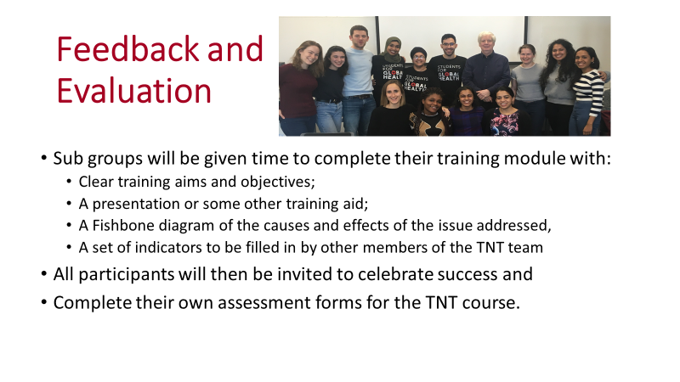

We hope that you have learnt from and enjoyed this TNT session and if anyone has suggestions that would improve the course we very much welcome your feedback. The SfGH Training Toolkits are available for your use and we hope you will improve, adapt and add to these. We hope modules developed during your training can be finalised and added to the Toolkits.

New Trainers who wish to develop their leadership skills further may use the Building Leadership for Health course materials [here](https://www.building-leadership-for-health.org.uk/building-leadership-for-health-course/) the Future Learn course [here](https://www.futurelearn.com/courses/healthcare) the Health Education England Management and Leadership Skills course [here](https://www.e-lfh.org.uk/programmes/management-and-leadership-skills/) and the World Health Organisation links to management courses [here](https://www.who.int/management/general/leadership/en/).

Training Toolkits on the SfGH web site include the following please submit further course you develop: