Training Toolkit 20: GAFFI Africa Ideas for Action

20
20

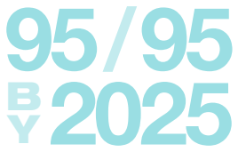
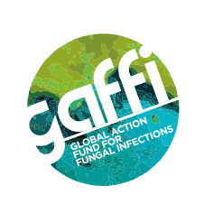

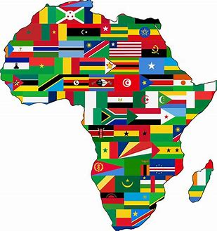
GAFFI AFRICA IDEAS FOR
ACTION

A Case Study in Action for Global Health
This case study presents issues relevant to current action to address Fungal Diseases in Africa as a practical case study of the options faced by the Global Action Fund for Fungal Disease (GAFFI) in developing a strategy to address Fungal Disease in Africa. Students for Global Health are invited to for working groups led by their Trainers to review the issues presented and develop an action plan to be put forward to Emma Orefuwa, GAFFI Director of Programmes for Africa.
It is suggested that SfGH groups should prepare proposals for how GAFFI might proceed:
- Building an alliance and working group(s) to address the problem.
- Developing a consistent framework for evaluating local needs and resources.
- Making the case for action, to address Fungal Diseases as part of an integrated health system.
- Listing the steps which might be included in local, national and Pan African programmes.
- Initiating one or more pilot projects in selected African Country locations
- Monitoring outcomes to demonstrate the social and economic costs and benefits.
- Expanding the programme to other African Countries.
Please contact Graham Lister at g_c-lister@msn.com for further information and to contact GAFFI. Note the issues raised here are also presented as general discussion topics in Toolkit 7.
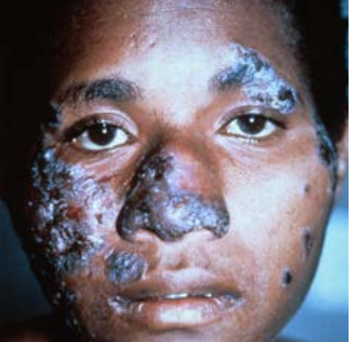
Fungal Infections:
The Hidden Crisis

Some 2 million deaths, are due, at least in part, to fungal diseases (FD), making this the 5th largest cause of death worldwide, many more suffer life changing conditions including blindness and disfigurement. FDs are prevalent in both the rural areas and urban slums of Lower Income Countries of Africa, where access to diagnostic laboratory services and drug treatments is likely to be poor. But this is largely unrecognized as they are seldom recorded as the ‘underlying cause of death’ in mortality. statistics.
GAFFI (Global Action Fund for Fungal Infections) reports that almost half of those who die with fungal conditions associated with AIDS (690,000 in 2019), 3 million people with TB like infections, some 160,000 people with Leukaemia and Lung Cancer, over 1 million people with Fungal Keratitis and hundreds of thousands of those with Neglected Tropical Diseases, could be cured, if relatively simple and low cost diagnosis and treatments, using modern drug developments, could be provided for fungal infections in Low and Lower Middle Income Countries. Their “95-95” campaign to ensure that 95% of people with serious fungal disease are diagnosed and 95% treated by 2025 can be viewed here.
Educational resources including guidance on laboratory procedures can be found on the web site of LIFE (Leading International Fungal Education) a partner organisation working with GAFFI (see here). The GAFFI campaign aims to persuade the WHO and governments to give greater priority to fungal diseases, to improve the skills and resources needed for diagnosis and treatment at local levels, to raise awareness and education about fungal diseases for health and community workers and the public as an important element of integrated healthcare systems. A project in Guatemala (see here) has shown the feasibility of this approach and is already proving its value. GAFFI ambassadors throughout Africa are seeking a similar strategy for improving FD diagnosis and treatment in rural and urban settings.
Some of the lessons, which may be relevant to Africa include:
- Priorities for addressing FDs depend upon the resources of rural and urban health systems.
- Co-producing responses to FDs with rural and urban communities is fundamental to success.
- Development must be attainable, in terms of staff and resources and financially sustainable.
- It is essential to take an integrated view of all aspects of health and wellbeing.
- E-Health has the potential to enable both community action and diagnosis and treatment.
- Public/private partnership can assist in the delivery of health information and resources.
- To rethink approaches to health and wellbeing services to meet local needs and resources.
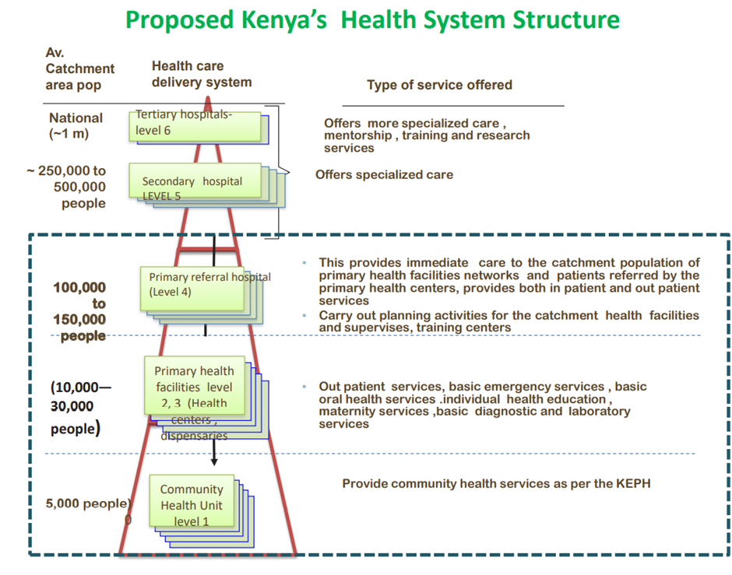
Health Systems in Rural and Urban Africa
The health systems of most of the countries of Sub Saharan Africa developed during the colonial period, based on Provincial/District Health Services focussed on (town) hospitals, led by doctors supported by nurses. Rural health services, where 60-70% of people lived were served by Missionary Hospitals (which still provide 20-30% of services in some areas) and local dispensaries. Post-colonial health systems continued to reflect this focus on hospital-based care, which dominate their health care budgets. While some countries like Cameroon and Algeria have social insurance systems, most state systems are tax funded, with total annual costs per capita ranging from less than $50 to over $500. The costs to users, for medicines, private services and “informal payments” to doctors and nurses, can be 30-50% of this. See the Lancet Commission report on the future of healthcare in sub Saharan Africa here.
The rural population of Sub Saharan Africa is currently estimated at 650 million, while there are 450 m people in urban areas, include 200 m people living with poor housing and unsanitary conditions (slums).
A new model for African health systems has now emerged, focussed on primary and community health, in both rural and urban settings, reflecting the 1978 Alma-Ata commitment to primary care for all, and the 2015 SDG goal of Universal Health Coverage. The first practical model of this approach was Tedros Ghebreyesus’ plan here, for the Tigray Region of Ethiopia. This introduced a cadre of community health workers and local health centres led by nurses and community action groups. This model has been followed by other African countries, see the 2019 Kenyan Primary Health Care Strategic Framework 2019-2024 here. Approaches to urban healthcare, particularly slum areas are more complex, see here.
All African health systems are under financial stress, so staffing, skills and other resources are often far below the level proposed in plans. Even if immediate requirements can be met from aid sources there may be little prospect of continued provision unless sustainable finance is secured.
For any programme to develop Fungal Disease services with communities in Africa it is be important to understand the national health systems and how it works and is resourced in local areas.
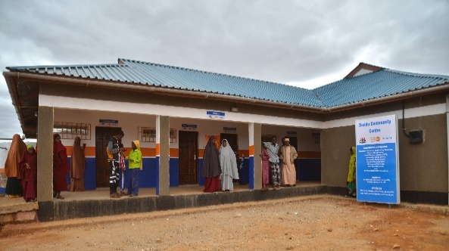
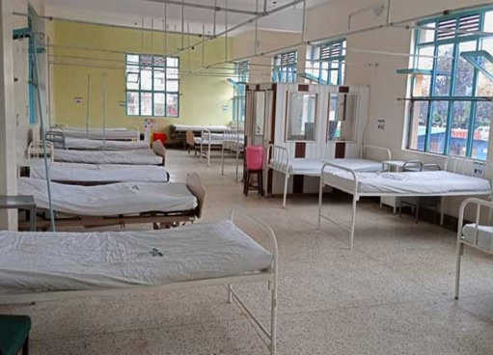
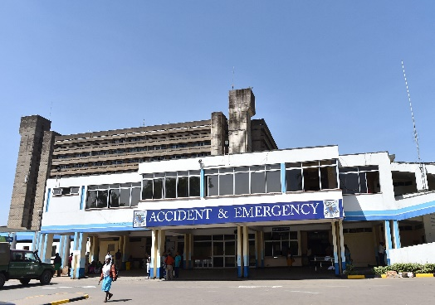
Health Facilities in Africa
Kenyatta Teaching Hospital Machakos General Hospital

Mandera Community Life Centre
Tertiary hospitals provide advanced diagnostic laboratory services and specialized medical treatments, they may also provide advice and training for staff from other facilities. Secondary and referral hospitals also include diagnostic and some specialist treatment, with more specialist treatment at secondary level. Primary Care Centres may include basic laboratory services able to undertake routine tests and routine nursing care procedures. Community Workers provide public health and community support services. For an analysis of the current state of health and health systems in Africa see the WHO Report here.
An essential starting point for setting priorities for health service development is to map the availability of relevant facilities and capability in the area targeted, bearing in mind the cost of travel for the people served. Where services are not available investment in facilities and training will be necessary.

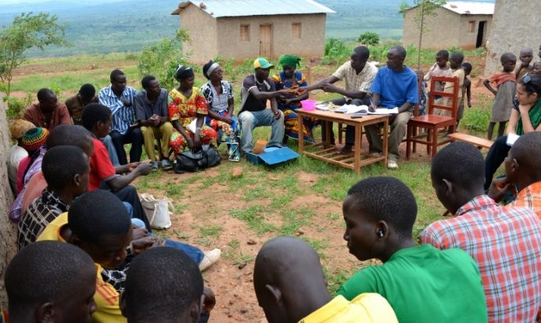
Co-Producing Community Action for Health in Rural Africa

Co-production is fundamental to Community Health. Any health project must be based on the trust, understanding and commitment of communities. A course on Leading Healthy Communities, for WHO Euro, can be found here and a practical example of co-production for health is here. The article by Nick Goodwin here is also helpful. WHO guidance on Community engagement for quality, integrated, people-centred and resilient health services can be found here and here. A health project in Namibia, which follows these guidelines included Village Health Committees, as co producers see here.
These examples demonstrate the importance of building trust through a process, described by Shelley Arnstein as a step-by-step approach to: improving information exchange, introducing better consultation processes, involving NGOs in decision making, developing joint action projects and supporting independent NGO action. This leads to the development of relationships between partners in the development process, from what social psychologist Eric Berne describes as a dysfunctional - “Parent/Child” relationship, to a mutually respectful “Adult/Adult” relationship.
An important aspect of such a relationship is to acknowledge faults in current arrangements and to recognize that any proposed improvements must be economically and financially sustainable. It is also essential to ensure transparency so local groups can monitor services against promised targets. Consultations should set basic targets against which community groups can judge project performance. Transparency International can help communities to monitor the local impact of aid projects, see here.
One experience used by trainers to illustrate this is to ask trainees to grasp their neighbour’s hand and place it where they choose on the desk in front of them. Then ask the trainees how this feels - it is easy to do but for the person whose hand is grasped, it feels intrusive and aggressive. Now ask them to support their neighbour’s hand from below, while the neighbour decides where to put their hand, using this support. Again ask how it feels – actually it is rather difficult to support your neighbour’s hand as you need to respond to their clues, while having your hand guided should feel empowering.
See the review here showing how training can help Community Health workers achieve health goals.
In developing a local programme to address Fungal Disease it will be important to build understanding and trust by steps to:
- Share information on health and Fungal Disease with community leaders and health providers
- Develop consultations on how health information and health services are currently provided
- Ask for joint proposals for service improvements with commitments from community groups.
- Prepare sustainable plans to improve community health, and Fungal Disease outcomes
- Support and monitor action by local health providers, community leaders and other partners.
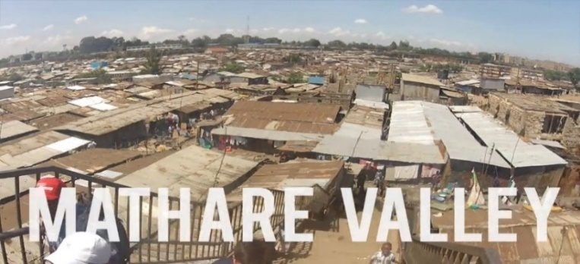
Co-Producing Community Action for Health in Africa’s Slums

Globally, nearly 1 billion people live in slums, defined as urban areas with a lack of basic services (sanitation, potable water, electricity), substandard housing, overcrowding, unhealthy and hazardous locations, insecure tenure and social exclusion. In Sub Saharan Africa, some 200 million people live in slums such as Mathare Valley and Kibera, the world’s largest slum in Nairobi.
Slums (see here) have high rates of Fungal Disease associated with: HIV/AIDs, TB and infectious diseases due to crowded, unsanitary conditions. Rates of morbidity and mortality are particularly high for children. Shared pit latrines and “flying toilets” are common forms of sanitation, water is fetched from communal standpipes and most houses are overcrowded corrugated iron huts with earth floors here.
Many slum residents could access health facilities located in Tertiary or Secondary Hospitals near their area, but they often lack awareness of the early signs of diseases such as fungal infection. And many residents may not be able to afford medicines because they do not earn enough from informal sector employment. Doctors and other health staff are often reluctant to provide services in these areas due to lack of security. It is also apparent that in some slum areas criminal gangs control many aspects of life. This can make tenure and employment uncertain, for people who have left their village due to poverty.
A meta study of projects to improve health and wellbeing in Africa’s slums by Lilford and Oyebode et al here shows an integrated approach to physical infrastructure and social development is needed to address the many interlinked issues that determine the health and wellbeing of people living in slums. An essential starting point is ownership of property, as without tenure, and security, coproduction is seldom possible. This requires listening and building trust with the community as well as investment by services including health and community workers, police, planners, water and sewerage departments.
The approach to Fungal Diseases in such areas must recognise that:
- People living in slum areas may feel alienated by lack of security and the dominance of gangs.
- Information on health will only be believed if delivered, or supported by trusted leaders.
- Hospitals may be close by but gaining an appointment and travel to hospital can be difficult.
- Co-production of health is one of many priorities for improving life and wellbeing in slums.
- Each urban slum area in Africa poses its own issues and priorities.

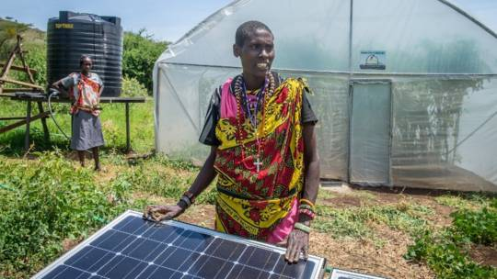
Attainability Resilience and
Sustainability

Any development of health and care services for African communities must match the resources available in the rural or urban locations served, this includes: the leadership and management of local services the skills of staff, physical resources such as laboratory equipment, electricity supply and internet connection. Moreover, as support by local community groups and organisations will be essential for many services, it is also important to consider community social capital. It is not only the immediate attainment of these resources that is important, it is the sustainability of such resources.
Thus as examples: the provision of skilled laboratory technicians may be achieved by training current staff, but when they move on or when technology changes it is essential to ensure the training programmes are in place for new staff. So too, if equipment is provided and its quality is assured, there must be a system for continued monitoring, repair and renewal to ensure its resilience. .
In most cases this will require continued funding from sustainable sources. As noted, current healthcare systems in Africa vary widely in their level and sources of funding, typically about a third of expenditure may come from government taxation, a third from international aid and a third from payments by users. In 2013 for 20 African countries user payments made up over 40% of healthcare funding see here.
It is therefore important to take a realistic view of what combination of these sources will be expected to sustain any proposed development. If this includes user charges it will be essential to gain community understanding and support for this. Out-of-pocket payments are a regressive way of funding health care, such payments can create financial barriers to health services and can impoverish people, it is not true that people only value services they pay for, see here.
Planning for local service improvements should consider both the planned project and its benefits and unplanned consequences that might arise and what can be done to mitigate them. For example, what could be done if the local clinic is unable to cope with extra demand, or if trained staff leave.
The case for any specific development of health services must therefore consider the total health and wellbeing of individuals, families and communities and the impact on the total health and care system.
For the development of services for people with fungal diseases it is important to:
- Assess current resources, how they can be upgraded and how this could be funded.
- Plan the support needed to sustain services and how this will be funded.
- Consult communities on the costs, benefits and funding of proposals to improve services.
- Be aware of and explain any unplanned positive or negative consequences that may arise.
- Make a case for investment in fungal disease services in the context of its total service impact.
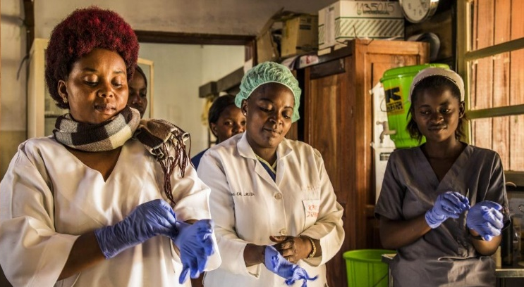
Integrated Care for
Whole Person
Whole Family
Whole Community

The experience that led to the GAFFI initiative is that projects narrowly focussed on the delivery of standard drugs and treatments for diseases such as HIV/AIDS, TB and Neglected Tropical Diseases, have failed to take into account the impact of Fungal Diseases as co-morbidities and associated conditions. As a result mortality has not reduced to the extent planned and the death toll now attributable to Fungal Disease in Africa is estimated at between 600,000 and I million per year see here.
If healthcare projects are to be sustainable in rural or urban Africa, they must be elements of integrated services addressing all aspects of whole person health, as set out in the World Health Assembly 2016, “Framework on integrated people-centred health services” see here. This sets out goals for all healthcare services of: Equity of access, Quality and safety, .Responsiveness and community participation, Efficiency and cost-effectiveness and Resilience and sustainability.
As all African healthcare systems are underfunded, it is also important to consider the financial impact of expenditure on any one element of health, that may divert resources from other fields. Thus it is essential to evaluate the impact on total health, in terms of its cost effectiveness, usually as a cost per DALY (Disability Adjusted Life Year). For a course on economic evaluation see here. The WHO One Health Tool may be used to examine alternative health planning options see here.
Many of the diseases associated with Fungal Disease have consequences for issues such as: the need for palliative end of life care, poverty, stigmatisation and orphaned children. In Africa many aspects of such care needs are addressed by extended family and kinship support. Community Health Workers can help mobilise these resources and provide a link to clinical interventions where necessary, if they are included in a management framework encompassing all aspects of integrated care. Examples of such services can be found here , unfortunately these are exceptions to normal practice in Africa.
Leadership and management of local services will normally be led by a Senior Nurse supported by Laboratory and Prescribing Technicians and Community Health Workers, in partnership with Community Leaders. It may be helpful to provide leadership and management training to support this, see here.
There may also be a need to rethink arrangements for the oversight, monitoring and support of services from regional or national level. This should include informing and consulting communities.
When developing plans for services to address Fungal Disease in Africa, it is suggested that:
- Service developments should be planned as an integral element of rural and urban services.
- Plans should be evaluated against the 5 criteria agreed at the World Health Assembly.
- Economic evaluation should demonstrate that planned developments are cost effective.
- Local management of integrated care and Provincial/National audit should be established.
- Leadership and management training may be an essential element for integrated care.
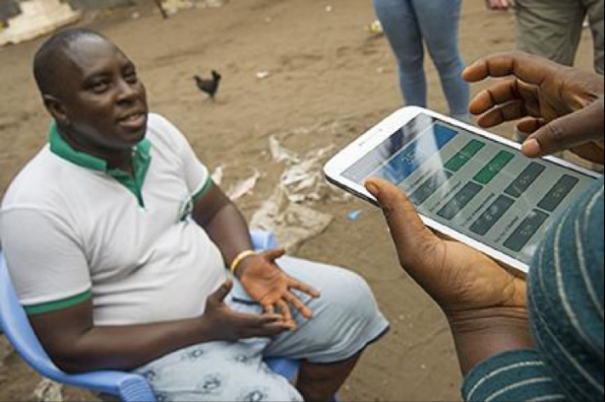
The Potential of E Health for Africa

Africa bears one-quarter of the global disease burden, yet has only 2% of the world’s doctors. In Europe there is 1 doctor per 350 - 650 people, in Africa there is 1 doctor per 10,000 – 15,000 people. But as most doctors work in urban areas, where they can earn from private practice, rural areas may have 1 doctor serving 50-60,000 people or more. Local services are managed by Nurses and Technical staff with limited training in diagnostic or specialist treatment options. E Health could transform this.
The potential contribution of E Health has long been recognized in Africa. The Pan African E Network Project (PAENP) was an information and communications technology project between India and the African Union to connect the 55 member states of the Union through a satellite and fibre-optic network to India and to each other. The project, was intended to enable access to and sharing of expertise in the fields of: tele-education, telemedicine, Voice over IP, infotainment, resource mapping, meteorological services, e-governance and e-commerce services. Investment in this $1billion project started in 2006. For healthcare, PAENP connects 5 regional Super Specialty Hospitals and 53 remote hospitals in all countries of Africa to Universities and hospitals in India, see the YouTube video here. Another example of a regional initiative for E-Health is the Education for Health Africa project, see here. At national level African countries have embraced the potential of E-Health, for example, Kenya has had a strategic plan for E-Health since 2011 see here, there are now calls for an E-Health Strategy for East Africa see here. Plans include further development of national and regional centres that can develop and contextualise online resources including basic medical and public health knowledge, reference knowledge for specific diseases, diagnostic tools and algorithms, and logistics support see “African Strategies for Health” here.
Internet resources are also used to support continuing clinical education and diagnostic and treatment protocols for health workers. For example, the “Jibu” (Swahili for “answer”) project supported by Amref Health Africa, provides training resources for Nurses in Kenya through mobile phones and tablets, this is called m-Learning for m-Health see here. Other examples of this technology include an app provided by the Kenyan Ministry of Health called “Integrated Management of Childhood Illness” and the “First Aid”, app offered by the Kenyan Red Cross. In Rwanda a UK provider called Babylon Health is developing a wide range of E-Health and m-Health services see here. There are also commercial phone apps used by the public to access and pay for medical advice and medicines. In Kenya these include: mDaktari, Hello Doctor/ Sema Doc, M-Tiba and MyDawa.
Applications that may be relevant to Fungal Diseases include:
- Online Mobile, Tablet or Flash Drive public health resources for Community Health Workers
- Public telephone advice line providing recorded information including for Fungal Diseases
- E Health / m-Health education resources for Laboratory Technicians and Nurses
- Diagnostic algorithms for assessing patient conditions and laboratory outcomes.
- Telemedicine resources to provide medical advice and second opinions.
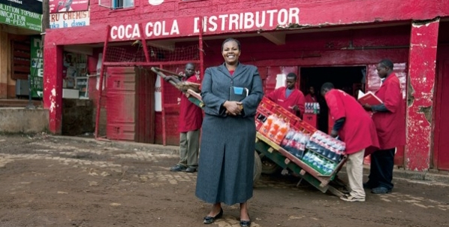
Working with Public/Private Partners

Public/Private Partnerships (PPPs) are an important element of healthcare provision in Africa. Experience suggests that, while they can improve services, they need to be carefully managed see here. so countries such as Kenya have specific policies frameworks and units to manage them see here.
Public Private Partnership with drug companies has been a feature of the response to Neglected Tropical Diseases (NTDs), as discussed here. Thirteen of the largest pharmaceutical companies have pulled together under the auspices of the CEO Roundtable to provide the largest drug donation in history. To date they have contributed more than $17.8 billion as drugs and contributions towards the cost of distribution and prescription. They are often drugs developed for other purposes, useful for NTDs.
Partnerships also include global alliances like GAFFI, which address specific diseases. Examples include: the Sightsavers Global Trachoma Mapping project here, and the BD-PEPFAR PPP which aimed to strengthen laboratory medicine systems and clinical practice in Africa to address HIV/AIDS see here.
There are also calls for partnerships to support E-Health and m-Health knowledge centres for Africa. This is an element of the African Union plan for a digital economy. It would ensure that while sharing in global networks, health knowledge is developed relevant to local needs to reflect the language and resources available and addressing issues such as Neglected Tropical Diseases and Fungal Diseases. Current E Health services include Amref, eCampus here with physical and mental health resources.
PPPs have also assisted in meeting the logistic problem of drug delivery to rural locations. Coca-Cola and the Global Fund to Fight AIDS, Tuberculosis and Malaria have expanded a project which uses the beverages giant's “expansive global distribution system and core business expertise" to help deliver critical medicines to remote parts of the world, beginning in rural Africa see here.
Cinema is also a thriving in Africa and can spread health messages during intervals. Films, including those from Africa, can be projected in halls or open spaces using mobile phone devices and screens.
There are now some 750 million SIM connections in sub-Saharan Africa, (this is about 75% of the population). This is a crucial resource for public health and for health providers. USAID and Orange telecommunications, have recently announced a new collaboration to find innovative ways to use mobile phone “m-Health” to accelerate access to health information and services in Africa see here.
GAFFI may wish to work with partners to address Africa’s Fungal Diseases, in areas such as:
- Provision of public health messages and content to attract community viewers
- Long term provision of pharmaceuticals and laboratory supplies relevant to FD.
- Support for delivery of pharmaceuticals to remote locations
- Education and training for front line nurses, prescribers and laboratory technicians.
- Access to mobile phone health information services for the public.
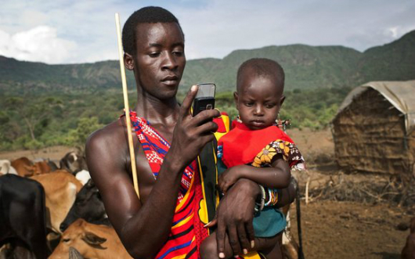
Rethinking Integrated Health Services for Africa

A re-imagining of how health services could be developed to improve services for people with Fungal Diseases in a Sub Saharan African community, might include the following elements:
- Community health workers and a GAFFI team review local health needs and services and consult on what developments are likely to be most welcomed, attainable and sustainable.
- A Community Health Committee is set up to guide improvements and communicate with local people, it might run cinema evenings, including health messages and advice on FDs.
- Similar sessions are provided at local schools so children take messages home to their family and local teachers are provided with training sessions and resources including advice on FDs.
- Content is provided in partnership with a film producer/distributor which also helps to produces tailored public health messages, they also help train local film makers.
- An m-Health, app developed in partnership with a telecommunications provider gives access to recorded health messages and can also connect callers to health services and advisors.
- Nurses, Laboratory technicians, Prescribers and Community workers receive online training, including leadership and management, in partnership with national/regional training centres.
- Remote diagnostic algorithms and image recognition systems are developed to assist in recognition of FDs, assessing laboratory cultures and managing prescriptions.
- A regional centre for development and dissemination of E-Health knowledge provided by a PPP including international partners shares knowledge relevant to needs and resources.
- Drug deliveries, including for FDs are managed by a PPP providing logistics and transport, partners include global logistics and delivery companies.
- Standards of services are monitored from provincial centres, which also provide advice. Community Health Committees, coproducing the project, are also kept informed.
This imagined scenario is not intended to suggest “a one size fits all” solution for rural and urban Africa. Each of the 48 states of Sub Saharan Africa has a different health system and every community has its own needs and resources. While similar technical and health support may be developed, every community needs to find its own solution. Where electricity supply and/or internet connection are inadequate online services might be replaced by Flash-drive based applications and solar panels.
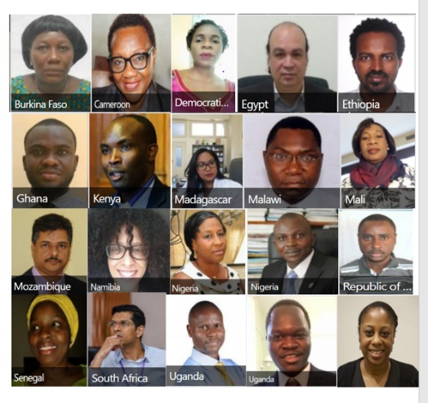
A Strategy for Fungal Infections in Integrated Care Settings

A strategy for improving the diagnosis and treatment of Fungal Infections in Sub Saharan Africa as an element of person centred integrated care might include the following elements:
- GAFFI Ambassadors from across Africa meet to agree on their approach and priorities for action, including: methods for assessing national and local needs and resources and potential cost/benefits of measures to improve FD services as an element of integrated health services.
- As both local provision and pan African initiatives require integrated approaches coalition with other providers and public private partnerships are established, e.g. HIV/AIDS, TB and NTD programmes and with IT, logistics and entertainment content providers.
- National and local assessments identify pilot areas for action in rural and urban settings in three countries, giving priority to FDs that can be addressed with current resources as an element in the ongoing improvement of integrated health services.
- Pan African plans are developed for a network of E-Health Centres providing knowledge for health professionals and public health information relevant to local resource and languages. This includes, but is not limited to training and public health information relevant to FDs.
- Throughout this process consultations are required with the African Union, WHO Africa, Governments and Charitable Foundations to agree milestones, funding and actions based on the GAFFI 95-95 targets.
- Pilot development in rural and urban settings and Pan African initiatives including E Health, Logistics and Entertainment with PH Messaging are evaluated as integrated programmes taking into account the impact on all aspects of personal and community health.
- Based on the outcome of these steps the approach should be revised and improved before application to other areas and countries, always remembering that each country and every community will have different needs and resources.

