Friends of Chalfonts and GX Community Hospital Engagement:
Suggestions for Community Action for Health and Wellbeing
We are delighted to hear that Buckinghamshire NHS Healthcare Trust (BHT) Buckinghamshire County Council (BCC), Oxford NHS Foundation Trust, South Central Ambulance Service NHS Trust and Buckinghamshire GP services will work together to develop an Integrated Care System focused on holistic physical and mental health, social care and wellbeing with services provided from Community Service Hubs serving 100,000 to 150,000 people and Local Integrated Teams serving 30,000 to 50,000.
The Marlow and Thame Hubs show how services can be delivered closer home. We hope to go further in developing a local health and wellbeing centre to engage community-based groups and businesses to work with health and social care professionals. We look forward to the extension of diagnostic services at Amersham Hospital. We hope to see our centre linked to these services by improved transport, while providing a range of local clinics such as audiology, podiatry and phlebotomy and services such as Community Assessment and Treatment, Rapid Response Intermediate Care, Mental Health, Frailty Support, Social Care Advice and Integrated Discharge and Long-Term Care Planning.
Working with BHT we have talked with local service providers and community organisations and representatives to identify opportunities to contribute to community health and wellbeing. We noted 16 ideas which could be supported by community action at the centre and there may be many others. Not all can be achieved immediately, so there will be a need for a local board to establish priorities.
- Frailty Support and extended social prescribing
- Local Provision of Health checks for people aged between 40 and 75
- Community support for people with early signs of potential mental health problems.
- A Dementia Friends initiative to provide community support and counselling
- A Drop -in Café for People with Health and Social Care issues
- Integrated support for parents of children with special educational needs and disabilities.
- Action to improve access to arts, sports and other activities for people with disabilities.
- Re-establish Breathe Easy Support Group for those with Chronic Obstructive Pulmonary Disease.
- A self-help support group and improved services for people with joint pain.
- Integrated support for mothers and babies, including those at risk of post-natal depression.
- Extension of services and self-care support for people with diabetes.
- Development of an integrated care for carers network and respite services.
- Further support for hospice at home services to give people greater choice of end of life care.
- A Digital Health and Wellbeing Centre to support users of online health and wellbeing services
- Support for people discharged from hospital or needing to move into long term care.
- Facilities for staff such as a common room to enhance multi-disciplinary teamwork.
Our hospital has a range of rooms providing space for clinics and services and several large rooms that have recently been cleared of medical records and other materials. On an adjacent site there is a Community Health Centre that will be used by the Chalfonts PCN and a GP surgery and some services currently provided from the hospital may be moved there, but we are assured there are no plans to close the hospital. There is a large parking lot, reception area with accessible toilets and a garden which is important for people with mental health issues. The Friends have some £2m in funds to support refurbishment of rooms and facilities to enhance health and wellbeing.
Community action and services to support health and wellbeing and contribute to the Buckinghamshire Integrated Care Strategy, should be cost effective, safe and compassionate, reducing demand for overstretched services (in particular GP and A&E services). It will also be important to ensure they are affordable, both for individuals (in terms of travel costs and charges) and for community organisations (in terms of charges for rooms). By serving as a focal point for community action. it could stimulate Health and Wellbeing in the Highstreets and Villages throughout S E Bucks.
Our Community Health and Wellbeing
The Denham, Gerrards Cross and Chalfonts area includes over 40,000 people, 8,000 in Denham, 13,000 in Chalfont St Peter, 6,700 in Chalfont St Giles, 3,000 in Seer Green, 8,400 in Gerrards Cross, 800 in Hedgerly and 500 in Fulmer. Communities in SE Bucks which might also be served include Iver and Richings Park (6,000) Wexham (4,000), Farnham (7,000) and Stoke Poges (4,000) over 60,000.
The Joint Strategic Needs Assessment (JSNA) and the Community Board Profile for this area shows our communities have a somewhat older age profile than other areas of Buckinghamshire, health outcomes are relatively good and the Index of Multiple Deprivation (IMD) relatively low, except for some areas of New Denham and Denham Green. A Prevention Matters report notes that two thirds of early deaths are preventable by addressing: overweight, smoking, alcohol consumption and high blood pressure. Key objectives are to improve physical activity, diet and other lifestyle behaviours, attendance at NHS Health Checks and participation in community health and wellbeing groups.
Health and care services are commissioned by Buckinghamshire Clinical Commissioning Group. Three primary care practices work together in the Chalfonts Primary Care Network which serves some 33,000 patients: the Hall Practice, the Allen Practice, and the Misbourne Practice (which also provides a surgery in Chalfont St Giles). Denham is served by the South Bucks PCN which also serves the Ivers and Richings Park, Wexham and Fulmer, the Farnhams and Hedgerley and Stoke Poges. BHT also provides secondary hospital care from High Wycombe and Stoke Mandeville and Oxford NHS Trust provides mental health services. Many patients in our area use the nearby Wexham Park Hospital operated by Frimley NHS Trust. There are many pharmacies and dental practices which, could also be partners, as Healthy Living Pharmacies and Healthy Living Dentists, providing health and wellbeing advice and signposting to relevant services. There is also a private sector operated ambulance station.
Public Health and Wellbeing and Social Care services are managed by BCC. Social care professionals are based in Amersham and High Wycombe with outposts in Beaconsfield and Burnham. Health and Social Care are coordinated by the Buckinghamshire Health and Wellbeing Board. There are more than 30 residential and care homes ranging from nursing homes to sheltered housing, and 4 homecare services, at least 7 homes offer support for people with Dementia. Specialist homes, including those of the Epilepsy Society, and Leonard Cheshire Disability, provide for people with disabilities.
There are many meeting rooms and halls available, including: sports halls, libraries (supported by community volunteers), Community centres and village halls in Denham, GX, Chalfont St Peter, Little Chalfont, Hedgerley, Jordans, Seer Green, Farnham Royal, Stoke Poges and Iver, with proposals to renew both Chalfont St Peter and Little Chalfont halls. There are over 25 church halls in S E Bucks, a new Baptist Church hall has opened as a “Community Hub” close to the hospital with a range of spaces. Chalfont St Peter Leisure Centre, run by a social enterprise (SE) called “Everyone Active” offers paid and concessionary health regimes including: Physical Activity Referral Schemes, Balance and Falls Prevention, Cardiac, Cancer and Pulmonary Rehabilitation, Diabetes, Weight Management and Mental Health Classes. The Evreham sports centre in Iver is run by another SE called “Better”.
Gerrards Cross Town Council and the Parish Councils play active roles in stimulating and supporting community action and events working with the Community Board. These include fun runs, walking events and dances that stimulate physical activity in many parks, open spaces and halls, in total there are over 300 local groups active in our area. With the support of Community Impact Buckinghamshire, provided through the community centre, they can make a major contribution to health and wellbeing.
An integrated team based at our hospital could support the Chalfonts and South Bucks PCNs in South-East Bucks (60,000-62,000) working with the Marlow Hub serving S-W Bucks. In the following pages broad estimates of community needs are based on populations of 40,000 and 60,000 with the characteristics analysed by the Denham, Gerrards Cross and the Chilterns Community Board.
The Chalfonts and Gerrards Cross Community Hospital
Until the recent COVID crisis, when services were disrupted by use as a Vaccination Centre this hospital provided a range of clinics and services, including:
  - Aortic Abdominal Aneurisms screening for males over 65.
  - Diabetes and Diabetic education -6 weekly sessions.
  - Continence advice, No Smoking Clinic, Dietician advice.
    - Consultant clinics: provided by BHT and Wexham Park consultants: Chest, ENT, General Surgery, Gynaecology, Neurology, Haematology, Ophthalmology, Orthopaedics, Paediatrics, Pain Control, Plastic Surgery, Rheumatology, Urology, Vascular Surgery, Colo-rectal, Respiratory
    - Audiology, Sexual Health, Heart Failure, Enuresis and Midwifery Clinics
  - Physiotherapy: Neuro Rehabilitation, Musculoskeletal and other conditions
  - Podiatry (Chiropody), Warfarin (INR), Tissue Viability (Wound Care)
  - X-Ray and Phlebotomy
  - Adult Community Healthcare Team providing home visits and care
  - Health Visitor, District Nurse and School Health Nurses are based at the hospital

We are all proud of the work done by PCN and hospital staff and volunteers in delivering 70,000 Covid Vaccine doses to our local population. We recognise that vaccination efforts may need to continue for some time, perhaps in conjunction with annual flu vaccinations. As demand reduces we hope that a system can be introduced to provide vaccinations without disrupting the return of other hospital clinics. This should be possible as there are 5 possible doors that could be used for public access.
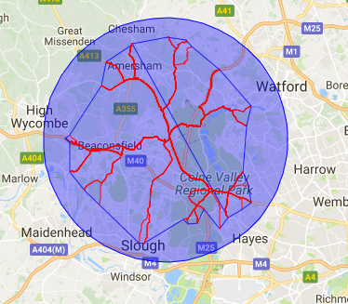
The development of Amersham Hospital as a Community Diagnostic Centre providing a range of complex diagnostic services is important. The benefit to local communities thus provided could be enhanced by improved transport and online communications. We suggest the Non-Emergency Patient Transport Service provided by: the NHS and South-Central Ambulance Trust, the Buckinghamshire Community Transport Hub and charities like Driving Miss Daisy and Dial a Ride could also be engaged.
We hope that while more complex diagnostic services will be provided from Amersham, complementary services at our hospital such as Audiology, Ear Wax Removal (provided by GX Plus Age Concern) and Podiatry supported by a local GP Practice other routine clinics and services like phlebotomy, aortic screening, continence advice, sexual health and wound care will resume at the hospital. We also support proposals for a Frailty Support Team, a Mental Health Team and Social Care Advice and Discharge and Care Planning Team.
From S E Bucks the hospital is quickly accessible by car, taxi, and bus (5 bus routes are available from the nearby Market Place). It is also within a few minutes walking of the three local primary care practices. The map shows areas withing 30 minutes drive at 15 mph.
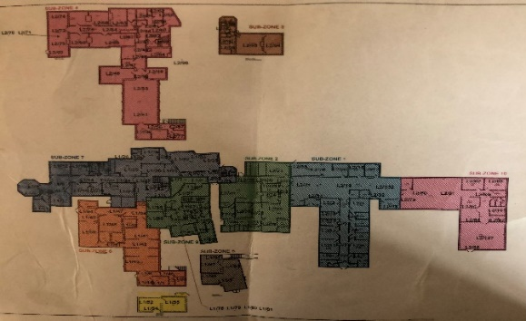
The hospital has vacant rooms and spaces that could be used by staff and community groups to provide health and wellbeing support. But a Health and Wellbeing Centre is not simply a space, it is a focus for groups and businesses such as the Rotary Club, the Feast of St Peter, the Co-op, Tesco’s and Waitrose which have already contributed funds to support the refurbishment of the hospital, for which we are most grateful.
Examples of Community Action for Health and Wellbeing
1 Frailty Support and Social Prescribing
Frailty refers to a person’s mental and physical resilience, or their ability to bounce back and recover from events like illness and injury, for example from chronic diseases or falls. Frail patients (7% of over 65s, a total of some 500 patients in the Denham, Gerrards Cross and Chilterns area and 750 in SE Bucks) use GP and hospital services at 5 times the average rate and account for more than 1/3rd of GP appointments. The Chalfonts PCN Frailty Support Team, will be of great value to such patients and also save time and costs to GPs, hospital services and social care.
Frail patients and their carers can also benefit from social prescribing to link them to community support groups. It has been estimated that some 20% of GP consultations are primarily for social needs. Research on the effect on demand for General Practice services reported an average 28% reduction for GP services following referral to Frailty Support and Social Prescribing services. A recent study showed that 20% of the population most at risk of an emergency admission to hospital accounted for 86% of hospital and 87% of social care expenditure.
Social prescribing is important for people with special needs. In the local community and SE Bucks there may be 1,200-1,800 women experiencing difficult menopause symptoms, 1,000-1,500 with endometriosis, 6,000-9,000 with some degree of hearing loss, 300-450 with poor eyesight due to macular degeneration, 500-750 with drug related issues, 3,000-4,500 who drink alcohol very frequently and 3,000-4,500 who smoke. Our centre could help people contact national organisations like Parkinson’s UK and support groups like Bucks Vision. It could promote NHS Health Checks and screening, such as for breast cancer, affecting 1,800-2,700 women and prostate cancer, affecting 1,200-1800 men in our area, working with Macmillan Cancer Services. There may also be some 700-1,000 stroke or TIA survivors who need better access to physio and other post-stroke support services.
Social Prescribing is not provided simply by referring patients to a link worker. It requires an integrated multi-disciplinary team approach offering whole person care and drawing on community resources such as Bucks Stroke Support Services, Bucks Live Well Stay Well and neighbourhood support and befriending. Our communities have many resources, including Age Concern clubs, GP exercise referral schemes, Simply Walk groups and Dial a Ride services, but services seem difficult to find.
It appears some community organisations such as Alzheimer’s Society, Care for Carers, Versus Athritis, Mind, Headway, I CAN, NCT, Diabetes UK and other patient support groups, are less active in S E Bucks. The transition of Gerrards Cross to Town status may improve this as the Council has set a goal of establishing health facilities to serve the town. A community health and wellbeing centre engaging community organisations could play an important role in helping local groups to befriend new members and in encouraging national patient groups and social care organisations to develop in our area. It could connect GP services with community organisations in halls and community spaces across S E Bucks to each other and to integrated physical and mental health and social care services.
2 Provision of Health Checks
Free NHS health checks are offered every 5 years to those between the ages of 40 and 75, they are highly effective in detecting early signs of cardiovascular diseases, lung cancer, diabetes, COPD and dementia. All of these conditions are prevalent in our local community and can be mitigated by advice and support for healthy lifestyle choices, patient group participation and relevant medication. In our area almost 99% of people are offered checks, but less than half of those offered the service attend for their check (45%). This suggests that the service could be more successfully delivered if supported by greater awareness raising and local marketing. Health checks could provide a starting point to help people share their complex issues and needs as a basis for personal health and wellbeing plans. Obesity, which could be indicated at such checks is an issue for over 25% of those between 40 and 75 (5,500-8,250 locally), is an underlying cause of many long-term health issues. A Health Check may be one point at which depression or other mental health issue are identified.
3 Support for People with Mental Health Problems
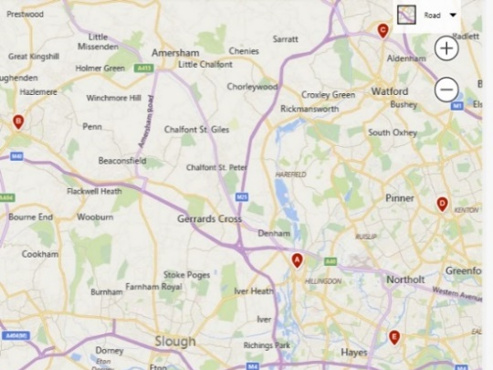
A map of mental health support groups shows the gap in our locality, the nearest sources of support are the Uxbridge Mental Health Services. It is estimated that 1 in 4 people will experience some form of mental health problem each year, ranging from generalised anxiety to depression or some form of psychotic, bipolar or personality disorder. This equates to some 10,500-16,000 people in our community. Most do not progress to a severe mental illness, but in our area 10.8% of GP registered patients (some 4,000-6,000 people) are identified as living with depression. If needs are recognised and integrated support is provided at an early stage, progression to mental illness can be reduced, lowering the burden of disease and demand on emergency services.
Following principles shown by Vanguard Projects, such as the CAMHS Community Team West: Frimley, a team might be established to bring together primary care, mental health and social care skills working with community patient support organisations such as Bucks Mind and Sport in Mind. The team could provide early support for children and adults, incorporate opportunities for those experiencing mental health issues, and their carers, to share problems and gain community support.
4 Support for People with Dementia and their Carers
Support for People with Alzheimer’s Disease
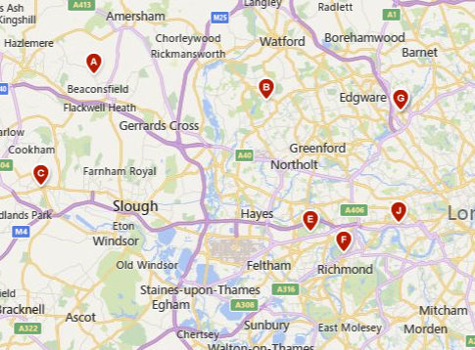
Dementia includes a range of diseases leading to impairment of mental functioning, the most common being Alzheimer’s. This is extremely distressing both for the person with the condition and their carers. it is estimated that 350 525 people in our area are diagnosed with dementia, however, studies suggest that only 67% of cases are diagnosed, so the true total is likely to be some 500-750 people. Studies have shown that music, art and other activities such as gardening can be beneficial for those living with the condition and their carers. People with dementia tend to avoid confusing large spaces. They want to socialise but need purpose and guidance and an inviting homely place to meet. Chalfonts and Gerrards Cross communities have choirs, art and gardening clubs that could assist in such programmes, perhaps with guidance from the Oxford Health Memory Service, the Alzheimer’s Society, Dementia Friends and Headway South Bucks. A wider community initiative might also engage local retailers and businesses (some of which have already shown willingness) in creating a Dementia Friendly Community. A map of support services shows the gap in our locality. This might build on local initiatives taken in the Denham area where Safe Space, Memory Café and other community initiatives provide examples of what can be achieved. Facilities could also be provided for services such as those provided by Headway, which runs an online counselling service for young people with mental health issues, a safe space might also be provided for in-person counselling at the Centre. A study by Hampshire County Council shows that awareness raising and engagement in these ways can result in better patient experience and lower use of NHS and Social Care services in the long term with limited short term economic cost.
5 A Drop-in Café for People with Health and Social Care issues
Many health and care issues affecting people’s lives are not easy to define or talk about. A Drop-in Café could provide a contact point perhaps for: a Social Care Clinic, a Memory Café, a Healthy Minds “Let’s Talk Health” centre, contact with organisations like the Armed Forces Charity SSAFA, the Red Cross, the Citizen’s Advice Bureau and Neighbourhood Police Teams sharing use of eHealth facilities.
6 Support Group for Parents of Children with Special Educational Needs and Disabilities
Parents of children with special educational needs and disabilities have long faced years of struggle to get their children’s needs acknowledged in a Statement of Special Needs. This system has now been replaced by the requirement for each child to have a Personal Education, Health and Care Plan. However, for many parents this is still a challenge and the change to the system at a time of local authority cuts has led to further delays.
In our area some 14% of pupils are estimated to have Special Educational Needs and Disabilities. That is some 1,00-1,500 children. Only perhaps 2.5% or 350-525 of these children may have Statements or PEHC Plans (broad estimates based on national statistics for 40,000-60,000 people). This service is managed by BCC through its SEND team, drawing on education, health and social care resources. BCC also offers an Impartial Information and Advice Service (SEND IAS). However, in other areas parents have got together to offer mutual support. This is not a replacement for professional advice but a support group to help parents and children come to terms with the issues and options they face. Community organisations such as the Council for Disabled Children Talkback and I CAN might help.
7 Community Support for People with Disabilities
Children and adults with disabilities are less likely to have the opportunity to participate in the arts, sport, community organisations and events. Access to such activities is not only a right but has special significance and value for many of those with disabilities. Community support can enable better access while improving health and wellbeing and reducing demands on health and care services. Some 6% of children, 16% of working age adults and 45% of those over retirement age have one or more disabilities. In our community this equates to 550-825 children, 3,500 5,250 working age adults and 4,000-6,000 people over 65.
We suggest local sports and leisure service providers and local clubs should be mobilised to support an initiative to meet this need, perhaps with the assistance of a community organisation such as the South Bucks Riding for the Disabled Association, Bucks Live Well Stay Well and Befriending Networks such as those supported by Age Concern GX Plus, Bucks Mind and Active Bucks.
People with disabilities often require home adaptations and aids. Timely coordination of health and social care services for all those in need should be a focus for integrated action from the centre. Other fields in which health and social care integration could be supported from our centre include assessment of needs for people who need residential and nursing support.
The number of people with disabilities increases with age, but this is not an inevitable process. Timely support and exercise for people with balance and other movement issues can greatly improve wellbeing. Simple balance exercises, such as those available at the Chalfont St Peter Leisure Centre and the Evreham Sports Centre in Iver can greatly lessen the risk of falls and injury. Local rehabilitation services could include real staircases and boarding platforms. Patients could practice driving a car and tending the garden. Such facilities could be incorporated at the hospital and would increase confidence and social contact for patients. A Falls Prevention Service provided by the Frailty Support Team could, by working with the Bucks Specialist Falls and Bones service and patient organisations such as the Freemantle Trust, provide these services, which significantly reduce A&E attendances.
A Disability Information and Support Services B Disability Sports and Classes
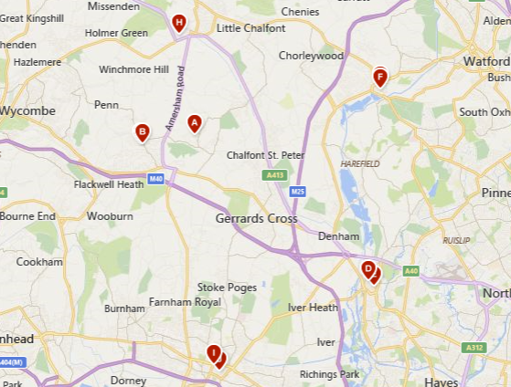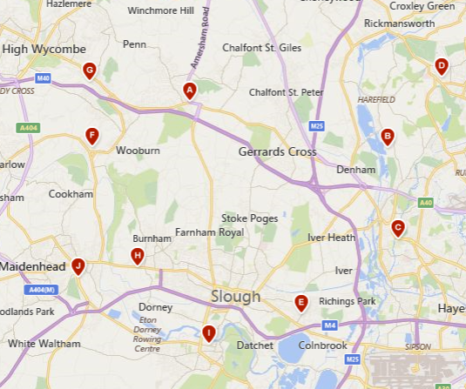
8 Support Group for People with Breathing Difficulties
Breathe Easy Support Groups
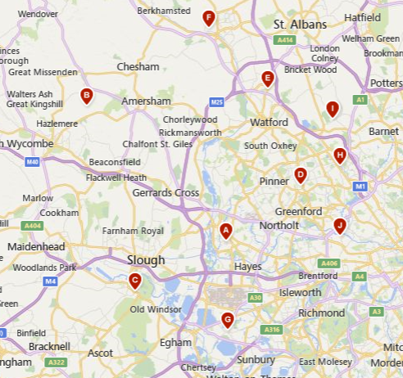
Chronic Obstructive Pulmonary Disease (COPD) is a common cause of breathing difficulties. It is limiting for those living with the disease and causes multiple health emergencies. This range of conditions is diagnosed in about 4% of people over 40 for the UK as a whole, with rather less in South-East England. For our community this suggest an estimate of some 800–1,200 people with COPD. It is a progressive disease that can be managed and aided by exercises such as singing and Pilates as well as psychological therapies as offered by Bucks Live Well, Stay Well.
Asthma also causes breathing problems affecting almost 3,500-5,250 people of all ages in our area. It is a manageable condition that also gives rise to many emergency admissions. Breathe Easy groups for both COPD and Asthma are supported by the British Lung Foundation. Evaluation has shown that such support groups are very beneficial for those attending on a regular basis, particularly when the group can also access medical advice at the meetings. This reduces long term health and care costs by improving health outcomes and reducing the demand for emergency services. In the past a COPD support group met in our hospital but now, as the map shows, there is a gap in our area.
9 Support for People with Joint Pain
Arthritis is one of the most common causes of pain in the back, hips, knees or other joints. It affects about 1% of women and 0.4% of men, this suggests a total of 200-300 people in our communities. It is most prevalent in women of 45 or older but forms of arthritis can also affect younger adults and children. Action to avert arthritis can be effective for health and, as arthritis leads to high costs of joint replacement, it can also be cost effective for the NHS. Measures to reduce the risk of arthritis progression include diet and exercise. Obesity is a major cause and complication for arthritis of knee and hip joints. The REAL Support Group in Harrow, assisted by Versus Arthritis, offers wellbeing and Yoga sessions for people with arthritis. It provides an example of a patient-led support group working with a clinical team, in this case, the Rheumatology Department of Northwick Park Hospital. The nearest similar group is in Watford.

10 Support for Mothers and Babies
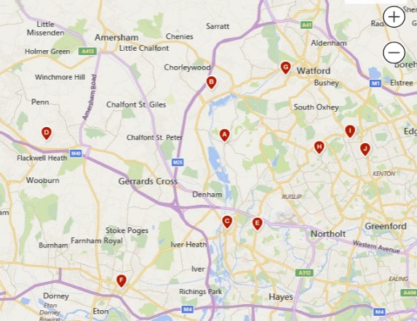
New Mother Support Groups
There are many challenges for new mothers in our area. They face the pressure of forming new relationships from home, particularly if they had previously commuted to work or recently moved to the area. Social contacts can help mothers learn to manage their new babies’ health and care, overcome breast feeding problems, develop a social support network and may help some deal with post-natal depression. In our community it is estimated that there are some 425-650 births a year, 180-270 are likely to be first children.
Some 60-90 mothers in our area are likely to experience post-natal depression each year. Whilst there are parent and toddler and parenting groups supported by local churches, we know of no local breastfeeding or other support groups for young first time mothers. Support for young mothers starts with Midwives, who often spot the first signs of problems, Health Visitors and other nurse specialists as well as GPs, but crucially community self-help groups can play a vital role. Support must be sensitive to the needs and preferences of the mothers but also well informed. Mothers for Mothers provides an example of a self-help group for those with post-natal depression. A range of support is offered by the National Childbirth Trust (NCT). The map shows the nearest mother and baby support groups, showing the gap in our locality. Start Well schemes also offer support for mothers with young children.
Mother and Baby Health and Development reviews could be provided at the hospital as a starting point for ongoing care and community support to meet the specific needs of the mother and her baby.
11 Support for People with Diabetes
Diabetes Information and Support Groups
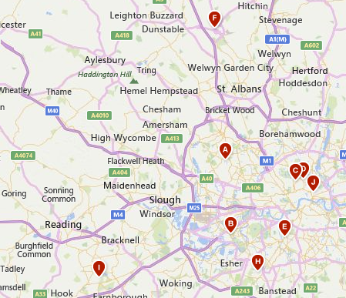
Diabetes, mostly type 2 Diabetes, is diagnosed in some 5.4% of patients at our local GP practices. That is 2,000-3,000 people. As this condition is difficult to detect at an early stage, it is likely that the real number of local people with this condition is over 3,000-4,500 people. Diabetes is a progressive disease that can lead to potentially life-threatening complications, such as heart disease, blindness and nerve damage. Self-care management of diet and exercise, alongside clinical monitoring, can greatly reduce the progression of the disease and consequent costs to the NHS. Our hospital provides Diabetic Education in 6 weekly sessions. Building on this we suggest that consideration should be given to self-help and action groups such as those sponsored by Diabetes UK and Bucks Live Well Stay Well, which provides a programme called 'Life and Health with Diabetes'. Support groups are available in other areas but not locally, see map. The engagement of supermarkets and other food shops and restaurants in a Health on the Highstreet initiative could include providing “Healthy Eating Aisles” or menus with diabetic friendly food can be both cost-effective and popular with food retailers.
12 Support for Carers
Carer Support Groups
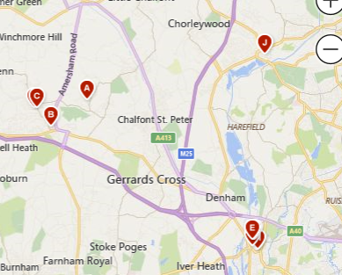
Most care in the community (about 70%) is provided by relatives and partners as “informal carers”. They provide support, encouragement and guidance for their loved ones. This becomes more difficult as people with conditions like dementia progress and as carers get older. Carers reaching the age of 75-80 and/or when the person they care for dies, often face their own health and social isolation issues (more than 25% of local people over 65 live alone). There are probably 3,500-5,250 people providing care for friends or family members in our communities. Their support is not only invaluable to those with long term health problems, it also greatly reduces the cost to the NHS and Adult Social Care Services. Support for carers, including respite care and the provision of information, advice and social support can be very helpful in extending their ability to care. Carers Bucks based in Aylesbury provides a range of self-help, support groups and services that could be provided for our informal carers. As our map shows there are some carer support groups in neighbouring towns but none, as yet, in our immediate locality. Surveys suggests 72% of carers face mental health and 60% other health issues.
13 End of Life Care
End of Life Care Services
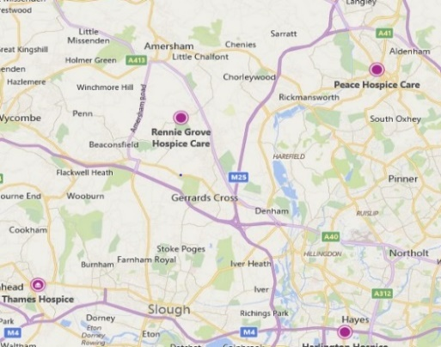
Most people would prefer to die in their own home (56%), a hospice or care home would be their second choice (24%) but in practice 66% of people die in NHS or private hospitals, 15% die in hospices or care homes and only 19% die in their own homes. In our area, Rennie Grove and Thames Hospice provide care at home each year for some of the 350 people who go on to die, but they cannot meet all demands.
This situation is not only distressing it is also a major cost and cause of bed blocking for the NHS. An augmented hospice at home scheme could be provided from our centre. This would build on the skills and experience of our Adult Community Healthcare Team, which already provides a service which can include end of life care. We suggest that collaboration with local religious and humanist organisations and volunteers would be welcomed, with support from Rennie Grove, Thames Hospice, the National Association of Hospice at Home and Marie Curie charities. It is also important to recognise that those bereaved can be isolated and may need social support such as offered by the Bucks Older People’s Action Group BOPAG at the Chalfonts Friendship Club.
14 A Digital Health and Wellbeing Centre
Increasingly people are asked to make use of online services to order medicines, contact health and care services and book appointments, attend clinics or find services. Many patients with chronic illness, or at risk of falls may make use of monitoring devices to monitor their condition and raise an alarm when necessary. Some find this technology difficult to use, uncaring and impersonal. The provision of a Digital Health and Wellbeing Centre, where they could be helped to use the technology, would alleviate this problem. It could also enable people to use online clinical consultations with the aid of an Allied Health Professional assistant where necessary, for example to check patient symptoms.
The Centre could also support the provision of general health and wellbeing advice. NHS, LA staff and community volunteers could be encouraged to pass on health and wellbeing messages through a version of the NHS England -Making Every Contact Count initiative. With support of the Bucks Health Trainer Service local Health Champions could be developed. This could enable volunteers such as shop assistants, GP receptionists, hairdressers and community librarians as well as health and care professionals to pass on simple advice and information, raising awareness of health and wellbeing issues as well as the role of the centre. This might be facilitated by training sessions such as those provided by the Reading Well initiative Social Prescribing for Library Staff. This approach could also further enhance local engagement with the BCC “Be a good neighbour scheme”, encouraging neighbours to offer support such as getting to health facilities, fetching medicines and on discharge from hospital. This might be supported by the Digital Health and Care Alliance working in partnership with Libraries Connected, Carers Bucks, Healthwise and eHealth providers such as Remap. The Tesco mobile “Little Helps” scheme might be asked for assistance in providing devices for vulnerable people.
A visible and welcoming Digital Health and Wellbeing Centre should be a place where patients/clients can come to ask for advice and support from the local team, it would require computer terminals but most importantly a place to sit and talk, perhaps with a cup of tea or coffee. The role of a local centre for health and wellbeing should also include raising awareness of local health and wellbeing issues and resources. We note, for example, that while some 30 local clinics and services are provided for our community only one clinic appears to use local “Facebook”, “NextDoor” or other online neighbourhood groups to raise awareness of health issues and provide information about resources such as Bucks Live Well Stay Well and Carers Bucks.
15 Support for people discharged from hospital or needing to move into long term care.
Our area has over 30 private nursing and care homes for elderly people and those with multiple health conditions (15 of these are served by the Chalfont PCN). There are however problems in making suitable arrangements for patients who may require specialist support, adaptations and medication at their own home or in specialist care homes. This requires a team approach working closely with patients and their carers and in partnership with care home providers and may be even more complex for patients discharged from Wexham Park, requiring reablement care (convalescence). There is a need for a team providing integrated support for patients on discharge in their home or care home.
16 Facilities for staff to enhance multi-disciplinary teamwork.
The need for integrated multi-disciplinary teamwork has been stressed by many of those we have spoken to. While teams from different organisations may require their own shared or full-time workplace, we suggest that a teamwork culture at the hospital would be greatly enhanced by a shared common room with facilities for rest and refreshment.
Resource Requirements
The resources needed for these developments are relatively simple: some office space for full time teams located at the hospital, shared office space for staff using the hospital on a visiting basis, a staff common room, rooms to meet patients including secure space for confidential meetings and a space for patient groups to meet, with accessible toilets and garden and a drop-in café. The current facilities of the hospital would require some refurbishment, and decoration plus, desks, computer terminals and coffee/tea machines.
Further Ideas and Priorities
These are only examples of the types of community action that could support integrated health and wellbeing, a local board will be required to continue to review demand and set priorities for action. The estimates provided of needs and demand provided here may need to be reviewed and updated. As far as we are able, we have made broad estimates for populations of 40,000-60,000 people, however, we do not have access to detailed data.
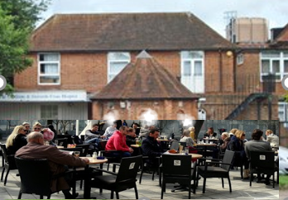
A Vision of our Future Health and Wellbeing Centre
Let us imagine a refurbished, repurposed Chalfonts and GX Community Hospital as a centre for health and wellbeing in SE Bucks. The the Old Surgery, looks out over what is now named Wellbeing Square, which provides a place to meet and talk over a coffee or tea. A noticeboard is used by local organisations supporting health and wellbeing and a door leads to the garden where volunteers have created a restful place to sit.
Inside, the Old Surgery provides a drop-in Centre for many different conversations as a café and meeting place for people with physical and mental health and social care issues. These are supported by both community organisations such as: Age Concern GX Plus, Bucks Mind, Citizen’s Advice, SSAFA and mental and physical health and care professional including: Mental Health Counsellors, Frailty Support staff, a Social Care Team and Social Prescriber Link Workers. There is a large garden room that is used by Patient and other Community Groups including people with mental health issues, and those with conditions such as Arthritis, COPD, Diabetes, Frailty, New Mothers and Babies and Carers. These are run by community organisations like Headway, with support from health and care professionals.
Clinics run from the hospital include a range of services supported by BHT and Wexham Park hospitals. These include Audiology, coupled with Ear Wax Removal supported by Age Concern GX Plus, Podiatry and other services such as: Five Year Health Checks, Falls Risk Assessment, Mental Health Assessment and Social Care Clinics. Services such as Phlebotamy requiring laboratory testing now have upgraded communications links and patients needing complex diagnostic services are now able to book appointments and transport to the Amersham Hospital Community Diagnostic Centre when needed. All services can now be booked through the hospital Reception and Direction Service.
There is also an eHealth Centre where people can be helped to use computer communications and monitoring devices. While many Local Clinics are provided in the upgraded Clinical Unit, patients can also access specialist consultant advice drawing on consultants from both BHT hospitals, Wexford Park and other specialist centres using computer links, with the assistance of a Nurse or Allied Health Professional when required. The eHealth Centre also provides a monitoring capability to call out emergency services when required and takes an active role on social media, promoting the services.
To the back of the hospital, facilities for physiotherapy rehabilitation provide opportunities for activities like gardening and an introduction to groups, such as those provided by Simply Walks Bucks and Sport in Mind. This increases self confidence as well as physical ability for those with frailty.
Upstairs and in the neighbouring Community Health Centre, refurbished rooms are provided for teams providing: Frailty Support, Community Assessment and Treatment, Health Visiting, District Nursing and School Health Nursing plus Mental Health and Social Care Support. Many Teams also support services and groups in Denham, Gerrards Cross, Chalfont St Giles, Farnham and Iver. They work together as an Integrated Multi-Disciplinary Health and Social Care Team, they report to the Buckinghamshire Integrated Care Partnership with a Board representing local stakeholders including the Chalfonts and South Bucks PCNs, local town and village councillors, the Friends and local community groups. Integrated multidisciplinary working, focussed on whole person and whole community care is facilitated by a shared Common Room providing space for refreshment and meeting. This is located in a larger room with a terrace overlooking the Wellbeing Square below.
The Health and Wellbeing Centre provides a new model of integrated care, providing outstanding services, supporting healthy communities and a great place to work. It reduces the burden on GP, A&E and Outpatient services while achieving higher standards of health and wellbeing at lower costs.

