Gateway Portsmouth Consultation with Stakeholders
Introduction
While in our team and in discussions with the Expert Advisory Panel we can take a view on who might be Stakeholders in the project, meaning groups with engagement and interests in the project, we need to check this with them. Thus in our initial Social Impact Matrix we assumed that the Stakeholders include: new immigrant community members, potential community advisors, community organisations (including BME, locality and interest groups), Portsmouth City Council (as understood by Service Leaders), NHS Portsmouth (as seen by health providers and representative groups), the Home Office (as seen by project coordinators) and Employers. Thus at this stage we need to ask them how they might wish to become engaged with the project and what their specific interests are. This note has been updated following piloting by Uta Schmidtblaicher.
Assumed Social Impact Matrix
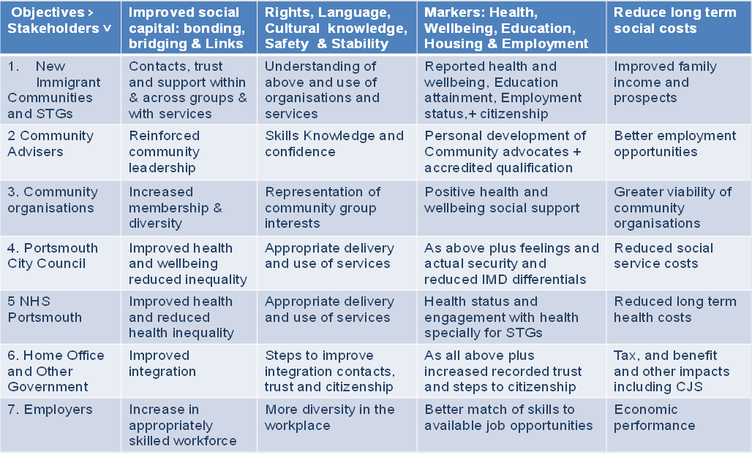
We have also formed our view of their likely goals and values, but we should not proceed without ensuring that we listen to their views and values. We can do this by open consultation at the launch of the project and by listening and recording their views and language. At this stage we don’t even know what stakeholders might consider to be the most relevant questions so we need to use an open ended approach using semi-structured interviews. This very simply means introducing the project and some potential topics for discussion and then listening to the respondents, using open ended questions and prompts to move from one subject to another, feeding back what you have heard and always ending with a completely open question.
In planning the project we proposed to undertake a project launch and about 30 such open ended question and answer sessions with stakeholders, to gain understanding of the language, meaning and value ascribed to various forms of social interaction that contribute to social capital. Time was allowed in the project plan for the design and application of the semi structured interviews.

Designing the Semi Structured Interviews
While semi structured interviews are very simply a conversation it is always good practice to try out or pilot the interviews to check that the questions raised are appropriate, can be understood, and produce meaningful answers, so at first it would be good to undertake a few such informal interviews to make sure the process works. Key points in the interview include:
- The introduction describing the reason for talking to the respondent and introducing the key points of the project. This needs to be consistent and brief but the first few pilots should check to ensure that the main points of interest to respondents are included.
E.g. As shown in the form, but if questions arise the more detailed description of the Gateway Process and Roles can help – but stress that at this stage we are still open to suggestions.
- The introduction of the topics to be discussed at this stage set out the areas you want to cover but let the respondent start on the issues that most concern them. You should not try to cover more than 6 areas.
E.g. I hope we can talk through the items listed in the form but respondents may wish to tell you their story so be prepared to listen first and follow up if necessary in an open conversation.
- The open ended questions if the respondent does not lead
E.g. So maybe we could now/start by talk about XX.. And your views on YY
- The prompts within question areas
E.g. So would you consider volunteering for such training.
- The recap summary that you provide:
E.g. So you would wish to emphasise the importance of ZZ
- The way the interview is recorded
While in an ideal world we might record interviews, I suggest just making notes of key points and language on the interview sheet. Do not disguise this make a point of recording key ideas e.g. Thanks that is a good point – I need to make a note of that.
- Follow up conversation
While the interview is intended to be open ended - to stress listening rather than asking questions, as it progresses you should explore particular issues and exchange views but only after you have listened to the respondent.
- Record and debrief to report back and reflect on what we have heard
The Interviewees
This sort of interview does not rely on a statistical sample but it is important to cover a reasonable range of potential stakeholders. At this stage we hope to interview:
- 6 BME Community Organisation leaders
- 6 Potential Community Advisers (must be STG groups)
- 3 Other new immigrants
- 6 Service Leads (people who will provide access to specific advice and services)
- 3 Employers, 3 Other Government Services, 3 Other
A Semi Structured Interview Note
My name is……. I can be contacted at ……..
I am working with Portsmouth City Council on the Gateway Portsmouth Project –this is a new project we are planning and we hope to get your ideas to help in the design of the project which is aimed at helping new immigrant women, young children, people over 65 and people with disabilities and to integrate with local communities who arrived in the last ten years - I was given your name by A as someone with an in depth knowledge of B. I am very grateful for the opportunity to listen to your ideas and suggestions for the project. I will take notes and pass on any points you make to my colleagues without mentioning your name – and only referring to your organisation in general terms.
The project is supported by the UK Home office and the European Integration Fund. It will recruit volunteers from the community and offer them training as Volunteer Community Advisors to help them to develop and pass on knowledge of local resources such as English Language classes and special support in areas like health, education employment, housing and safety and security. We hope Community Organisations will act as hosts for these Advisors and will suggest people who might welcome such training and places where advice could be given.
Can I first ask you to tell me a little about your group/ community and your experience of issues affecting the integration of immigrant communities in the Portsmouth area.

Can we discuss 6 main issues in any order you choose
1 How could the project help you/your community/organisation? | 2 How could you/your organisation work together with the project?
3 What you see as the most important things the project should do | 4 The main problems or barriers you/new immigrants face in understanding/contacting/ participating in local services and community groups
5 The best way of overcoming problems and barriers to integration | 6 Any other issues you would like to raise about the project
Follow up Conversation Points
1 For new immigrants  What are the key issues you face as a new immigrant?  Have you or anyone in your family got special needs or problems?  Does everyone speak English if not is this a problem?  What contact do you have with local or national organisations and services? –what has been most helpful?  Where do you find information – notices/ internet/newspapers/personal contacts  What information advice or contact would you find most helpful?  Who is best able to help you? | 2 For potential Community Advisers  Do you know of any services or support from the Council or voluntary organisations that have helped improve integration?  Would you like to get involved as a Community Adviser –helping people make contacts and advising them how to get help?  What sort of time commitment could you make to this?  What sort of training would you need?  How much time could you give to training?  - Would 5 hours a week for 6 weeks be OK  Would getting some sort of initial qualification help you in your career?
3 For existing Community Organisation leaders  What community do you serve: ethnic/ religious/ common interests/ other?  What sources are most relevant internet/ newspapers/ word of mouth?  Could you identify people who would welcome training as voluntary Community Advisors?  How could CAs help your community?  Would your organisation consider hosting CAs?  What sort of facility or opportunities for contact could you provide?  Have you had experience of similar projects? | 4 For PCC/NHS Service Leaders  Do you know what special needs new immigrants have in relation to your services?  What problems or opportunities do you have in communicating with new immigrants?  How do you communicate with new immigrants? Do new immigrants have problems using your services?  How could CAs help you to deliver services advice and information to new immigrants?  How could they work with you by: contacts, signposting, referral or advocacy?  Have you had experience of similar projects?
5 For Home Office/Other Government  What immediate and long term issues arise for government in relation to new immigrant communities?  How could better integration with local communities improve immediate and long term outcomes?  How would you assess or measure the success of such efforts?  What are the key differences that CAs could make? | 6 For employers  What issues arise in relation to employing or serving new immigrants?  What sorts of skills and attributes are you looking for in new employees?  How could CAs help in this regard?

Record of the interview
This is a good example of how a simple record can be kept of the conversation from a pilot interview by Uta Schmidtblaicher
08/01/13
Interviewee: Health trainer, sessional worker at Chinese lunch club, member of cross cultural group & diverse carers group
- The aims Gateway could help you/your community/organisation achieve | Links to health trainer’s service: advocates can refer to health trainers
- How you/ your organisation could contribute to Gateway | Cross cultural women’s group: some members of the group might be interested in becoming advocates
- What you see as the most important things Gateway should do | Providing health information, diet, food, information about location of services, local transport, help immigrants to learn basic things to get by, communication, being able to seek emergency advice, police, community centres, self-esteem, confidence
- The main problems or barriers you/new immigrants face in understanding/contacting/ participating in local services and community groups | Fear of being looked down at because western countries are seen as “more advanced”, services not helpful and friendly, different attitudes can cause tension, people being judgmental, language, homesickness, neglecting themselves, mental health, diet, addiction, meeting the wrong people
- The best way of overcoming problems and barriers to integration | direct migrants to “friendly places”, places where people can learn English, free computer access, for example library, medical centres, walk in centres
- Any other issues you would like to raise about the Gateway Project | -Training should be held in local & easily accessible venue, for example Navigator’s centre, Friendship house. Training shouldn’t be too long.  -Advocate skills: basic counselling, listening, being non-judgmental, basic knowledge, legal matters  - Health trainers communicate with migrant clients by using visual information, pictures  - Knowledge needs: education system for children, local knowledge about immediate help, health issues, opening times of shops, street safety: where in Portsmouth not to go after darkness, police stations

Debrief
The debrief session is simply a meeting of those who conducted the interviews to draw inferences and conclusions, drawing conclusions from what we have heard. In a structured research setting we might use content analysis techniques to discover the meanings invested by the respondents in their answers. For now however we can use our common sense to answer some basic questions raised by the interviews:
- What are the main problems as seen by new immigrants, is improving contacts and referral and specifically the development of Community Advisors seen as likely to help?
- Are eligible people likely to volunteer to become Community Advisers, if so how much time would they be prepared to give to this, what training and support would they require?
- Do Community Organisation Leaders welcome this idea, how would they support it and how do they think it could work?
- Do Service Leaders see advantages in the development of Community Advisors, how would they work with them and what benefits would this bring for their services?
- What issues do other Home Office and Other Government representatives believe this project should address and how do they see Community Advisors contributing to this?
- Do employers see advantages from the project, what impacts do they hope the project will achieve for them?
- How can the concept and operation of the project be improved to meet the aims and objectives of all stakeholders?

