Co Producing Integration with a Community of Migrant Women and Measuring the Social Return on Investment Achieved
Graham Lister, Alison Strang, Mohammed Ali, Jane Leech, Uta Schmidtblaicher, Marshada Chowdhury, Sarah Cheverton.
Abstract
The project applied co-production to support the social integration of new migrant women from Non-EU countries and explored the impact and cost effectiveness of this approach. The project was supported by the European Integration Fund (EIF) and the Home Office. Participants were consulted to understand their needs for language, rights, education, health and employability training and were trained as coproduction partners. The 102 participants developed as a community of women who provided mutual support and acted as advisors and guides for others. They developed self-confidence and a sense of identity and purpose that they described as transforming their lives. The project was evaluated using qualitative and quantitative evaluation techniques and valued in terms of the Social Return on Investment, this showed that the project made an important contribution to personal development, aided social capital formation and was very good value for money. This provided a practical demonstration of how recommendations of the Casey Review (2016) can be applied in practice.
Introduction: The Social Value of Integration
The project was an EU Integration Fund supported initiative led by the local City Council to help new migrant women to integrate with their local communities. This paper examines the process and outcomes of the programme and considers how the social value of its impact could be evaluated in qualitative and quantitative terms. The evaluation took as its starting point the OECD definition of social capital, as discussed by Roslyn Harper (2002) as the values and norms of behaviour that fosters bonds within community groups, bridges between groups and links with formal and informal organisations.
The development of such social capital required action to inform and empower migrants to integrate with and contribute to communities and to exercise their rights and responsibilities. This was planned and carried out as a series of measures to progressively empower new migrant women to define and achieve their own personal and group goals for integration. These steps towards the coproduction of integration included their engagement in the direction and evaluation of the programme.
These actions give rise to social value to participants and their families, the community, local and national government agencies and employers. To understand these values the project undertook both qualitative and quantitative research to describe the value of outcomes as perceived by all participants and to measure and quantify these outcomes and their socio-economic value.
The project evaluation drew on: a literature review, a baseline review of statistics concerning migration to the area and levels of social capital, participant focus groups, semi-structured interviews with stakeholders, a learning history report describing the experiences of project participants an evaluation report and tool setting out the outcomes and assumptions concerning their social value. Detailed papers on each of these aspects were made available online. The conduct of the research and evaluation and the judgements made with regard to social values were reviewed by an independent Expert Advisory Panel.
The increasing diversity of new Non-EU migrant communities in the project area was a challenge as indicated by James Laurence, (2009). But it was also apparent that new migrant women shared many aims and challenges, which are related to their common experience as migrants and as women. Moreover, interviews with Participants and Community Organization leaders suggested that the variation in their needs and aspirations was mainly driven by personal differences and experience rather than ethnicity. Recognising the complexity and individuality of the needs of migrant women, the approach adopted by the project was to inform and offer choices to the participants and then to engage them in the design, execution and management of their own programmes.
Moving from information provision and research to delegation and ongoing partnership required all stakeholders to take “steps towards co production”. This project showed examples of the practical steps towards co production that can help to build social capital with new migrant women:
- Project support: investigating current levels of integration and preparing the team
- Recruit New Migrant volunteers: through local organizations and shops.
- Consult to understand community needs: through community events and structured dialogue with community organizations
- Provide training to empower recruits: encouraging bonds, bridges and links to services, including mutual “buddying” schemes across cultural boundaries.
- Adapt training and develop joint opportunities for partnership action, including public events group meetings, research and the development of an online presence.
- Provide opportunities to support others and lead initiatives recognising personal development and contributions by giving certificates and holding award ceremonies.
- Evaluate outcomes with participants, giving them responsibility and leadership.
Methods: Towards Co-production
Commencing in November 2012 over an 18 month period integrated training and support programmes were designed and delivered in consultation with new migrant volunteers in: generic advice and information giving, English for speakers of other languages (pre ESOL) and other elements of education support for UK living, employability and health advice. In each field participants received the training they requested and were also enabled to support others. Participants trained and carried out elements of the evaluation of the project and provided education, information advice and support to other members of the community. They participated in, organised and led community events, online initiatives and discussions and even a link to a health community support project being initiated by a participant returning to Bangladesh. Figure 1 shows the steps in this process.
Figure 1 Steps Towards Coproduction
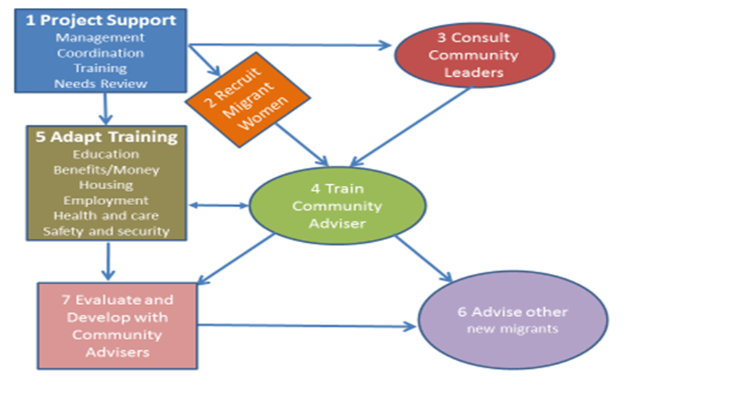
The project adopted an Action Research approach, Linda Richings et al (2004) learning from stakeholders, as new ways of working were explored together. It was therefore important to consider, with the help of an Expert Advisory Panel, both the intended process of co production and what unintended consequences might threaten the intended outcomes. This identified two potential unintended consequences. First, by training volunteer community advisors, the project might be perceived as bypassing current community leaders and service providers and might thereby undermine existing mechanisms for social capital development. Second there was a danger that since the nature of the project meant that goals, targets and processes had to be defined at the outset before engaging participants, their perspectives and needs might be underrepresented by the project. The project therefore included steps to engage and listen to both community leaders and project participants.
The specific integration objectives for each stakeholder were clarified as the project progressed. The social impact matrix set out in Figure 2 was developed from feedback from project participants.

Figure 2 Social Impact Matrix setting out Community Integration Objectives

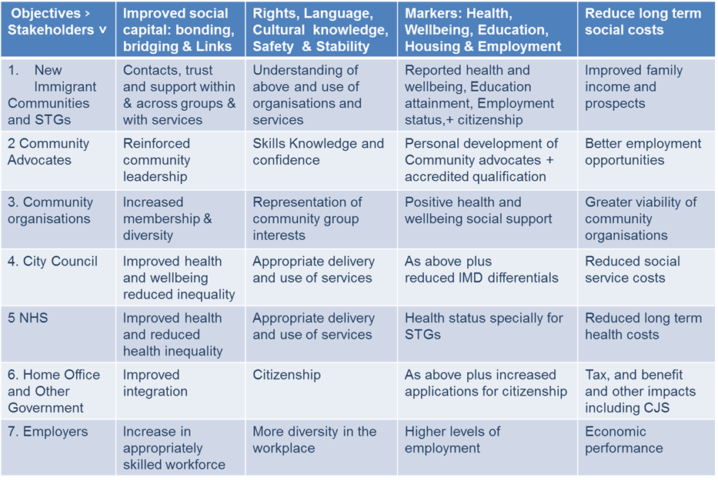
The numbers age, sex and origins of recent non–EU migrants living in the project area were assessed by comparing 2001 and 2011 census data. This estimate was refined by gathering data from higher education establishments to separate students who arrived and then departed in this period, from long term migrants. The likely increase in the age of migrants over the period and their likelihood of having further children was also considered. This helped Council staff gain a better understanding of the diversity of new migrants.
Measures of current levels of integration for new migrants to the area were examined in relation to the categories defined by Alastair Ager and Alison Strang (2004) and updated by Ben Gidley (2012): Employment, Housing, Education, Health, Social Bridges, Social Bonds, Social Links, Language and Cultural Knowledge, Safety and Stability, Rights and Citizenship for the new migrant communities. This data was drawn from national and local sources, it provided valuable insights into the needs and issues likely to be most relevant to new migrants to the project area. Detailed findings are set out in a Baseline Review.
New migrants were informed and engaged, by disseminating leaflets through meeting places and local shops used by migrants and by talking to community leaders. Semi structured interviews were designed and carried out with 30 existing community leaders and service providers, not only to understand the values and potential that these stakeholders saw in the project but to encourage them to partner with the project. Discussions with stakeholders primarily focussed on migrant community organisation leaders but also included NHS and other public and voluntary sector service providers and employers. Some of the themes that emerge from this dialogue were: that social integration starts within communities, community organisations are a major resource for migrants and for the local community of which they were a part. Measures to develop co production support for new migrants can be valuable ways of improving and speeding integration. They enable people both to use existing public and voluntary services and community support and to contribute to them. Most immediate benefits came from alleviation from social isolation, loneliness and in some cases potential mental illness.
The fact that responses varied between individuals and different community support organisations highlighted the need to continue to renew social networks and contacts to reflect the diversity of new migrants. It also indicated the danger of generalising about the integration needs of migrants – each participant had their own distinctive needs and expressed them in different ways.
Volunteers were trained to run a series of 6 Focus Group discussions for project participants. Training explained the purpose and operation of focus groups, emphasising the need to avoid bias and explained the practical aspects of the conducting sessions. All sessions were observed by a trained member of the team who took the notes which were analysed applying a thematic, content analysis approach, Stephen Cavanagh, (1997).
These focus groups presented an opportunity to understand how participants viewed their experiences of integration in the UK and the impact of the project on this process. The detailed findings, with quotes from participants as recorded by the observer were presented in a Focus Group Report. This highlighted the range of benefits brought to the lives of migrant women participating in the project in view of the complex needs and values of this diverse group. They showed an array of positive experiences and also difficulties faced during the integration process on both practical and emotional levels. Many participants described their experience of project participation as “life changing”. They changed from a self-image as “just at home” to defining themselves as project volunteers, women with a plan for their education and employment and a role in society. In their words:
"The project opened a gate for me, opened a door to help other people in the city" (E2).
"My mind is fresh coming here" (H4).
"Opened new avenues to explore, networking" (E6).
[The project] brought back forgotten things. Interaction, brain storming, gave adrenaline. Felt awakened to get back out there and to things again. Not just a mum, but a person! (E6).
"[The project] has changed people's lives, especially advisors. When I meet them I can see they are happy, feel their confidence building. Happy to talk to you. Wish we can be with project as long as possible. Feel change in others. Life changing project" (C6).

Results: Qualitative Outcomes
The project engaged 102 new migrant women over the eighteen-month period, 93 of whom completed initial questionnaires. About half joined each year, most of those who joined in the first year stayed with the project and participated in the second year. The participants had all arrived over the previous 10 years with (42%) having spent three years or less in the area, a detailed Evaluation and Social Return on Investment Report was prepared.
Participants at first came to training events alone or with people from similar backgrounds and socialised mainly within these groups (bonding), but over the course of only 4/5 weeks, despite language barriers, they rapidly developed contacts and friendships across the training group comprising people from many different backgrounds (bridging). As they gained better skills in English and knowledge of services and contacts (linking) they also gained in confidence. Individuals emerged as leaders in relation to specific aspects of the project, like the use of IT, but also as spokespersons for the group and for community on particular topics. They developed as a “community of women migrants”. This was reinforced by “buddying” – pairing participants to act as mutual mentors across ethnic groups.
Participants shared interests and concerns about children, education, health and community safety. As the project progressed they increased their self-confidence and gained a sense of purpose and self-esteem. Whereas at the start of the project they waited for instructions, they began to take their own initiatives, to make their voice heard and to take a lead on actions and events. These included events on Female Genital Mutilation, Mental Health issues and Careers in Adult Social Care. A further initiative was the development of a web site “The Voice of Diversity” with contributions from participants and directions to resources relevant to community members.
As participants’ confidence developed they increasingly identified themselves as Community Advisers and spoke about their life, education and career aims. This seemed not only to develop greater confidence in their assimilation as a resident of the area, but also to strengthen their confidence in defining their role within their family and ethnic community and their integration as member of the community of migrant women in the area.
Training courses evolved throughout the project as lessons were learnt from the feedback from participants. In all cases the aim was to provide both class room training and experiential learning – that is guided learning by enabling participants to support others through community action in information and advice sessions, ESOL courses, employability and health advice provision.
Over the course of the project 71 participants attended more than 10 weeks of training and co-produced community action. In total there were 2,450 session attendances. Training and community action sessions were normally 2 ½ hours, some were longer and some shorter.
A questionnaire, administered by trained volunteers (who were inter alia trained to observe and inform participants of confidentiality and anonymity), in person or by telephone, at the completion of training obtained responses from 57 participants, who were asked to compare their perceptions before and after completing the training. Naturally a reflection like this can give a distorted view since respondents contrast their situation now with a memory of past feelings and they may wish to please the interviewer. For this reason comparable questions were also asked before and after their experience of the project.
Respondents were asked how many friends outside their family they met regularly before and after their participation, the number before was an average of 4 while after gave an average of over 8, largely reflecting the friends they met on the project. Those who could not give a number most often replied few friends before and a lot after.
Participants were asked to mark how confident they felt before and after on a 9-point scale with sad to happy faces (this proved most appropriate in view of language barriers). Average confidence before scored 5 and after was scored at almost 8. As noted, participants very often referred to improvement in confidence as a major benefit from the programme. They also showed their perception of improvements in their English, improvement was noted both for participants focussed on ESOL courses (77%) and for those on other courses (31%).
Perception of health was a sensitive issue for some respondents, who told the interviewers that they did not like to admit to physical and particularly mental health problems. However, many respondents did mention feelings of anxiety and loneliness leading to poor mental health before the project and feeling better after, as shown. Many respondents also mentioned their feeling of insecurity in areas of the town, they gave instances of being made to feel unsafe, for example, by groups of children, or youths in the street. After participating perceptions of safety were notably higher. General trust in community is a measure sometimes used to assess social capital, while it is difficult to define, respondents found this question easy to answer, generally feeling the project increased their trust in community.
While as young mothers, often with language problems, many respondents had a realistic view that they would have difficulty in getting a full-time job they also began to consider steps towards employment such as further language classes, other education courses and volunteering as a step towards employment. Their confidence was reinforced by “work taster sessions” which were offered to participants, accompanying staff in various work settings. In addition many participants provided advice and support to others, which was also a factor in reinforcing perceptions of self-worth. This resulted in a substantial increase in self-perceptions of employability as shown.
These results are summarised in Figure 3, note that while respondents also added comments, in all cases positive, these were not reported as they often revealed details of respondents which would have breached their anonymity.

Figure 3 Changes in Perception Before and After Engagement in Coproduction
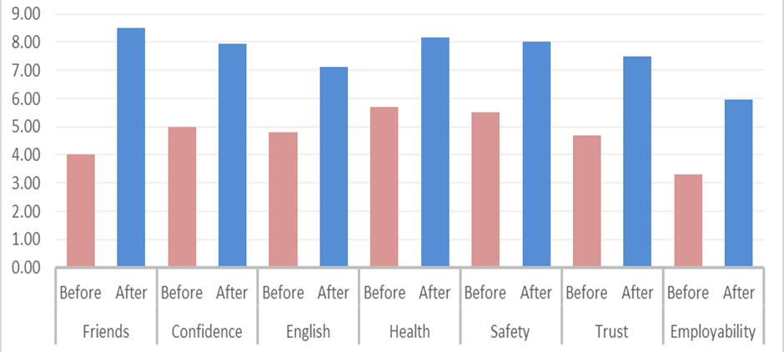
The 57 project participants who responded to the experience questionnaire recorded a total of 625 week s of volunteering activity. The advice and support they gave to others included 628 instances of help referral and signposting recorded by 25 participants who completed records of the nature of the advice they gave. It should be noted that only a minority of participants provided this sort of feedback but it nevertheless provides a useful indication of the scope of assistance provided particularly helping others with English language in classes and in dealing with services.

Results: Quantitative Evaluation of Social Return on Investment
Outcomes were measured and valued by applying assumptions relating to the time over which integration would happen and benefits would arise without the project and the assumed social value of benefits generated for all stakeholders. The social values were based on values attributed to similar outcomes by national and international studies applying assumptions relevant to the current project. In each case a range of values were suggested reflecting different assumptions that could be applied in this analysis.
The social value that can be ascribed to the outcomes of the project were identified as: the value that participants derive from specific social contact and friendship, the additional value of improved English language skills and knowledge providing opportunities for extended social contacts, the value of education programmes that enhance long term employability and the value generated for others supported by participants as advisers.
A literature review identified reference points for ascribing a social value to the benefits to people who volunteer. The paper by Fujiwara et al (2013) shows that the increase in life satisfaction scores shown by 31,170 people from the British Household Panel Survey (BHPS) from 2000, 2002, 2004 and 2008 associated with people who volunteer at least once a month is equivalent to the increase in life satisfaction scores associated with an increased household income of £13,500 per year in 2011 (or £273 per week in 2013 values). Note that this does not imply that volunteers would be willing to pay this amount but that it contributes to their life satisfaction to this extent.
Volunteering gives rise to benefits from opportunities for friendship, feelings of self-worth from contributing to others and opportunities to develop skills. All these factors were demonstrated by participants. It is suggested that the value to participants should include the time spent training and volunteering because it introduces friends and engages them in purposeful activity and is very important for personal development. This may be considered a conservative estimate because many will continue to meet in friendship and volunteering beyond the timescale of the project. This was also an important endorsement for the project as it showed that while naturally some participants only briefly engaged (a single participation was treated as zero weeks), a great proportion stayed with the project and participated from the point at which they were recruited until the end.
Valuing the social benefit of participation in this way would generate a social value to participants of £888,888 or £8,100 per participant. If this is adjusted to reflect the household incomes expected amongst new immigrant families in the area (75% of median incomes for UK) this would suggest a lower estimate of £666,666. However, a paper by Groot et al (2006) notes that the value attributed to volunteering by women in the Netherlands was 35% higher than for men, thus a higher value might be appropriate.
The additional value of ESOL and Citizenship training was based on figures from the Fujiwara study which shows a 2011 value of £17,300 per year household income decline, associated with the same reduction in perceived life satisfaction as “not being able to meet up with friends a number of times a week”. The rationale for applying this value was that lack of English ability and cultural confidence are very significant barrier to making friends and social contacts.
The rate at which migrants would have improved their English without support was considered by comparing participants’ initial reported capability in English with the length of time they had spent in the UK. This showed very little correlation (R2=0.0439) indicating that without intervention participants would be very slow to improve their English. For this reason it would be conservative to add 12 months per participants to the estimated duration of impact to give a high estimate of added value.
Training, including ESOL, employability and training as a community, health, ESOL or employment adviser can also be assumed to increase the long-term likelihood of subsequently finding employment. BIS Research Paper No 38 (2011) identifies the societal added value of basic skills training for individuals to enter work and participate in society. Basic skill training including ‘Skills for Life’ literacy and numeracy qualifications, and English for Speakers of Other Languages (ESOL) qualifications at Qualifications and Credit Framework (QCF) level 2. The social value of developmental learning courses at QCF level 1 is estimated £19,000 in 2008/9.
Course attendance data was therefore analysed to show those participants who attended more than 10 sessions of training – since this would be equivalent to about 20-25 guided learning hours required for a course at this QCF level. This showed that 71 participants had attended more than 10 sessions (42 attended 20 or more sessions) sessions). As a conservative estimate a low assumption was used that they were 75% less likely to work than other trainees.
The benefits of increased employability to government include increased tax income and reduced benefits payment. This was broadly estimate by comparing household income, including benefits less direct and indirect tax for the bottom 2 quintiles of the income distribution for non–retired households in the UK as shown by the Office for National Statistics (2011). On this basis, it was assumed that 35% of the benefits of increased income from employability may increase taxes and reduced benefit payments to government.
Increased employability is also likely to generate increase profit to employers from the ability to fill jobs and to move to higher value added production with more highly skilled employees. It is extremely difficult to make any generalisation about the level of expected return to employers since this depends upon the nature and profitability of businesses, as a starting point, it was assumed that a £10,000 increase in employee income would be likely to be associated with profits of at least £1,000 per year. It was therefore assumed that 10% of benefits from increased employability are realised as employer profits. On these assumptions 55% of employability benefits would result in increases in household disposable income.
As participant volunteers became active they worked with clients from migrant groups and others to support, advise and provide information. Those trained to provide generic advice and information can signpost clients to a wide range of support services, provide more specific referrals or help them directly. This covered a very wide range of possible fields including: assistance at pre ESOL classes, contact with council or other services including employment support, contact with BME groups and multicultural events, addressing physical and emotional health needs and dealing with personal and emotional issues.
Records of client contacts from 628 encounters categorised as: help, referral or signpost. It was hoped to base the social value of advice and information on the type of assistance and the field in which it was provided. On analysis it was found that the range and nature of such contacts was so great that these categories were insufficient to define suitable values. Moreover, the only national study that might provide a basis for valuing general volunteer advice was “Making the Case: The value to society of the Citizens Advice Service” (2014). This suggests an average value of £50 for their advice which included signposting and referral to other services, 60% of their cases and detailed advice and support, 40% of their cases. Further research is now being undertaken to refine the value of advice services. For this reason indicative values of £40 for help, £30 for assistance and £20 for signposting, were applied giving an overall added value of £17,540 which may be increased by 10% to give a high estimate and decreased by 10% for a low estimate. This demonstrates the principle but will not have a significant impact on the overall SROI of the project.
The analysis of quantifiable data, including before and after responses to questionnaires (in an anonymised format) and details of activity and cost and value assumptions are set out in the Toolkit for Evaluating Social Return on Investment and Displaying Outcomes.
Based on this assessment of costs and social benefits, the overall Social Return on Investment of the project was estimated as £4.67 social value return for every £1 spent with a high and low range, making more or less positive assumptions for sensitivity analysis of £5.36 to £2.98. Excluding research and evaluation costs (because these are not operating costs) shows a SROI of £5.76 with a range of £6.60 to £3.68 social value for every £1 spent. Analysing SROI by beneficiaries shows that costs would be less than the value of future social value generated to government as shown in figure 4.
Figure 4 SROI by Beneficiaries
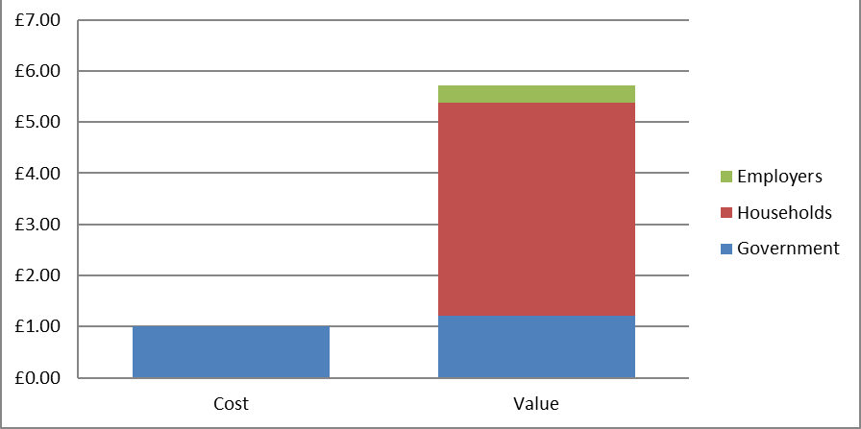

Discussion: The Value of Co-production for Integration
Experience of the project led to the conclusion that an approach to integration and social capital formation based on co production to design and deliver integrated training and support programmes with new migrant women offers life changing opportunities for participants and is very cost effective in terms of the Social Return on Investment. This supports many of the recommendations of the Casey Review (2016) including a focus on women migrants, the provision of opportunities for learning English, enabling participating in children’s education, improving employability and increasing IT literacy. It also demonstrates how progress towards community integration can be measured and valued.
The challenges of adopting this approach were considerable, it was unconventional to focus on a community of new women migrants, rather than communities as defined by ethnicity. However, women’s shared experiences and needs created bridges that quickly built their sisterhood. It was also unconventional to develop training and other initiatives “with” rather than “for” women, yet who knew their needs better? And it was difficult to balance the perspectives of existing community leaders (mostly male) with those of the newly emerging leaders of the community of women. A lesson learnt was that each generation of migrants, and each community, faces its own issues and needs to find its own leaders. Involving the women in the evaluation was also a risk but one with far more positives than negatives.
The process of co production could not have been achieved in one step, it required the development of mutual respect, trust and the sharing of skills and knowledge between participants and the support team, this took time and effort on everyone’s part. This provided a practical example of Arnstein’s (1969) ladder of citizen participation as interpreted by the Engagement Spectrum proposed by the Action Learning Team of the Office of the Deputy PM (2004). As Catherine Needham and Sarah Carr (2009), note there are many concerns and limitations to be addressed when developing co-production. It requires that service providers take an enabling role to ‘work with rather than do unto users’. This was a challenge for Participants, Community Leaders and Council Officers; to learn together to build common understanding and trust between all parties. This “pathway” approach maximised engagement within and between migrant community group members and with wider community organisations. This approach has since been identified by Jenny Phillimore (2012) as a key to successful integration. It is a tribute to the programme support team that this approach was adopted.
The social value of outcomes was estimated applying the principals of Social Return on Investment as set out in the Guide by Jeremy Nicholls, Eilis Lawlor, Eva Neitzert and Tim Goodspeed, (2009). This provides a very useful consistent basis for applying assumptions to outcome, but it is important to note this would be unconvincing were it not for the qualitative evidence provided by questionnaires, focus groups, learning history and individual testimonies of the participants.
The project showed the importance of women migrants as social integrators for their families, for health and across ethnic community groups. Perhaps the clearest route to social integration and guidance for young people is through their mothers. As a member of our Expert Advisory Panel observed, quoting Malcolm X: "If you educate a man, you educate one person. If you educate a woman, you educate and liberate a whole nation".

References
Louise Casey (2016) “The Casey Review: A review into opportunity and integration” Crown Copywrite Department for Communities and Local Government, London
Rosalyn Harper (2002) “The Measurement of Social Capital in the UK” National Statistics, London
James Laurence, (2009) ”The Effect of Ethnic Diversity and Community Disadvantage on Social Cohesion: A Multi-Level Analysis of Social Capital and Interethnic Relations in UK Communities” European Sociological Revue (2009) doi: 10.1093/esr/jcp057
Linda Richings, Sarah Collins, Claire Evans, Bob Coe/Brian Harris, Steve Rose. Peter Langford/Nicola Henson, Myra Garrett, Richard Powell, John Smith, Catherine Johnstone, Claire Cowley, (2004) “Community engagement action learning set report, May 2004” Office of the Deputy Prime Minister , European Urban Knowledge Network
Fujiwara, Oroyemi and McKinnon, (2013) “Wellbeing and Civil Society: Estimating the value of volunteering using subjective wellbeing data” Department of Work and Pensions Working paper 112 Explanation and Discussion HMSO, London
Wim Groot, Henriette Maassen van den Brink, Bernard van Praag (2006) “The Compensating Income Variation of Social Capital" IZA DP No. 2529 Institute for the Study of Labor University of Zurich and IZA, Bonn.
BIS Research Paper No 38 (2011) “Measuring the Economic Impact of Further Education” Department for Business Innovation and Skills, HMSO London.
Office for National Statistics Statistical (2012): “The Effects of Taxes and Benefits on Household Income, 2010/11” ONS, London.
Citizen’s Advice Service (2014) “Making the Case: The value to society of the Citizens Advice Service” CAB London.
Alastair Ager and Alison Strang (2004) “Indicators of Integration: Final Report” Home Office, London
Ben Gidley (2012) “Measuring Integration in the UK” Chapter18 in Rob Bijl and Arjen Verweij eds Netherlands Institute for Social Research “Measuring and Monitoring Immigrant Integration in Europe: Integration policies and monitoring efforts in 17 European countries ” European Commission 2012
Arnstein, Sherry R. (1969)"A Ladder of Citizen Participation," JAIP, Vol. 35, No. 4, July 1969, pp. 216-224
Catherine Needham and Sarah Carr, (2009) “SCIE Research briefing 31: Co-production: an emerging evidence base for adult social care transformation” Social Care Institute for Excellence London
Jenny Phillimore (2012) “Implementing integration in the UK: lessons for integration theory, policy and practice” Policy & Politics, Volume 40, Number 4, October 2012, pp. 525-545(21)
Stephen Cavanagh, (1997) “Content analysis: concepts, methods and applications” Nurse Researcher Royal College of Nursing, London
Jeremy Nicholls, Eilis Lawlor, Eva Neitzert and Tim Goodspeed, edited by Sally Cupitt, (2009) “A Guide to Social Return on Investment” Cabinet Office, Office of the Third Sector, London

