 

**Evaluation of the Adult Expert Patient Programme**

**Introduction and Summary**

The Greenwich Public Health Intelligence Team is congratulated on the inclusion of an evaluation discipline in their development and delivery of Expert Patient Programmes (EPP) for residents with chronic health conditions. To assist in this development a brief review of the data available and outcomes achieved after one year has been undertaken to produce a tool that can be adapted and updated with further evidence and to report on the cost effectiveness of the programme in terms of cost utility and social return on investment achieved to date.

At present the data are limited in some respects, however, on the basis of the available evidence a preliminary evaluation suggests that the programmes are well regarded by participants and empower them to take positive steps to improve their health and wellbeing. The programmes were taken up by a diverse mix of local residents with only 30% describing their ethnicity as white English, drawn from a full range of levels of areas of deprivation. Some 60% of respondents scored the programmes at 4 or 5 out of 5 for the perceived benefit of the programmes for a range of 19 factors reflecting their empowerment to cope with aspects of their health conditions.

Preliminary outcomes suggest that the respondents achieve a similar level of cost utility in terms of cost per health gain, measured as quality adjusted life years (QALY) to the national study of the cost effectiveness of EPP[1] by G Richardson et al (2008), which showed that EPP for chronic patients would meet the criteria of costing less than £20,000 per QALY gained. The national study was based on costs and values at 2003, if the criteria for cost effectiveness were updated by NHS expenditure inflation, the current threshold would be £38,200, however, the National Institute for Health and Clinical Excellence (NICE) has decided to keep the threshold at £20,000 and on this basis the Greenwich EPP would not meet the cost utility criteria if only demonstrable health improvements are considered.

Taking a broader view of the impact of EPP in Greenwich by applying social return on investment analysis, takes into account not only health gains but also the wellbeing impact of relaxation, physical activity, social activity and volunteering, training, education and employment and language support (as provided by courses in another language). Taking these factors into account alongside the health benefits, drawing on proxy values taken from the HACT Social Values Bank[2], demonstrates that using the most conservative estimates of value would generate over £2.85 of social value for each £1 spent. This shows that the programme is likely to be considered cost effective in SROI terms.

**Data Analysis**

In total data were collected for 280 respondents attending Expert Patient Programmes. However, before and after evidence were only available for 50 of these as shown in Table 1. Unfortunately data were not available for patients with chronic conditions who did not attend EPP courses so it was not possible to compare outcomes with and without the intervention in order to assess the likely outcomes without intervention a comparison was drawn with the national reference study by Richardson et al.

As Table 2 shows almost 70% of respondents were female and the average age was almost 60 years.



Respondents were drawn from areas of high and low multiple deprivation as shown in table 3.

Only 33% of respondents described their ethnicity as “White British” as shown in chart 1

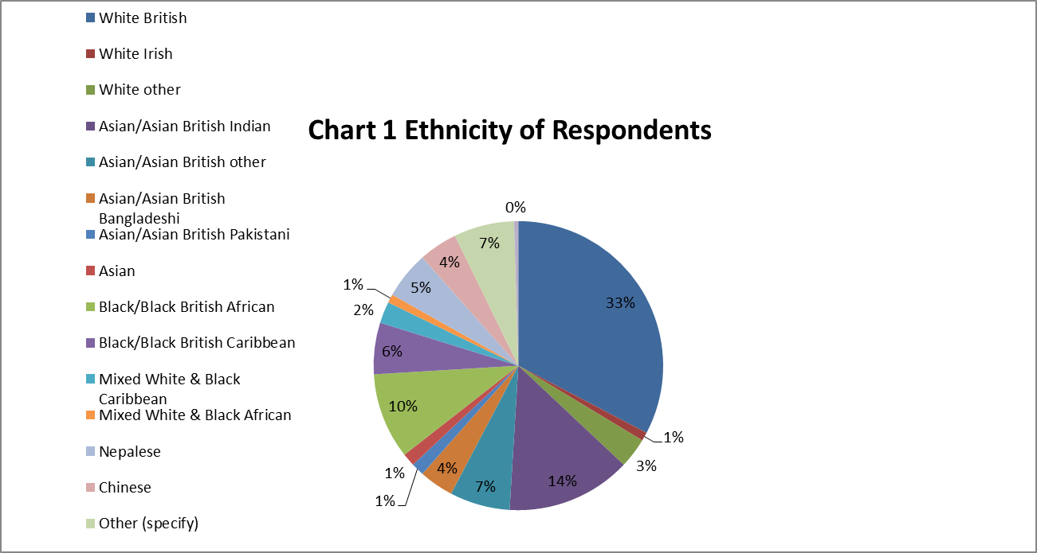

More than 50% of respondents described their presenting medical conditions as complex, involving more than one condition.

The EPP courses attended were as shown in Table 6.

Chart 2 shows the relative evaluation scores after 12 weeks and 1 year, showing particularly high evaluations for issues which empowered the respondents to take decisions about their health: Action Planning, Medication Usage, Informed Treatment choice and also Healthy Eating and Physical Activity and Exercise. This supports the conclusion drawn by Chris Griffiths et al [3]"How Effective are expert patient (lay led) education programmes for chronic disease" that increasing "self-efficacy" is a major benefit of Expert Patient Programmes.

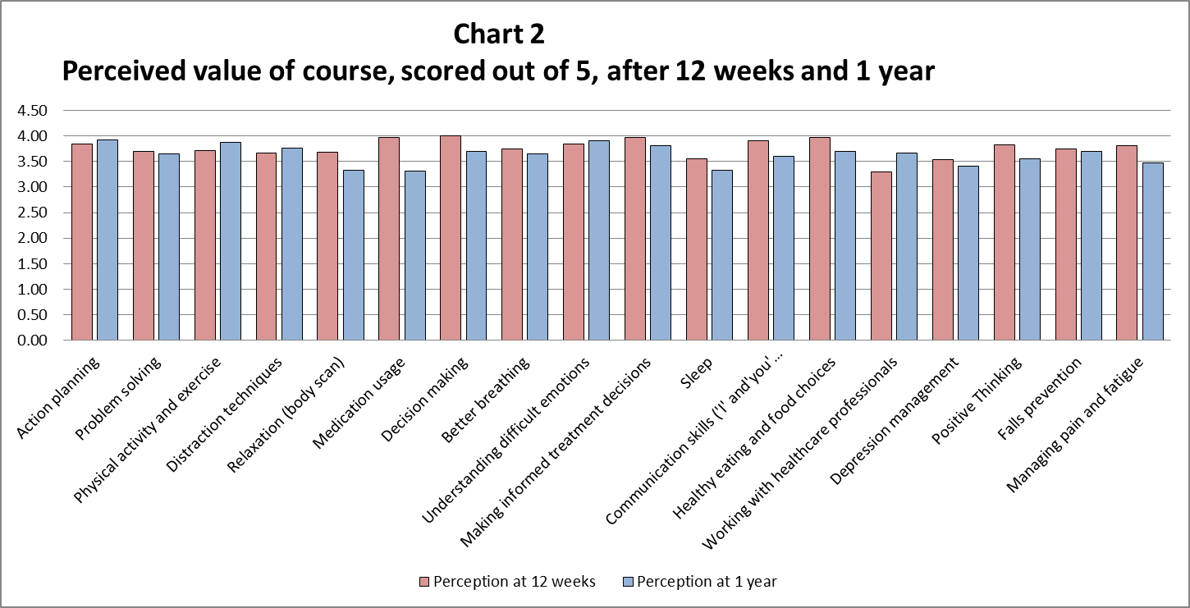

Where before and after data are available the evidence suggests a high proportion of respondents take steps to improve their health and wellbeing, moreover in many cases respondents persisted or even increased steps to improve health and wellbeing a year after initiation. However, as noted above the data available are relatively limited.



This resulted in an apparent improvement in health as shown in Table 10 from the level recorded pre the courses to the level at week 12 as measured by EQ5D (a composite measure of 5 dimensions of health: mobility, ability to self-care, ability to perform usual activities of daily living, level of pain or discomfort and level of anxiety and depression. From week 12 to 1 year the level of EQ5D recorded appeared to reduce, lessening the overall gain. However, it is important to bear in mind that an overall decline in health, and its perception might be expected during this period. Unfortunately the current study did not include a control group in order to compare what would have happened with and without EPP.



Use of NHS services varied depending upon the nature of the course and hence the types of chronic health conditions. It was particularly noticeable that participants in the Adult Generic Language courses, taught in other languages, were likely to use NHS services far less than others. Moreover, though increased at 12 weeks, their use after 1 year appeared to decline further.



Where before and after data are available an increase in NHS service use can be seen at 12 weeks and 1 year, this may be due to the progression of the chronic conditions and/or increased awareness by respondents of their health needs.



**Costs**

The cost of commissioning and delivering the Expert Patient Programmes analysed by Greenwich Council Finance Department, show a delivery cost of £206.64 per participant and commissioning costs (including management, administration, events and other sundry) of £322.86 giving a total cost per participant of £529.50.

As current data do not provide details of the types of NHS services used by participants the data presented in the G Richardson et al (2008) national study were drawn on assuming a similar pattern of use by respondents with chronic conditions. Cost were updated by the overall increase in NHS expenditure from 2003- 2013, this is a conservative estimate (i.e. it is higher than expected). Applying these data suggests a cost per NHS visit of £232. A more precise estimate could be derived by applying the NHS National Reference Cost Database for 2012-2013[4].

**Outcome Thresholds and Social Values**

Cost utility analysis provides a way of comparing current costs with benefits, which are comparable in nature and can be valued using the same measure. For health outcomes NICE suggests the use of QALYs as an outcome measure to assess the additional cost per QALY achieved this is known as the o the Incremental Cost Benefit Ratio (ICBR). The appropriate threshold value for an incremental cost per QALY has been assessed in terms of public willingness to pay for marginal health improvements or to avoid health risks and in terms of the additional NHS costs required to achieve an improvement in health of one additional life tear at full health. The value of £30,000 per QALY was adopted in 1999 with a lower value of £20,000 and a higher value of £70,000 applied in exceptional cases. Since that time NICE has focussed on a value of £20,000 and has not increased this in line with inflation either to match household inflation or to match increases in NHS expenditure. This has had the effect of reducing the threshold for cost utility studies in real terms, and reducing the value attributed to health outcomes in relation to the value attributed to other social benefits.



If the Expert Patient Programmes are considered to fulfil wider social goals (wider than health improvement and NHS cost reduction), then additional values may be attributed to other social outcomes by applying Social Return on Investment (SROI). Such values and how they are applied are highly problematic, it is therefore essential to understand the users' views of these benefits through the use of Focus Groups and/or other consultations. In this case the responses shown in table 8 have been used as a measure of the proportion of respondents who benefited from steps to improve their health in the ways indicated, the proportion of patient in generic –language courses was also considered.

For this tool proxy values have been identified from the HACT Social Value Bank (SVB) for each of the main outcomes identified in table 8 plus the benefits of language support for those participating in the Adult – Generic Language courses.

It could be argued that the gain in relaxation time achieved by respondents can be offset against the time required to attend the course, thus the Low assumption is of no nett gain. High value is taken from the SVB value attributed to participation in hobbies in London over 50 at least once a week for at least two months. This is not, of course, an exact match.

The Low value for physical activity is the SVB, London over 50 value attributed to participation in keep fit exercise at least once a week for at least 2 months. The high value is the London over 50 value of mild exercise that does not make you sweat or raise heart rate significantly at least once a week for at least 2 months. However, these values are also reflected in the value for good overall health. They have therefore been excluded from estimates of the cumulative value of health and social benefits.

The Low value attributed to social activity and volunteering is the SVB, London over 50 value attributed to regular attendance at least once a month for at least 2 months at voluntary or local organisations. The high value is the London over 50 value of being a member of a social group.

The Low value attributed to training, education and employment is the SVB, London over 50 value attributed to participation in basic employment training. The high value is the London over 50 value of part time employment.

The high value attributed to language support is the SVB, London over 50 value attributed to being able to obtain advice locally. The low value is 1/3 of this assuming that health is only one field in which advice might be sought.

**Outcomes**

Applying these value to the outcomes for respondents for whom before and after data are available makes it possible to derive measures of cost utility in terms of cost per QALY and Social Return on Investment in terms of the social value achieved for each pound spent. This outcome varies depending upon the assumptions applied in particular whether benefits are assumed to persist for only 6 months or for one year (though even this seems a short impact) and whether the costs include commissioning costs or only include direct delivery costs as appears to be the case in the national reference study.

Table 18 shows the outcome of cost utility analysis which shows the cost per QALY under different assumptions it should be noted that case 5 which applies similar assumptions to the national reference study shows an outcome in terms of incremental cost per QALY which would be similar to that demonstrated by the national study if it were translated in 2003 prices and values.



Table 19 shows the result of applying Social Return on Investment analysis to the available data applying different assumptions. It shows that if the social benefits of EPP are taken into account then even applying low value added assumptions throughout would result in a positive outcome of a return of £2.85 for each pound spent. Applying the high values throughout would demonstrate a social value of some £10 for each pound spent.



**Lessons and Further Developments**

The outcomes suggested by this preliminary review are encouraging but there are lessons to be learnt and more work to be done. It is suggested that members of the commissioning and delivery team, who will have greater insight into the EPP courses should review the detailed outcomes as revealed by the Evaluation Tool to consult users and explore ways in which the benefits could be increased and perhaps costs reduced. In view of the clear social wellbeing benefits demonstrated it might be suggested that these factors should be emphasised in the programme and or links made to other potential sources of support such as language development, keep fit, cooking and diet and social support.

The main deficiencies in the current data are, that it is not possible to compare outcomes with a control group without the intervention and that there are a limited number of respondents for whom before and after data are available. As more data are gathered the evaluation tool can be updated, by patching more rows of data above row 285 in the data entry page. The Evaluation Tool could also be updated to accept data for a control group, but this will require some reconfiguration.

The way in which some of the data are recorded could also be improved for example it is more difficult to deal with data that are entered as lines of text particularly when there are multiple answers. It would be helpful to see if there are missing issues, for example while questions about the usefulness of healthy eating advice are included there is no enquiry as to whether respondents have actually changed their behaviour. Note that the SVB attributes higher values to the impact of such changes than are shown by QALY outcomes. And it would also be possible to match some questions to the requirements of the HACT Social Value Bank, so that a precise value can be allocated rather than a general proxy. To show the nature of the HACT SVB an extract is included at Annex 1.

**Conclusions**

This preliminary evaluation shows that the Greenwich Public Health Intelligence Team have made very good progress towards developing the ongoing evaluation, improvement and extension of its Adult Expert Patient Programmes. The programmes are highly valued by users and show clear benefits to both health and social wellbeing which mean they are likely to be cost effective in terms of the Social Return on Investment achieved, even when evaluated in relatively conservative terms and with limited data.

This review was undertaken within a budget of £3,750 by Professor Graham Lister, with assistance from Divinia Mistry and Mai Khidir of the Greenwich team and David Reeves of the National EPP Evaluation Team, all assumptions and errors are the responsibility of the author.

**References**

1. G Richardson, A Kennedy, D Reeves, P Bower, V Lee. E Middleton, C Gardner, C Gately, A Rogers (2008) “Cost Effectiveness of the Expert Patient Programme (EPP) for patients with chronic conditions” Centre for Health Economics, York, Journal of Community health 62: 361-362
2. Daniel Fujiwara, (2013)“Social Value Bank” produced by HACT, accessed on 10/10/2015 at www.socialvaluebank.org.
3. Chris Griffiths, Gill Foster, Jean Ramsay, Sandra Eldridge, Stephanie Taylor.(2007) “ How effective are expert patient (lay led) education programmes for chronic disease?” BMJ Vol 334 1254-1256.
4. Department of Health (2014)NHS National Reference Cost Schedule 2012-2013 <https://www.gov.uk/government/publications/nhs-reference-costs-2012-to-2013>

   **Annex 1 Examples of Values from HACT Social Values Bank**

   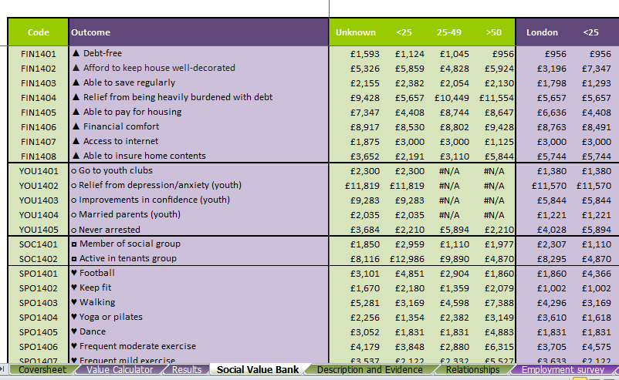

   The basis for the values included in the HACT Social Values Bank are explained in the paper by Daniel Fujiwara, “ The Social Impact of Housing Providers”. The SVB adopts what is described as a “wellbeing valuation method”. This values the impact on wellbeing in accordance with the monetary difference in household income that would produce the same increase in levels of self-reported wellbeing as the changes in the factor being valued, (in this case relating to housing conditions). These values are derived from a multiple regression analysis of variables including changes in income level, health, family and other relationships and other factors with measures of wellbeing, Life Satisfaction and happiness. The analysis technique makes it possible to identify the impact of particular variable on wellbeing while controlling for other factors. Since the analysis is based on changes in income levels and other factors it also means that it can be adjusted for differences between people at different ages and locations. Data for the analyses were drawn from the British Household Panel Survey, an annual survey of some 10,000 adults. While this study focussed on factors most relevant to housing provision, the general approach and its findings can also be applied to other factors that increase wellbeing.