Updates to the Health Trainer Service Evaluation Tool 2014
Introduction
The Health Trainer Service Evaluation Tool is designed to help you evaluate the Value for Money of Health Trainer Services, taking into account the latest estimates of the Burden of Disease in England from the World Health Organisation and views from Public Health England, NICE and a wide range of health commissioners and providers who responded to a questionnaire. The original evaluation tool supported by Portsmouth NHS was based on a wide range of data set out in the report by Graham Lister, it is important to read this as an introduction and explanation. We must stress that the Evaluation Tool is only as good as the data and assumptions on which it is based it must be updated as new research reveals the cost and impact of the behaviour changes that HTS support.
This second update was commissioned by Em Rhaman PH Workforce Development Manager at Health Education Wessex and undertaken by Professor Graham Lister and Ian McAleer. It updates the values used in the tool to 2014/15 prices and provides a facility for further upgrade with inflation in future years. Recent studies have allowed us to update data on the health impacts and cost to the NHS and Local Authorities of behaviours addressed by Health Trainer Services (HTS).
In brief, the tool requires users to enter the cost of HTS and details of the targeted population and intermediate outcomes achieved. The intermediate outcomes include support for community development and the number of clients reaching personal health improvement targets in each area and those benefiting from emotional support. The tool calculates the likely long term impact on health and other outcomes, taking into account studies that show the rate at which HTS clients either persist with behaviour change or fall back into previous behaviour (most behaviour change is only maintained for a relatively short time). The estimate of the health impact of behaviour in each field is derived from WHO Global Burden of Disease studies applied to UK outcomes. Comparing current estimates of the Burden of Disease in England with estimates of the population exhibiting the causal behaviour over the prior period of 20 years provides a best estimate of the marginal impact of one person’s behaviour change over one year. This is applied to the projected behaviour of those clients partially or fully achieving their intermediate behaviour change goals over their remaining life. This then makes it possible to compare costs with the discounted value of future health and other impacts
The tool addresses some complex issues of value and impact and depends upon many estimates and assumptions. It provides a range of estimates of value for money and Social Return on Investment including sensitivity analysis to examine the impact of changes to the basic assumptions and the discount factor used. We suggest commissioners and providers of HTS should come together to apply the tool and share their understanding of the data and assumptions, note that these assumptions can be updated and adjusted to reflect both new data and local conditions. We suggest that it is helpful to set this qualitative evaluation alongside qualitative studies that demonstrate how HTS changes people’s lives and health.
This tool and others like it, with training materials are available from the web site noted below.

Updates to Burden of Disease Estimates
The most significant updates arise from the Government Policy Paper “Living Well for Longer” and the study of the updated WHO 2010 Global Burden of Disease findings to UK data by the Institute of Health Metrics and Evaluation. The data presented in these papers show significant differences from previous estimates of the burden of disease measured in Disability Adjusted Life Years (DALYs) arising from key behavioural causes for the UK. This is both because of real changes since 2004 when the data was last applied and because the method of calculating DALYs applied by IHME has changed. In previous versions DALYs included weightings depending on the age and also included internal discounting (at 3%). This meant that it was necessary to apply correction factors to convert DALYs to an estimate of Quality Adjusted Life Years (QALYs). Both QALYs and DALYs assess the quality of life of those affected and the period for which they are affected. QALYs are determined from patient surveys (and therefore vary depending how and when the survey is undertaken) , while DALYs are based on expert judgements (and it might be argued are international rather than reflecting UK values) . In effect it simplifies this issue, now QALYs gained are equivalent to DALYs reduced. Detailed aspects of the new analysis (i.e. breakdown in terms of Years of Life Lost and Years Lived with Disability) are taken from the Institute of Health Metrics and Evaluation web site. However this analysis does not cover every behaviour addressed by Health Trainer Services so where no new data is available other sources have been used (see Table 1)
Updates of the Cost Impacts of Conditions addressed by HTS
Estimates of the cost to the NHS from the causes and conditions addressed by Health Trainer Services are most often based on the Population Attributable Fraction (PAF) associated with each behaviour (i.e. how much of each disease outcome is due to each behavioural cause) costs to the NHS of each disease outcome (for example from the NHS Programme Budget) can then be attributed to each behaviour. The problem with such estimates is that there are many gaps and they apply different assumptions and sources. It would be useful to have a consistent set of estimates based on an agreed source of PAFs and NHS costs. However until such time as Health England can establish a consistent approach to such estimates we must rely on the best available evidence. Estimates of costs have been updated and revised over the past two years see below and table 2:
- The Government Alcohol Strategy estimates the annual cost to the NHS of alcohol related illness and accidents in England at £3.5 billion in 2009-2010 price levels equivalent to £3.24 b in 2008/9 expenditure levels.
- Alcohol related crime in England is estimated to give rise to annual costs of £11 billion in 2010-2011 prices¹ equivalent to £ 10.65b in 2008/9 when adjusted by RPI.
- Lost productivity related to alcohol is estimated to cost £7.3 billion per year in 2008/9 for the UK¹ . Adjusting for England on the basis of population suggests £6.120 b.
- The cost to the NHS of poor diet related ill health was estimated as £5.8 billion for the UK in 2006-7. This suggests a cost estimate for NHS England of £5.7 b in 2008/9.
- The cost to England’s economy of lost employment productivity due to absence and premature death attributable to obesity was estimated as £2.5 billion in 2002/3 prices Adjusting by the Retail Price Index this is equivalent to £3.0 b in 2008/9.
- UK NHS Costs associated with physical inactivity £ 0.9 billion in 2006-7⁷. Adjusting for population and prices suggests an estimate of NHS costs for England of £1.17 b in 2008/9.
- UK NHS costs related to smoking are estimated as £ 3.3 billion in 2006-7⁷. Adjusting for population and costs suggests an estimate of NHS costs for England of £3.24 b in 2008-9.
- The cost to the economy of the additional time off work and lost working days due to early deaths associated with smoking is estimated at £1.4 billion for the UK in 2011 A wide range of measures have been suggested for the economic impact of “fag breaks” an estimate of £2.9 b for the UK in 2008/9 prices gives a total employment impact of £3.5 b for England 2008/9.
- Cost of illicit drug use in England is estimated as £1.2 billion in cost to the NHS including mental health and drug related services in 2003/4 adjusted for NHS expenditure this equates to £1.7 b in 2008/9 assuming expenditure has increase in line with NHS expenditure.
- Wider costs to society of drug related crime in England is estimated at £13.9 billion in 2003/4 costs adjusted for RPI this would equate to £16.6 b in 2008/9.
- The cost to the NHS of treating people with mental illness was estimated cost of mental as £6.5b, LA social care costs as £1.4 b and the economic cost of lost output as £23.1 b in 2002/3 values. In 2008/9 prices this suggests costs of some £8b to the NHS, £2.6 b to LA services and £42 b in lost output. But not all mental illness manifests as emotional wellbeing problems. Thus while 20% of the burden of disease has been associated with mental illness only 7.8% is attributable to mental wellbeing. Thus the estimates have been adjusted for this proportion to show the cost impact of emotional wellbeing as £3.2 b for NHS costs, £1 b for LA social care costs and £16 b for economic impacts.
- The value of a QALY used as a basis for calculating the Social Return on Investment has been updated as suggested by NICE. They previously agreed with a value of £25,000 in 2007/8 prices but now suggest a value of £20,000 in 2013/14 prices with no allowance for inflation.
We have been unable to find a convincing study of the employment impact of drug misuse but it is unreasonable to suppose that early deaths and poor productivity do not result from drug misuse, thus until someone provides a better measure an indicative value of £1.7 b in 2008/9 (equivalent to treatment costs) is included to indicate the probable impact.
Adjusting for England and Inflation in Costs
These health impact figures have been adjusted where necessary from UK population estimates, to apply to NHS England. Expenditure increases have been set to a baseline of 2008/9 and then increased in line with net NHS expenditure for England to 2014/15. Local Authority costs have similarly been increased to 2014/15 values and other costs adjusted in line with the Retail Price Index (RPI) movements. Clearly these are broad assumptions, it is known that rates of disability and death associated with behavioural factors are generally worse in Scotland Northern Ireland and Wales than for England so these are likely to be slightly overstated. Increasing all costs to the NHS by overall expenditure increases ignores the possible redistribution of expenditure between services and increasing other costs by RPI is also a broad estimate. The tool now includes a facility to adjust for inflation beyond 2014/15.
Social Return on Investment
As in the previous version of the tool a facility is provided to estimate the Social Return on Investment based on a standard value for a QALY. The tool also makes it possible to apply a weight for impact on disadvantage and/or to use the Health England Leading Prioritisation based formulae. However, neither DH or Public Health England support the use of differential weights for impacts on disadvantaged groups – they suggest an alternative approach - the Health Inequalities Intervention toolkit available from the London Health Observatory.
Sensitivity Analysis Varying the Social Time Preference Rate
A facility has also been introduced to make it easier for users to test the sensitivity of outcomes to higher or lower assumptions concerning the extent of change achieved and the persistence of changes as well as variations in the discount rate used to represent the social time preference rate (the rate at which future social benefits such as health improvements are discounted to an equivalent present value). While the Treasury Green Book still recommends a discount rate of 3.5% for the first 30 years and 3% thereafter, NICE recommend that the sensitivity to different assumptions about social time preference should be tested at say 1.5% and 6%. It is not clear on what basis this is proposed but in order to reflect this advice a facility is provided.
Further Research and Training
As HTS and other health and wellbeing services are now the responsibility of Local Authorities we suggest that it would be timely to provide further training and research to support the use of this and similar tools. It is important for policy makers, commissioners and providers to gain a shared understanding of the value for money of behaviour change and how it can be measured. We also note that a further tool is in development to assess the health and other wellbeing impacts of all forms of Social Capital. Here again we suggest research and development should be matched by mutual exchange and shared learning opportunities as it is important to develop our understanding together and to make sure that any tools developed meet the needs of decision makers.
Graham Lister 23/05/2014
Chaplin, R., Flatley, J. and Smith, K. (2011) Crime in England and Wales 2010/11. Home Office Statistical
Bulletin 10/11. London: Home Office. Supplementary Tables 7 http://www.homeoffice.gov.uk/scienceresearch/
research-statistics/crime/crime-statistics/bcs-supplementary-tabs/.
Chaplin, R., Flatley, J. and Smith, K. (2011) Crime in England and Wales 2010/11. Home Office Statistical Bulletin 10/11. London: Home Office.
http://www.alcohollearningcentre.org.uk/_library/IAS_workplace_Factsheet.pdf
Institute of Alcohol Studies; Alcohol Knowledge Centre Economic Impacts Factsheet at http://www.ias.org.uk/Alcohol-knowledge-centre/Economic-impacts/Factsheets/Economic-costs.aspx
Table 1 United Kingdom Health Burden DALYS 2010 Total and % By Cause
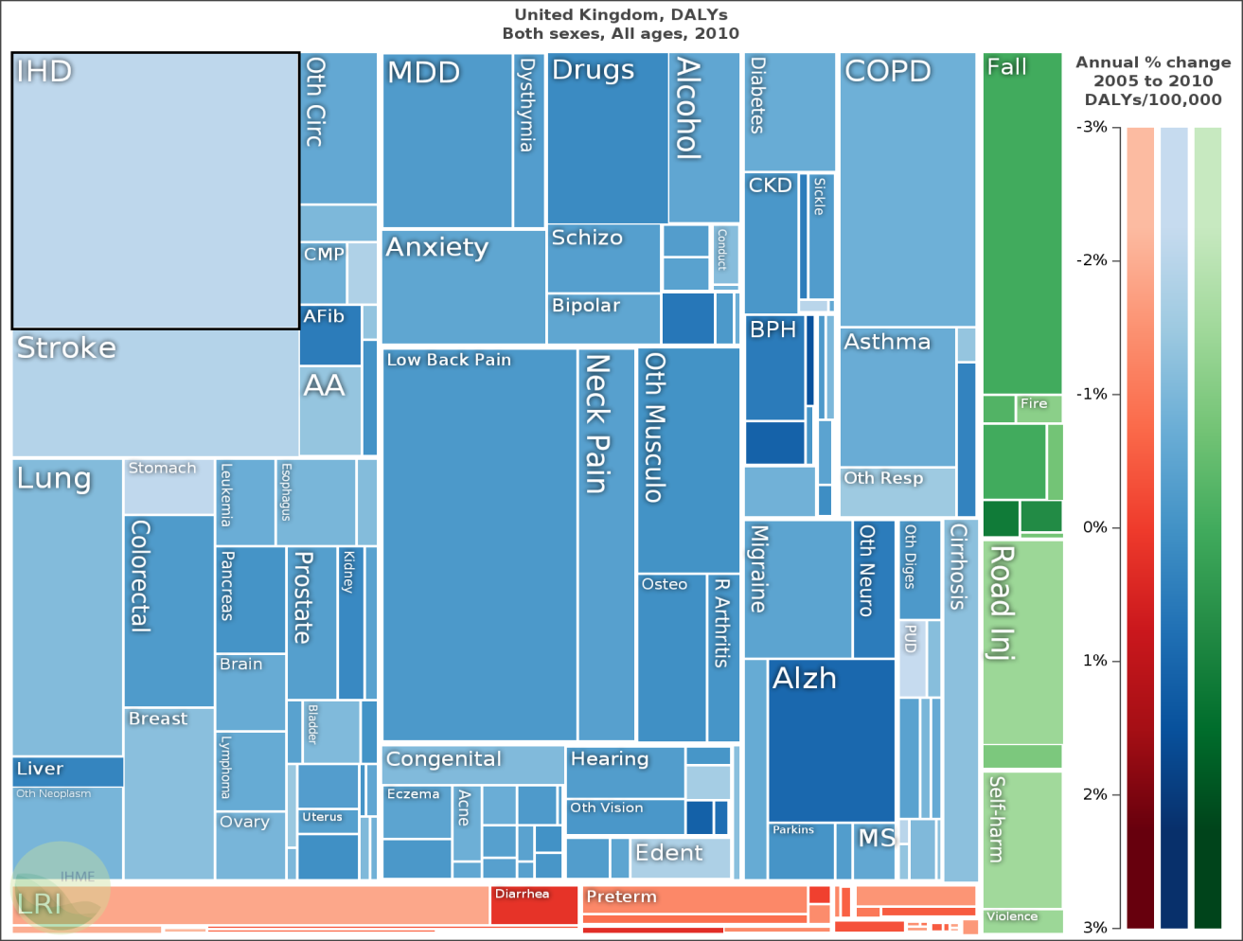
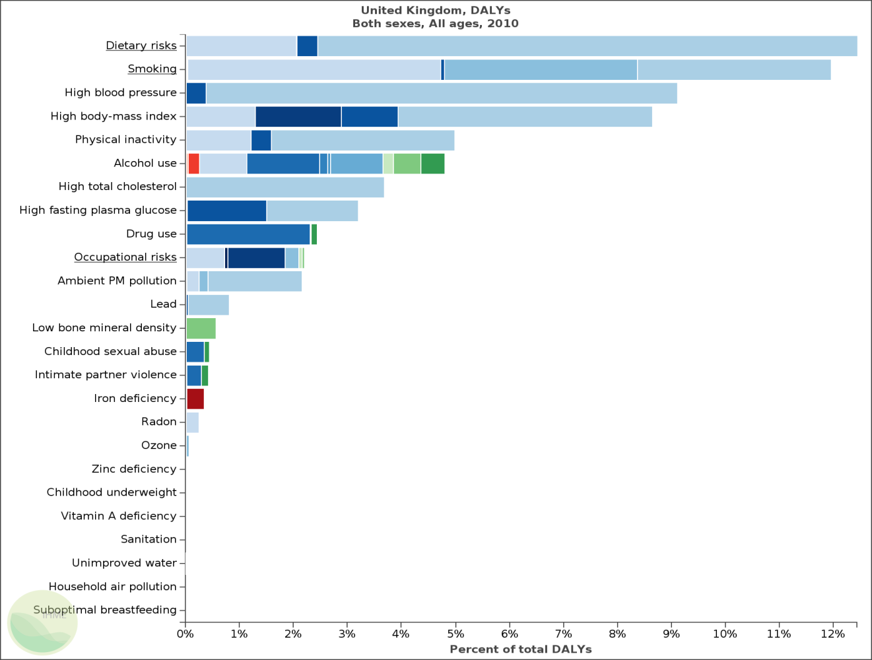

Graham Lister (2010) ”Assessing the Value for Money of Health Trainer Services” available from http://www.building-leadership-for-health.org.uk/evaluating-behaviour-change/
Department of Health (2013) “Living Well for Longer: a Call to Action to Reduce Avoidable Premature Mortality” 2013
Prof Christopher JL Murray MD et al (2013) “UK health performance: findings of the Global Burden of Disease Study 2010” The Lancet available at http://www.thelancet.com/journals/lancet/article/PIIS0140-6736(13)60355-4/fulltext data
Institute of Health Metrics and Evaluation: GBD Compare web site at http://viz.healthmetricsandevaluation.org/gbd-compare/#
NHS Networks (2014) 2012-13 “Programme Budgeting is Now Available” http://www.networks.nhs.uk/nhs-networks/health-investment-network/news/2012-13-programme-budgeting-data-is-now-available
Secretary of State for the Home Department (March 2012) “The Government’s Alcohol Strategy.” HM Government
Scarborough, P. Bhatnagar, P. Wickramsinghe, KK. Et al (May 2011) “The economic burden of ill health due to diet Physical inactivity, smoking, alcohol and obesity in the UK: an update of the 2006-07 NHS Costs. Journal of Public Health , Oxford vol 33:4 pp.527 535
House of Commons Select Committee (2004) “Obesity: Third Report of Session 2003/4. The stationery Office london
Stephen F Weng, Shehzad Ali and Jo Leonardi-Bee “Smoking and Absence from Work: systematic review and meta analysis of occupational studies” Addiction Vol 108 Issue 2 pp 307-319.
Robert Nash & Henry Featherstone (2010) “Cough up: Balancing tobacco income and costs in society” Policy Research Note
National Audit Office (March 2010) “Tackling problem drug use“ National Audit Office HMG
Home Office, Measuring different aspects of problem drug use: methodological developments 2006, The economic and social costs of Class A drug use in England and Wales, 2003/04 http://www.homeoffice.gov.uk
The Sainsbury Centre for Mental Health (2003) “Policy 3: The economic and social cost of mental illness”. London
Rachael Harker (2012) “ NHS Funding and Expenditure standard note SN/SG/724 April 2012House of Commons Library
Matrix Consulting Ltd Health England Leading Prioritisation http://help.matrixknowledge.com/
London Health Observatory at: www.lho.org.uk/LHO_Topics/Analytic_Tools/Health- InequalitiesInterventionToolkit.aspx

